Pre-Test
Working one-on-one with students in a special education setting is not out of the norm for intervention specialists. For this lesson one student will work with me to work on reading comprehension, predications, story recall, and the use of graphic organizers. To begin this lesson a pre-test will be taken based on the K-W-L chart. It will help identify the students prior knowledge of what is known, what is going to be learned, and what the student wants to learn based on the subject.
I large teacher book will be placed in the classroom and the student will have their own version of the book. By flipping through the pictures the student will complete the K-W-L chart with the assistance of the teacher. The student will be asked three questions. What does he know about the book, what does he believe he will learn from the book, and what does he want to learn from the book.
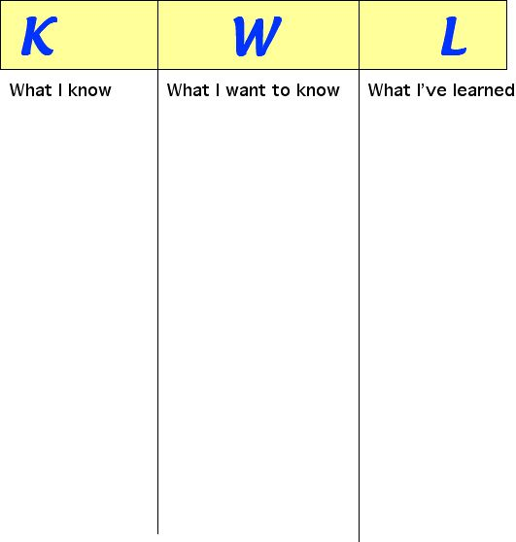

Post Test
The post-test will allow the intervention specialist the student will be assessed on his knowledge of the book in the form of a cause and effect graphic organizer. The student will recall what occurred during the book and fill out a cause and effect chart to assess the content and sequence of the story. The student will use the assistance of the intervention specialist for spelling, but not with the ideas and content of the story. It will be with the cause and effect chart that the intervention specialist will be able to see if the student correctly understood and comprehended the content.
