Instructional Design Project
(EDTL 7100)
March 30, 2010
Nelle Nutter

Rationale/Statement of Purpose
The purpose of this project is to create a set of hands-on lessons that address the state standards, while relating the lessons to real life applications. Inquiry-based science instruction is "the creation of a classroom where students are engaged in (essentially) open-ended, student centered hands-on activities. This means that students must make at least some decisions about what they are doing and what their work means—thinking along the way" (Colburn 2003). The lessons that I have created include activities, materials, and are cross-curricular due to the fact that they include mathematic and language arts standards. It was important to create this unit because studies show that hands-on science instruction allows success beyond the classroom, hands-on activities excite students about learning and science in general, and that the hands-on activities create confidence in the children (Puentes, 2007). Teachers, even with limited instructional time for science instruction, reported that hands-on and inquiry based science methods had positive effects on child engagement in learning (Puentes, 2007).
The reason I have focused on creating hands-on activities is because I have noticed in my classroom that students immediately become more drawn in to a lesson that they are directly involved in. Research comparing schools with hands-on, student-centered science instruction versus more traditional teacher-directed, textbook-based science instruction demonstrates considerable student achievement gains for those in hands-on programs (Jorgenson, 2005). I have also aimed to create lessons that have real life application. Topics that are relatable to the students will have more meaning to them, and because of that they will most likely be more interested in the information given.
I would say that I followed the 5-E Learning Cycle Model (Chiarelott, 2006) for the majority of the lesson plans that are included. Each lesson starts with student engagement, moves on to student exploration, followed by teacher explanation. The students also have the opportunity to reflect on the activities for each lesson. There is an extension of the lessons in the form of homework and the building of the lessons, and each ends with some sort of evaluation. I really try to include the engagement and exploration components in my math and science lessons, and this model seems to be perfect for that.
I am interested in covering the state standards in order to help prepare the students for the Ohio Achievement Assessments (OAAs). There is currently not a science test for the fourth grade students, but the information that is covered in fourth grade is tested on the fifth grade OAA. I will incorporate language arts and mathematic standards throughout the unit due to the fact that the students do have those OAAs in fourth grade.

Subunit Learner Outcomes
Students will be able to:
(Science)
-Identify characteristics of a simple physical change (e.g., heating or cooling can change water from one state to another and the change is reversible). (application)
-Identify characteristics of a simple chemical change. When a new material is made by combining two or more materials, it has chemical properties that are different from the original materials (e.g., burning paper, vinegar and baking soda). (application)
-Explain that matter has different states (e.g., solid, liquid and gas) and that each state has distinct physical properties. (application)
-Compare ways the temperature of an object can be changed (e.g., rubbing, heating and bending of metal). (application)
-Select the appropriate tools and use relevant safety procedures to measure and record length, weight, volume, temperature and area in metric and English units. (application)
-Analyze a series of events and/or simple daily or seasonal cycles, describe the patterns and infer the next likely occurrence. (application/analysis)
-Develop, design and conduct safe, simple investigations or experiments to answer questions. (application/evaluation/synthesis)
-Explain the importance of keeping conditions the same in an experiment. (comprehension)
-Describe how comparisons may not be fair when some conditions are not kept the same between experiments. (application)
-Formulate instructions and communicate data in a manner that allows others to understand and repeat an investigation or experiment. (synthesis)
-Record the results and data from an investigation and make a reasonable explanation. (analysis)

(Language Arts)
-Use organizational strategies (e.g., brainstorming, lists, webs and Venn diagrams) to plan writing. (comprehension)
-Produce informal writings (e.g., messages, journals, notes and poems) for various purposes. (synthesis)
-Create categories to sort and organize relevant information charts, tables or graphic organizers. (synthesis)
-Predict and support predictions using an awareness of new vocabulary, text structures and familiar plot patterns.
-Draw conclusions from information in maps, charts, graphs and diagrams. (evaluation)

(Mathematics)
-Identify and select appropriate units of measure:
A. perimeter
B. area
C. volume (application)
-Write, solve and verify solutions to multi-step problems involving measurement. (synthesis)
-Represent and interpret data using tables, bar graphs, line plots and line graphs. (synthesis)
-Interpret and construct Venn diagrams to sort and describe data. (application/analysis)

Pre Assessment

States of Matter Pre Assessment
As a class, ask the following questions and have the students fill in the KWL paper that is to be passed out, and then fill in a KWL chart for the class.

1. What are the three states of matter?
2. What state of matter has its own shape and takes up a definite amount of space?
3. Can you name two characteristics of a liquid?
4. How would you change a liquid to a solid?
5. How would you change a liquid to a gas?
6. What are two differences between a solid and a liquid?
7. What happens to the molecules in an object if it is heated?
8. What happens to the molecules in an object if it is cooled?
9. What do you think the reaction is called when two kinds of matter break apart and make a new kind of matter?
NAME:

States of Matter Unit

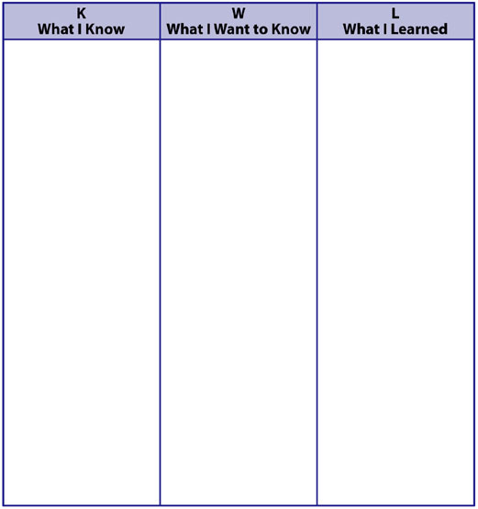

Lesson Plans
Subject: Science Grade: 4th

Topic: Discovering Matter- solids, liquids, gases Lesson: 1

Standard/Indicator:
Physical Sciences (Nature of Energy): Explain that matter has different states (e.g., solid, liquid, and gas) and that each state has distinct physical properties.
Writing Processes (Prewriting): Use organizational strategies (e.g., brainstorming, lists, webs and Venn diagrams) to plan writing.
Doing Scientific Inquiry: Select the appropriate tools and use relevant safety procedures to measure and record length, weight, volume, temperature and area in metric and English units.
Doing Scientific Inquiry: Develop, design and conduct safe, simple investigations or experiments to answer questions.
Science (Nature of Matter): Identify characteristics of a simple physical change (e.g., heating or cooling can change water from on state to another and the change is reversible).
Mathematics (Measurement): Identify and select appropriate units to measure: a. perimeter b. area c. volume

Lesson Objective: This activity gives students an opportunity to discover characteristics of the different types of matter, and to learn the definition through hands-on activities.

Focus Question: What two characteristics do all types of matter have? (Engagement)

Anticipatory Set: Show the students a book, a soda, and blow air in front of you. Tell them that all three of these things are called “matter.” The book is a “solid,” the soda is a “liquid,” and your breath is a “gas.” (5-7 minutes)

Materials: (needed for each group)
- water in small container (amount not important)

- large empty container

- science journals

- a solid object (vary for each group)

- ruler

- three 4” pieces of string

- two balloons and string

Procedures: (student instructions) (35 minutes)
(exploration)

1. Examine each solid object and journal your observations.

2. Examine the water, not the container. Before you begin writing your observations, pour the water into the other container, and watch what happens to the shape of the water, then journal your observations.

3. Examine your breath, a gas. Blow air, or gas, out of your mouth and journal your observations. Then follow these procedures:

- Blow up one balloon.
- Tie it with a string to the 1” mark on the ruler.
- Tie the empty balloon to the 11” mark on the ruler.
- Tie the other piece of string to the 6” mark and observe the other balloons to see which is heavier. If students have trouble seeing which is heavier, draw a straight line on the board and have students hold the ruler with balloons in front of the line. This will allow them to see that one side is slightly heavier.
(explanation)
- Look over your journals on each type of matter and try to find two things that are the same of each kind. (The teacher should eventually point out that the only two things which are the same for all kinds of matter are that they have weight and take up space.)
-Create a “Definitions” page in the science journals.
- Copy the definition of matter in your journal on the definition page: “Matter is anything that has weight and takes up space.”

Closure: In their science journals, have the students title one page “Matter” and then divide the page into three sections labeled “Solid,” “Liquid,” and “Gas,” and draw an example of each. (extension, 10 minutes)

Homework: Have students find examples of solids, liquids, and gases at home, list three of each to be turned in the next class. (evaluation)

Subject: Science Grade: 4th

Topic: Liquids Lesson: 2

Standard/Indicator:
Physical Sciences (Nature of Energy): Explain that matter has different states (e.g., solid, liquid, and gas) and that each state has distinct physical properties.
Doing Scientific Inquiry: Develop, design and conduct safe, simple investigations or experiments to answer questions.
Writing application: Produce informal writings (e.g., messages, journals, notes and poems) for various purposes.
Science (Nature of Matter): Identify characteristics of a simple physical change (e.g., heating or cooling can change water from on state to another and the change is reversible).

Lesson Objective: Students will make close observations of liquids in order to ascertain their similarities and differences.

Focus Question: Are all liquids the same? (engagement)

Anticipatory Set: (5-7 minutes)
1. Blindfold a student and have him/her feel and solid and a liquid and identify them by type of matter. Ask how he/she could so easily identify the liquid.

2. Write this Word Bank of adjectives on the board as a springboard for descriptions: clear, sticky, greasy, yellow, sharp, heavy, slowly, and quickly.

Materials: (needed for each group)
- four clear plastic cups, each containing 1/4 cup of water, honey or syrup, vinegar, cooking oil

- four plastic baggies

- a spring scale

- newspapers covering table/desks

- data-capture sheet

Procedures:
(exploration, 35 minutes)
1. Review the observations of matter, specifically the characteristics of liquids.

2. Tell students that today they are going to further examine liquids to see if they are all the same. They will use their eyes, noses, hands, and brains for this observation.

3. Feel each liquid and record what you feel on your data-capture sheet.

4. Look at the liquids and record their color on your data-capture sheet.

5. Pour one liquid from the cup into the plastic baggie. Observe how it pours and record what you see on your data-capture sheet.

6. Weigh the liquid in its plastic baggie on the spring scale and record the weight on your data-capture sheet.

7. Pour a little of the liquid on your newspaper to see if it can sit by itself or if it spreads all over the newspaper.

8. Repeat these steps for each of your other liquids.

9. Answer the questions at the bottom of your data-capture sheet. (explanation)

Closure: Discuss the observations, determining which things the student teams found to be similar about the liquids and different. Have the students journal their findings. (evaluation, 10 minutes)

Homework: Have students note the different types of liquids in their homes, listing five different types to be turned in the next class.

Data Capture Sheet:
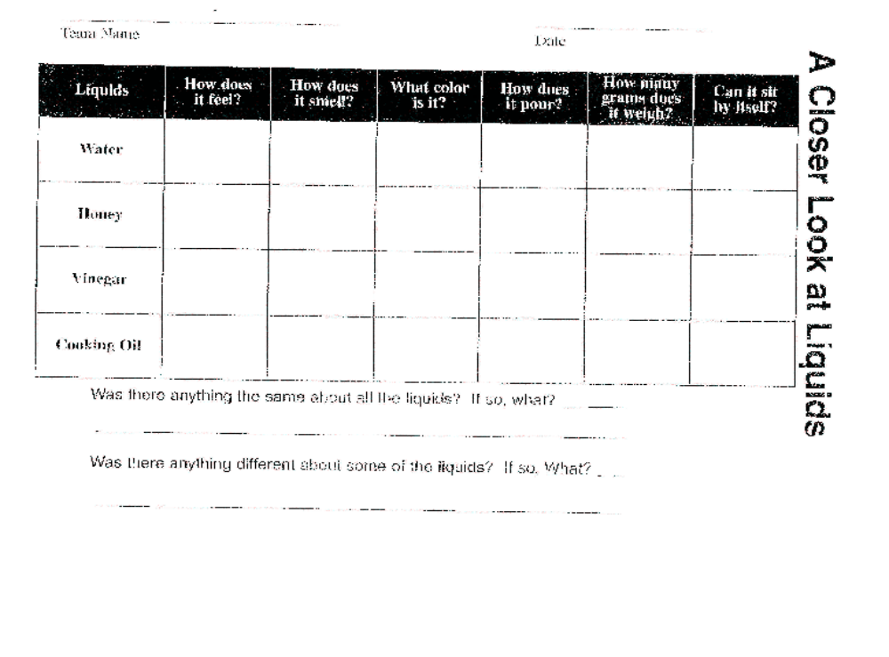
Teacher Created Materials, Inc. http://www.teachercreated.com/lessons. p. 33. March, 2010.

Subject: Science Grade: 4th

Topic: Solids Lesson: 3

Standard/Indicator:
Physical Sciences (Nature of Energy): Explain that matter has different states (e.g., solid, liquid, and gas) and that each state has distinct physical properties.
Science (Nature of Matter): Identify characteristics of a simple physical change (e.g., heating or cooling can change water from on state to another and the change is reversible).
Writing Processes (Prewriting): Use organizational strategies (e.g., brainstorming, lists, webs and Venn diagrams) to plan writing.
Mathematics (Measurement): Identify and select appropriate units to measure: a. perimeter b. area c. volume
Mathematics (Data Analysis and Probability Standard): Interpret and construct Venn diagrams to sort and describe data.
Mathematics (Measurement): Write, solve and verify solutions to multi-step problems involving measurement.

Lesson Objective: Students will make close observations of solids in order to ascertain their similarities and differences.

Focus Question: Are all solids the same? (engagement)

Anticipatory Set:
(7-10 minutes)
1. Show students a piece of paper and a book. Ask them what form of matter these objects are. Allow several students in the class to feel them and pick them up to compare their weight.

2. Ask them if the objects are alike in any way and if they can identify which type of matter these objects are.

3. Write this Word Bank of adjectives on the board as a springboard for descriptions: heavy, light, hard, soft, rough, smooth, pliable, rubbery, and earthy.

Materials: (needed for each group)
- a ruler

- four plastic baggies

- a spring scale

- a bowl

(All of the following materials should be about the size of a jacks ball)

- cotton balls, rubber ball, wad of clay, wad of paper

- Venn diagram worksheet

Procedures:
(exploration, 35 minutes)
1. Review the observations of matter, specifically the characteristics of solids.

2. Tell students that today they will make close observations of some solids in order to see what things are the same and different about solids. They will journal their findings, and will use their eyes, noses, ears, and brains.

3. Feel each solid and record what you feel in your journal.

4. Smell each solid and record what you smell in your journal.

5. Look at the solids and record their color in your journal.

6. Put each solid in the bowl. Do they keep their own shape as they sit in the bowl or do they take the shape of the bowl?

7. Weigh the solid in its plastic baggie on the spring scale and record the weight on the data-capture sheet.

8. Put the solid on the table to see if it can sit by itself.

9. Repeat the previous steps with each of your other solids.

10. (Pass out Venn Diagrams) Have students use Venn Diagrams to compare and contrast liquids to solids. (explanation)

Closure: Discuss the observations, determining which things the student teams found to be similar about the solids and different. Have the students journal their findings. (extension, 10 minutes)

Homework: Have students note the different types of solids in their homes, listing five to be turned in the next class. (evaluation)

NAME:

Liquids vs. Solids


LIQUIDS

SOLIDS
Same

Subject: Science Grade: 4th

Topic: Gases (air) Lesson: 4

Standard/Indicator:
Physical Sciences (Nature of Matter): Explain that matter has different states (e.g., solid, liquid, and gas) and that each state has distinct physical properties.
Doing Scientific Inquiry: Develop, design and conduct safe, simple investigations or experiments to answer questions.
Writing application: Produce informal writings (e.g., messages, journals, notes and poems) for various purposes.

Lesson Objective: Students will conduct an experiment in which they observe that air takes up space.

Focus Question: Does air take up space?
(engagement)

Anticipatory Set:
(5 minutes)
1. Ask a student to blow up a balloon. Ask the students what happens to inflate the balloon. Ask the students what the inflation of the balloon proves (that gases exist).

2. Ask the students what they know about “air”, and whether air is matter.

Materials: (needed for each group)
- newspapers

- large, deep, clear container filled 3/4 full of water

- a paper towel

- Science Experiment Form

- Observation Chart

Procedures:
(exploration, 35 minutes)
1. Tell students that today they will be learning about “air” to better understand gases.

2. Tell students that some air (gases) around us enters our body as breathable oxygen. When you blow your air (gases) from your body when you exhale, that air takes up space (as proven by blowing up the balloon earlier).

(student directions:)
3. Follow the steps on your experiment sheet, making sure to first develop a team hypothesis and writing it in the space provided. Be certain to check off each step as you complete it. Complete your observation sequence sheet as you work.

4, Write the results of your experiment, telling what you actually saw happening, write this in the “results” section. (explanation, 7-10 minutes)

5. Come to a conclusion to answer the question of whether air takes up space.

Closure: Discuss what the students observed in the experiment, making sure to ask them why the towel did not get wet. Be sure that they understand that air was taking up space in the little cup. Remind them that two kinds of matter cannot stay in the same place at the same time. In this case, the air was taking up space in the cup. Because it was taking up space, the air would not allow the water into the cup. (evaluation, 7-10 minutes)

Homework: Have students write a story from the viewpoint of the paper towel in their experiment. It might begin like: “It was just another day hanging on the roll when a little boy/girl pulled me off!”

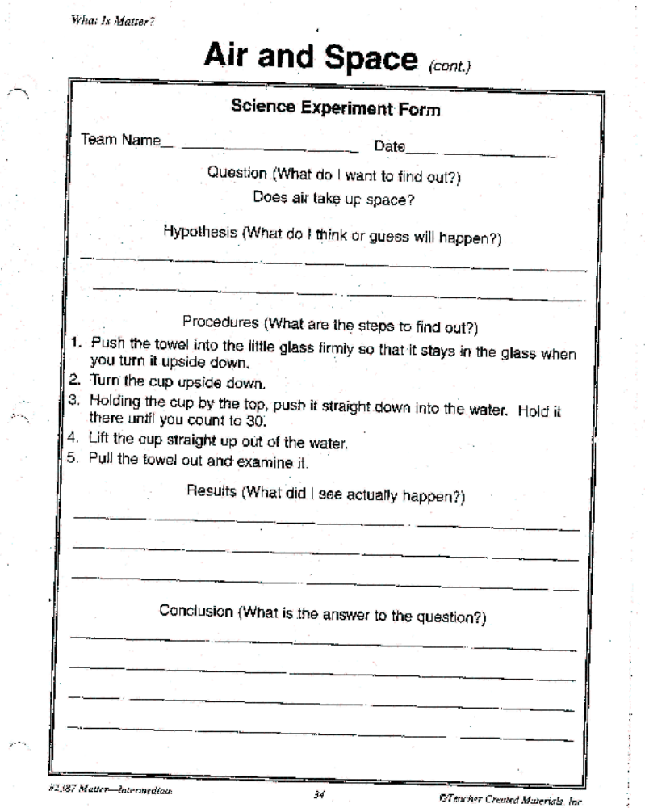

Teacher Created Materials, Inc. http://www.teachercreated.com/lessons. p. 34. March, 2009.

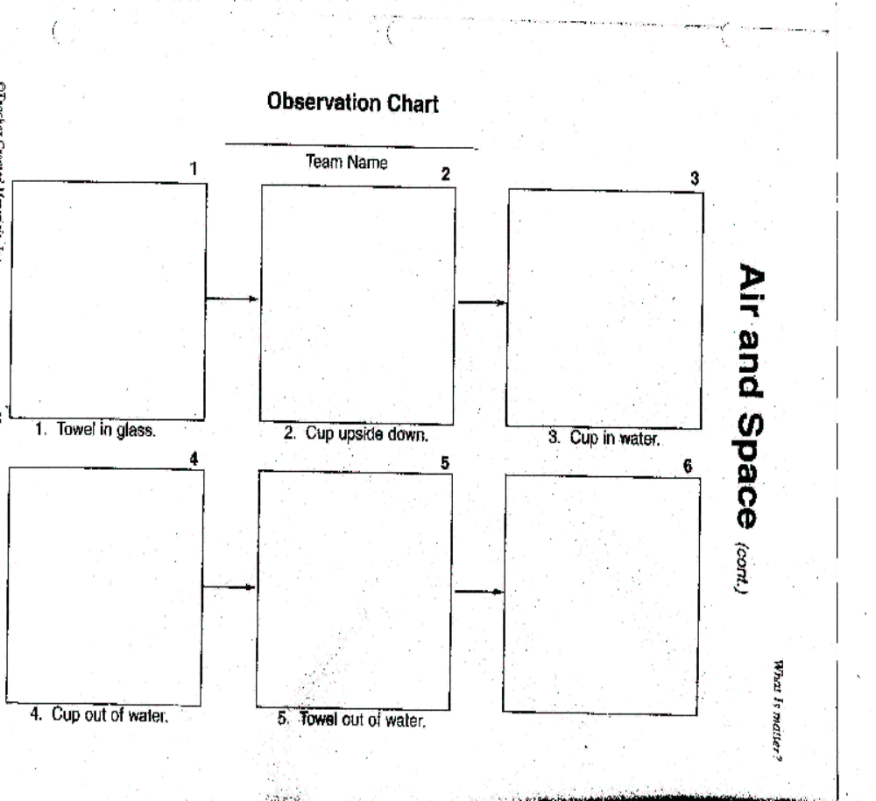

Teacher Created Materials, Inc. http://www.teachercreated.com/lessons. p. 35. March, 2009.

Subject: Science Grade: 4th

Topic: Freezing (physical changes) Lesson: 5

Standard/Indicator:
Physical Sciences (Nature of Matter): Identify characteristics of a simple physical change (e.g., heating or cooling can change water from one state to another and the change is reversible).
Doing Scientific Inquiry: Develop, design and conduct safe, simple investigations or experiments to answer questions.
Writing application: Produce informal writings (e.g., messages, journals, notes and poems) for various purposes.

Lesson Objective: Students will conduct an experiment in which they observe the characteristics of a physical change (liquid to solid).

Focus Question: Do all liquids freeze at the same rate?
(engagement, 5-7 minutes)

Anticipatory Set:
1. Ask for a show of hands of students who have had a snowball fight in July. (The purpose of this discussion is to eventually get to the concept that we have snow in winter months due to cold temperatures.)

2. Ask the students if they know at what temperature water freezes.

Materials: (needed for each group)
- three clear plastic cups, each cup should be labeled "water", "salt water", or "vinegar"

- a container with vinegar and a separate container with water

- container of salt

- teaspoon

- access to a freezer

- a timer (for the teacher)

Procedures:
(exploration, 10-15 minutes)

1. Tell students that today they will be learning about how different liquids undergo physical changes, in this case liquids to solids.

2. Discuss the term freezing point as the temperature at which a liquid changes to a solid, making sure to repeat the earlier discussion of water freezing (liquid to solid) at 32 degrees Fahrenheit. Make sure to discuss that freezing is the removal of heat energy.

(student directions:)

3. Set out 3 of your clear plastic cups.

4. Fill two cups 1/2 way with water. Fill the third cup 1/2 way with vinegar.

5. Place five teaspoons of salt into the cup of water labeled "salt water".

6. In your science journal, make a prediction about which liquid will freeze first, which liquid will freeze second, and which liquid will freeze last. Make sure you explain your prediction.
(explanation)

Closure:
(extension, throughout the day)
Discuss the predictions as a class, then place the clear plastic cups from each group into the freezer and start the timer. You will need to monitor the cups in pre-determined time increments (e.g. hourly) in order to allow the students to journal their observations. The students should observe the plain water freeze first, followed by the salt water and vinegar. To explain to the students the reasoning behind their observations, explain that the freezing points are different for water, salt water, and vinegar. For example, while water freezes at 32 degrees Fahrenheit, salt causes the freezing point of water to be lowered. Finally, vinegar freezes at 28 degrees Fahrenheit.

Homework: Ask students to consider why salt trucks spread salt on icy streets in freezing weather. As an extension, you can ask why the salt does not work when the temperatures reach levels in the teens or lower.
(evaluation)

Post Assessment Tools: Please check the Power Point Jeopardy game that is also attached to the cMap. This will be used as a review tool before the final assessment is taken.

Final Post Assessment:

States of Matter Quiz
Name ____________________________ Class ____________________ Date ______________
Write the correct response on the line given. Please take your time and do your best!

1. Name the three states of matter. _______________________________________________________

2. What state of matter has its own shape and takes up a definite amount of space? ________________

3. What are two characteristics of a liquid? ______________________________________________________________________________
______________________________________________________________________________

4. How would you change a liquid to a solid? ______________________________________________________________________________
______________________________________________________________________________

5. How would you change a liquid to a gas? _____________________________________________________________________________
_____________________________________________________________________________

6. What are two differences between a solid and a liquid? ______________________________________________________________________________
______________________________________________________________________________

7. What happens to the molecules in an object if it is heated? ______________________________________________________________________________
______________________________________________________________________________

8. What happens to the molecules in an object if it is cooled? _____________________________________________________________________________
_____________________________________________________________________________

9. What is the reaction called when two kinds of matter break apart and make a new kind of matter? ______________________________________________________________________________

10. Explain what you enjoyed most about this unit. _____________________________________________________________________________
_____________________________________________________________________________

References

Chiarelott, Leigh. (2006) Curriculum in Context: Designing Curriculum and Instruction for Teaching and Learning in Context. Thomson Wadsworth. Belmont, CA. p. 90-91.
Colburn, A, The Lingo of Learning: 88 Educational Terms Every Science Teacher Should Know. Arlington, Va: NSTA Press, 2003
Cooney, T., DiSpezio, M.A., Foots, B.K., Matamoros, A.L., Nyquist, K.B., & Ostlund, K.L. (2003) Scott Foresman Science, Pearson Education, Inc. Glenview Ill. p. B9-B25.
Jorgenson, Olaf. (2005). What K-8 Principals Should Know About Hands-On Science.
Principal, 85(2).
Ohio Department of Education. (2002) Academic Content Standards, K-12 Mathematics. Office of Curriculum and Instruction. Columbus, OH
Ohio Department of Education. (2002) Academic Content Standards, K-12 English Language Arts. Office of Curriculum and Instruction. Columbus, OH
Ohio Department of Education. (2002) Academic Content Standards, K-12 Science. Office of Curriculum and Instruction. Columbus, OH
Puentes, Christina. (2007) Interactive and textbook lessons in science instruction:
Combining strategies to engage students in learning. Online submission. http://www.eric.ed.gov/ERICWebPortal/Home. 5, Aug, 2009.
Teacher Created Materials, Inc. http://www.teachercreated.com/lessons. p. 33, 34, 35. March, 2010.

