Bowling Green State University
Biotechnology Instructional Plan
Subunit of the Genetics Unit

Matt Reising
4/1/2010

Rationale
Biotechnology is one of the most hotly debated topics in today’s society, but it is not thoroughly covered in biology classes. Therefore, students should have the opportunity to gain a better understanding of the topic that is developing our present and future scientific status as a society. The educational goal of this Biotechnology subunit is to make students more aware of themselves biologically, and how biotechnology impacts society. It is my goal to encompass the four competence areas in biology education: subject knowledge; inquiry acquisition; subject-related communication; and valuing and decision making (Elster, 2009). These competencies are characteristics that encompass and support the constructivist paradigm. This paradigm argues that learning is based on the individual’s construction of understanding and meaning from experience (Chiarelott, 2006). Learning is powerfully affected by prior experience, perceptions of relevance to self and society, and the context in which learning occurs (Chiarelott, 2006).
I will be using a different instructional design model for each lesson that I am going to teach. I will be using the concept attainment model, the inductive model, and the group investigation model. I will use the concept attainment model in a lesson on ethics where I will have multiple examples of ethical and unethical situations. The students will then write down whether they think the situation is ethical or unethical, and why they think so. After the activity, there will be a class discussion on each example. The students will then come up with their own examples and categorize them on their ethical standpoint.
The inductive model will be used with the DNA cloning lesson to express the pros and cons of DNA cloning. Possible categories will be the difference in plant and animal cloning, human cloning, etc. The students will then make their own survey on cloning to find out what other people think on the practice. Before the students distribute their survey to other people, they will predict what the general public thinks they know about cloning. Upon completion of the survey, the students will compile their survey data and present their findings to the class.
The group investigation model will be used as a tool to cover a lesson on stem cells. In this lesson, the students will understand the potential use of stem cells and why they work so well in constructing new tissue in organisms. The students will specifically focus on the factors on why stem cells have not been used in mainstream practice yet, and the implications of stem cell technology. Each member of the group will have different responsibilities when it comes to the research. One student will research how stem cells work, one will research what they could be used for in the medical field, and one will research why stem cells have not caught on to the mainstream medical practice yet. Students will then report their findings to the class.

Biotechnology Learning Outcomes
- Students will be able to come up with various examples of why DNA technologies would be/could be used. (Economically, personal reasons, healthier foods, etc.) (Application)

- Students will be able to describe the process of cloning in plants and animals. (Knowledge)

- Students will be able to justify whether certain DNA technology experiments or practices would be ethical or not. (Evaluation)

- Students will be able to describe the importance of stem cells (and meristems in plants) and what they can do for us. (Comprehension)

- Students will be able use their knowledge of biotechnology and ethics to develop their own biotechnology experiment and report to the class that it would be helpful to better the world or community. (Synthesis)

Name:____________________
Pre-Assessment
Survey: Circle the number that you think best describes your opinions concerning biotechnology (1=Strongly Disagree…4=Strongly Agree).
Descriptions: | 1  Strongly Disagree | 2  Disagree | 3  Agree | 4  Strongly Agree
There are ethically acceptable reasons for cloning technologies to exist. | 1 | 2 | 3 | 4
The cloning of entire human beings is ethically acceptable. | 1 | 2 | 3 | 4
The cloning of animals for research purposes is an ethically acceptable practice. | 1 | 2 | 3 | 4
I am able to provide an adequately definition of the term “genetic engineering.” | 1 | 2 | 3 | 4
Parents should have the right to design their own children as this capability becomes available. | 1 | 2 | 3 | 4
Genetic technologies should be used for eradicating human diseases. | 1 | 2 | 3 | 4
I am aware of the research conducted with embryonic and adult stem cells. | 1 | 2 | 3 | 4
I am able to provide an adequate definition of cloning. | 1 | 2 | 3 | 4
I have substantial knowledge regarding cloning technologies. | 1 | 2 | 3 | 4
I am aware of the ethical issues arising from the modern cloning debate. | 1 | 2 | 3 | 4
The cloning of plants is ethically acceptable. | 1 | 2 | 3 | 4
Adult stem cells come from adults. | 1 | 2 | 3 | 4
Embryonic stem cells come from infants or babies. | 1 | 2 | 3 | 4
Biotechnology only refers to the “green movement,” in the hopes of reducing carbon emissions. | 1 | 2 | 3 | 4

Lesson 1: What is Biotechnology?
Audience:
High School Biology Class

Concept:
Defining biotechnology and cloning.

Objectives:
- Students will learn the definition of biotechnology and everything associated with it.
- Students will learn about aspects of cloning from the perspective of plants and animals.
- Students will dispel any misconceptions of cloning.

Lesson Procedure: (Approximate total time in class = 2 class periods)

Introduction: (15-20 minutes)
- Go through the following PowerPoint presentations on Biotechnology to introduce the topic.

Slide 1 | 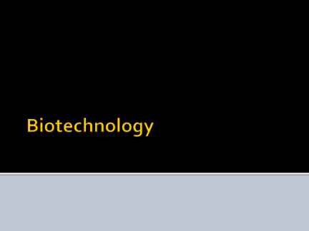
Slide 2 | 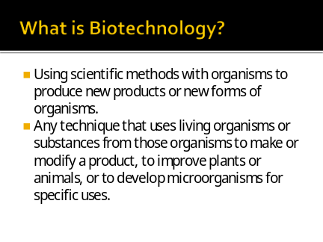
Slide 3 | 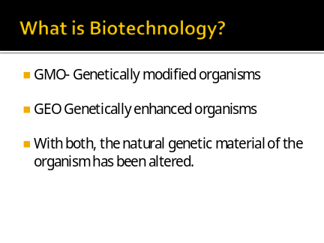
Slide 4 | 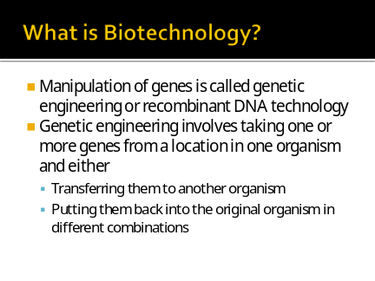
Slide 5 | 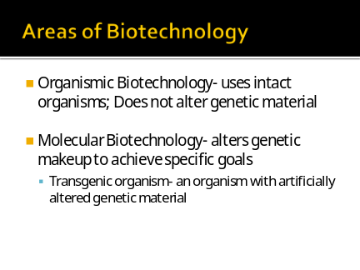
Slide 6 | 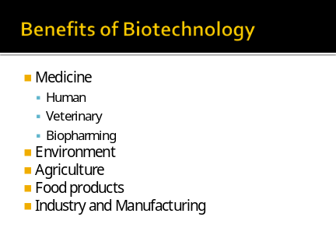
Slide 7 | 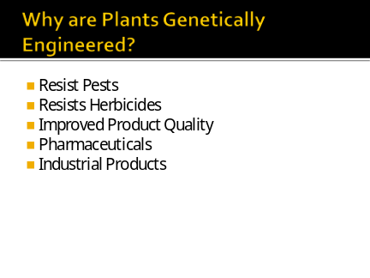
Developmental: (30 minutes)
- The teacher uses the “Inductive Model” to go over the concept of cloning.
  - Phase One: Teacher has students call out examples of things that have been cloned and topics on cloning. (3-5 mins)
  - Phase Two: Group the examples that are given by the students into commonalities on the board. (3 mins)
  - Phase Three: Have the students come up with labels for each of the groupings. (3 mins)
  - Phase Four: Have students write these groupings on a sheet of paper, and have them write down relationships they can identify among the groups. (10 mins)
  - Phase Five: Discuss as a class about the different relationships that the students identified. (10 mins)
  - Phase Six: Students come up with their own misconceptions that they think the general public understands about cloning. (7 mins)
  - Phase Seven: Students are instructed to develop a survey about the misconceptions they thought of, and administer the survey to at least 10 people as homework. (Give them 3 days to complete survey and administer it)
  - Phase Eight: Students compile their data as homework.
  - Phase Nine: Spend a whole period on students presenting their findings to the class.

Conclusion: (10 minutes)
- Have students write a reflective journal on their experiences of administering their survey and gathering data. Also have them write about their perceptions about cloning upon completion of the assignment.

Evaluation:
- Collect student surveys and data to grade.
- Collect and grade students’ reflective journals.

Materials:
- Biotechnology PowerPoint file
- Computer and projector

Lesson 2: Stem Cells and Meristematic Tissue
Audience:
High School Biology Class

Concept:
- Stem cells in animals.
- Meristematic tissue in plants.

Objectives:
- Identify properties of stem cells.
- Describe plant meristematic tissue properties.

Lesson Procedure: (Approximate total time in class = 3 periods)

Introduction: (15-20 minutes)
- In order to introduce the topic of stem cells and meristematic tissue, go through the PowerPoint with the students.

Slide 1 | 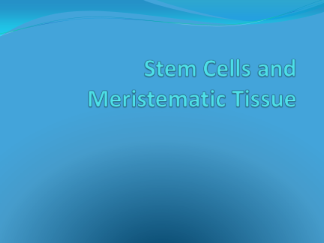
Slide 2 | 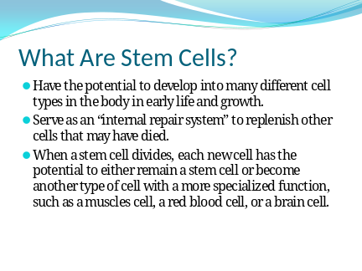
Slide 3 | 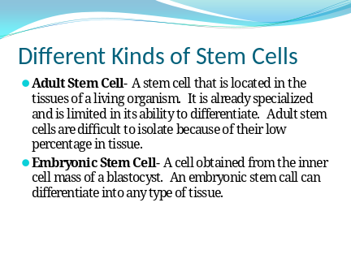
Slide 4 | 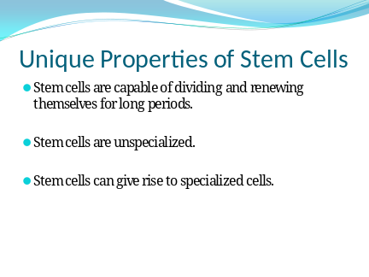
Slide 5 | 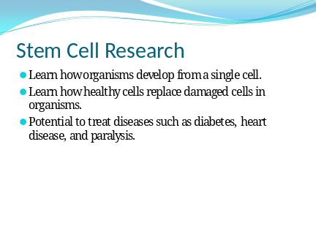
Slide 6 | 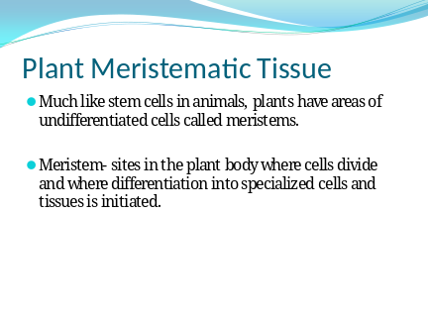
Slide 7 | 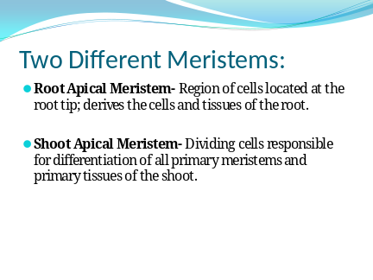
Slide 8 | 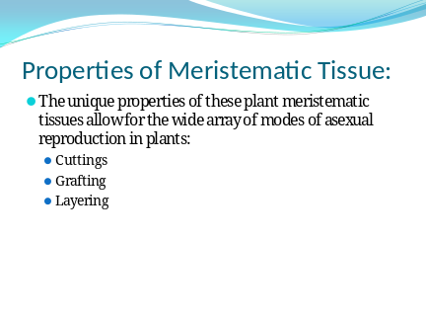
Developmental: (45 minutes)
- The Group Investigation Model will be used during this activity on stem cells.
  - Phase One: Each student will write down on a piece of paper the implications of stem cell research and what they know about it. (5 mins)
  - Phase Two: In groups of 3, the students will discuss what each of them wrote to gain a wider perspective on the issue. (5-7 mins)
  - Phase Three: Students will narrow down the situation into stem cell research being effective, but not being used in the mainstream medical field.
  - Phase Four: There will be different tasks each member of the group will be given to research: how stem cells work, how stem cells are used in the medical field, and why stem cells have not caught on in the mainstream medical field.
  - Phase Five: Students will be given one class period to research their topic in the computer lab. (50 mins) A poster will be made to present to the class what they found. (Done outside of class)
  - Phase Six: The groups will get back together after the presentations to reflect on the findings that the class as a whole came up with. Each student will write a reflection on the process they went through to obtain their information, and interesting things they have learned. (10 mins)

Conclusion: (10 minutes)
- Students will write a letter to stem cell research scientists explaining why or why not they should be pushing the use of stem cells into the mainstream medical field.

Evaluation:
- All student group work is collected and graded along with the posters they put together for the class presentation.
- Reflections and letter to scientist will also be collected to review their final stance on stem cell research.

Materials:
- Computer and projector for PowerPoint on Stem Cells and Meristems
- Computer lab
Lesson 3: Bioethics

Audience:
High School Biology Class

Concept:
- Ethics and Bioethics

Objectives:
- Distinguish between ethical and unethical situations.

Lesson Procedure:

Introduction: (10 minutes)
- Start a discussion with your students about the word ethics. Ask them what they think it means.
- Define what the term ethics means for the students and write it on the board (that branch of philosophy dealing with values relating to human conduct, with respect to the rightness and wrongness of certain actions and to the goodness and badness of the motives and ends of such actions).
- Define the term bioethics and write it on the board (a field of study concerned with the ethics and philosophical implications of certain biological and medical procedures, technologies, and treatments, as organ transplants, genetic engineering, and care of the terminally ill).

Developmental: (30 minutes)
- The Concept Attainment Model will be used in this lesson on bioethics
  - Phase One: Via the PowerPoint presentation on ethics, go through each slide one-by-one and ask the student whether they think what is being displayed is ethical or not. Have them write their responses silently and individually on the given worksheet. (15 mins)

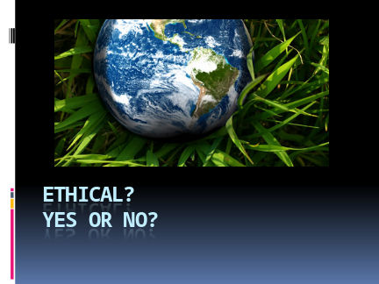
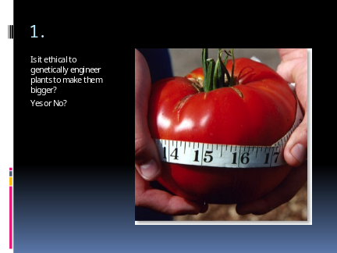
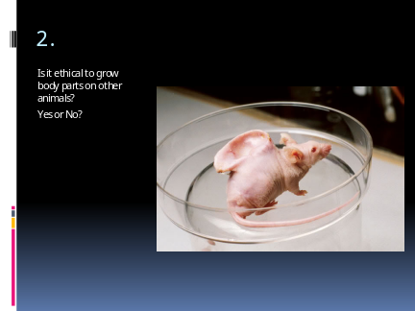
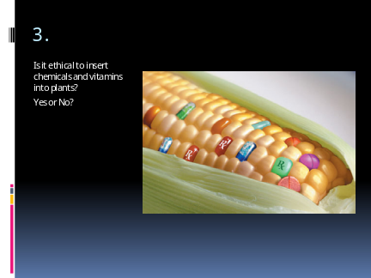
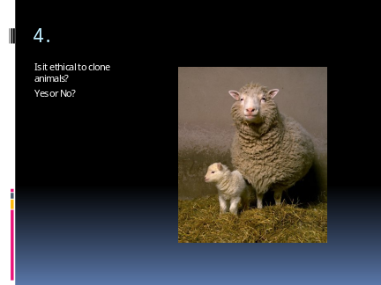
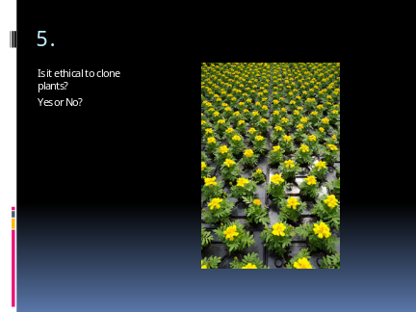
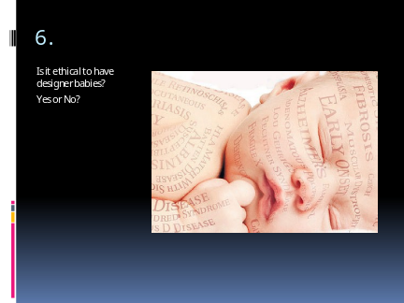
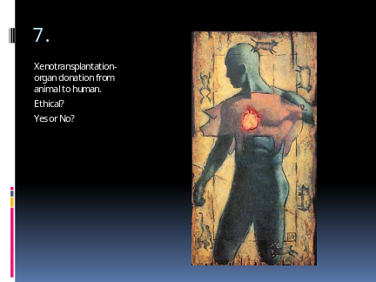
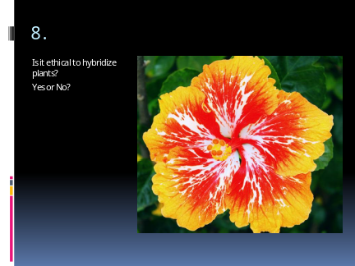
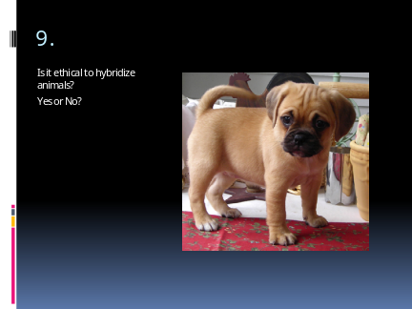
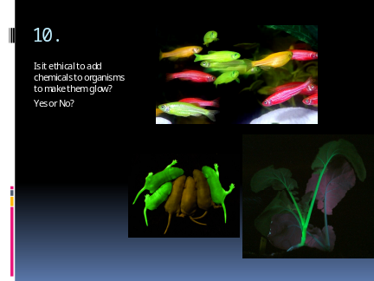
  - Phase Two: Students state on their worksheet if they think the example being displayed is ethical or unethical and why they think so. This will cause them to tangle with the ethical subjects presented. (Done concurrently with Phase One)
  - Phase Three: Once the slide show is finished, ask the students if they can think of anymore ethical or unethical situations and have them list them on the worksheet as well. (3 mins)
  - Phase Four: Go back through the slide show one more time. This time, discuss as a class what the students classified the situation as, and come up with a consensus as a class as to whether the situation is ethical or not. (12 mins)

Conclusion: (10 minutes)
- Have students come up with a hypothetical experiment, and explain the ethics that are associated with it.

Evaluation:
- Collect and grade the activity worksheets.
- Collect and grade the experiments that the students came up with.
Materials:
- Ethics PowerPoint presentation
- Computer and projector
- Worksheet (Provided on next page)

Name:__________________________

Ethical: Yes or No?
Directions: As we go through the PowerPoint, state whether you think what is being shown is ethical or not. Provide reasoning for your choice.
1.

2.

3.

4.

5.
6.

7.

8.

9.

10.

Post-Assessment
Name____________________________
Part 1: True or False
Directions: Indicate whether you believe the statements below are True or False. If you choose false, cross out the incorrect part and rewrite the statement to make it true.
- _____ Biotechnology only refers to the “green movement” and reducing carbon
emissions.
- _____ Genetically Modified Organisms have become abundant in the world’s food
supply.
- _____ A complete human has been cloned before.
- _____ Some plants and animals can clone themselves naturally.
- _____ Adult stem cells come from adults.
- _____Embryonic stem cells come from children and infants.
- _____ Plants contain areas of actively dividing cells that can turn into any type of cell
that the plant may need.
- _____ Clones are not genetically identical to the parent.
Part 2: Multiple Choice
Directions: Circle the correct answer
- Stem cells come from where?
a. tissues in the body
b. they are produced by scientists in a lab
c. bacteria
d. plants
- What is the term we use when discussing a form of plant asexual reproduction when a plant is cut and replanted in the ground?
a. propagation
b. grafting
c. reproduction
d. genetics

- Which answer is an example of biotechnology?
a. genetic engineering
b. human insulin production
c. making biofuels for cars
d. A,B,C are all examples of biotechnology

Part 3: Short Answer
Directions: Answer the following questions to the best of your ability.
- Describe what biotechnology is.

- Why would you need genetically engineered plants and animals? Give an example of a plant or animal that has been genetically engineered, and the reason why it was genetically engineered.

Part 3: Essay
Respond to the prompt with a paragraph or two (5-10 sentences or more).
- Ethics are a major component to consider when doing science. Please describe what you believe ethics are. Provide an example of an ethical experiment, and provide an example of an unethical experiment.

References
Chiarelott, L. (2006). Curriculum in Context. Belmont, CA: Thomson Wadsworth.
Elster, D. (2009). Biology in context: Teachers' professional development in learning communities. Educational Research, 43(2), 53-61.

