Instructional Mini-unit:
Interior Angles of Triangles & Quadrilaterals
Shannon Sample

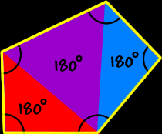

Rationale
The instructional subunit addressed here is interior angles of triangles and quadrilaterals. There are several reasons involved as to why students need to be familiar with the concepts associated with surface area and volume. Triangles and quadrilaterals are two of the most recognizable shapes that make up various objects. The interior angles of these polygons can be important for things like mapping out a blueprint of a house and making sure certain angles of a room are complementary and supplementary to one another. Since triangles and quadrilaterals are concrete items, the concepts can be easy for students to understand at this stage of their cognitive development. Also, because this unit builds off of the more familiar basic operations which addition, subtraction, multiplication, and division, students may feel a bit more comfortable in putting forth the effort to learn the algorithms involved in finding the interior angles of different shapes. The design I have selected utilizes contextualized teaching because it provides students with an authentic, tangible application as the basis of their learning. In addition to this, my design will allow students to enhance their basic math skills by applying them to more intricate formulas such as the formulas used to calculate the interior angles of each addressed polygon.
Assessment of learning in this unit will take place in the form of formative assessments. These evaluations will include a pre- and post-assessment, which is one assessment that will be administered to students before and after the content is taught. Also, students will be evaluated in various ways which include an activity with forming triangles on their own and measuring the angles with the appropriate tool, an informal assessment that entails students forming groups and forming “human triangles,” and other Ohio Assessment Test preparations from a few manuals provided by the Ohio Department of Education. All in all, I feel as though my instructional design will serve as a benefit to students as it attempts to reach multiple learning styles using contextualized learning strategies.

Subunit Three: Geometry & Spatial Sense
- Students will be able to label the parts of an angle.
- Students will describe parts and properties of lines.
- Students will determine the relationship between the radius, diameter, center, and circumference of a circle with respect to Pi.
- Students will use the properties of congruent figures to solve problems.
- Students will use physical models to determine the sum of the interior angles.
    - (This unit consists of all lessons with the highlighted outcome as the lesson objective.)
    - For all lessons:
      - Grade level: 5
      - Time length: 45 min.
      - Number of students: 26

LESSON ONE: INTRO TO COMMON POLYGONS
Goals
The student will enhance his/her understanding of polygons--specifically triangles.
Objectives
- Use physical models to determine the sum of the interior angles of triangles and quadrilaterals. (OACS, Geometry and Spatial Sense 5.5)

Materials and Resources
Teacher
- The Greedy Triangle by Marilyn Burns
- Chart paper
- Different colored permanent markers
- Pre-Assessment worksheets (enough to give one to each student)

Student
- Pencil
- Notebook paper

Motivation- 20 min.
Begin class by asking students to give examples of shapes. Students may say “circle, rectangle, square, triangle, etc.” Next ask, which of the named shapes have angles. Students should answer “square, rectangle, triangle, etc.” Ask why these particular shapes have angles. Students should answer “They have sides that connect to form corners.” Proceed to tell students that in this unit, we will be dealing with shapes that have angles. Connect and introduce The Greedy Triangle to students and read it to them. While reading, be sure to use expressive tones of voice and stop to ask students questions such as “what items do you know of that are this shape?” in order to encourage student interaction.
After reading the book, ask students if they can come up with any other examples of shapes that were not mentioned in the book. Students should mention “flag, desktop, back of chair, piece of cake, etc.” Explain to students that angles are everywhere, even in places where we don’t readily recognize them. Next ask “Have you ever wondered what the sum of all the angles in a whole shape was?” Students may respond “100 degrees, 180 degrees, 200 degrees, etc.” Do not give correct answer yet, but let students know that different shapes have different sums, such as triangles are different from squares, etc. Now, distribute a “pre-assessment” sheet to each student and give students a few minutes to complete it until all are finished. Proceed to tell the students that we will be learning about the sums of the angles in triangles and quadrilaterals, and will also learn how to calculate them.
Lesson Procedure-15 min.
- Once motivation is completed, chart paper should be set up onto dry erase board. Tell students “Now, I would like to see what you know about shapes and angles so far. Tell me everything you know and I can write down what we know as a class so that we can come back to it at the end of this unit to see how we’ve progressed in our knowledge.” As students raise hands, write each comment stated on the class chart paper. *Note: Be sure the chart paper is labeled with the class period.
- As students suggest things to put on the chart paper, encourage them to elaborate more on each suggestion in order to expand their thinking on the topic.
- Draw three different sized triangles and three different sized quadrilaterals on the board.
- Ask students “Do you think these three triangles have the same total sum of degrees inside? Do you think the three quadrilaterals have the same total sum of degrees inside?” Students may respond with mixed answers of “yes or no.” Students who say no may believe this because they are different sizes. They may think the smaller shapes have a smaller measurement, while the bigger shapes have more area so they have larger measurements. Students who say yes may say so because they recognize that the same shapes will always have the same angle sums.
- Introduce to students that the sum of the angles inside a triangle is 180 degrees, and the sum of the angles inside a quadrilateral (four-sided shape) is 360 degrees. Write this on the board.
- Let students know that we will get to add up our own angles of these shapes tomorrow to see it for ourselves.

Closure-10 min.
Review main points of lesson. Have students recap what they know about triangles and quadrilaterals, referring to chart. Make sure they include the newly learned information from the lesson such as the sum of the angles in a triangle is 180 degrees and in a quadrilateral 360 degrees.

Extension
Have students stand up at their desks. In order to sit down, each student must name one thing that they would like to learn throughout our interior angles unit. They can say things like “I want to learn how different sized triangles can have the same sum of angles.” Each student should be encouraged to say something different from their classmates.
Assessment
The suggestions on chart paper served as an informal assessment of what students knew prior to the start of the unit. This chart will be revisited at the end of the unit to compare new knowledge with the previously learned information.

Pre-Assessment

For each statement below, write “T” if you believe the statement is true, and “F” if the you believe the statement is false.

Name:

Hour: 1 2 3 4

Before After

- The sum of all angles in a triangle is 180 degrees.
T or F

- A quadrilateral is a shape that has 5 sides. T or F

- The total sum of the angles in any type of triangle is
always the same. T or F

- The sum of all angles inside a quadrilateral is 360
degrees. T or F

- Squares and rectangles are the only types of four-
sided shapes. T or F

- A circle is a polygon. T or F

LESSON TWO: INTERIOR ANGLES OF A TRIANGLE
Goals
The student will understand that the sum of the interior angles of an accurate triangle is 180 degrees.
Objectives
- Use physical models to determine the sum of the interior angles of triangles and quadrilaterals. (OACS, Geometry and Spatial Sense 5.5)

Materials and Resources
Teacher
- Dry erase board and marker
- Pre-cut large triangle
- Sticky notes (1 for each student)
- Protractor
- Magnets

Student
- Pencil
- Notebook paper
- Scissors
- Protractor (class set, one on each desk)

Motivation-5 min.
Start off lesson by holding up a large, paper pre-cut triangle to students. Ask them “Who remembers what the sum of the angles inside this shape is?” Students should answer “180 degrees!” Next, explain that today we are going to do an interesting activity that shows how we find 180 inside of a triangle.
Lesson Procedure-30 min.
- Proceed to show students the corner angles of the triangles. Explain that the angles represent the amount of space, or degree found in the triangle.
- Ask students “How do we measure this amount of space? Answer by holding up the object we use to do this. This is called a?” Students should answer “Protractor!”
- With students watching, proceed to mark off each angle on the pre-cut triangle. Tear off each angle and put them together to form a straight line, using magnets to hold it up on the board.
- Next, explain that if we were to measure the angles that form this straight line, that we would get an answer pretty close to 180 degrees. Ask “Would you like to try this yourself?” Students should be eager to do this!
- Proceed to explain that “We will be creating our own triangles, and finding out their total degree measurements by tearing off the angles, placing them to form a straight line, and finally measuring the angles in that straight line.” Each one of us will make our own and as a class we will construct a graph to record our results.
- Using our graph, we will find the maximum and minimum sum, as well as the average sum of our results. To make sure each of you record your results, each of you will get a sticky note to place on the board to create our class graph.
- Next, ask students to get out a piece of notebook paper, their protractor, and scissors. Instruct them to make their triangles large enough to be cut out and measured accurately. After clear instructions are given, allow students to begin creating their triangles.
- While students are creating, cutting, and measuring pass one sticky note out to each student. Also, remind students of the diagram on the board to model their straight line of angles after, once they are ready to measure with their protractor.
- Once students are done recording their measurement on their sticky note, ask “How many students have a sum of less than 175 degrees?” and “How many have a sum of more than 185 degrees?” For the students that raise their hands for this, find out the minimum and maximum measurements and use them as the beginning and end points of the line plot graph constructed on the board.
- Have students come up in small groups to record the measurements of data in between the minimum and maximum measurements.
- Once all measurements are up on the board, prompt students to look for patterns and anything that “pops out” to them on the graph. Students should recognize that many of the measurements are close to 180 degrees.

Closure-10 min.
Ask students “Why do you believe all the measurements were close to 180 degrees?” They should be able to explain that “Since the sum of angles inside a triangle is equal to 180 degrees, all of the measurements should be close to that.” Next, ask students “If this is true, then why didn’t all the angles come out to be exactly 180 degrees?” Students should respond “that not everyone cut out a perfectly measured (accurate) triangle. Also, the angles of the triangle were not measured to total to 180 degrees before cutting them out. As a final question ask students “So what should the sum of the angles inside of an accurate triangle be?” Students should answer “180 degrees!”
Extension
Draw four triangles on the board, write in two estimate angle measurements for each, and have students discover the third angle for each triangle.
Assessment
Students will be assessed through their ability to recap and summarize the main points of the lesson during our closure.

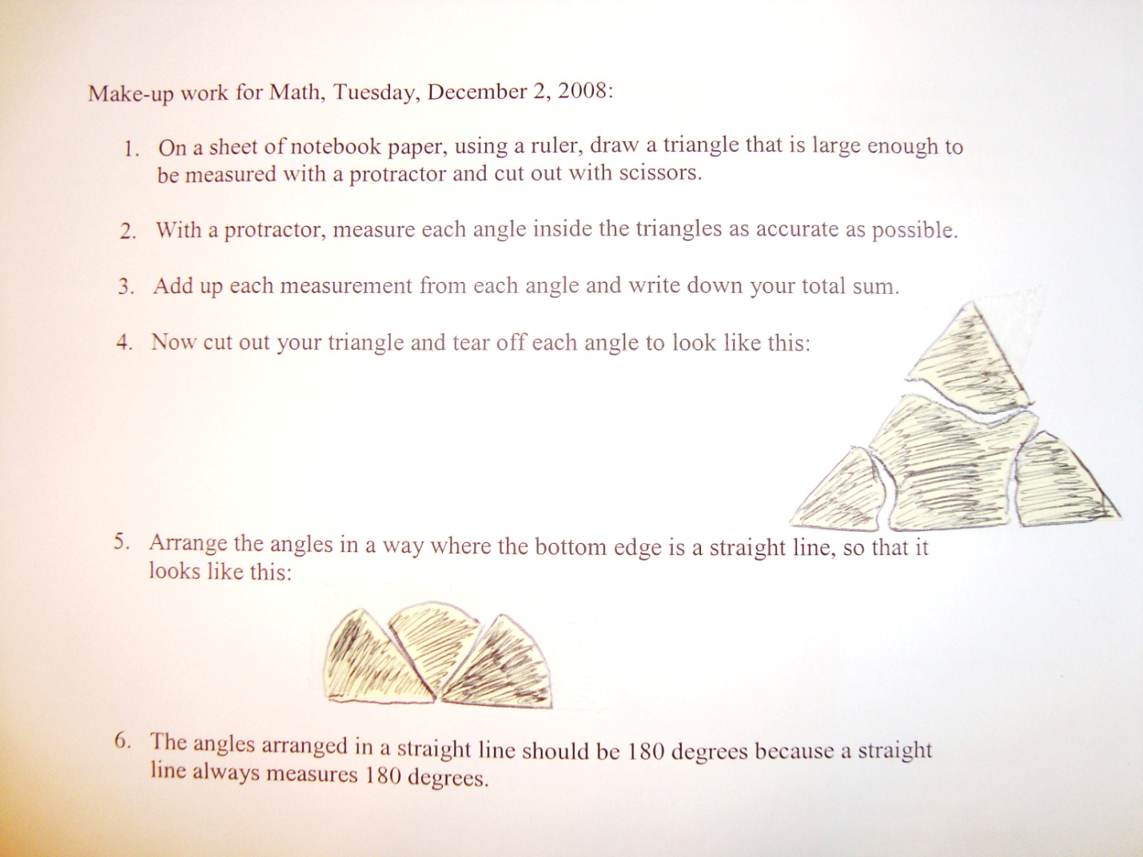

LESSON THREE: MEASURING INSIDE TRIANGLES
Goals
The student will develop his/her understanding of triangles and measurement.
Objectives
- Use physical models to determine the sum of the interior angles of triangles and quadrilaterals. (OACS, Geometry and Spatial Sense 5.5)

Materials and Resources
Teacher
- Pipe cleaners (3 per student)
- Dry erase board and marker
- Protractor

Student
- Pencil
- Paper
- Glue stick

Motivation-10 min.
Begin the lesson by asking for six volunteers. Once volunteers are chosen, assign one to draw a scalene triangle on the board, one to draw an equilateral, one to draw an isosceles, and draw one right triangle. Once each student draws their assigned triangle, ask “What did we learn about triangles yesterday?” Students should answer “that all angles inside of a triangle total to 180 degrees.” Point to each triangle drawn by each student and ask “Even these are 180 degrees?” Students should answer “Yes!” Proceed to tell students that “Today we will put what we learned into action through making our own triangles using pipe cleaners!”
Lesson Procedures-25 min.
- “Before we start our activity, let’s review what types of triangles there are. Who can define them for me?” As students raise hands, have one student define one triangle each. They should define scalene as having no equal sides, isosceles as having two equal sides, and equilateral as having three equal sides.
- As students define them, label and write each definition on the board as a reference to use during the activity.
- Instruct students to get out two pieces of notebook paper and a pencil.
- “Before we start constructing our very own triangles, you need to know that each of you will be making 3 triangles. You can choose to make scalene, equilateral, or isosceles triangles. One of each, all of one type, or mix them as you see fit. Also, once you construct your triangles, you will need to use your glue sticks to glue them down to a piece of notebook paper.”
- As students start to construct their shapes, walk around the room and remind them to measure out the length of each side (all equal sides if equilateral, two equal sides if isosceles, no equal sides if scalene) and afterwards, to measure the angles formed by the sides. Remind students to make sure to measure their angles as accurately as they can and to be sure that the angles total to exactly 180 degrees.
- After students measure each angle of each triangle, require students to do their calculations on the extra sheet of notebook paper. On the other sheet of paper, students should glue their triangles down, and label all but two angles on each triangle, leaving out one angle on each for their neighbor to find.
- Once students are finished creating, measuring, gluing down, and labeling their triangles, announce that they will switch with their neighbor to check their measurements.
- Students may find inaccuracies in their peers’ measurements and shapes, and can help one another in correcting measurement mistakes.
- Continue to walk around and monitor student progress while encouraging students to check their addition and subtraction.
- When students are finished discovering missing angle measurements, instruct them to clean up their areas.

Closure-10 min.
Once students are settled back in seats, ask “Did you find it difficult to construct accurate triangles?” Answers should vary. If students answer yes, ask why. They may answer that “it was hard to measure each of the angles perfectly to add up to 180 degrees.” Encourage the students that we will get more practice with measuring angles tomorrow. Ask students to summarize what we did in class, making sure to include the definitions we reviewed and the activity that we did. Students should be able to define the three types of triangles without looking at the board.
Extension
Ask students to look think about the different types of triangles that they encounter in everyday life. Also ask them to name objects that they encountered already during the day that were triangles. They should be able to name things such as “pizza slices, half slice of toast, cake slices, etc.”

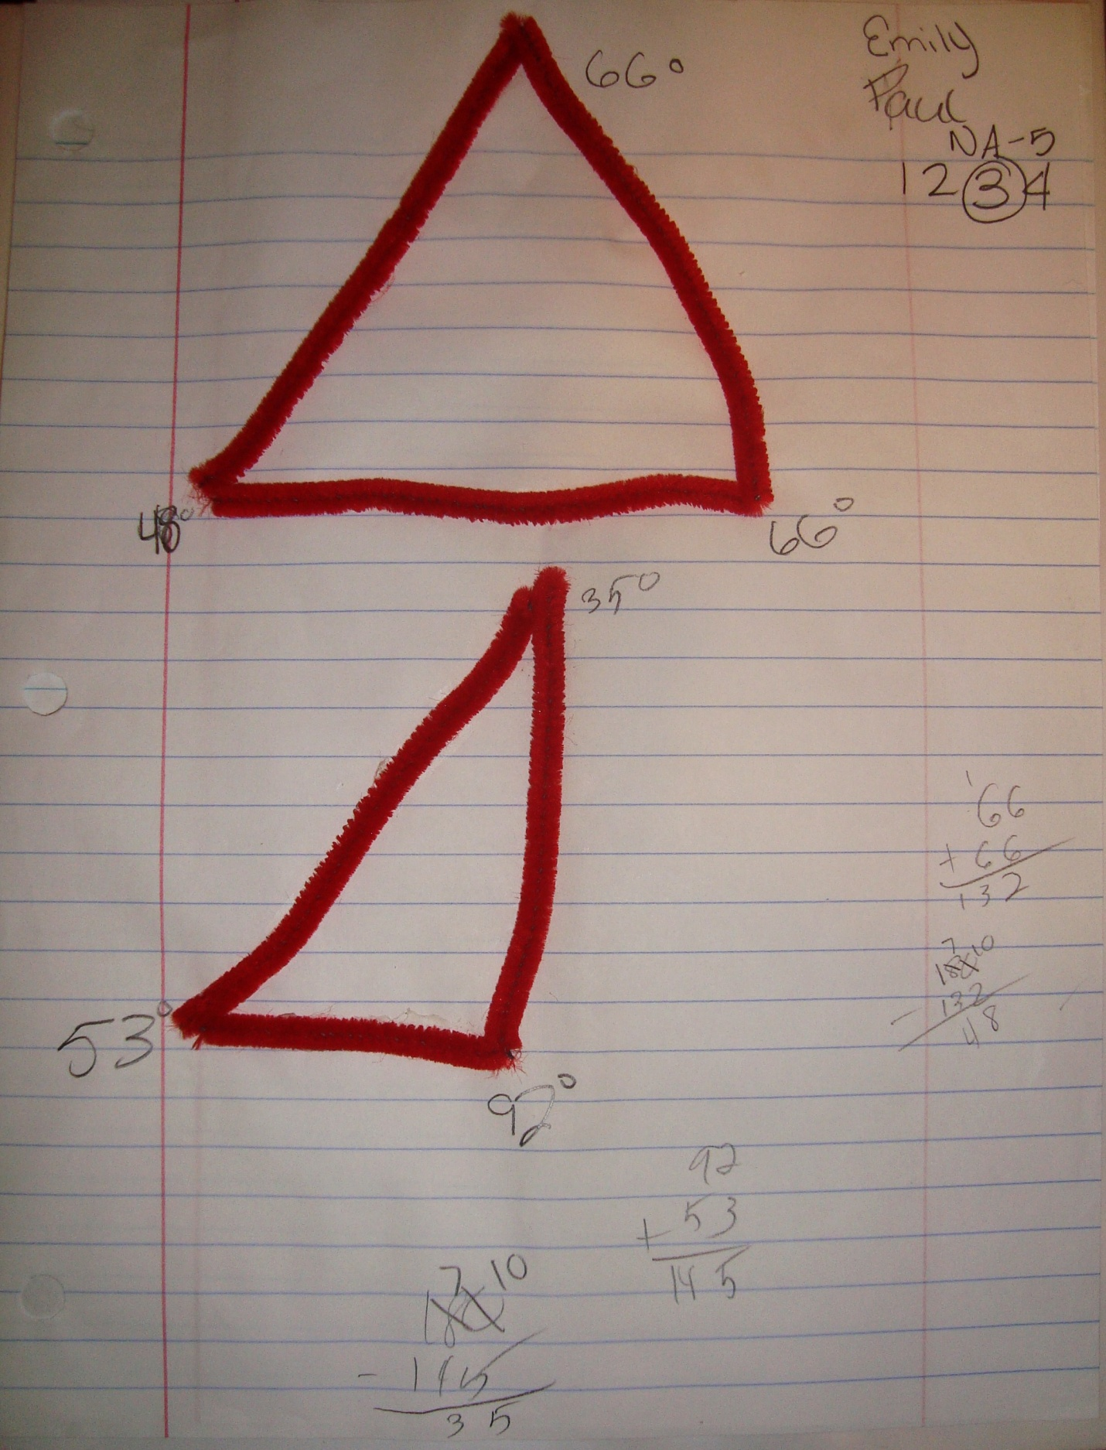
LESSON FOUR: UNDERSTANDING HOW ANGLES ARE FORMED
Goals
The student will further his/her understanding of triangles and measurement.
Objectives
- Use physical models to determine the sum of the interior angles of triangles and quadrilaterals. (OACS, Geometry and Spatial Sense 5.5)

Materials and Resources
Teacher
- Dry erase board and marker
- Protractor
- 5 triangle angle sum sets (Plastic baggies containing 10 construction paper cards with angle measurements written on them, pairs will be paper clipped)

Student
- Notebook paper
- Pencil

Motivation-10 min.
Start the lesson by asking the students to stand up. Explain that “Over the past few days we have been talking about the sum of the angles inside what type of shape?” Students should answer “Triangle!” “With the person next to you, together I want you to form each type of triangle with your arms.” State each type of triangle (scalene, isosceles, equilateral) as students form each one with their arms. Have students say the sum of angles (180 degrees) for each type of triangle as each is mentioned. Proceed to explain to students that “Today, we will be making human triangles!”
Lesson Procedures-30 min.
- Instruct students to sit down.
- Explain that the students will be put into groups based on their seating arrangements. Also tell students that they will be forming five different types of triangles in their groups and that some group members will serve as “sides” and some will serve as “angles.” The two group members who represent the angles of the triangle will take the two angle measurement cards from the sum set bag and show the other group members what size angle they represent. Using this information, the team will figure out the size of the angle that is not accounted for in the bag.
- Offer to use six volunteers to demonstrate an example of the “human triangle” procedure.
- Choose six students to come up. Place them in the shape of an equilateral triangle. Assign one “angle” person to be 60 degrees and another “angle” person to be 60 degrees. Draw a diagram of the shape formed by the students on the board along with the corresponding angles and ask students to figure out the missing angle. Students should readily answer “60 degrees” for the missing angle.
- Explain to students that this is what they will be doing in their groups. Proceed to hand out one triangle angle sum set to each group, and allow them to start forming their triangles.
- While students are interacting with one another, walk around and monitor their progress, checking to see if they are forming the correct types of angles and shapes to match what their card reads.
- When each group is done, instruct them to sit in their seats and discuss what the group did to form the shapes, while waiting for their classmates to finish.

Closure-5 min.
Once students are settled back into seats, ask “How did it feel to create human triangles?” Students should reply “it was fun!, hard to match the shape with the angles we had, etc.” Ask students what they learned today as a result of our lesson. Students’ answers will vary, but should be something like “I learned that the shape has to match what the angle that is formed, for it to be an accurate shape.”
Extension
Have students get out a piece of paper, a ruler, and a pencil and instruct them to draw three shapes with one side more than a triangle (they should know this means four sides). Have them measure the sums of the angles inside this shape and see what number all the sums are close to. Students should be able to recognize that the sums are all close to 360 degrees. Let them know that we will talk more about this next class time.
Assessment
Students are assessed when asked to express their understanding of the “human triangle” activity. Their understanding of this concept is checked through their ability to correctly correlate the angle measurement with the size of the type of shape.

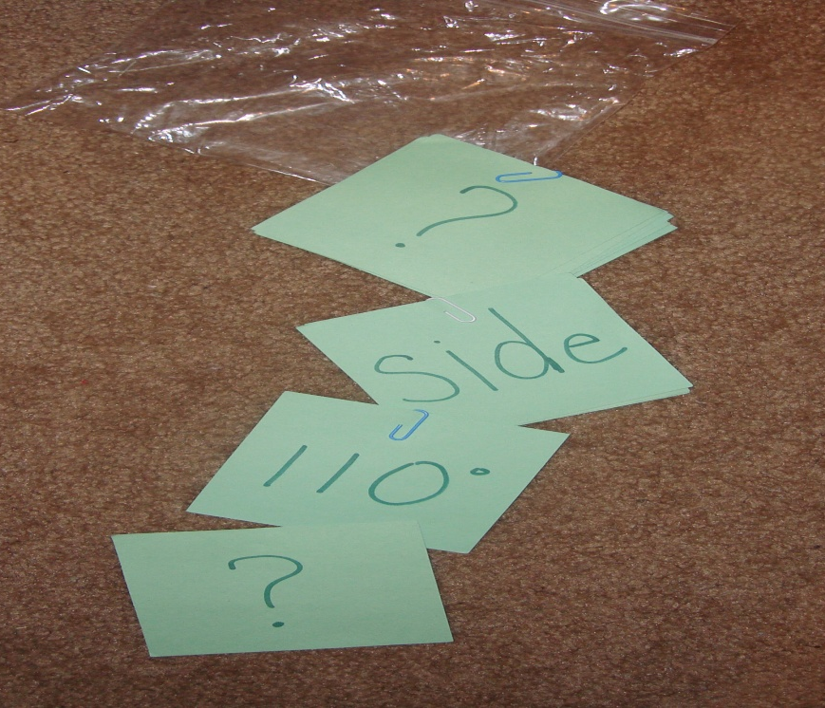

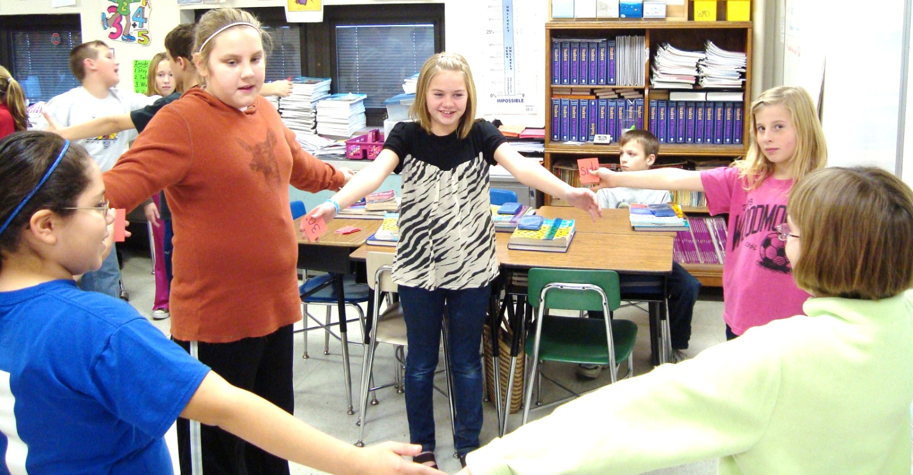

LESSON FIVE: REVIEW OF INTERIOR ANGLES
Goals

Student will have a complete understanding of the sum of the inside angles of triangles and quadrilaterals.

Materials and Resources

Teacher
- Dry erase board and marker
- List of vocabulary words associated with unit
- Timer (stop watch)
- Previously prepared (From Day 1) chart paper with class knowledge on shapes and angles

Student
- Pencil
- Notebook paper
- Buckle Down Achievement Workbook
- Ohio Achievement Test Coach Workbook

Motivation-15 min.

By this time, students should be experts on the vocabulary and terms associated with this unit. Begin by asking for volunteers who believe that they are confident in what we learned so far. Next, assign groups based on seating arrangements, and announce that each group represents a team. Obtain the vocabulary list which contains every word that was addressed throughout the unit, including triangle, scalene, isosceles, equilateral, right triangle, rectangle, rhombus, square, trapezoid, and kite. Instruct each group to take out one piece of paper per group.

Explain to students that this is a competition to see who “knows their stuff” concerning the terms we’ve learned throughout the unit. Tell them that they will be timed to see who can come up with the most complete, accurate definition for each term. They will be given 90 seconds to define each term to the best of their ability and the group that does the best in this time, receives a prize for each correctly defined word. Proceed to set timer and give students the first word on the list of vocabulary words. Go through each word on the list and declare one group a winner for each word after the winning definition is given. After the words are finished, explain to students that “Today is a review day, and you will get to put into action the concepts that you’ve learned throughout this unit.”

Lesson Procedure-20 min.

- Once students are settled after the vocabulary activity, explain to them that they will be required to complete a few pages out of their workbooks that will assess what they have learned so far.
- Instruct students to open their Buckle Down workbook to page 126 and complete pages 126 and 127. Tell students that if they need to be refreshed of the information found in the questions, they can refer to pages 124 and 125 or raise their hand for help. Also instruct students to work on these pages individually.
- Once students complete the Buckle Down assignment, instruct them to complete page 126 in their Coach workbooks. If they have questions about the problems in this assignment, they can refer to pages 123 through 125 or raise their hand for assistance.

Closure-10 min.

Bring out chart paper from lesson 1 of this unit that contains the information that students knew previous to this unit. As a class, discuss what has been learned since the first lesson, and add new information to the chart so that students can see what progress has been made.

Extension

Keeping in mind what has been learned throughout the unit, ask students what information they think could be addressed as a result of this unit. Students may say “we could learn about the sum of interior angles of a five-sided shape, or a six-sided shape.” Students can also guess what this actual sum could be. Some may guess “400 degrees or 500 degrees.” Introduce students to the fact that the sum of the angles of a five sided shape (pentagon) is 540 degrees and a six sided shape (hexagon) is 720 degrees.

Post-Assessment

Students will be assessed by what new information they added to their class knowledge chart. If they added the main objectives of the lesson to their chart, then they have successfully learned the information. Also, the assigned pages of students’ workbooks will be checked and recorded for a grade as a summative assessment.

