Name: _________________Class_____________Date______Score______/44

ASSESSMENT 2

Biology – Search for better health 9.4.3 and 9.4.4

Examine timings

Pre reading, 2 min
Exam time, 35 min

All questions to be attempted and carried out in pencil.

There are 3 sections to this assessment

SECTION 1 Experimental evidence 10 marks
SECTION 2 Diseases 13 marks
SECTION 3 Disease defences 21 marks

SECTION 1 (10marks)

EXPERIMENTAL EVIDENCE

The hypothesis
Pasteur noted that broth (soup) would spoil and become contaminated with bacteria and moulds. He hypothesised that this contamination was caused by micro-organisms and their spores entering the broth from the air.

How the hypothesis was tested

To test the hypothesis Pasteur placed broth into two different glass flasks. One flask had a top that was a long S-bend (the experiment) while the other had the S-bend broken off near the base (the control). The S-bend allowed air to enter, but spores of bacteria and mould became trapped in the liquid in the S bend and could not enter the flask. (see picture)

Pasteur boiled the broth in each flask to kill any micro-organisms in the broth. The steam from the boiling sterilised the walls of the flasks. Both flasks were then allowed to stand in a room.

The result
The flask with the S-bend broken near the base (the control) quickly developed bacteria and mould on the surface. The broth spoiled. The broth in the flask with the S-bend (the experiment) did not spoil. Bacteria and mould did not form on the broth.

How the result was interpreted
Both the experiment and control had been sterilised to kill microorganisms at the start. Micro-organisms only infected the flask that allowed micro-organisms and their spores to enter from the air (the control). Micro-organisms did not infect the experimental flask.
Pasteur drew two conclusions. Micro-organisms were responsible for the spoiling of broth. When micro-organisms were not present the broth did not spoil. Micro-organisms did not spontaneously generate. There had to be either micro-organisms or their spores for them to occur. Complete the following questions

Question 1. Identify the difference between the set up of the experimental and
control flasks in Pasteur.s experiment and give your reasons for this method?

______________________________________________________
______________________________________________________

______________________________________________________

______________________________________________________
/3marks

Question 2. One theory that was popular at the time of Pasteur’s experiment was that bacteria were created spontaneously from air.
a. Describe what aspects of Pasteurs experiment disproved this theory? (HINT look at the s bent flask)
b. Hypothesize what would happen if the experiment did not disprove the theory.

______________________________________________________

______________________________________________________

/3marks

Question 3. Evaluate what would happen to both flasks if the flask was left over a number of days.
______________________________________________________

______________________________________________________

______________________________________________________

______________________________________________________

/4marks

SECTION 2 (13 marks)

DISEASES

Question 1. Koch postulated that a specific micro-organism could be said to cause
a disease if several conditions were met. List THREE of these
conditions.

_________________________________________________________

_________________________________________________________

_________________________________________________________

/2marks

Question 2. Individuals in an isolated village become sick. A physician establishes
that all the sick individuals are infected with a particular strain of bacteria.
A sample of this strain is taken from a sick individual and grown in pure
culture away from the sick individual. This strain of bacteria was not found
in any healthy individuals.

What TWO other pieces of information are required to establish that
the disease was caused by the strain of bacteria?
_________________________________________________________

_________________________________________________________

_________________________________________________________
/2marks

Question 3. A biologist took a scraping of a diseased patch on the leaf of a plant.
He cultured the scraping and found that a pure culture of bacteria
developed. The bacterial culture in the culture dish may be
responsible for the disease on the plant leaf. What steps would Koch
have followed to determine this?
_________________________________________________________
_________________________________________________________
_________________________________________________________

/3marks

Question 4. There are many types of prion diseases. Name two types of prion
disease that occur in humans.
_____________________________________________________

_____________________________________________________

_____________________________________________________

/2marks

Question 5. Name two features of prion diseases that would make them difficult
to treat.
______________________________________________________

______________________________________________________

______________________________________________________

/2marks

Question 6. What is the cause of prion disease?
______________________________________________________

______________________________________________________

/2mark

SECTION 3 (21 marks)
DISEASE DEFENCES
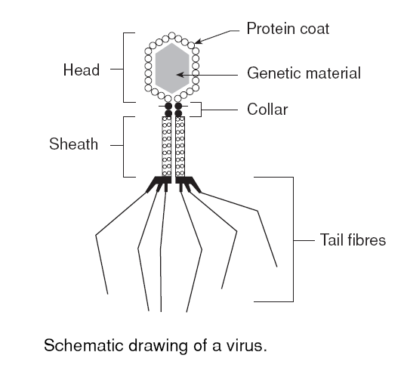

Question 1. Label the above schematic of a virus.

/3marks

Question2. Name one disease caused by a viral pathogen. Name a symptom and a treatment of this disease?

_____________________________________________________

_____________________________________________________

_____________________________________________________

/3marks

Question 3. Label the above schematic of a hair follicle and skin

/14marks

Question 4. There are three lines of defence in the human body. Name them and for
each give two examples of defence mechanisms.

_____________________________________________________

_____________________________________________________

_____________________________________________________

Question 5. The first line of defence provides barriers to stop pathogens entering the
body. Which one is able to stop pathogens? Circle the correct response.

A. Skin
B. Mucous membranes
C. CILIA
D. All of the above

/1mark

END ASSESSMENT

Please turn over paper and sit quietly until teacher directs requirements

