Changing Weather Patterns
How does the melting of ice sheets affect the weather? The melting of ice sheets influences the weather by affecting atmospheric heat movement globally. The transfer of heat is driven by differences in temperature. The greater the difference, the faster heat flows. As the polar areas warm, the difference in temperature between the poles and the equator is reduced, resulting in a change in the world’s current weather patterns.
A warming atmosphere and ocean make a great deal of energy available for the creation of weather, causing a severity of storms, droughts, rainfall, and floods. Extreme weather conditions are likely to become even more frequent and more damaging.
Both flooding and drought might increase. There could be more hurricanes and other tropical storms, and they might become more powerful. While the warmer conditions might contribute to precipitation patterns overall, some regions could become dryer.
Melting ice sheets put more fresh water into the ocean, potentially capping the warmer water, preventing it from releasing its heat to the atmosphere, further warming the water.
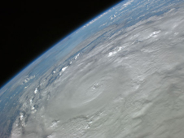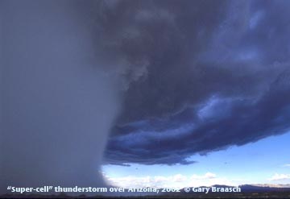
Hurricane Super-cell thunderstorm
A>E>H
Melting of arctic glaciers is a contributing factor to sea-level rise around the world.
A>H>L>B>A
Warming is likely to alter the release and uptake of greenhouse gases from soils, vegetation, and coastal oceans.
E>H>A
Decreasing the transport of CO2 contained in water from the surface to the deep ocean would contribute to further increases in the level of CO2 in the atmosphere and thus lead to further warming (due to CO2).
A>H>B
Through global warming, the surface waters of the oceans could become warmer, increasing the stress on ocean ecosystems, such as coral reefs. High water temperatures can cause a damaging process called coral bleaching. When corals bleach, they expel the algae that give them their color and nourishment. The corals turn white and, unless the water temperature cools, they die. Added warmth also helps spread diseases that affect sea creatures.

Resources
http://earthobservatory.nasa.gov/Features/Greenland/greenland_sidebar.php
http://www.nasa.gov/worldbook/global_warming_worldbook.html
http://www.epa.gov/climatechange/effects/polarregions.html

http://www.worldviewofglobalwarming.org/pages/weather.html

http://www.whoi.edu/page.do?pid=12317&tid=282&cid=9206

http://www.nasa.gov/mission_pages/station/multimedia/hurr_ike091008.html

