Water Treatment

Introduction
Untreated water contains dissolved minerals, gases and particulates. The removal or otherwise 'treatment' of each of these is critical to efficient boiler operation for different reasons. Minerals lead to scaling that acts as in insulator reducing boiler efficiency; gases can be corrosive and particulates can contribute to both problems. Water treatment is dynamic and varies from boiler to boiler and can vary month to month with the same boiler.
Water quality is primarily an issue with steam boilers that use a lot of make-up water. Closed-system hot water boilers are the least effected by water quality because they use the least amount of make-up water and operate at lower temperatures.
The common minerals in water that lead to scaling problems are iron, calcium, magnesium and silica. When water containing these dissolved minerals are heated, it looses its ability to hold the minerals in solution. When they come in contact with metal boiler parts, scale forms. In addition to reduced efficiency, scale can lead to boiler tube failure if the tubes are over-heated.
Oxygen and certain other gases in water are corrosive. Deaerators and chemicals that remove oxygen can reduce the corrosiveness of the water.
Primary indicators of boiler water treatment are pH, TDS (Total Dissolved Solids), TSS (Total Suspended Solids) and hardness.

Water pH
Water pH is a measure of its relative acidic or alkalinity. A neutral level is pH = 7. A number lower than 7 is acidic and higher than 7 is alkalinic (caustic). Both extremes are corrosive to boiler metal.
More on pH Treatment

Methods to Remove Water Impurities
The best way to remove impurities is before they enter the boiler. Small amounts of impurities can be effectively treated inside the boiler to keep them in solution or allow them to be discharged via blowdown.
External Treatment
External treatment refers to the chemical and mechanical treatment of the water source. The goal is to improve the quality of this source prior to its use as boiler feed water, external to the operating boiler itself. Such external treatment may include:
- Clarification (removes solids, very large boiler systems)
- Filtration (removes solids)
- Softening and Demineralization (removes dissolved minerals)
- Dealkalization
- Deaeration and Heating (removes oxygen and other corrosive gases)

Internal Treatment
Even after the best and most appropriate external treatment of the water source, boiler feed water (including return condensate) still contains impurities that could adversely affect boiler operation. Internal boiler water treatment is then applied to minimize the potential problems and to avoid any catastrophic failure, regardless of external treatment malfunction.
- Addition of chemicals (pH Control, Oxygen Removal, other)
- Blowdown (removes accumulated solids from boiler water)

Monitoring Water Quality
Water quality monitoring varies from weekly litmus test strips to continuous electronic instrumentation and automated chemical treatment. The size of the boiler, the importance of water quality and the skills of the boiler operators are all factors in deciding how best to monitor boiler water quality.

Deaerator

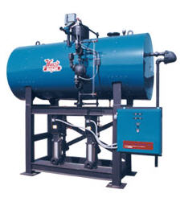
Introduction
Mechanical and chemical deaeration is an integral part of modern boiler water protection and control. Deaeration, coupled with other aspects of external treatment, provides the best and highest quality feed water for boiler use.
Simply speaking, the purposes of deaeration are:
- To remove oxygen, carbon dioxide and other noncondensable gases from feed water
- To heat the incoming makeup water and return condensate to an optimum temperature for:
  - Minimizing solubility of the undesirable gases
  - Providing the highest temperature water for injection to the boiler
Deaerators are typically elevated in boiler rooms to help create head pressure on pumps located lower. This allows hotter water to be pumped without vapor locking should some steam get into the pump.

Reason to Deaerate
The most common source of corrosion in boiler systems is dissolved gas: oxygen, carbon dioxide and ammonia. Of these, oxygen is the most aggressive. The importance of eliminating oxygen as a source of pitting and iron deposition cannot be over-emphasized. Even small concentrations of this gas can cause serious corrosion problems.
Makeup water introduces appreciable amounts of oxygen into the system. Oxygen can also enter the feed water system from the condensate return system. Possible return line sources are direct air-leakage on the suction side of pumps, systems under vacuum, the breathing action of closed condensate receiving tanks, open condensate receiving tanks and leakage of non-deaerated water used for condensate pump seal and/or quench water. With all of these sources, good housekeeping is an essential part of the preventive program.
One of the most serious aspects of oxygen corrosion is that it occurs as pitting. This type of corrosion can produce failures even though only a relatively small amount of metal has been lost and the overall corrosion rate is relatively low. The degree of oxygen attack depends on the concentration of dissolved oxygen, the pH and the temperature of the water.
The influence of temperature on the corrosivity of dissolved oxygen is particularly important in closed heaters and economizers where the water temperature increases rapidly. Elevated temperature in itself does not cause corrosion. Small concentrations of oxygen at elevated temperatures do cause severe problems. This temperature rise provides the driving force that accelerates the reaction so that even small quantities of dissolved oxygen can cause serious corrosion.

Operation
Mechanical deaeration is the first step in eliminating oxygen and other corrosive gases from the feed water. Free carbon dioxide is also removed by deaeration, while combined carbon dioxide is released with the steam in the boiler and subsequently dissolves in the condensate. This can cause additional corrosion problems.
Because dissolved oxygen is a constant threat to boiler tube integrity, this discussion on the deaerator will be aimed at reducing the oxygen content of the feed water. The two major types of deaerators are the tray type and the spray type. In both cases, the major portion of gas removal is accomplished by spraying cold makeup water into a steam environment.
Tray-Type Deaerating Heaters
Tray-type deaerating heaters release dissolved gases in the incoming water by reducing it to a fine spray as it cascades over several rows of trays. The steam that makes intimate contact with the water droplets then scrubs the dissolved gases by its counter-current flow. The steam heats the water to within 3-5 º F of the steam saturation temperature and it should remove all but the very last traces of oxygen. The deaerated water then falls to the storage space below, where a steam blanket protects it from recontamination.
Nozzles and trays should be inspected regularly to insure that they are free of deposits and are in their proper position

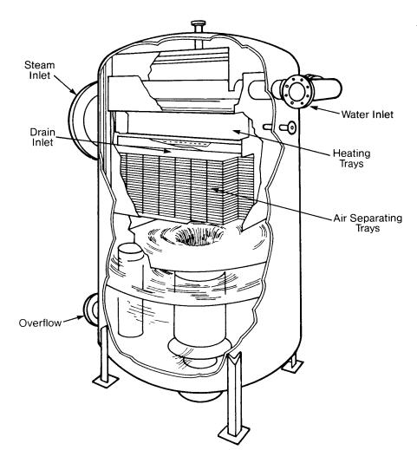
Tray-Type Deaerating Heater (Cochrane Corp.)

Spray-Type Deaerating Heaters
Spray-type deaerating heaters work on the same general philosophy as the tray-type, but differ in their operation. Spring-loaded nozzles located in the top of the unit spray the water into a steam atmosphere that heats it. Simply stated, the steam heats the water, and at the elevated temperature the solubility of oxygen is extremely low and most of the dissolved gases are removed from the system by venting. The spray will reduce the dissolved oxygen content to 20-50 ppb, while the scrubber or trays further reduce the oxygen content to approximately 7 ppb or less.
During normal operation, the vent valve must be open to maintain a continuous plume of vented vapors and steam at least 18 inches long. If this valve is throttled too much, air and nonconclensable gases will accumulate in the deaerator. This is known as air blanketing and can be remedied by increasing the vent rate.
For optimum oxygen removal, the water in the storage section must be heated to within 5 º F of the temperature of the steam at saturation conditions. From inlet to outlet, the water is deaerated in less than 10 seconds.
The storage section is usually designed to hold enough water for 10 minutes of boiler operation at full load.
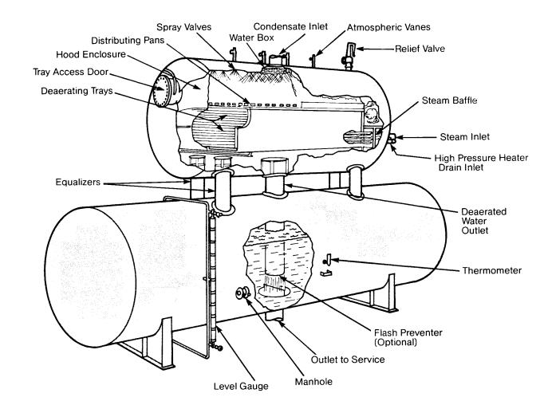
Click on image for larger view
Spray-Type Deaerating Heater (Graver)
Limitations
Inlet water should be virtually free of suspended solids that could clog spray valves and ports of the inlet distributor and the deaerator trays. In addition, spray valves, ports and deaerator trays may become plugged with scale that forms when the water being deaerated has high hardness and alkalinity levels. In this case, routine cleaning and inspection of the deaerator is very important.

Economizers
Where economizers are installed, good deaerating heater operation is essential. Because oxygen pitting is the most common cause of economizer tube failure, this vital part of the boiler must be protected with an oxygen scavenger, usually catalyzed sodium sulfite. In order to insure complete corrosion protection of the economizer, it is common practice to maintain a sulfite residual of 5-10 ppm in the feed water and, if necessary, feed sufficient caustic soda or neutralizing amine to increase the feed water pH to between 8.0 and 9.0.
Below 900 psi excess sulfite (up to 200 ppm) in the boiler will not be harmful. To maintain blowdown rates, the conductivity can then be raised to compensate for the extra solids due to the presence of the higher level of sulfite in the boiler water. This added consideration (in protecting the economizer) is aimed at preventing a pitting failure. Make the application of an oxygen scavenger, such as catalyzed sulfite, a standard recommendation in all of your boiler treatment programs.
For more on economizers.

Chemical Deaeration
Complete oxygen removal cannot be attained by mechanical deaeration alone. Equipment manufacturers state that a properly operated deaerating heater can mechanically reduce the dissolved oxygen concentrations in the feed water to 0.005 cc per liter (7 ppb) and 0 free carbon dioxide. Typically, plant oxygen levels vary from 3 to 50 ppb. Traces of dissolved oxygen remaining in the feed water can then be chemically removed with the oxygen scavenger.
Oxygen scavengers are added to the boiler water, preferably in the storage tank of the deaerator so the scavenger will have the maximum time to react with the residual oxygen. Under certain conditions, such as when boiler feedwater is used for attemperation to lower steam temperature, other locations are preferable. The most commonly used oxygen scavenger is sodium sulfite. It is inexpensive, very effective and rapidly reacts with the trace amounts of oxygen.
It is also easily measured in boiler water. In most cases it is the oxygen scavenger of choice. There are instances in some higher pressure boilers (generally above 900 psig), that some of the sulfite may decompose and enter the steam, causing problems in the condensate systems and condensing steam turbines. In these cases, substitute (usually organic-based) oxygen scavengers can be used.
New oxygen scavengers have been introduced in recent years. The decision to use them or rely on sodium sulfite should only be made by those qualified to make boiler water treatment decisions. In all cases the new product should be carefully added and its effectiveness evaluated in accordance with operating procedures.
Phosphate is used almost as often as oxygen scavengers. However, phosphate also plays several important roles in boiler water treatment:
- It buffers the boiler water pH to minimize the potential for boiler corrosion
- It precipitates small amounts of calcium or magnesium into a soft deposit which can then accumulate in mud drums or steam drums rather than as hard scale
- It helps to promot the protective oxide film on boiler metal surfaces
Common phosphate compounds added to treat boiler water include sodium phosphate (monosodium phosphate, disodium phosphate or trisodium phosphate) or sodium polyphosphate. They all function approximately the same; the choice of which to use depends on the quality of the boiler water and the handling requirements of the user.

Measurement of Dissolved Oxygen
  - Indigo Carmine - A colorimetric procedure for determining dissolved oxygen in the 0 to 100 ppb range. Standards are also available for high range (0-1 ppm),
  - AmpuImetric - This test offers ease of operation and minimum time in collecting reliable data. Capsules are available in the 0-100 ppb and 0-1 ppm range.
  - Oxygen Analyzers - Offers accurate reliable direct measurement in liquid streams. Used to monitor dissolved oxygen continuously or intermittently at various points in the condensate and feedwater systems.

Oxygen Analyzers
Basically there are two general techniques for measuring Dissolved Oxygen (DO). Each employs an electrode system in which the dissolved oxygen reacts at the cathode producing a measurable electrochemical effect. The effect may be galvanic, polarographic or potentiometric.
One technique uses a Clark-type cell which is merely an electrode system separated from the sample stream by a semi-permeable membrane. This membrane permits the oxygen dissolved in the sample to pass through it to the electrode system while preventing liquids and ionic species from doing so. The cathode is a hydrogen electrode and carries a negative applied potential with respect to the anode. Electrolyte surrounds the electrode pair and is contained by the membrane. In the absence of a reactant, the cathode becomes polarized with hydrogen and resistance to current flow becomes infinite. When a reactant, such as oxygen that has passed through the membrane is present, the cathode is depolarized and electrons are consumed. The anode of the electrode pair must react with the product of the depolarization reaction with a corresponding release of electrons. As a result, the electrode pair permits current to flow in direct proportion to the amount of oxygen or reactant entering the system; hence, the magnitude of the current gives us a direct measure of the amount of oxygen entering the system.
The second basic measuring technique uses an electrode system that consists of a reference electrode and a thallium measuring electrode. No semi-permeable membrane is used; the electrode system is immersed directly into the sample. Oxygen concentration is determined by measuring the voltage potential developed, in relation to the reference electrode, when dissolved oxygen comes in contact with the thallium electrode. At the surface of the electrode the thallous-ion concentration is proportional to the dissolved oxygen. The voltage potential developed by the cell is dependent upon the thallous-ion concentration in this layer and varies as the dissolved oxygen concentration changes. The cell output rises 59 millivolts for each decade rise in oxygen concentration. This technique uses a potentiometric system. The method measures directly the concentration of oxygen in the sample. As in the first technique, temperature compensation is a must and is achieved in about the same way. In both techniques, interfacial dynamics at the probe-sample interface are a factor in the probe response. A significant amount of interfacial turbulence is necessary and for precision performance, turbulence should be constant.
Source: http://www.cip.ukcentre.com/do.htm

Heat Exchange on Boiler Feed Water
Whenever heat can be recovered from another source, feed water is one of the best streams to receive this heat. The higher the temperature of the feed water going to the boiler, the more efficiently the boiler operates. However, any type of migratory deposition can impede the heat exchange process. Consequently, the highest quality feed water provides the highest heat exchange rate in either economizers or heaters. It is important to understand that none of these heat exchangers can be blown down during boiler operation.
For more information see Economizers and Blowdown Heat Recovery

Deaerator More

Introduction
Removing dissolved oxygen from boiler feed water is absolutely necessary to protect your boiler equipment from severe corrosion. But the make-up water necessary in any boiler system inevitably contains dissolved oxygen. Oxygen can sometimes enter condensate systems as well. A good deaerator is essential to trouble-free boiler operation.

Operation
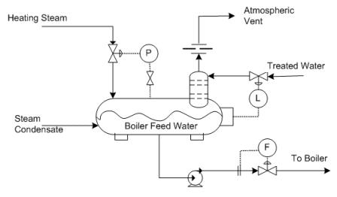
Above is a typical "older-style" boiler feed water deaerator. You'll see why I call it "older" in a moment. The theory here is relatively simple. Treated water containing dissolved oxygen is fed onto a contacting device where the water can be heated and contacted with steam which is also fed to the vessel. The steam heats the incoming treated water to around 250 °F (120 °C) and allows oxygen to escape (along with any small amount of uncondensed steam) to the atmosphere. Notice that the returning condensate is NOT contacted with the steam in this system. Some systems feed the treated water and condensate together to ensure a very low oxygen content. Other systems do not bother as the returning condensate is expected to already have a low oxygen content. You'll see that newer systems are designed to treat both sources in most cases.
A next generation deaerator system from Hurst Boiler, called the Oxy-Miser, utilizes a scrubbing section to contact oxygen-rich feedwater with steam rather than the more traditional tray arrangement.
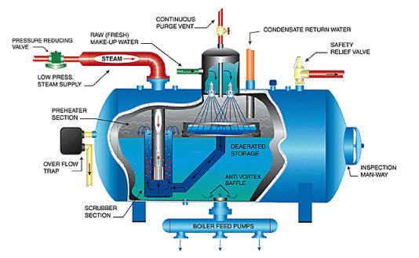
In this design, both the treated boiler feed water and the condensate return are sent through the scrubbing section of the deaerator. The Oxy-Miser system is available in capacities ranging from 5,000 to 200,000 lb/h (2300 to 91000 kg/h).
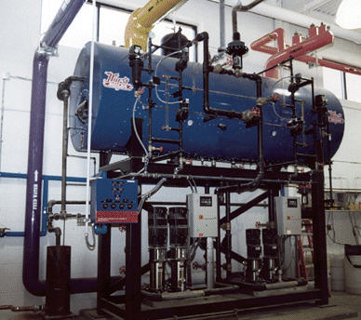

pH Treatment

Introduction
What is pH?
Acidic and basic (alkaline) are two extremes that describe chemicals, just like hot and cold are two extremes that describe temperature. Mixing acids and bases (alkaline) can cancel out their extreme effects, much like mixing hot and cold water can even out the water temperature. A substance that is neither acidic nor basic (alkaline) is neutral.
The pH scale measures how acidic or basic (alkaline) a substance is. It ranges from 0 to 14. A pH of 7 is neutral. A pH less than 7 is acidic, and a pH greater than 7 is basic (alkaline). Each whole pH value below 7 is ten times more acidic than the next higher value. For example, a pH of 4 is ten times more acidic than a pH of 5 and 100 times (10 times 10) more acidic than a pH of 6. The same holds true for pH values above 7, each of which is ten times more alkaline (another way to say basic) than the next lower whole value. For example, a pH of 10 is ten times more alkaline than a pH of 9.
Pure water is neutral, with a pH of 7.0. When chemicals are mixed with water, the mixture can become either acidic or basic (alkaline). Vinegar and lemon juice are acidic substances, while laundry detergents and ammonia are basic (alkaline).
Chemicals that are very basic or very acidic are called "reactive." These chemicals can cause severe burns. Automobile battery acid is an acidic chemical that is reactive. Automobile batteries contain a stronger form of some of the same acid that is in acid rain. Household drain cleaners often contain lye, a very alkaline chemical that is reactive.

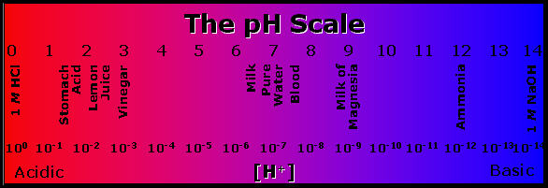
An Acid is a substance that produces H3O+ (H+) when it is dissolved in water. It is a proton donor and an electron pair acceptor or a species that donates protons. For example: HCl, NH4, AlCl3.
A Base is a substance that produces an OH- when it is dissolved in water (Arrhenius). A proton acceptor (Brønsted), or a electron donor. For example: NaOH, KOH, CH3NH2.
H2O can act as an acid or a base because it auto-ionizes itself, meaning it gives protons back and forth within itself, thus acting as both an acid and a base.

Boiler pH
Natural water is usually between 6.5 and 7.5 pH. A common recommendation is to maintain boiler water at 8.5 pH.
Acidic water is corrosive. Alkalinic water is more prone to scaling.
Alkalinity is a measure of the bicarbonate (HCO3), carbonate (CO3) and hydroxyl (OH) ions in the water. pH and alkalinity ratings are NOT the same and are NOT proportional. pH is rated on the Scale and alkalinity is measured in parts per million (ppm). A typically recommended alkalinity rating is 140 - 700 ppm for boilers operating below 300 psi.

Controlling pH
pH is controlled by either removing water impurities or adding other chemicals to neutralize the condition. For example, Caustic Soda, an alkaline, is added to neutralize CO3, carbonic acid.

pH Related Corrosion
Acid Attack
When the boiler water pH drops below about 8.5, a corrosion called acid attack can occur. The effect exhibits rough pitted surfaces. The presence of iron oxide deposits on boiler surfaces can encourage this kind of corrosion. A low boilerwater pH is usually caused by contamination of the boiler feedwater, from sources such as hydrochloric or sulfuric acid from leaks in demineralizers and condenser leaks of cooling tower water. Contamination can also occur from process leaks of acid or acid-forming materials into the return condensate system.

Caustic Attack
Caustic attack on boilers is a localized attack due to extremely high pH (12.9 +). It can take two forms: caustic gouging or caustic cracking, also called caustic embrittlement. Caustic attack or caustic corrosion, is often encountered in phosphate treated boilers in which deposits of phosphates or other 'scale' occur in high heat transfer areas. Boiler water can permeate the porous deposit resulting in localize corrosion. When it is coupled with significant heat flux, concentration of the boiler water occurs rapidly speeding the corrosion.
The corrosion action is a result of the formation of caustic-ferritic compounds through the dissolving of the protective magnetite film. Once the process begins, the iron in contact with the boiler water will attempt to restore the protective magnetite film. Caustic corrosion (typically in the form of gouging) continues until the deposit is removed or the caustic concentration is reduced to normal.
Caustic soda (NaOH) is the only normal boiler water constituent that has high solubility and does not crystallize under typical boiler conditions. Its caustic concentration can be as high as 10,000-100,000 ppm.
Careful control of boiler water chemistry can prevent caustic gouging. If the “free hydroxide alkalinity”
is set too high or uncontrolled, then caustic gouging may result. Prevention of porous deposit formation (such as iron oxide) eliminates a place for caustic gouging to occur.

Water Softener and Demineralization

Introduction
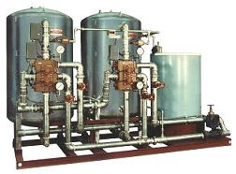
The removal of impurities, such as calcium, magnesium, iron and silica which can cause scale, is known as water softening or demineralization. Common treatment methods to remove these impurities include lime softening, sodium cycle cation exchange (often called sodium zeolite softening), reverse osmosis, electrodialysis, and ion ex-change demineralization. Which treatment is most appropriate depends on the water supply quality, the purity requirements of the boiler, and to some extent - the budget.
Water Hardness is measured in grains per gallon or ppm. The conversion is 17.1 ppm = 1 grain
One cubic foot of softener resin is typically good for 30,000 grains in exchange. Softeners are typically set to regenerate once the resin is 90% exhausted. Regeneration is accomplished with a variety of chemicals for various purposes, but is commonly simple table salt brine, NaCl. The last part of the regeneration cycle is a fresh water flush to prevent salt from entering the boiler.

Operations
Quick Lime and Clarifiers
Quick or slaked lime added to hard water, reacts with the calcium, magnesium and, to some extent, the silica in the water to form a solid precipitate. The process typically takes place in a clarifier. The lime is added to the “rapid mix zone”, where it reacts with some of the calcium, magnesium and silica. The combined precipitate is removed from the bottom of the clarifier and the treated water is now softer than the untreated inlet water but still unsuitable for the boiler.
Lime softening treatment is followed by either sodium cycle cation exchange or ion ex-change demineralization. Cation exchange is usually picked for lower pressure boilers (450 psig) and demineralization for higher pressure boilers (above 600 psig).

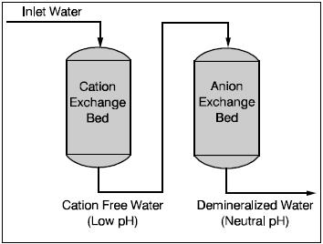

Ion Exchange
Ion exchange is just what it implies: a process that exchanges one type of ion (charged particle) for another. Many troublesome impurities in supply water are ions, making this process extremely important in boiler water treatment. Ion exchange takes place in a closed vessel which is partially filled with an ion exchange resin. The resin is an insoluble, plastic-like material capable of exchanging one ion for another. There are two types: cation and anion resins. Each is capable of exchanging one or the other types of ions.
Cation = positively charged Ions
Anion = negatively charged Ions
Another method of ion exchange involves a sodium exchange softener, where hard water enters the unit and the calcium and magnesium are exchanged for sodium. The treated water will normally have most of the hardness removed, but will still contain other impurities. This method is suitable only for low pressure boilers.
If very pure water is required, for high pressure boilers for example, then demineralization is required. A demineralizer contains one or more cation exchange beds, followed by one or more anion exchange beds.
In the demineralizer, water is treated in two steps. First, it is passed through the cation exchange bed, where the cations (calcium, magnesium and sodium) are exchanged for hydrogen ions. The treated water is now free of cations but is too acidic and cannot yet be used in the boiler. In the second step the water passes through the anion exchange bed where the anions (sulfate, chloride, carbonate and silica) are ex-changed for hydroxide ions. The hydrogen and hydroxide ions react to form water, now suitable for use in the boiler. A third ion exchange could be used to control alkalinity.
For higher purity water, more elaborate systems are employed, but the basic principle remains the same.
Ion exchange resins have a limited capacity and will eventually become exhausted. They can be regenerated however; sodium cycle cation exchange beds are regenerated with salt brine, cation exchange beds are regenerated with hydrochloric or sulfuric acid and the anion exchange beds become regenerated with caustic soda. Salt brine regeneration is followed by a fresh water rinse to assure that no salt enters the boiler.

Dealkalizers
Dealkalizers reduce the alkalinity of softened water through a chloride anion exchange process. Softened water is passed through the anion exchange resin where bicarbonate, carbonate, sulfate and nitrate ions are exchanged for chloride ions. The anion exchange resin is regenerated by salt (NaCl) and softened water. Some dealkalizers add a small amount of caustic during the regeneration cycle to increase capacity and provide a slightly elevated pH level.
The primary benefit of using dealkalized water is the prevention of CO2 generation inside of the boiler. CO2 leaves the boiler with the steam and can form carbonic acid in the condensate, leading to the primary cause of condensate system corrosion.

Other Technologies
Other technology is sometimes employed to remove undesirable impurities from the water supply, including reverse osmosis, electrodialysis, and electrodialysis with current reversal. These are all known as membrane processes. Reverse osmosis uses semipermeable membranes that let water through but block the passage of salts. In the case of electrodialysis, the salts dissolved in the water are forced to move through cation-selective and anion-selective membranes, removing the ion concentration.

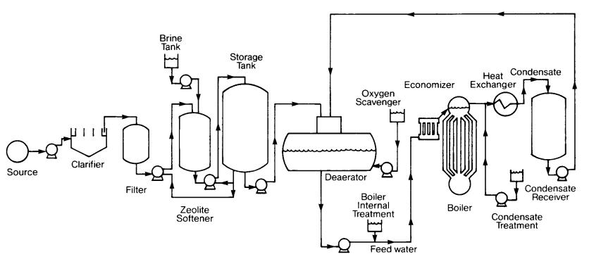

Water Chemicals

Oxygen Scavengers
Sulfites - typically for boilers up to 800 psi; sulfites react with oxygen to form sulfates that are removed from the boiler via blowdown. There are two forms of sulfite: Catalyzed - uses a catalyst to improve reaction time; Non-catalyzed - slower reaction time and must be used in hot water
Hydrazine - typically for boilers over 800 psi. At pressure higher than 800 psi, sulfite begins to break down into acidic gases of sulfur. Sulfite also creates additional Total Dissolved Solids (TDS) which is a problem for high pressure applications. Hydrazine removes O2 without producing acidic gases or TDS, but is considered a possible carcinogen.

Hydroxides
Sodium Hydroxide - NaOH or Caustic Soda, or Soda Ash - used to maintain boiler water pH in the 10.0 - 11.5 range. Hydroxide increase boiler alkalinity to prevent acidic corrosion. If heavy scale is present, caustic soda can accumulate to cause Caustic Attack. See pH Treatment
Calcium-Hydroxide - reacts with calcium and magnesium bicarbonates to form sludge that is removed via blowdown.

Phosphates
Phosphate treatment causes calcium and magnesium to precipitate into sludge where it can be removed via blowdown.

Polymers
Polymers are long, complex molecules that attach to impurities and prevent them from sticking to boiler metal to form scale. This creates TDS that are removed via blowdown.

Chelants
Chelants can prevent scale from forming and over time, remove existing scale. Chelants in contact with 02 is corrosive. It must therefore be used in an 02- free environment.

Neutralizing Amines
Neutralizing amines hydrolyze in water to generate the necessary hydroxide ions required for neutralization of the carbon dioxide. The normal approach to treating systems with these amines is to feed sufficient quantity to neutralize the carbon dioxide and then provide small additional amounts to buffer the pH to 8.5 or 9.0. At this pH, continued preservation of the magnetite film (boiler metal) is also achieved. It is also implied that corrosion will not exist at a pH>8.0-8.5.

Filming Amines
Filming amines function by forming a protective barrier against both oxygen and carbon dioxide attack. These amines form films directly with the condensate line metal and develop a barrier to prevent contact of the corrosive condensate with the return piping. By design, film formers have been developed to function best at a pH of 5.5-7.5. In addition, these amines are highly surface-active and will slough loosely adherent iron oxide and other corrosion products back to receiving points or to the boiler. Care must be exercised with the feed of filming amines.
Combination Amines. Over the past several years, combinations of filming and neutralizing amines have been shown to be extremely effective, particularly in complex systems. While the combination amine is still functionally a filmer, the neutralizing amine portions provide for reduction in fouling potential and more uniform coverage of the filmer.
Filming amines and combination amines are generally fed to steam headers. Dosages are based on steam production.

Water Quality Monitoring

Introduction
Water quality monitoring varies from weekly litmus test strips to continuous electronic instrumentation and automated chemical treatment. The size of the boiler, the importance of water quality and the skills of the boiler operators are all factors in deciding how best to monitor boiler water quality.

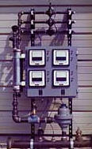

Common water monitoring is for oxygen, Total Dissolved Solids (TDS), and pH. A different type of instrument is required for each.

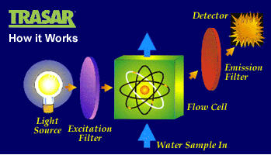
Sample Meters and Instruments
DLR Mechanical Services
The DLS10000 series Blowdown Heat Recovery System adjust automatically to changing system demands, and recover up to 90% of the heat normally lost during boiler surface blowdown operation.
Blowdown/Heat Recovery systems will usually result in a payback in a few short months from fuel savings alone.
The DLS 10000 series Packaged Blowdown Heat Recovery System provides several features not found in other units:
- It automatically controls the surface blowdown to maintain the desired level of total dissolved solids (TDS) in the boiler, reducing the amount of blowdown to a minimum.
- It recovers the heat from the high temperature blowdown, and transfers it to the incoming cold make-up water, maximizing boiler efficiency.
- The conductivity controller controls the actual boiler conductivity ( TDS ) level, keeping blowdown to the required minimum and reduces chemical costs
- The BTU system records the actual energy saved and the amount of make-up water used. Invaluable information for the boiler operator and plant engineer
- The Stainless Steel blowdown heat exchangers are uniquely designed to handle the blowdown and make up water. The unique spiral plate design provides U Factors as high as 1000 BTU/SqFt/Degree, and maintains high fluid velocities preventing scaling and fouling.
Significant Fuel Savings for Any Size Boiler: Transfers the blowdown heat to the make-up, thereby decreasing fuel costs.
Go to their web site at www.dlrmechanical.com

NALCO
TRASAR is a versatile technology that allows Nalco to determine where its products are going during the treatment process and how effectively they are working. It solves two typical problems with today's industrial water treatment systems: overfeeding and underfeeding. TRASAR eliminates the application of unnecessary chemicals, saving the customer money. TRASAR also prevents underfeeding, thus eliminating poor performance and extending equipment run life.
Direct, real-time control by TRASAR measures the actual chemical level in the system. Chemical injection systems linked to the TRASAR controller keep the treatment at the target levels, continuously making automatic adjustments. The results include: greater accuracy, tighter control and better reliability than indirect control.
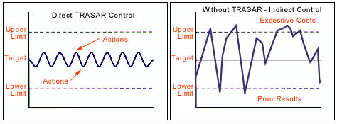

Blowdown

Introduction
Blowdown is a very important part of any water treatment program. Its purpose is to limit the concentration of impurities in the boiler water. The right amount of blowdown is critical: too much results in energy loss and excessive chemical treatment cost; too little and excessive concentrations of impurities build up. There are no hard and fast rules as to the amount of blowdown because of the variation in water quality varies from place to place. It can range from 1% (based on feedwater flow) to as much as 25%.

TDS
Total Dissolved Solids - TDS is a measurement of boiler contamination and therefore an indicator of when blowdown needs to occur. Actual TDS is measured in ppm (parts per million). The measurement instrument used is based on the boiler water's conductivity/resistance. Pure water is a very poor conductor of electricity. Water with a high level of TDS conducts electricity quite well. A very sensitive meter converts the electrical signal to ppm -or- depending on the type of meter - an electrical reading is converted from a meter reading to ppm manually on a chart provided by the instrument's manufacturer.
A common, and much less sophisticated method of TDS "measurement" is a clear-sight-glass that visually indicates the boiler water condition. When the boiler operator sees the water getting dirty, they perform a blowdown.
Common practice may be to simply blowdown the boiler at every shift change for a given period of time. This method may or may not be effective and could be wasting energy from excessive blowdown losses of both heat and boiler chemicals.

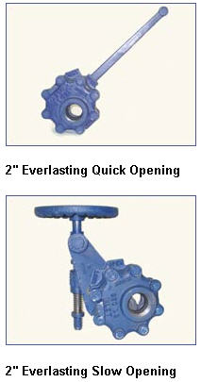
Operation
There are two types of boiler blowdowns - continuous and manual. A continuous blowdown utilizes a calibrated valve and a blowdown tap near the boiler water surface. As the name implies, it continuously takes water from the top of the boiler at a predetermined rate. A continuous blowdown is an optional feature and is not included on all boilers. However, all steam boilers must include a means for manual blowdown as standard equipment. Manual blowdowns allow for the removal of solids that settle at the bottom of the boiler.
Proper blowdown is performed as follows: (Manual)
Blowdown should be done with the boiler under a light load. Open the blowdown valve nearest the boiler first. This should be a quick opening valve. Crack open the downstream valve until the line is warm. Then open the valve at a steady rate to drop the water level in the sight glass ½ inch. Then close it quickly being sure that the hand wheel is backed off slightly from full close to relieve strain on the valve packing. Close the valve nearest the boiler.
Repeat the above steps if the boiler has a second blowdown tapping. Water columns should be blown down at least once a shift to keep the bowls clean. Care should be taken to prevent low water shutdown if this will affect process load. Be sure blowdown piping is not obstructed.
Note: Boilers that operate below 100 psi may have only a single blowdown control valve.
Here are some principles to help establish an effective blowdown program:

- In drum-type boilers, the concentration of the water should be controlled by blowdown from the steam drum. Continuous blowdown is preferred.
- Also in drum boilers, blowing from the mud drum or bottom headers removes suspended solids from the boiler. Trying to control the concentration of impurities by blowdown from this location can cause a severe disruption of circulation in the boiler, causing damage to the boiler. Bottom blowdown should be of short duration, on a regular basis. These are determined by boiler design, operating conditions and the accumulation rate of suspended solids.
- Fire tube boiler blowdown can be either continuous or intermittent. It can be blown down from below the surface or from the bottom. Type, frequency and duration depend on boiler design, operating conditions and the type of water treatment program.

A way to reduce the energy loss is to install a continuous blowdown heat recovery device. These are now economical for blowdowns as low as 500 lb/hr.

For information on blowdown heat recovery.

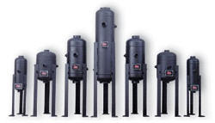
Blowdown Separators
Low pressure boilers typically blowdown directly from the boiler to a floor drain. However, even with low pressure boilers the presence of live steam, very hot water and blowing contaminates can be a safety issue. Also, where the boiler drain is connected to a city sewer, local code may require that the blowdown water be cooled to less than 120F before it enters the sewer. This is accomplished by mixing with cold, fresh water.
Blowdown separator take water from the boiler during blowdown and reduce it to atmospheric pressure for disposal. The separator accomplishes this by separating the subsequent flashed steam from the hot water. As the blowdown enters the vessel, it is forced into a centrifugal pattern by means of a striking plate. The steam is vented to the atmosphere through a top connection. Separators are built as per requirements Section VIII of the ASME Code and stamped by the National Board of Pressure Vessel Inspectors.
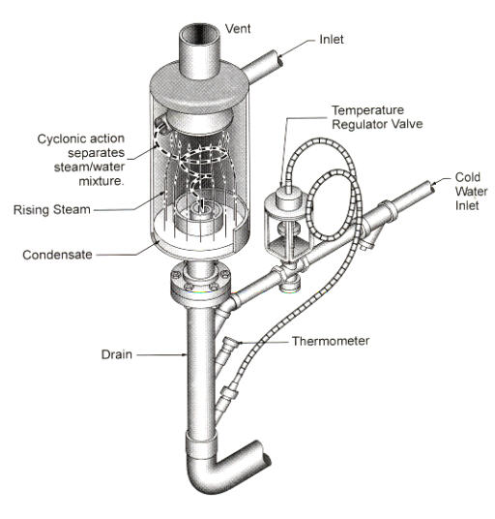

Blowdown Control

Introduction
Although all steam boilers must be blowndown to control TDS, excess blowdown results in wasted thermal energy and boiler water treatment chemicals.
See Blowdown for a discussion about TDS and measurement.

Blowdown Control Measures
TDS recommendation is according to boiler operating pressure. For boilers operating up to 300 psi, the typical limit recommendation is 3,500 ppm. As the boiler pressure increases, the TDS recommendation drops to a smaller number.
- If boiler blowdown is according to a time or visual-check basis, monitor boiler water with a TDS measurement system
- Use a continuous TDS Meter to monitor boiler water and blowdown only when TDS limits are reached
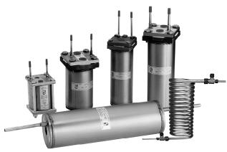
- Often the boiler TDS level can be much higher than the steam system can tolerate. If this is the case, install a steam trap or sample cooler off the steam header, near the boiler, and measure the TDS content of the condensate. Blowdown only when the TDS carryover to the steam system reaches the pre-determined limit.
- Install a blowdown heat recovery system

Blowdown Heat Recovery

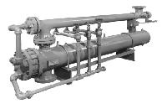
Introduction
All steam boilers must blowndown to reduce the amount of TDS in the boiler water. See Blowdown However, along with the solids, boiler chemicals and thermal energy is lost; blowdown heat recovery systems cannot recover the chemicals, but they do recover up to 90% of the heat energy that would otherwise be lost down the drain. The recovered heat is use to pre-heat boiler make-up water before it enters the deaerator, and for low pressure steam to heat water inside the deaerator, which reduces the cost to run the deaerator and improves overall boiler efficiency.
Reducing the temperature of the blowdown before it reaches the sewer drain is a typical Code requirement. Therefore, a heat recovery system also eliminates the need to dilute blowdown with cold water before it enters the sewer.
Blowdown heat recovery systems offer a fairly rapid payback, depending on blowdown volume. Several boilers can be connected to a single heat recovery unit, reducing capital costs. Typical payback is under 12 months.
A blowdown heat recovery system should be considered when:
- ~ 5% of boiler water is make-up (smaller boilers; lower percentage for larger boilers)
- ~ 500 lbs/hour steam is blown-down
- Continuous blowdown systems of at least 1 gpm
Blowdown heat recovery in combination with Blowdown Control to both limit total blowndown volume and recover the heat is the best combination for overall efficiency.
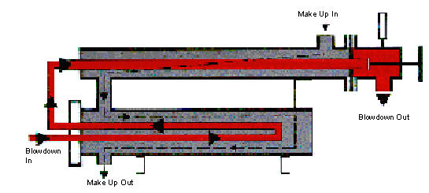

Operation
It doesn't matter wether blowdown is from the surface or bottom of the boiler, heat is lost along with the solids. Depending on the boiler operating pressure, steam and/or flash steam provides the most intense heat, but condensate heat recovery provides additional heating. The colder the incoming water (such as with cold make-up water and limited or no condensate return) the higher the overall efficiency.
The following diagrams show several different ways to recover the heat from blowdown. Which system makes the most economic sense will be a factor of the operating pressure of the boiler (the higher the pressure the more flash steam available), the total volume of blowdown, and the temperature and volume of the make-up/condensate return water.
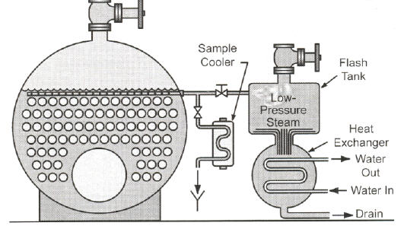
The above diagram shows Flash Steam recovered for the steam distribution system and the hot blowdown condensate flowing into a heat exchanger to pre-heat incoming make-up water.
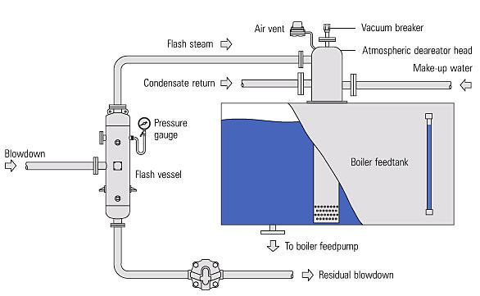
In this diagram, only flash steam is used to pre-heat make-up water in an atmospheric deaerator; the hot condensate from the blowdown is dumped to drain. It may require a cold water mixing valve to meet local codes.
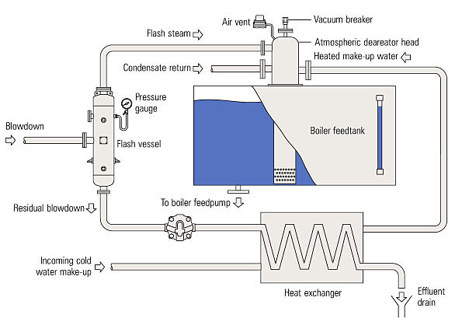
In this variation, both flash steam and hot blowdown condensate are used to heat make-up water with the addition of a heat exchanger. This system works well if cold make-up water is always flowing at the same time that blowdown is occurring.
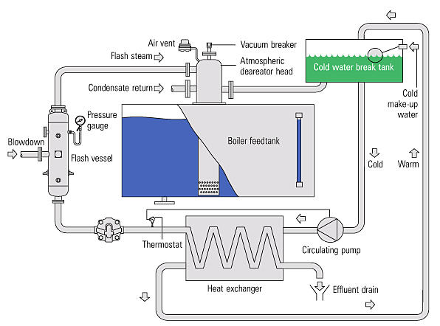
This variation adds a cold water storage tank with a circulator pump through the heat exchanger. This option means that cold make-up water and blowdown do not have to occur at the same time in order to recover heat from the blowdown condensate.

Estimating Savings
Blowdown heat recovery systems can recover about 90% of the blowdown thermal value. The value varies with volume, boiler pressure, method/frequency of blowdown and fuel cost. Continuous blowdown systems use 5 - 10% boiler capacity. Therefore, if estimating a value, 5% of average boiler capacity is reasonable. The blowdown BTU value varies with boiler steam pressure; the higher the boiler pressure the higher amount of higher value flash steam. Assume 25% flashes to steam and remainder is hot condensate for boilers under 300 psi.
The General Formulas:
Average Boiler Capacity in pounds per hour of steam x 5% = Blowdown volume
(Blowdown volume x 25% x 1,200 BTUs per Pound) + (Blowdown volume x 75% x 140 BTUs per Pound) = Total BTUs
Total BTUs x 90% Efficiency / (1,000,000 BTUs x Boiler Efficiency) = Millions of BTUs per Hour Recovered
MMBTUs x $ per MCF = Hourly Savings

EXAMPLE: 50,000 lbs per hour boiler at 200 psi steam with continuous blowdown
50,000 lbs per hour x 5% = 2,500 lbs per hour blowdown
(2,500 x 25% x 1,200 BTUs) + (2,500 x 75% x 140 BTUs) = 1,012,500 BTUs per hour in Blowdown
(1,012,500 x 90% Efficiency) / (1,000,000 x 85%) = 1.07 MMBTUs per hour
1.07 x $7.00 per MCF = $7.50 per hour = $180 per day = $5,400 per month
NOTE: In some applications the amount of flash steam produced by the blowdown recovery can exceed the amount of steam needed by the deaerator. This can lead to excessive steam venting from the deaerator and reduce the overall saving potential of the recovery system.
See also Appendix B of the CIBO Energy Efficiency Handbook 1997 Edition for sample calculations.

