Instructional Design-Washington D.C Unit for Special Needs Students

Justin M. Firks
Bowling Green State University
Fall 2010

Sequencing Rationale:

The curriculum design for the Interdisciplinary Unit on Washington, D.C., for Special Needs students takes the students through four important sections: Historical background on Gettysburg, Gettysburg Address (100 years later), The Month That Saved America, and the Washington, D.C., National Mall. Each section increases importance as we explore our nation’s capital and prepare for the senior class trip in the spring of 2011.
The first subunit explores the Battle of Gettysburg, which is often described as either the turning point of the war or the site of Robert E. Lee’s greatest blunder. The students will gain an appreciation of one of history’s greatest battles and the contributions of such key individuals as Abraham Lincoln, Robert E. Lee, and Ulysses S. Grant.
The Gettysburg Address is one the most historically significant speeches in United States history. It is critically important for the students and citizens of our country to not only be introduced to this document, but to explore the impact it will have on the United States in 1863 and 1963. The students will analyze how the contributions of people from various racial, ethnic, and religious groups have helped shape the national identify. The student will accomplish this by applying critical thinking skills, communicating in oral, written, and visual forms, and acquiring these skills through a variety of sources.
Once students understand the importance and significance of the Battle of Gettysburg and the Gettysburg Address, it is then important for them to analyze the last few weeks of the Civil War, from President Lincoln’s second inauguration, to the surrender at Appomattox Courthouse, the assassination of Lincoln and the final laying down of arms by the Confederacy.
The fourth subunit allows the students to research the nation’s capitol, its monuments, the memorials, and the United States Presidents. This unit allows the students to tie in history, geography, science, and the visual arts curriculum to locations around the Washington Mall. As stated in the statement of purpose, interdisciplinary teaching focuses on meaningful learning skills that occur across content and curriculum and helps assist students in becoming lifelong learners. This subunit will allow the students to understand and experience US history, geography, science and art in the context of a metropolitan setting.
This sequencing rationale provides a more in-depth look at the Interdisciplinary Unit for Washington, D.C. for special needs students. Working through each subunit allows the students to build the necessary knowledge, vocabulary skills, and skill set to prepare them for the class trip in the spring of 2011. The sequence allows the students to build their knowledge of the history of our county and of the nation’s capitol and how racial equality has been a constant struggle in our nation’s history. The students will leave this unit with a firm understanding of Washington, D.C., and its historical significance.
The learning environment that will be displayed in the classroom will be one that follows The Concept Attainment Model (Chiarelott, 113). For the special education students, it is critically important that the concepts be facilitated through the classroom teacher, and then analyzed to see what they have learned in order to complete the various projects. As the unit moves from the beginning to the conclusion, it will be taught with new examples provided to the students. This model best suits my classroom due to the thinking patterns of my students and the increased use of hands-on, quickly changing activities that will take place during the lesson.

Interdisciplinary Unit on Washington, D.C. For Special Needs Students Objectives:

Subunit One: Historical Background on Gettysburg:

- Students will analyze maps of the battle of Gettysburg and be able to describe the movement and engagement of troops in that battle.

- Students will compare and contrast the maps from July 1, 2, 3 and will develop a multi-tier time line of the key events that took place on those days.

- Students will complete the 10 question assessment from the maps and will engage in a classroom discussion on the events that took place in Gettysburg.

- Students working in pairs will analyze the three maps (comparing and contrasting) and will discuss the content of those maps.

- Students will create a Gettysburg timeline and will be able to place important events and decisions that were made during the course of the battle. The students will share why they feel their chosen events are important.

- Students will use the Gettysburg worksheet to answer the 10 questions with 80% accuracy on the provided handout.

Subunit Two: Gettysburg Address-100 years later:

- Students will compare and contrast two Gettysburg speeches delivered 100 years apart. They will research and analyze social issues raised in the speeches and will evaluate the progress of racial equality in America.

- Students (working alone or in pairs) will read both speeches and discuss the contents.

- Students will create a color Venn diagram of the speeches.

- Students will research the racial and social issues in each speech and will add this information to the Venn diagram.

Subunit Three: April 1865: The Month That Saved America:

- Students will watch The History Channel special, The Month That Saved America, and will complete a post-viewing activity on the second day.

- Students will compare and contrast the differences and opposing views of Robert E. Lee and Jefferson Davis on a wallboard.

- Students will list five adjectives that describe Lee’s troops and the state they were in at the end of the war.

- Students will engage in an open forum discussion on the last scene of the special and will participate in a focus free write on what its meaning had on you.

- Students will create a T-chart that will compare and contrast Jefferson Davis and Robert E. Lee.

Subunit Four: Washington DC National Mall:

- Students will understand and experience the US government in action by researching the nation’s capitol, its monuments, memorials, and the US Presidents.

- Students will complete a pre-assessment activity to determine students’ prior knowledge about prominent, historically significant locations in our nation’s capitol.

- Students will gather historical facts for features on the predetermined monument that they have chosen to research.

- Students will engage and participate in an open forum discussion and present the facts that they located on the internet research project.

- Students will analyze a numbered map of Washington, D.C. National Mall and vicinity with simplified location names.

Evaluation Strategy

The primary evaluation strategies that will be used during the Interdisciplinary unit on Washington, D.C. will involve both formative and summative methods. These types of evaluations will allow for the instructor to gain information about the student’s prior knowledge on the topic, the stages of improvement they are making during the unit and what they have learned by the end or what they potentially will learn in the future.
Prior to beginning the unit, a student questionnaire will be distributed to each student. This questionnaire will check previous knowledge, concepts, and vocabulary words that will be critically important for this unit of study. This method will allow the instructor to recognize the strengths, weaknesses, and current level of understanding on Washington, D.C. that the students have. In addition, classroom discussions, exit slips, and focus free writes will be used as informative assessments to measure the student’s current level of understanding during or after a lesson.
These summative assessments are conducted after a unit or certain period of time to determine how much learning has taken place. Students will have both group and individual projects incorporating all of the material. These will include authentic assessments that allow students to work in pairs and will analyze three maps (comparing and contrasting) and will discuss the content of the maps. The students will create a Gettysburg timeline and will be able to place important events and decisions that were made during the course of the battle. The students will share why they feel they are important. The students will then answer the Gettysburg worksheets to answer the ten questions that will be provided on the handout.

Washington D.C. & Gettysburg Class Trip
Lesson #1: Historical Background on Gettysburg
Grade Level: 12th
Lesson Duration: 2 Class Periods

Introduction:
Gettysburg is often described as either the turning point of the war or the site of Lee’s greatest blunder. Regardless of how you look at Gettysburg, it must be considered as one of history’s greatest battles.

Objectives:
- Students will analyze maps of the battle of Gettysburg and be able to describe the movement and engagement of troops in that battle.
- Students will compare and contrast the maps from July 1, 2, 3 and will develop a multi-tier timeline of the key events that took place on those days.
- Students will complete the 10 question assessment from the maps and will engage in a classroom discussion on the events that took place at Gettysburg.

Ohio Academic Content Standards For Social Studies (K-12)
- Explain the course and consequences of the Civil War with emphasis on:
  - The battle of Gettysburg (History)
  - Contributions of key individuals, including Abraham Lincoln, Robert E. Lee, and Ulysses S. Grant

Activity:
Step 1: Students working in pairs will analyze the three maps (comparing and contrasting) and will discuss the content of those maps (15 minutes)
Step 2: Students will create a Gettysburg timeline and will be able to place important events and decisions that were made during the course of the battle. The students will share why they feel they are important (15 minutes)
Step 3: Students will use the Gettysburg worksheets to answer the 10 questions that will be provided on the handout (12 minutes).

Assessment:
Worksheet will be graded on accuracy of information and an understanding of the battle demonstrated through contributions to a class discussion.
Timeline will be graded on historical accuracy, creativity of the project, and communicating the importance with the rest of the groups.

Resources:
Gettysburg Worksheet
Gettysburg Map: July 1, July 2, and July 3.

Modifications:
Place students in partnerships or groups of heterogeneous language abilities. A timeline graphic organizer will be provided for the exploration process.
Visual Evidence
Map 2: The Disposition of Both Armies During the Three Days of the Battle
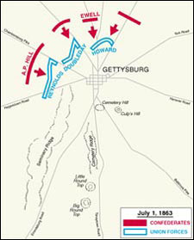  July 1 | 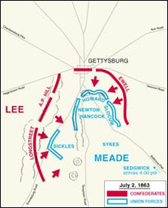  July 2
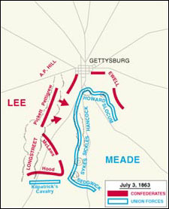  July 3 |  | Each of these maps represents the positions of the opposing armies before the day's major battle action.

Maps retrieved from the National Park Service (U.S. Department of the Interior)
www.nps.gov

Gettysburg Pre-Assessment Worksheet

Use the three maps of the Battle of Gettysburg to answer the following questions.
Each of these maps represents the positions of the opposing armies before the day’s major battle action.
Both the Army of Northern Virginia (Confederates) and the Army of the Potomac (Union) concentrated their forces near Gettysburg after May 1863. The network of roads surrounding Gettysburg was the key to each army’s arrival at the battle.

- According to the maps, how did each army’s position change between the start of July 1’s main fighting and the start of July 2’s main fighting? (in your description, be sure to refer to the roads and terrain feature named on the map).

- According to the map, how did each army’s position change between the start of July 2’s main fighting and the start of July 3’s main fighting? (refer to the roads and terrain features listed on the map)

- What was the main event of July 3, 1863 (according to information on the map)?

- How did the Union army use the terrain to its advantage during the Battle of Gettysburg?

- Which army had the advantage after the first day of fighting?

- What were some of the primary reasons for their successes?

- What was the situation by the evening of July 2?

- What evidence from the previous day’s fighting brought General Lee to decide on the strategy for Picket’s Charge on July 3?

- What was the result of Picket’s Charge?

10. Why did General Lee decide to withdraw from Gettysburg?

Gettysburg Timeline

- How long did the Battle of Gettysburg last? What were the dates, the location, and significance from this battle?

- Summarize the battle in a well-written paragraph. Include the movement of the Confederate army, the leader, and goal they were trying to accomplish?

- Summarize Day 1 through Day 3 of the battle, the significant events that took place, the locations of the battles, and the major outcomes from those battles?

- Describe the outcome and significance from this battle, the major figures that were involved in the truce, the development of the Emancipation Proclamation, and the impact it had on European support of the fight?

Gettysburg Pre-Assessment Answer Key

1. The Confederates led by Generals’ A.P Hill and Ewell began the invasion North and Northwest of Gettysburg. They utilized Chambersburg Pike and Baltimore Pike roads as transportation methods during the initial stages of the battle. As June 2 arrived, the Confederates were joined by General Longstreet to the West and have pushed the Union Army south of Gettysburg and have began to try to flank the Union Army to the East and the West. The Union Army is being led by Generals’ Sickles, Newton, Hancock, Howard, and Slocum.

2. From June 2 to June 3rd, the Confederate Army has been joined by General Robert E. Lee, and the Union has begun to be reinforced by General Sedgwick, who arrives at 4:00 pm. The Union Army has started to form their famous “fishhook defense” and have also engaged the Confederates with Kilpatrick’s Cavalry. The Confederates have started to move into formation for the infamous “Pickett’s Charge.”

3. The Main event from June 3rd was Pickett’s Charge and the “Fishhook Defense.”

4. The Union Army utilized elevated areas to the south of Gettysburg to gain a major advantage during the crucial stages of the battle.

5. In the initial stages of the battle the Confederate Army had an advantage over the Union.

6. The Confederacy had more soldiers at their disposal, battle tested Generals, and momentum from previous victories on their side.

7. By June 2nd, the Union had been pushed back south of Gettysburg and had begun to take positions on the elevated land and areas of terrain.

8. General Lee was becoming frustrated with the Confederacy’s inability to gain any push from where the Union was located.

9. Picket’s Charge was a demoralizing defeat for the Confederate Army.

10. The North had received reinforcements and advanced on the Confederacy’s position after Pickett’s Charge had failed.

Gettysburg Timeline Answer Key:
How long did the Battle of Gettysburg last? The Battle of Gettysburg was fought between July 1 and 3, 1863. The battle was fought between the Union and the Confederate in and around Gettysburg, Pennsylvania. The Battle of Gettysburg witnessed the heaviest loss of life and property in the American Civil War.
Gettysburg Battle Summary:
Why did the Battle of Gettysburg happen? The battle was a turning point in the American Civil War. The defeat of the Confederate army led by Gen. Robert E. Lee by that of the Union, led by Maj. Gen. George Gordon Meade was a decisive factor in the civil war. The Confederates marched through Shenandoah Valley, after a successful confrontation at Chancellorsville. The aim was to reach Pennsylvania or Philadelphia, with the intent of furthering Confederate influence to Northern politicians.
Day 1: President Abraham Lincoln ordered Maj. Gen. Joseph Hooker to position his army in and around Gettysburg, ahead of Meade. The two armies clashed at Gettysburg on July 1, 1863. The Confederate fight back was effective in bringing down a cavalry division and quickly replenished Union lines. The Union army was forced to retreat to the hills, south of Gettysburg.
Day 2: On the second day, the Union held fast as the Confederate army raged through and attacked the fishhook defensive. Throughout the little town of Gettysburg, heavy assaults at Little Round Top, Devil's Den, Wheatfield, Peach Orchard, Culp's Hill and Cemetery Hill raged, causing significant losses on either side. However, the Union personnel held their positions, strengthening resistance.
Day 3: On July 3, the battle commenced at Culp's Hill. The fronts were by now to the east and south of the town. The main event on Day 3 was the 12,500 infantry assault by the Confederates, on the concentrated Union line at Cemetery Ridge. The Confederate army suffered huge losses and retreated to Virginia.
Outcome:
The three day battle saw nearly 51,000 Americans succumb as casualties. There was a huge cemetery consecrated for the mass burials and it is at this event that President Lincoln delivered his famous Gettysburg Address. The Gettysburg National Cemetery stands in honor of those who died in the battle.
Significance:
The onset of the monsoons drove the Confederate, half-spirited, out of Gettysburg. After the Battle of Gettysburg, Union victory in the American Civil War was inevitable. The Confederates lost complete political and military control. Vice President of the Confederate, Alexander Stephens approached Union lines at Virginia to negotiate and announce a truce. European support of the Confederacy was withdrawn without delay.
The Battle of Gettysburg culminated in favor of the Union army on account of the blind faith in inexperienced commanders placed by the Confederates. The subsequent days witnessed the popular Emancipation Proclamation and the empowerment of the people with President Lincoln's famous definition of democracy – government of, for and by the people. The principles of equality and liberty that were an integral part of the US Constitution were upheld, with the union of the states at the center and the release of thousands of slaves across America. The outcome of the Gettysburg Battle was a trigger factor that sparked a crack down on the Confederation and European support of the Confederates.

Washington D.C. & Gettysburg Class Trip
Lesson #2: Gettysburg Address-100 years later
Grade Level: 12th
Lesson Duration: 2 Class Periods

Introduction:
The Gettysburg Address is one of the most historically significant speeches in United States history. It is critically important for us to not only be introduced to this document but to explore the impact it will have on the United States in 1863 and 1963.

Objectives:
- Students will compare and contrast two Gettysburg speeches delivered 100 years apart. They will research and analyze social issues raised in the speeches and will evaluate the progress of racial equality in America.

Ohio Content Standard for Social Studies (K-12):
- Analyze the consequences of Reconstruction with an emphasis:
  - Attempts to protect the rights of and enhance opportunities for the freedman, including the basic provisions of the 13, 14, and 15 Amendments to the Constitution.
- The student applies critical thinking skills and uses information required from a variety of sources including electronic technology.
- The student communicates in written and oral forms
- The student will analyze how the contributions of people from various racial, ethnic, and religious groups have helped to shape the national identity.

Activities:
- Students (working alone or in pairs) will read both speeches and discuss the content.
- Students will create a color Venn diagram of the speeches.
- Students will research the racial and social issues raised in each speech and add this information in a focus free-write (formative assessment).

Modifications:
Jigsaw the groups into specific areas of responsibilities. A graphic organizer will be provided to the students for the Venn Diagram portion of the assignment.

Student Product:
Venn Diagram of the two Gettysburg speeches and the research.

On November 19, 1963, although not in Gettysburg, Kennedy made the following statement for the Centennial.
.
“From the past man obtains the insights, wisdom and hope to face with confidence the uncertainties of the future. Abraham Lincoln was keenly aware of this when, a century ago, he journeyed to Gettysburg to make “a few appropriate remarks.” Today, as we honor Lincoln’s immortal eulogy to the dead on Cemetery Ridge, let us remember as well those thousands of American patriots whose graves at home, beneath the sea and in distant lands are silent sentries of our heritage. Lincoln and others did indeed give us “a new birth of freedom;” but the goals of liberty and freedom, the obligations of keeping ours a government of and by the people are never-ending. On this solemn occasion let us all re`dedicate ourselves to the perpetuation of those ideals of which Lincoln spoke so luminously. As Americans, we can do no less.”

Four score and seven years ago our fathers brought forth, upon this continent, a new nation, conceived in liberty and dedicated to the proposition that “all men are created equal.”
Now we are engaged in a great civil war, testing whether that nation, or any nation so conceived and so dedicated, can long endure. We are met on a great battlefield of that war. We have come to dedicate a portion of it, as a final resting place for those who died here, that the nation might live. This we may, in all propriety do. But in a larger sense, we cannot dedicate, we cannot consecrate, we cannot hallow, this ground. The brave men, living and dead, who struggled here, have hallowed it, far above our poor power to add or detract. The world will little note, nor long remember what we say here; while it can never forget what they did here.
It is rather for us the living, we here be dedicated to the great task remaining before us—that from these honored dead we take increased devotion to that cause for which they here gave the last full measure of devotion—that we here highly resolve that these dead shall not have died in vain, that this nation shall have a new birth of freedom, and that government of the people, by the people, for the people shall not perish from the earth.

Venn Diagram: Lincoln vs. Kennedy Gettysburg Speeches
Lincoln Same Kennedy
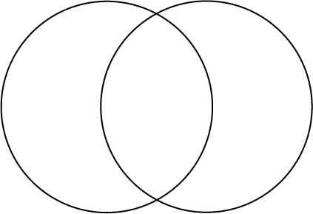

Focus Free-Write:
Question: How did the racial and social issues that President Lincoln had to deal with compare to the issues that President Kennedy had to 100 years later? What was similar in American society and what was different? Did the Civil War deal with the issue of ending slavery or did it simply stop the spread of it to other forming states?

Washington D.C. & Gettysburg Class Trip
Lesson #3: April 1865: The Month That Saved America
Grade Level: 12th
Lesson Duration: 2 Class Periods

Introduction:
This one hour video covers the last few weeks of the Civil War, from President Abraham Lincoln’s second inauguration, to the surrender at Appomattox, the assassination of Lincoln, and the final laying down of arms of the Confederacy.

Objectives:
- Students will watch The History Channel special, The Month That Saved America, and will complete a post-viewing activity on the second day.
- Students will compare and contrast the differences and opposing views of Abraham Lincoln and Jefferson Davis on a T-Chart wallboard.
- List five adjectives that describe Lee’s troops at the end of the war.
- Students will interact in an open forum discussion on the last scene and will complete an exit slip on its meaning and impact on you.

Ohio Content Standards for Social Studies (K-12):
- Explain the causes of the Civil War with an emphasis on:
  - The emergence of Abraham Lincoln as a national figure in the Lincoln-Douglas debates, the presidential election of 1860, and the South’s secession.
- Explain the course and consequences of the Civil War with emphasis on:
  - Contributions of key individuals, including Abraham Lincoln, Robert E. Lee, and Ulysses S. Grant
- Analyze the consequences of Reconstruction with an emphasis on:
  - President Lincoln’s assassination and the ensuing struggle for control of Reconstruction.

Activities:
- Students will watch selected scenes from The Month That Saved America.
- Students will create a T-Chart that will compare and contrast Jefferson Davis and Abraham Lincoln.
- Students will pair up with a previously selected partner and will brainstorm five adjectives of Lee’s troops at the end of the war.
- Classroom will have an open forum discussion on the last scene of the video and an exit slip on what its meaning had on you.

Modification:
Jigsaw the groups into specific areas of responsibilities. A graphic organizer will be provided to the student for the T-chart portion of the assignment.

Student Product:
Completion of the T-Chart, Five Adjective Handout, Focus Free Write
Jefferson Davis Robert E Lee
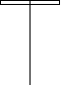

Vocabulary Words:
- benevolent- marked by or disposed to doing good.
- Confederate-United in a league or the allied Southern States during the Civil War.
- Dixie- The states of the SE United States and those which made up the Confederacy.
- guerilla warfare-type of warfare tactic that allowed small-scale forces to compete with large-scale military forces on the field of battle.
- inauguration-formal ceremony to begin a leaders term in office.
- malice-to inflict harm or injury on another out of deep-seated meanness.
- retribution-punishment or vengeance
- segregation-act of separating a group of people based on gender, race or ethnicity.
- strategy-a plan, method, or series of maneuvers to obtain a certain goal.
- trench warfare-combat in which each side occupies a series of protective trenches
- Union- The Northern Army that defeated the Confederacy in the Civil War.
- Yankee-Nickname given to a federal or northern soldier in the Civil War.

Washington D.C. & Gettysburg Class Trip
Lesson #4: Washington DC National Mall
Grade Level: 12th
Lesson Duration: 2 Class Periods

Introduction:
Prior to leaving on the class trip to Washington D.C., the 12th grade students will research the nation’s capitol, its monuments, memorials, and the United States Presidents.

Objectives:
  - The students will understand and experience the United States government in action.
  - The students will understand and experience United States history, geography, science, and art in the context of a metropolitan setting.
  - The students will tie in history, geography, science, and visual arts curriculum to locations around the Washington Mall.
  - The students will have a class wide discussion on any interesting facts or features that they found on the monuments during the research.

Materials:
- National Mall Survey: What do you know about the Mall?

Key Vocabulary:
  - mall-a shady public walk or promenade
  - monument-a structure erected as a memorial
  - memorial-something serving as remembrance of a person or an event.

Procedures/Activities:
- The teacher will introduce the Washington, D.C. unit by handing out a pre-assessment activity to determine the students’ prior knowledge about prominent and historically important locations in our nation’s capitol.
- Students are given 40 minutes to complete an assessment activity matching location names with a simplified numbered map of the Washington, D.C. National Mall and vicinity.
- Students will travel to the computer lab for an opening activity on Day 2 of the lesson and will spend the first 20 minutes gathering any historical facts or features on the predetermined monument they were provided.
- The class will spend the last 20 minutes of class in an open forum discussion and present the facts that they located on the internet.

Assessment/Evaluation:
- Worksheets are collected, tallied, and evaluated to determine the level of the students’ prior knowledge about Washington, D.C.

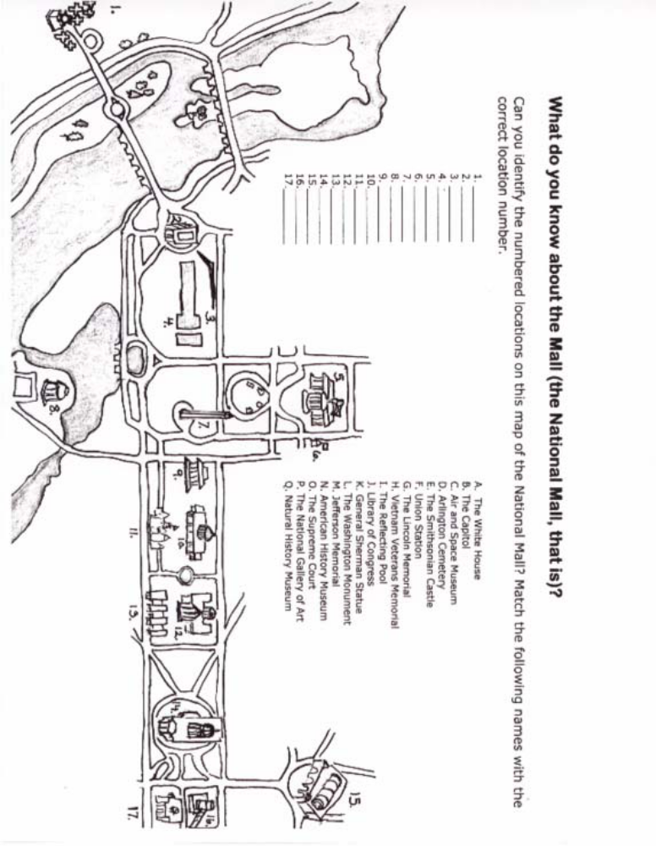

Washington DC Mall Maps retrieved from www.visitingDC.com

Washington D.C. & Gettysburg Class Trip
Lesson #5: Washington DC Photo Scrapbook
Grade Level: 12th
Lesson Duration: 2 Class Periods

Introduction:
During the class trip to Washington, D.C. and Gettysburg the 12th grade students will complete an individualized photo scrapbook of the entire trip. The class is encouraged to collect brochures, pictures, and artifacts that will reflect the four day trip.

Objectives:
- Students will create a meaningful journal and scrapbook of trip memories.
- Students will write brief summaries of travel experiences in a journal setting.
- Students will include formal sketches of Washington D.C. scenes.
- Students will present the scrapbook at the Open House in October.

Materials:
- Washington, D.C. workbook/journal for each student.
- Camera and film
- Colored pencils
- Drawing paper

Activities:
- Before departing for Washington, D.C., hand out the individual workbook/journal packet and allow the students to decorate and examine them. Students are responsible for packing this learning material in their backpack for use on the trip.
- Remind the students to routinely fill out the third page of their packet about travel experiences in a journal format.
- During the first evening group meeting after arriving in Washington, D.C., hold a group discussion about documenting travels. Remind students that they are responsible for keeping their journal packet with them at all times and for recording travel experiences which might include: collecting brochures, taking pictures, making sketches, buying postcards, etc.
- During each evening group meeting the first order of business will be giving the students time to update the individuals’ information. On these sheets the students will make notes, write down their thoughts and experiences, and organize their collected materials. Encourage them to make sketches of the scenes that were of special significance to them that day and to record personal experiences and impressions.

Assessment/Evaluation:
- Assessment of the workbook/journal trip packet will be completed after the students return from Washington, D.C. and put together their memory books.

Daily Checklist
Use the following checklist to help you organize your days. You need to collect certain items for your scrapbook, so check this list to make sure you don’t forget anything.

Day 1: Gettysburg
_________1. Picture from Gettysburg Museum that shows a CAUSE of the Civil War
_________2. Picture from Gettysburg Museum that shows an EFFECT of the Civil War
_________3. Picture of Picket’s Charge
_________4. Picture of (or from) Little Round Top
_________5. Picture of any statue or memorial
_________6. Journal Entry #1: Introductory paragraph that includes the causes of the Civil War, middle paragraph should include the effects of the Civil War; ending paragraph should be a reflection of what you saw during the museum tour, “New Birth of Freedom” movie or guided bus tour.

Days 2-4: Washington, D.C. and Arlington, VA
_________7. Pictures of the Three Branches of Government:
A) Supreme Court _______ B. Capitol Building________ C. White House ____
_________8. Picture of any scene at Arlington National Cemetery
_________9. Picture of John F. Kennedy (JFK) “Eternal Flame” Grave Site
_________10. Picture of the Tomb of Unknown Soldiers
_________11. Picture of the Space Shuttle Challenger Memorial
_________12. Picture of Robert E. Lee’s Mansion
_________13. Picture of Iwo Jima Memorial
_________14. Picture of the Lincoln Memorial
_________15. Picture of the Jefferson Memorial
_________16. Picture of the Korean War Memorial
_________17. Picture of the Vietnam Memorial (“The Wall”)
_________18. Picture of Name (from Virtual Wall Rubbing) at Vietnam War Memorial
_________19. Picture of the Vietnam War Women’s Memorial
_________20. Picture of the F.D.R. Memorial
_________21. Picture of the Washington Monument
_________22. Picture of the Washington Monument
_________23. Picture of the World War II Memorial
_________24. Journal Entry #2: Introductory paragraph should include background information on the site visited, middle paragraph should include facts you learned about a particular site (most detail), and an ending paragraph which expresses your opinion or personal reaction to what you experienced.

Other Required Items
The following items must be collected sometime during the trip. Pictures 1, 2, and 3 all must be at a historically significant place with a caption explaining WHY you picked that specific spot.
_________25. Picture of you, alone, at your favorite spot with a detailed caption
_________26. Picture of your group and chaperone alone with a detailed caption
_________27. Picture of you and your partner alone with a detailed caption
Daily Journals

While on your trip, you are required to keep a daily journal. Each journal entry must include the following:

- Each entry is to be a minimum of 3 paragraphs. All of your paragraphs must be at least seven quality sentences in length.

- Your journal entries should include a positive summary of your day, and your reactions to what you experienced. DO NOT WRITE ABOUT FOOD OR OTHER INSIGNIFICANT FACTS.

- The specific requirements for Day 1-Gettysburg are as follows:
  - Introductory paragraph should include the causes of the Civil War.
  - Middle paragraph should include the effects of the Civil War.
  - Ending paragraph should be a reflection of what you saw during the museum tour, “New Birth of Freedom” movie, or the guided bus tour.

- The general requirements for Days 2, 3, and 4 are as follows:
  - Introductory paragraph should include general background information.
  - Middle paragraph(s) should include facts you learned about particular sites. This will have the most amount of detail.
  - Ending paragraph should be a conclusion, which expresses your opinion or personal reaction to what you experienced.
***Remember that changes in time, idea or place indicate a new paragraph***

- Each day your chaperone will check and initial your journal write-up to make sure that they are complete. Be sure to write your name on all pages submitted. When you return, all journal entries are to be typed and they are to become part of your completed scrapbook. You are also to keep the original copy in your scrapbook. You will lose points if the original journal entries with your chaperone’s initials are not included in your scrapbook.

$$ D.C. Dollars $$

D.C. Dollars will be given for your good work and effort during the trip. This would include actions such as good citizenship, punctuality, helpfulness and personal responsibility. These dollars will become a part of your scrapbook and will count as bonus points for the scrapbook project!

Civil War End-of-Unit Vocabulary Assessment
Industrial Revolution Vocabulary Quiz

A. benevolent G. retribution
B. Confederate H. segregation
C. Dixie I. strategy
D. guerilla warfare J. trench warfare
E. inauguration K. Union
F. malice L. Yankee

__I___ 1. a plan, method, or series of maneuvers to obtain a certain goal.

__L___ 2. Nickname given to the federal or northern soldier in the Civil War.

__E___ 3. formal ceremony to begin a leader’s term in office.

__H__ 4. act of separating a group of people based on gender, race, or ethnicity.

__A___ 5. marked by or disposed to doing good deeds.

__B___ 6. United in a league or the allied Southern States during the Civil War.

__D___ 7. type of tactic that allowed small-scale forces to compete with large-scale military forces on the field of battle.

__G___ 8. punishment or vengeance.

__C___ 9. the nickname of states of the SE United States and those which made up the Confederacy

__F__ 10. to inflict harm or injury on another out of deep-seated meanness.

__J___ 11. combat in which each side occupies a series of protective bunkers.

__K__ 12. The Northern Army that defeated the Confederacy in the Civil War.

