Travis Lepley
EDTL 7100
11-5-10
Instructional Design

I. Rationale
For any student to gain any measurable success in mathematics they must review previously learned concepts to build upon their foundation of knowledge. The repetition of skills is seen more often in lower level mathematics. Many students at these levels are learning some concepts for the first time, or they need extra remediation for the mastery of skills. As students get older and their knowledge in math grows it may seem that they do not need the review of skills as younger less experienced math students. I initially taught my Advanced Math students under this presumption that did not require remediation before moving onto the main topics of our course. After realizing that the students needed proper review of Algebra 2 skills, I restructured the course to include a unit that would review those skills.
The Relations, Functions, and Graphs unit is the necessary unit for the Advanced Math students to review their Algebra 2 skills, and to build upon them with an extension of the topics. Another reason that the review is necessary is because these students will be introduced to graphing calculators. Only a few of the students have even used one before. There are techniques with the calculator that we can use that can make some of the review topics much easier to understand, and the calculator allows the students to find solutions much faster. The lessons for this unit will be set up following the Basic Lesson Planning Model (Chiarelott, 2006). I chose this model because its structure is simple and basic for a math class. The students need to be given an engaging activity to start class. That can be followed by plenty of examples for the content that is being studied. The class period can conclude by having the students do a few exercises on their own with immediate teacher response. Math is sequential much like this lesson model.
As the students finish this unit, they will be prepared for the more intense topics that follow. The mastery of manipulating equations and understanding the properties of graphs will be valuable as the class moves into trigonometric equations. Doing this unit will make the transition into the late units of the course much smoother. Before the inclusion of this unit, the students struggled with many of the concepts because they lacked the mastery of these almost “basic” skills at this level of mathematics.

II. Pre-Assessment
Pre-Assessment of Linear Relations and Functions
Directions: Place a check in the number box that best describes your knowledge of the following.
1- never seen 2- below average 3- average 4- above average 5- expert
 | 1 | 2 | 3 | 4 | 5
Abscissa (x-value)
Absolute value function
Boundary
Coinciding lines
Composite
Composition of functions
Constant function
Domain
Family of graphs
Function
Function notation
Greatest integer function
Half plane
Iterate
Iteration
Linear equation
Linear function
Linear inequality
Ordinate (y-value)
Parallel lines
Perpendicular lines
Piecewise function
Point-slope form
Range
Relation
Slope
Slope-intercept form
Standard form
Step function
Vertical line test
x-intercept
y-intercept
Zero of a function
Best-fit line
Correlation coefficient
Goodness of fit
Model
Pearson-product moment correlation
Prediction equation
Regression line
Scatter plot
Read the directions carefully and answer all questions to the best of your ability. Show your work.
Evaluate each function for the given value.
1. $f\left(4\right) if f\left(x\right)= 5x-10 2. f\left(m+1\right) if f\left(x\right)= x^{2}+3x$

$$Find \left(f+g\right)\left(x\right), \left(f-g\right)\left(x\right), \left(f∙g\right)\left(x\right), \left(\frac{f}{g}\right)\left(x\right) for each f\left(x\right)and g\left(x\right).$$
3. $f\left(x\right)= x^{2}+4x g\left(x\right)= x-2$

4. $f\left(x\right)=x^{2}-4x g\left(x\right)= \frac{4}{x-4}$

Find $f\left(g\left(x\right)\right) and g\left(f\left(x\right)\right) for each f\left(x\right)and g\left(x\right).$
5. $f\left(x\right)=x^{2}-4 g\left(x\right)= 2x 6. f\left(x\right)=x^{2}-5 g\left(x\right)=x+1$

Graph each equation.
7. $y=3x+6 8. 7x+2y=-5$

Write an equation in slope-intercept form for each line described.
9. $slope=2, y-intercept=-3 10. Passes through A\left(-4, 2\right) and B(2, 5)$

Write an equation of the line that is parallel to the given equation and passes through the given point.
11. $y=x+1; (1, 1)$

Write an equation of the line that is perpendicular to the given equation and passes through the given point.
12. $y=-2x+\frac{1}{4}; (4, -8)$

III. Unit Intended Learning Outcomes
Relations, Functions, and Graphs
Subunit One: Linear Relations and Functions
- Students will determine whether a given relation is a function and perform operations with functions. (application)
- Students will evaluate and find zeros of linear functions using functional notation. (application)
- Students will graph and write functions and inequalities. (comprehension, application)
- Students will create and interpret graphs with the graphing calculator. (comprehension, application)
- Students will write equations of parallel and perpendicular lines. (knowledge, comprehension, application)
- Students will model data using scatter plots and write prediction equations. (comprehension, application, analysis, synthesis, evaluation)
- Students will use calculator programs to model real world data. (application)
Subunit Two: Systems of Linear Equations and Inequalities
- Students will solve systems of equations and inequalities. (application)
- Students will define matrices. (knowledge, comprehension)
- Students will add, subtract, and multiply matrices. (application)
- Students will use matrices to model transformations. (application, analysis)
- Students will find determinants and inverses of matrices. (application, analysis)
- Students will use linear programming. (application, analysis, synthesis, evaluation)
- Students will exhibit satisfactory competency with the applications of the graphing calculator. (application)
Subunit Three: The Nature of Graphs
- Students will graph functions, relations, inverses, and inequalities. (application, analysis)
- Students will analyze families of graphs. (analysis)
- Students will investigate symmetry, continuity, end behavior, and transformations of graphs. (comprehension, application, analysis)
- Students will find asymptotes and extrema of functions. (application, analysis)
- Students will solve problems involving direct, inverse, and joint variation. (application)
- Students will evaluate and interpret the graphs with the graphing calculator. (comprehension, application)

Subunit Four: Polynomial and Rational Functions
- Students will determine roots of polynomial equations. (application)
- Students will solve quadratic, rational, and radical equations and rational and radical inequalities. (application)
- Students will find the factors of polynomials. (application, analysis)
- Students will approximate real zeros of polynomial functions. (analysis, synthesis)
- Students will write and interpret polynomial functions that model real-world data. (synthesis, evaluation)
- Students will use the proper techniques on the graphing calculator to evaluate the functions. (application)
Students will also be provided with extra examples to help them reach their outcomes.

IV. Lesson Plans
Subunit One: Linear Relations and Functions
Lesson Plan Day One: Relations and Functions
Subunit Outcome:
- Students will determine whether a given relation is a function and perform operations with functions. (application)
- Students will evaluate and find zeros of linear functions using functional notation. (application)
- Students will graph and write functions and inequalities. (comprehension, application)
- Students will create and interpret graphs with the graphing calculator. (comprehension, application)
- Students will write equations of parallel and perpendicular lines. (knowledge, comprehension, application)
- Students will model data using scatter plots and write prediction equations. (comprehension, application, analysis, synthesis, evaluation)
- Students will use calculator programs to model real world data. (application)
Lesson Objective:
- Students will determine whether a given relation is a function.
- Students will identify the domain and range of a relation or function.
- Students will evaluate functions.
Procedures:
A. Introductory Activity: 5 minutes
Ask students to relate items that can be paired with another. Have each student give an example of relating one item to another as a pair. Example, salt and pepper, bread and butter, Mickey and Minnie, etc.
Give students two sets of data with the same amount of elements and have the students list the data as ordered pairs.
B. Developmental Activity: 30 minutes:
The class will examine the data in ordered pairs to find the domain and range, and to determine if the relation is a function. The class will use examples of various graphs to find the domain and range of the relations, and determine whether or not it is a function. The students apply the vertical line test to determine if a graphed relation is a function. Examples will be presented that evaluate functions for given values. The students will learn how to find the domain for rational functions.
C. Concluding Activity: 5 minutes
Have the students evaluate a relation to determine whether or not it is a function. Give the students a graph to determine if it is a function, and to find its domain and range. Finally, have students evaluate a function for a given value, and find the domain of a rational function.

Summary/Closure/Evaluation Strategy: 5 minutes
The students will be able to show that they can find the domain and range of a relation. They will be able to explain successfully if a relation is a function, and the criteria that determine it. The will understand the importance of stating the domain of a rational function. Assign the students worksheet 1.1 (Holliday, Cuevas, Carter, McClure, & Marks, 2001). Check student work during the last few minutes of class. Work with students during intervention period.
Materials:
White Board Dry erase markers
Student textbook Student notebook
TI 83 Graphing Calculator Worksheet 1.1

Lesson Plan Day Two: Composition of Functions
Subunit Outcome:
- Students will determine whether a given relation is a function and perform operations with functions. (application)
- Students will evaluate and find zeros of linear functions using functional notation. (application)
- Students will graph and write functions and inequalities. (comprehension, application)
- Students will create and interpret graphs with the graphing calculator. (comprehension, application)
- Students will write equations of parallel and perpendicular lines. (knowledge, comprehension, application)
- Students will model data using scatter plots and write prediction equations. (comprehension, application, analysis, synthesis, evaluation)
- Students will use calculator programs to model real world data. (application)
Lesson Objective:
- Students will perform basic operations with functions (add, subtract, multiply, divide).
- Students will perform composition of functions and evaluate composite functions.
- Students will iterate functions using real numbers.
Procedures:
A. Introductory Activity: 5 minutes
Give students a series of warm-up questions that focus on basic math operations with small variable expressions. Also, give students warm-up questions reinforcing the concept of substitution.
B. Developmental Activity: 25 - 30 minutes
Examples will be presented performing the four basic math operations for variable expressions of varying degrees of difficulty. The students will also be presented with examples of composite functions, and the process of composition. The students will also learn about iterates, and how to complete iterations.
C. Concluding Activity: 5 minutes
The students will be given a few variable expressions increasing in difficulty to perform the basic operations. They will combine pairs of the functions as composite functions. For all problems the students will be sure to state the domain when necessary.
Summary/Closure/Evaluation Strategy: 5 minutes
The students will be able to add, subtract, multiply, and divide any combination of two functions in simplest form. They will determine and include the domain of functions when it is appropriate. The students will also be able to perform composition of functions. Assign the students worksheet 1.2 (Holliday, Cuevas, Carter, McClure, & Marks, 2001) . Check student work during the last few minutes of class. Work with students during intervention period.
Materials:
White Board Dry erase markers
Student textbook Student notebook
TI 83 Graphing Calculator Worksheet 1.2

Lesson Plan Day Three: Graphing Linear Equations
Subunit Outcome:
- Students will determine whether a given relation is a function and perform operations with functions. (application)
- Students will evaluate and find zeros of linear functions using functional notation. (application)
- Students will graph and write functions and inequalities. (comprehension, application)
- Students will create and interpret graphs with the graphing calculator. (comprehension, application)
- Students will write equations of parallel and perpendicular lines. (knowledge, comprehension, application)
- Students will model data using scatter plots and write prediction equations. (comprehension, application, analysis, synthesis, evaluation)
- Students will use calculator programs to model real world data. (application)
Lesson Objective:
- Students will graph linear equations.
- Students will find the x- and y-intercepts of a line.
- Students will find the slope of a line through two points.
- Students will find zeros of linear functions.
Procedures:
A. Introductory Activity: 5 minutes
The students will be given two sets of related data to create ordered pairs, and then plot the points on the x-, y-coordinate plane on the white board. After all of the points are plotted, a line will be drawn connecting them all. The students will also compare and contrast a few linear equations so that they can be classified into separate forms.
B. Developmental Activity: 25 - 30 minutes
After the classification of the equations has been determined as standard or slope-intercept form the students will change a couple more examples from one from to the other. Next, the class will graph the given linear equations by hand on separate sheets of graph paper. The class will begin graphing the equations using the graphing calculators. We will go step-by-step to input the equation, and then make the graph appear on the screen with the correct dimensions. We will compare the handwritten graphs with the calculator generated graphs. The class will perform a couple examples to find zeros of functions.
C. Concluding Activity: 5 minutes
The students will continue to graph a few equations by hand, and then proceed to graph with the calculators. The students will wait for teacher approval of graphs on their calculators before moving on. The students will also find the zeros of linear equations if they exist.
Summary/Closure/Evaluation Strategy: 5 minutes
The students will be able to graph linear equations by hand and by calculator. The students will be able to identify equations in standard and slope-intercept form. They will be able to manipulate equations from one form to the other. Assign the students worksheet 1.3 (Holliday, Cuevas, Carter, McClure, & Marks, 2001). Check student work during the last few minutes of class. Work with students during intervention period.

Materials:
White Board Student textbook
Dry erase markers Student notebook
TI 83 Graphing Calculator Overhead
Overhead Coordinate Plane Transparency
Graph paper Worksheet 1.3

Lesson Plan Day Four: Writing Linear Equations
Summary/Closure/Lesson Outcome:
- Students will determine whether a given relation is a function and perform operations with functions. (application)
- Students will evaluate and find zeros of linear functions using functional notation. (application)
- Students will graph and write functions and inequalities. (comprehension, application)
- Students will create and interpret graphs with the graphing calculator. (comprehension, application)
- Students will write equations of parallel and perpendicular lines. (knowledge, comprehension, application)
- Students will model data using scatter plots and write prediction equations. (comprehension, application, analysis, synthesis, evaluation)
- Students will use calculator programs to model real world data. (application)
Lesson Objective:
- Students will write linear equations in slope-intercept and point-slope forms.
- Students will write linear equations based on real-world models.
Procedures:
A. Introductory Activity: 5 minutes
The students will be given data on average personal incomes throughout the past thirty years to predict the average personal income for the current year and future years. The students will make simple estimations based on the data.
B. Developmental Activity: 25 - 30 minutes
The students will be given examples to create linear equations given a slope and y-intercept, a slope and a point, or two points. The class will use the graphing calculators to graph the income data using the list feature and stat plot. Students will select two points that exist in the graph to create a linear equation that would be approximate for all of the values. The students would then predict the personal incomes for the current year, and future years.
C. Concluding Activity: 5 minutes
The students will list all the different sets of information that are needed to write equations of a line. The students will write equations in slope-intercept form or point-slope form depending on the given information.
Summary/Closure/Evaluation Strategy: 5 minutes
The students will be able to convert equations from point-slope form to slope-intercept form. They will make those equations given any combination of slope, y-intercept, or points. The students will also be able to successfully plot points from a set of data onto their calculators. Assign the students worksheet 1.4 (Holliday, Cuevas, Carter, McClure, & Marks, 2001). Check student work during the last few minutes of class. Work with students during intervention period.

Materials:
White Board Dry erase markers
Student textbook Student notebook
TI 83 Graphing Calculator

V. Notes
Day One: Relations and Functions
Introductory Activity:
Examples of paired items/things – salt and pepper, bread and butter, Mickey and Minnie, etc.
Wind Speed (mph) | Wind-chill Temperature (F)
5 | 19
10 | 3
15 | -5
20 | -10
25 | -15
30 | -18
Data set for Wind-chill Factors at 20 degrees F.

Developmental Activity: List the data as ordered pairs, and state the domains and ranges. The domain values are the x-values and the range values are the y-values. Determine if each relation is a function. If a domain value repeats then the relation is not a function.
x | Y
1 | -3
2 | -2
3 | -1
4 | 0
5 | 1
6 | 2
7 | 3
x | Y
5 | 10
4 | 9
3 | 8
2 | 7
5 | 6
0 | 5
-1 | 4

Evaluate the functions for the given values.
$$f\left(-3\right) ;f\left(x\right)={4x}^{3}+x^{2}-5x$$
$$f\left(-3\right)=4{\left(-3\right)}^{3}+{\left(-3\right)}^{2}-5\left(-3\right)$$
$$f\left(-3\right)=4\left(-27\right)+9+15$$
$$f\left(-3\right)=-108+24=-84$$
Find the domain of the function.
$f\left(x\right)=\frac{x^{3}+5x}{x^{2}-4x}$ Factor the denominator and set it equal to zero. $x^{2}-4x; x\left(x-4\right)= 0;$
$x=0 and x-4=0;x=4 therefore x=0 and 4.$ The domain includes all real numbers except 0 and 4.
x | Y
-4 | -7
-3 | -4
-2 | -1
-1 | 2
0 | 5
1 | 8
2 | 11
Concluding Activity:
Find the domain and range; determine if the relation is a function.

Evaluate the function.
$g\left(4\right) if g\left(x\right)= 2x^{2}-4+2$

State the domain of the function.
$f\left(x\right)= \sqrt{x+1}$
Evaluation: Worksheet 1.1 (Holliday, Cuevas, Carter, McClure, & Marks, 2001)
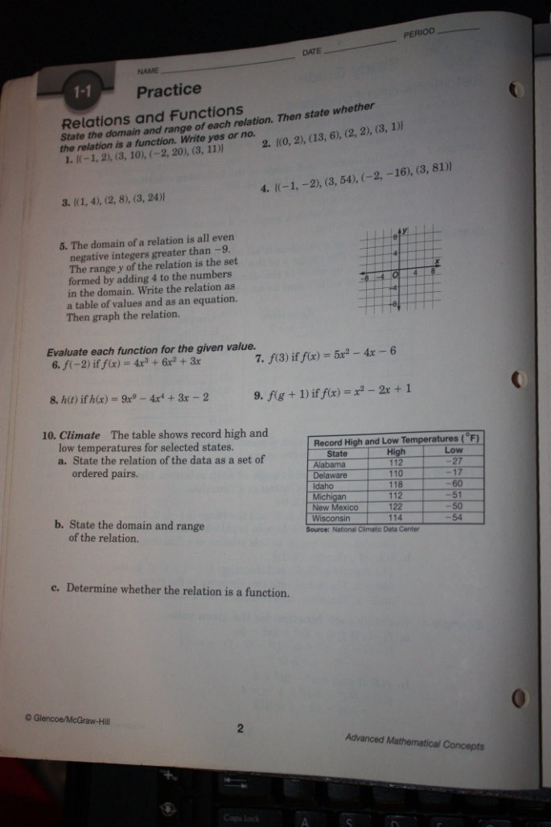
Day Two: Composition of Functions
Introductory Activity:
Simplify the following expressions:
$\left(2x+1\right)+\left(5x-4\right) \left(-3y+9\right)-\left(2y+5\right) \left(3x+4\right)\left(x-1\right) \frac{16x-8}{4}$
Answers: $7x-3 -5y+4 3x^{2}+x-4 4x-2$
Substitute for y in the following expressions.
$y=3x y=4x-3$
$2x-3y -5x+2y$
Answers: $2x-3\left(3x\right)=2x-9x=-7x -5x+2\left(4x-3\right)= -5x+8x-6=3x-6$

Developmental Activity:
Given $f\left(x\right)=2x-1 and g\left(x\right)= x^{2} find \left(f+g\right)\left(x\right), \left(f-g\right)\left(x\right), \left(f∙g\right)\left(x\right), \left(\frac{f}{g}\right)(x)$
$\left(f+g\right)\left(x\right)= 2x-1+x^{2}= x^{2}+2x-1 \left(f-g\right)\left(x\right)=2x-1-x^{2}=-x^{2}+2x-1$
$\left(f∙g\right)\left(x\right)=\left(2x-1\right)\left(x^{2}\right)=2x^{3}-x^{2} \left(\frac{f}{g}\right)\left(x\right)=\frac{2x-1}{x^{2}}, x≠0$ This must be stated
because if x = 0 then the expression would be undefined, and the expression cannot be simplified.
Have students try the same operations for $f\left(x\right)= {3x}^{2}-4 and g\left(x\right)=4x+5.$
Composite Functions: Find $f\left(g\left(x\right)\right) and g\left(f\left(x\right)\right) for f\left(x\right)= x^{2}-1 and g\left(x\right)=3x$
$f\left(g\left(x\right)\right)=f\left(3x\right)=(3x)^{2}-1=9x^{2}-1$
$g\left(f\left(x\right)\right)=g\left(x^{2}-1\right)=3\left(x^{2}-1\right)=3x^{2}-3$
Have students try composition both ways for $f\left(x\right)=2x-3 and g\left(x\right)= x^{2}-2x$
Iterates: Find the first three iterates $x_{1}, x_{2}, and x_{3 }of f\left(x\right)=3x+2 for an inital value of x_{0}=4.$
$f\left(4\right)=3\left(4\right)+2=14 f\left(14\right)=3\left(14\right)+2=44 f\left(44\right)=3\left(44\right)+2=134$

Concluding Activity:
Students can try basic operations and composition of functions for $f\left(x\right)=x^{2}-2x and g\left(x\right)=x+9$
Evaluation: Worksheet 1.2 (Holliday, Cuevas, Carter, McClure, & Marks, 2001)
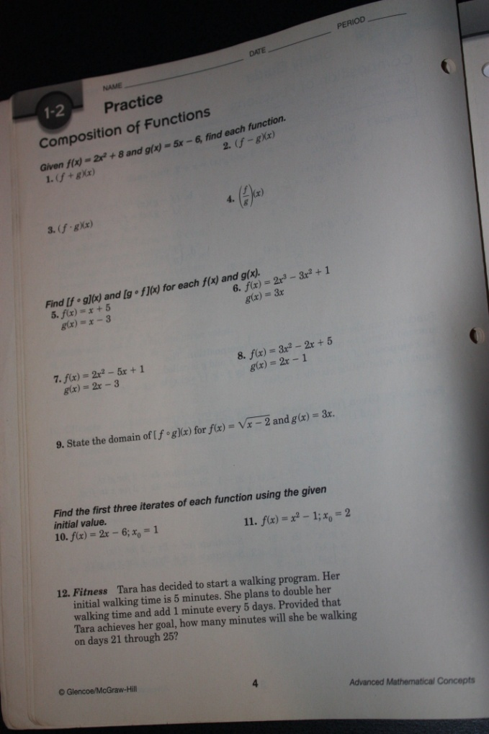

Day 3: Graphing Linear Equations
Introductory Activity:
Data for plotting points on the white board with a coordinate graph transparency.
Input: $-3, -2, -1, 0, 1, 2, 3, 4, 5$ Output: $-5, -3, -1, 1, 3, 5, 7, 9, 11$
See if the students can figure out that the equation of the line is 2x + 1.

Separate the equations into separate groups by similarities.
$3x+2y=6 y=\frac{3}{4}x-1 2x+1=y 4x-2y=8$
Developmental Activity:
Convert the equations from standard form to slope-intercept and vice versa.
$standard: 3x+2y=6 4x-2y=8 slope-intercept: y=\frac{3}{4}x-1 2x+1=y$
$Standard to slope-intercept, get y by itself. 3x+2y=6 2y=-3x+6$
$\frac{2y=-3x+6 }{2} y=-\frac{3}{2}x+3$
Have the students try the next standard form. $4x-2y=8 becomes y=2x-4$
$Slope-intercept to standard;x and y are on the same side with integer coefficients.$
$y= \frac{3}{4}x-1 \frac{3}{4}x-y=1 multiply everything by 4 3x-4y=4$
Have the students do the next one and another example. $2x+1=y becomes 2x-y=-1$
$y= -\frac{1}{2}x+4 becomes x+2y=8.$

Graph functions through slope-intercept form. y = mx +b. Make the first point on the y-axis by finding the y-intercept which is b. Move to the next point by using the slope m. Remember rise over run. The numerator determines if the point moves up (positive) or down (negative) and the denominator will move the point to the right. If students do not like this method they may find points that exist by inputting a value for x and solving to find the corresponding y-value to plot (x,y) coordinate points. Graph the following equations: $y= \frac{3}{4}x-1$, $2x+1=y$, $y=-\frac{3}{2}x+3$
After graphing by hand graph the equations in the calculators. Make sure the students follow the steps. Press Y= and type in the first equation into Y1. Press GRAPH to see the result. If the window is not in the standard view Press ZOOM: Select ZOOM 6: ZOOMSTANDARD. The graph will now be in standard view. Do the same steps for the remaining equations.
Find the zero of a function by setting the function equal to 0, and solve for x.
$$f\left(x\right)=5x+4 5x+4=0 5x=-4 divide both sides by 5 x= -\frac{4}{5}$$
$$f\left(x\right)= 19 There is no x in the function. So there will be no zero.$$

Concluding Activity:
Have students graph a couple more functions and find their zeros if they exist.
$y=\frac{2}{3}x-4 3x-4y+2=0$

Evaluation:
Worksheet 1.3 (Holliday, Cuevas, Carter, McClure, & Marks, 2001)

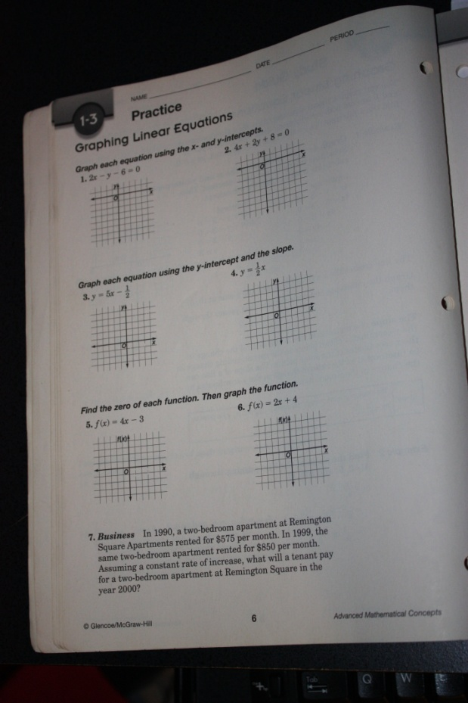

Day 4: Writing Linear Equations
Introductory Activity:

Years since 1980 | Average Personal Income ($)
0 | 9,916
5 | 13,895
10 | 18,477
11 | 19,100
12 | 19,802
13 | 20,810
14 | 21,846
15 | 23,233
16 | 24,457
17 | 25,660
The students will make simple estimations of the average income in 2010, and make estimations for the year 2020. As a class we will come to a consensus on a single estimation for both.
Developmental Activity:
The class will be refreshed about slope-intercept form ( y = mx + b), and point-slope form $[ y- y_{1}=m\left(x-x_{1}\right)]$. The class will write equations of lines in slope-intercept form for the following examples: $slope=5, y-intercept= -2 passes through A\left(4, 5\right), slope=6$
Answers: $y=5x-2 y-5=6(x-4)$
$y-5=6x-24 add 5 to both sides$
$y=6x-19$ The students will do a couple more examples.
$slope= -\frac{3}{4} , y-intercept=0 x-intercept=-8 and y-intercept=5$ Answers: $y= -\frac{3}{4}x \left(-8, 0\right) and \left(0, 5\right) intercepts as coordinates$ Find the slope first $\frac{5-0}{0-(-8)}= \frac{5}{8} y= \frac{5}{8}x+5$ Now, the class will use their graphing calculators to plot the data from the introductory activity as points on a graph. Press STAT, Select EDIT: Edit:1 , Enter the years data in L1 and the income in L2. After the data has been entered Press 2ND , Y=. Turn Plot 1 ON. Press GRAPH. Ask the class if they see anything. The response should be no. Press ZOOM, 9: ZOOMSTAT to fit the statistical data on the screen. After they have done this everyone should have the same image on the screen. The students should select two points on the graph that are in line with each other, but not next to each other. Using those two points they will find the slope of a line that would go through the majority of the points. After finding the slope they can use the point-slope form to find an equation of a line, and then convert it to slope-intercept form. With the equation in slope-intercept form the students can make predictions about the average income in 2010 by substituting 30 in for x in the equation.

Concluding Activity:
Continue working with students on their calculator steps. There will be many students that need assistance. Allow students that can do the tasks successfully to help their classmates.
Evaluation:
Worksheet 1.4 (Holliday, Cuevas, Carter, McClure, & Marks, 2001)
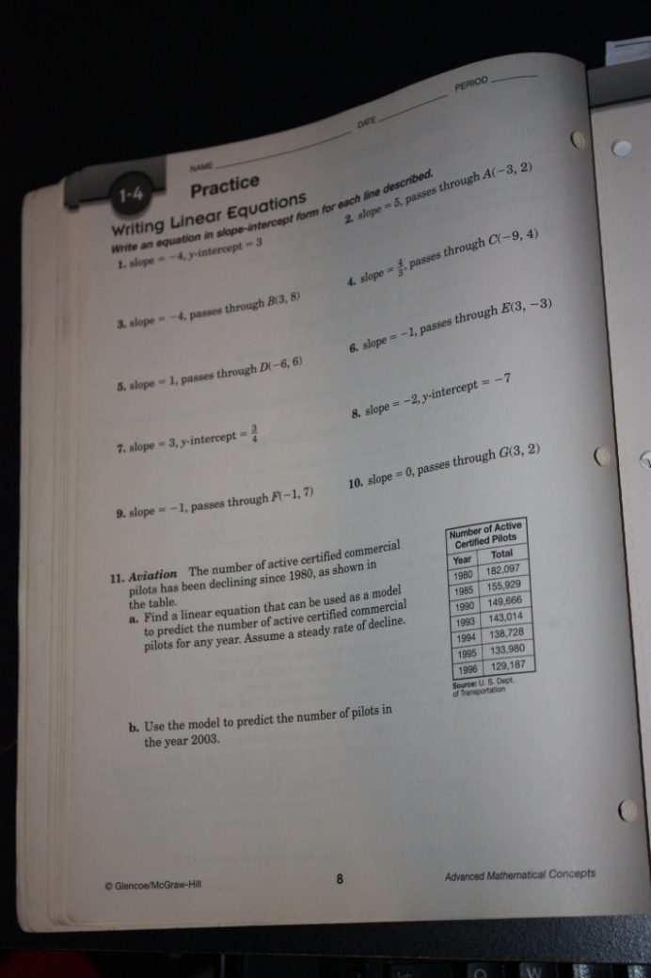

VI. Post-Assessment
Post-Assessment of Linear Relations and Functions
Directions: Place a check in the number box that best describes your knowledge of the following.
1- never seen 2- below average 3- average 4- above average 5- expert
 | 1 | 2 | 3 | 4 | 5
Abscissa (x-value)
Absolute value function
Boundary
Coinciding lines
Composite
Composition of functions
Constant function
Domain
Family of graphs
Function
Function notation
Greatest integer function
Half plane
Iterate
Iteration
Linear equation
Linear function
Linear inequality
Ordinate (y-value)
Parallel lines
Perpendicular lines
Piecewise function
Point-slope form
Range
Relation
Slope
Slope-intercept form
Standard form
Step function
Vertical line test
x-intercept
y-intercept
Zero of a function
Best-fit line
Correlation coefficient
Goodness of fit
Model
Pearson-product moment correlation
Prediction equation
Regression line
Scatter plot
Read the directions carefully and answer all questions to the best of your ability. Show your work.
Evaluate each function for the given value.
1. $f\left(4\right) if f\left(x\right)= 5x-10 2. f\left(m+1\right) if f\left(x\right)= x^{2}+3x$

$$Find \left(f+g\right)\left(x\right), \left(f-g\right)\left(x\right), \left(f∙g\right)\left(x\right), \left(\frac{f}{g}\right)\left(x\right) for each f\left(x\right)and g\left(x\right).$$
3. $f\left(x\right)= x^{2}+4x g\left(x\right)= x-2$

4. $f\left(x\right)=x^{2}-4x g\left(x\right)= \frac{4}{x-4}$

Find $f\left(g\left(x\right)\right) and g\left(f\left(x\right)\right) for each f\left(x\right)and g\left(x\right).$
5. $f\left(x\right)=x^{2}-4 g\left(x\right)= 2x 6. f\left(x\right)=x^{2}-5 g\left(x\right)=x+1$

Graph each equation.
7. $y=3x+6 8. 7x+2y=-5$

Write an equation in slope-intercept form for each line described.
9. $slope=2, y-intercept=-3 10. Passes through A\left(-4, 2\right) and B(2, 5)$

Write an equation of the line that is parallel to the given equation and passes through the given point.
11. $y=x+1; (1, 1)$

Write an equation of the line that is perpendicular to the given equation and passes through the given point.
12. $y=-2x+\frac{1}{4}; (4, -8)$
References
Chiarelott, Leigh. (2006). Curriculum in context: designing curriculum and instruction for teaching and learning in curriculum. Belmont, CA: Thomson Wadsworth.

Holliday, B, Cuevas, G.J., Carter, J.A., McClure, M.S., & Marks, D. (2001). Advanced mathematical concepts: precalculus with applications. Columbus, OH: Glencoe/McGraw-Hill.

