Katie Porter

Instructional Design Project

EDTL 7100: Fall 2010

Dr. Lena Ballone Duran

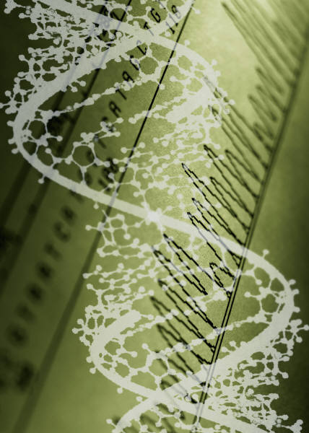

**STATEMENT OF RATIONALE**

I have chosen to construct a unit on genetics. I found out during my student teaching experience that students tend to misunderstand how traits are passed from parents to offspring and have misconceptions about genetics in general. It is important that students learn why they look the way they do and be able to apply their knowledge of genetics to themselves, others around them, and even animals and plants.

Students are naturally curious about genetics. They are constantly interacting with others who act as living, breathing examples of gene exchange. At this point in their education, students are developmentally ready to explore deeper concepts of genetics. The text fails to address many practical aspects of genetics that students often see, such as a hair and eye color. This unit focuses on common traits that students see daily. My goal is to have students gain a working knowledge of possible genetic combinations and apply this knowledge to the environment around them.

**LEARNING OUTCOMES**

Lesson 1: Student will be able to:

* Explain that different inherited characteristics are traits and that traits are passed from parents to offspring;
* Explain that inherited traits are determined by genes;
* Identify dominant and recessive alleles;
* Explain Mendel’s contribution to science (methods of pollination including type of plants used, etc.)
* Demonstrate the steps in the process of cross-fertilization and self-fertiliztion.

Lesson 2: Student will be able to:

* Identify dominant and recessive alleles;
* Define given vocabulary and relate Mendel’s laws to Punnett squares;
* Complete a monohybrid cross using a Punnett square.

Lesson 3: Student will be able to :

* Identify the probably of allelic combinations using fractions, ratios, and percent
* Identify dominant and recessive alleles;
* Complete monohybrid crosses using Punnett squares
* Apply knowledge of dominant and recessive alleles to real-life situations.

Lesson 4: Student will be able to :

* Identify phenotypes as a result of given genotypes;
* Identify genotypes using homozygous, heterozygous, dominant, and recessive;
* Complete monohybrid crosses using Punnett squares;
* Create a creature based on genotypes.

**PREASSESSMENT**

I determine student’s previous knowledge using a preassessment. We take this quiz using Quizdom wireless response devices as well as by recording it on paper. I display a graph of the class responses to allow students to see how their peers answered. I remind them that the most common answers are not necessarily the correct answers. Students always want to know whether or not they got the correct answer right away; they want instant feedback. I do not tell them if they are correct, but instead explain that the questions are focus questions that we will answer throughout the unit.

I review each student’s sheet by walking around the room while they are answering. Students are responsible for keeping their own preassessment sheets. We periodically revisit these sheets throughout the unit to see where the students stand as far as content mastery. Students can expect to find the questions on the preassessment on the final assessment. I have the students retake the preassessment the day of the review so that they can find areas of weakness and strength. This time, however, they get instant feedback as I have their response devices score their answers. I show them a graph of class data so they can see where they rank as far as correct answers.

**PREASSESSMENT**

AGREE

1.

2.

3.

4.

5.

6.

7.

8.

9.

10.

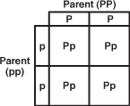

DISAGREE

QUESTION

1 .**Gametes** are male or female sex cells.

2. A plant pollinates itself through **cross-fertilization.**

3. Different forms of **genes** are called **alleles**.

4.**Dominant** traits are the ones seen or expressed.

5. Our **genotype** is determined by our **phenotype.**

6.A **monohybrid** cross is used to cross two **t**raits.

7. A **dominant** allele is represented by a capital letter.

8. An organism is **heterozygous** for a trait if they have two of the same alleles.

9. Genes for each trait are inherited **separately** from eachother.

10. The offspring in the square below has a 25% chance of being homozygous.

**LESSON PLAN: DAY 1**

|  |
| --- |
| Name: Katie Porter Grade: 9 Subject: Biology |

A. Content Standard/Benchmark/Indicator:

**Life Sciences**

Students demonstrate an understanding of how living systems function and how they interact with the physical environment. This includes an understanding of the cycling of matter and flow of energy in living systems. An understanding of the characteristics, structure and function of cells, organisms and living systems will be developed. Students will also develop a deeper understanding of the principles of heredity, biological evolution, and the diversity and interdependence of life. Students demonstrate an understanding of different historical perspectives, scientific approaches and emerging scientific issues associated with the life sciences.

**Benchmark C:** Explain the genetic mechanisms and molecular basis of inheritance.

**Grade Ten:** *Heredity*

6. Explain that a unit of hereditary information is called a gene, and genes may occur in different forms called alleles (e.g., gene for pea plant height has two alleles, tall and short).**A C A D E M I C C**

8. Use the concepts of Mendelian and non-Mendelian genetics (e.g., segregation, independent assortment, dominant and recessive traits, sex-linked traits.

a. Objectives (What will the successful learner be able to do at the end of the lesson?)

Student will be able to :

* Explain that different inherited characteristics are traits and that traits are passed from parents to offspring;
* Explain that inherited traits are determined by genes;
* Identify dominant and recessive alleles;
* Explain Mendel’s contribution to science (methods of pollination including type of plants used, etc.)
* Demonstrate the steps in the process of cross-fertilization and self-fertiliztion;

b. Materials/Resources (What will be used to communicate understanding to the pupils?)

-Smartboard, pre-assessment worksheets, Class survey worksheets

1. Instructional Procedures (What motivating activities, techniques, and methods will be followed?) Include time allocation for each activity.

\*Attendance

**i. (8 minutes)**

-Pass out worksheets to students.

-Have students complete pre-assessment worksheets individually.

-Collect pre-assessment.

- Explain that answers to pre-assessment will be taught and reviewed throughout the unit.

**ii. (10-15 minutes)**

-Pair students with partner seated next to them.

-Give examples of traits which are sometimes confusing to students(i.e. find a student with a widow’s peak and a student without a widow’s peak hairline. Have each student show the class their hairline. Repeat the procedure with attached and unattached earlobes.)

-Review behavioral expectations with students.

-Have students complete class survey lab with partner and record answers on their chart.

http://www.mysciencebox.org/files/traits\_handout.pdf

-They should record results and prepare to share them with the class.

**iii.(10 min)**

-Pull up worksheet on Smartboard.

-Record class results on Smartboard chart.

-Have students record class results on their paper.

-What do you notice about the results? What causes us to look differently? What is genetic information bundled in?

-*Genetics:* study of how these traits are passed through generations.

-We did not always know all of this information, there has been hundreds of years of studies done.

-*Mendel*: father of genetics

-collect student sheets

**iv. (8 minutes)**

-Look at <http://www.dnaftb.org/dnaftb/1/concept/>

-look at concept 1, 2, 4

-Discuss Mendel/contributions

-Demonstrate process of pea plant fertilization

-Have students diagram fertilization on their paper

-Introduce concept of meiosis(will discuss further in 10.2)

-Pass out homework Reading guide 10.1

v. and turn in before leaving.Exit ticket

-Have students complete exit ticket

1. Evaluation Strategies (How will I know if the students have learned what I wanted them to learn?)

-Collect worksheets at end of class and grade for understanding.

-Exit ticket:

* From whom do you get your traits? (Many students believe it’s from their aunts/uncles/other family members)
* How did Mendel’s contributions to science earn him the nickname “The father of genetics?”

1. Adaptations for Special Needs Students

**•** All students on IEP or with special needs work in class with Mr. Eicher(intervention specialist) in class. They may be given additional time to complete homework or may be given further clues to help ensure proper and fair learning. Students with problems seeing are seated closer to the front of the room or in the first row.

1. Reflection/Lesson Evaluation (Did the pupils accomplish the objectives? Were the methods and materials appropriate and effective? How could the lesson be altered to improve its effectiveness?)

**CLASS SURVEY OF TRAITS**

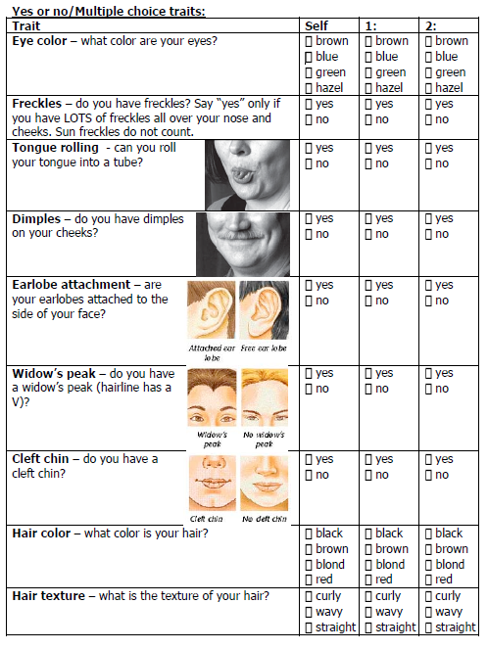

**LESSON PLAN: DAY 2**

|  |
| --- |
| Name: Katie Porter Grade: 9 Subject: Biology Date: |

A. Content Standard/Benchmark/Indicator:

**Life Sciences**

Students demonstrate an understanding of how living systems function and how they interact with the physical environment. This includes an understanding of the cycling of matter and flow of energy in living systems. An understanding of the characteristics, structure and function of cells, organisms and living systems will be developed. Students will also develop a deeper understanding of the principles of heredity, biological evolution, and the diversity and interdependence of life. Students demonstrate an understanding of different historical perspectives, scientific approaches and emerging scientific issues associated with the life sciences.

**Benchmark C:** Explain the genetic mechanisms and molecular basis of inheritance.

**Grade Ten:** *Heredity*

6. Explain that a unit of hereditary information is called a gene, and genes may occur in different forms called alleles (e.g., gene for pea plant height has two alleles, tall and short).**A C A D E M I C C**

8. Use the concepts of Mendelian and non-Mendelian genetics (e.g., segregation, independent assortment, dominant and recessive traits, sex- linked traits.

a. Objectives (What will the successful learner be able to do at the end of the lesson?)

Student will be able to :

* Identify dominant and recessive alleles;
* Define given vocabulary and relate Mendel’s laws to Punnett squares;
* Complete a monohybrid cross using a Punnett square.

b. Materials/Resources (What will be used to communicate understanding to the pupils?)

-Smartboard, bellwork 10.1#1, Punnett square worksheets, Reference sheet, Powerpoint presentation 10.1

1. Instructional Procedures (What motivating activities, techniques, and methods will be followed?) Include time allocation for each activity.

\*Attendance

**i. (6 minutes)**

-Have students complete bellwork 10.1 #1 and turn in.

-Go over answers by randomly drawing a name using notecards.

-Collect bellwork

**ii. (15minutes)**

-Powerpoint presentation/notes over 10.1

-Students should record focus words in their packets

-Focus on vocab mastery and providing examples

**iii.(15in)**

**-**Discuss P1, F1, F2 generations

-Introduce monohybrid crosses using Punnett squares

-Complete problems on Smartboard using Punnett squares

-Talk about different ways to express answers(ratio, %, or fraction)

**iv. (6minutes)**

-Pass out homework Dragon Genetics worksheet and ask for any questions.

-Do the first questions as an example.

1. Evaluation Strategies (How will I know if the students have learned what I wanted them to learn?)

-Assess student knowledge while completing Punnett squares

-Monitor student feedback

-Exit ticket:

* What do the 4 squares in the Punnett square show?
* How do P1, F1, and F2 generations compare to eachother?
* Give an example of a dominant and recessive allele.

1. Adaptations for Special Needs Students

**•** All students on IEP or with special needs work in class with Mr. Eicher(intervention specialist) in class. They may be given additional time to complete homework or may be given further clues to help ensure proper and fair learning. Students with problems seeing are seated closer to the front of the room or in the first row.

1. Reflection/Lesson Evaluation (Did the pupils accomplish the objectives? Were the methods and materials appropriate and effective? How could the lesson be altered to improve its effectiveness?)

**BELLWORK**

Bellwork 10.1 #1

Name:

1. Who was the father of genetics?
2. What type of plants did he use to study genetics?
3. How did Mendel breed one plant with another? What were his methods? (Hint: the plants he used *can* self-pollinate)

**REFERENCE SHEET**

Reference Sheet: Genetics/Punnett Squares

BD07206_

**P1 generation(parents):**

Father: Brown hair

Mother: Blond hair

*Note:*

*Brown hair is* ***dominant*** *to blond hair*

Alleles:

Brown=\_\_\_\_\_\_ Blond=\_\_\_\_\_\_\_\_\_

The three possible ***genotypes*** are: Phenotypes:

1. ***Homozygous dominant***: \_\_\_\_\_\_ \_\_\_\_\_\_ \_\_\_\_\_\_\_\_\_\_\_\_\_\_\_\_\_\_\_\_\_
2. ***Heterozygous:*** \_\_\_\_\_\_ \_\_\_\_\_\_ \_\_\_\_\_\_\_\_\_\_\_\_\_\_\_\_\_\_\_\_\_
3. ***Homozygous recessive***: \_\_\_\_\_\_ \_\_\_\_\_\_ \_\_\_\_\_\_\_\_\_\_\_\_\_\_\_\_\_\_\_\_\_

FATHER MOTHER

***Phenotype***: Brown hair ***Phenotype***: Blonde hair

Genotype:\_\_\_\_ \_\_\_\_ or \_\_\_\_ \_\_\_\_\_ Genotype: ­­­­\_\_\_\_\_ \_\_\_\_\_

**F1 Generation(first offspring):**

**-**Use a Punnett square to find all of the possible genotypes of the child IF THE FATHER IS HETEROZYGOUS.

-List the genotype of the blond mother(one allele per box) on one side and the genotype for the father on the other. Note: it does not matter what side the father or mother are on.

|  |  |
| --- | --- |
|  |  |
|  |  |

Genotypes: Phenotypes:

**Definition**

**Symbol**

Example

# Allele

Variation of a gene

Letter

## A,a,B

**Dominant**

# Trait

Trait that is always expressed/seen

Uppercase letter

## A, B

**Recessive**

**Trait**

Trait that is masked by the dominant trait

Lowercase letter

a,b

### Genotype

Written combination of alleles

Set of letters

## Aa,bb

**Phenotype**

The visible characteristics or what is seen (Behavior/physical looks)

None

Hair/eye color, freckles, etc.

Homozygous

(or true-bred)

Having all dominant or all recessive alleles for a trait (same)

Two of SAME letters(both uppercase or both lowercase)

## AA,bb

Heterozygous

(or hybrid)

Having one dominant and one recessive allele for a trait (hetero=other)

Two DIFFERENT

Letters (one uppercase and the other lowercase)

Aa,Bb

**PUNNETT SQUARE WORKSHEET**

BD07896_Dragon Genetics

Name:

**Directions:** You are a geneticist on Mystery Island. Your job is to research different combinations of dragons to see what types of offspring they can produce. Complete the following questions.

**Information:**

Purple wings are DOMINANT: D

Green wings are RECESSIVE: d

1. Zelda Dragon is homozygous for having green wings.
   1. What is her genotype?
   2. What is her phenotype?
2. Marvin Dragon is heterozygous for having purple wings.
   1. What is his genotype?
   2. What is his phenotype?
3. Marvin and Zelda choose to have offspring. Cross Zelda, a homozygous green-winged dragon,(using your answer to 1a) with Marvin, a heterozygous purple-winged dragon(using your answer to 2a). Draw and complete the Punnett Square.
   1. What are the two(2) possible genotypes?
   2. What are the two(2) possible phenotypes?

Think: What are the chances of each phenotype occurring?

|  |  |  |
| --- | --- | --- |
| List the genotype | Fraction | Percentage |
| Phenotype a:\_\_\_\_\_\_ |  |  |
| Phenotype b:\_\_\_\_\_\_ |  |  |

**LESSON PLAN: DAY 3**

|  |
| --- |
| Name: Katie Porter Grade: 9 Subject: Biology Date: |

A. Content Standard/Benchmark/Indicator:

**Life Sciences**

Students demonstrate an understanding of how living systems function and how they interact with the physical environment. This includes an understanding of the cycling of matter and flow of energy in living systems. An understanding of the characteristics, structure and function of cells, organisms and living systems will be developed. Students will also develop a deeper understanding of the principles of heredity, biological evolution, and the diversity and interdependence of life. Students demonstrate an understanding of different historical perspectives, scientific approaches and emerging scientific issues associated with the life sciences.

**Benchmark C:** Explain the genetic mechanisms and molecular basis of inheritance.

**Grade Ten:** *Heredity*

6. Explain that a unit of hereditary information is called a gene, and genes may occur in different forms called alleles (e.g., gene for pea plant height has two alleles, tall and short).**A C A D E M I C C**

8. Use the concepts of Mendelian and non-Mendelian genetics (e.g., segregation, independent assortment, dominant and recessive traits, sex- linked traits

a. Objectives (What will the successful learner be able to do at the end of the lesson?)

Student will be able to :

* Identify the probably of allelic combinations using fractions, ratios, and percent
* Identify dominant and recessive alleles;
* Complete monohybrid crosses using Punnett squares
* Apply knowledge of dominant and recessive alleles to real-life situations.

b. Materials/Resources (What will be used to communicate understanding to the pupils?)

-Computer lab, Webquest worksheets

1. Instructional Procedures (What motivating activities, techniques, and methods will be followed?) Include time allocation for each activity.

\*Attendance

**i. (5 minutes)**

-Hand out webquest worksheets

-Have a student read directions aloud

-Emphasize on-task behavior/expectations

-Have students bring up website on the computer

-Complete a sample problem

**ii. (30 minutes)**

-Students will complete a webquest over the given material by following the worksheet.

-Teacher will monitor student work and answer questions.

**iii.(7 min)**

-Ask for any final questions.

-Collect worksheets

1. Evaluation Strategies (How will I know if the students have learned what I wanted them to learn?)

-Collect worksheets at end of class and grade for understanding.

-Exit ticket:

* Make a Punnett square for a heterozygous mother and homozygous recessive father.
* Identify the possible genotypes and phenotypes of the offspring.
* Express your answers to the above in fraction, decimal, and percentage form.

1. Adaptations for Special Needs Students

**•** All students on IEP or with special needs work in class with Mr. Eicher(intervention specialist) in class. They may be given additional time to complete homework or may be given further clues to help ensure proper and fair learning. Students with problems seeing are seated closer to the front of the room or in the first row.

1. Reflection/Lesson Evaluation (Did the pupils accomplish the objectives? Were the methods and materials appropriate and effective? How could the lesson be altered to improve its effectiveness?)

**WEBQUEST**

Name:\_\_\_\_\_\_\_\_\_\_\_\_\_\_\_\_\_\_\_\_\_\_\_\_\_\_\_\_\_ Class Period:\_\_\_\_\_\_\_

MCj02396690000[1]Genetics Webquest

Directions: You are to work ALONE to complete this webquest. You may quietly ask a neighbor if you need help determining features or traits. You are to stay on-task and only visit the websites provided. You will have the class period to complete this assignment and will turn in this worksheet at the end of the period.

1. Follow the link: <http://www.copernicusproject.ucr.edu/ssi/HighSchoolBioResources/Genetics/Laws_of_Inheritance.asf> Watch the video and answer the following questions.
2. \*\**Note: click next/okay until the video starts to play. Make sure your volume on the side of the computer is turned up. You may want to read the questions BEFORE watching the video so you know what to look for. You can make it full screen by clicking the arrow in the lower right corner.*
3. a. When Mendel cross bred the 1st generation of peas, the recessive characteristics showed up in ¼ of the \_\_\_\_\_ generation. 2min20s
4. b. Each parent contributes \_\_\_\_\_\_ factor(allele) for each characteristic. 2min50s
5. Visit the website <http://learn.genetics.utah.edu/content/begin/tour/>
6. At the top, select **“What is a gene?”** Read the first slide.
7. What is a gene? \_\_\_\_\_\_\_\_\_\_\_\_\_\_\_\_\_\_\_\_\_\_\_\_\_\_\_\_\_\_\_\_\_\_\_\_\_\_\_\_\_\_\_\_\_\_\_\_\_\_\_\_\_\_\_\_\_\_\_\_\_\_\_\_\_\_\_\_\_\_\_\_\_\_\_\_\_\_\_\_\_\_\_\_\_\_\_\_\_\_\_\_\_\_\_\_\_\_\_\_\_\_\_\_\_\_\_\_\_\_\_\_\_\_\_\_\_\_\_\_\_\_\_\_\_\_\_\_\_\_\_\_\_\_\_\_\_\_ Now, click “next.” What are genes made of?\_\_\_\_\_\_\_\_\_\_
8. Now click under **“What is a chromosome?”** Watch the entire slide show by clicking next.
9. How much DNA does each human cell have?\_\_\_\_\_\_\_\_meters
10. How does all of the DNA fit into our cells? \_\_\_\_\_\_\_\_\_\_\_\_\_\_\_\_\_\_\_\_\_\_\_\_\_\_\_\_\_\_\_\_\_\_\_\_\_\_\_\_\_\_\_\_\_\_\_\_\_\_\_\_\_\_\_\_\_\_\_\_\_\_\_\_\_\_\_\_\_
11. Humans have 2 sets of \_\_\_\_\_\_\_\_\_\_ chromosomes, or \_\_\_\_\_\_\_\_\_chromosomes total.
12. Now watch the slide show **“What is heredity?”** and answer the following questions:
13. Each person has \_\_\_\_\_\_\_\_\_\_\_\_\_\_\_\_\_\_\_ of genes.
14. Where do we get our chromosomes? \_\_\_\_\_\_\_\_\_\_\_\_\_\_\_\_\_\_\_\_\_\_\_\_\_\_\_\_\_\_\_\_\_\_\_\_\_.
15. Unlike most other cells in our body, sperm and egg cells contain \_\_\_\_\_\_\_set(s) of chromosomes.
16. When the sperm and egg unite, the fertilized cell is called a \_\_\_\_\_\_\_\_\_\_\_\_\_\_\_\_\_\_\_.
17. Parents contribute chromosomes \_\_\_\_\_\_\_\_\_\_\_\_\_\_\_\_\_\_\_ to each child.
18. Go to the following website: <http://www2.edc.org/weblabs/Punnett/punnettsquares.html>
    1. We will do the first set of problems together
    2. Start on the table that looks like this: Read the directions and fill in the table on this worksheet as you go.

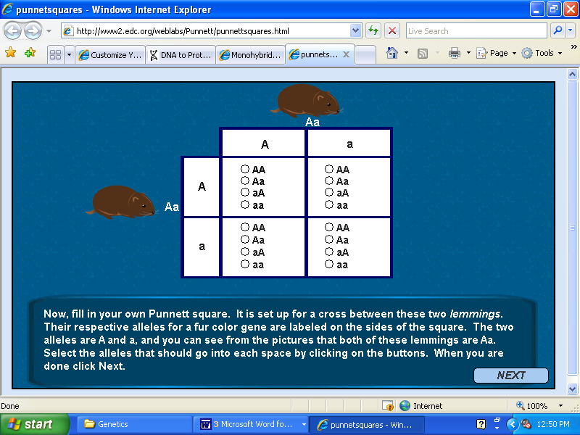

* 1. Choose the correct response by filling in the circle below. Then, explain how you came up with that response.

/

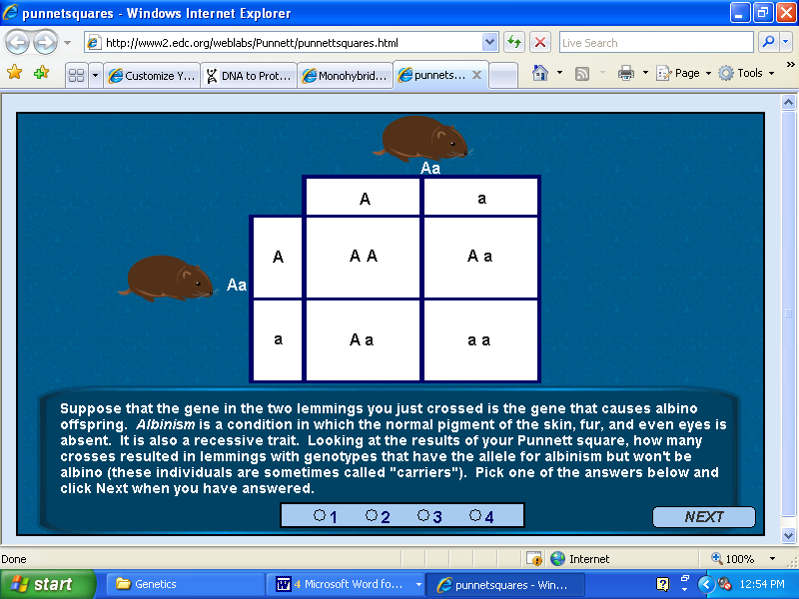

**LESSON PLAN: DAY 4**

Daily Lesson Plan

|  |
| --- |
| Name: Katie Porter Grade: 9 Subject: Biology Date: |

A. Content Standard/Benchmark/Indicator:

**Life Sciences**

Students demonstrate an understanding of how living systems function and how they interact with the physical environment. This includes an understanding of the cycling of matter and flow of energy in living systems. An understanding of the characteristics, structure and function of cells, organisms and living systems will be developed. Students will also develop a deeper understanding of the principles of heredity, biological evolution, and the diversity and interdependence of life. Students demonstrate an understanding of different historical perspectives, scientific approaches and emerging scientific issues associated with the life sciences.

**Benchmark C:** Explain the genetic mechanisms and molecular basis of inheritance.

**Grade Ten:** *Heredity*

6. Explain that a unit of hereditary information is called a gene, and genes may occur in different forms called alleles (e.g., gene for pea plant height has two alleles, tall and short).**A C A D E M I C C**

8. Use the concepts of Mendelian and non-Mendelian genetics (e.g., segregation, independent assortment, dominant and recessive traits, sex- linked traits

a. Objectives (What will the successful learner be able to do at the end of the lesson?)

Student will be able to :

* Complete monohybrid crosses using Punnett squares;
* Create a creature based on genotypes;
* Identify phenotypes as a result of given genotypes;
* Identify genotypes using homozygous, heterozygous, dominant, and recessive.

b. Materials/Resources (What will be used to communicate understanding to the pupils?)

-Paper, markers, Reebop chromosomes in envelopes, Reebop worksheet

1. Instructional Procedures (What motivating activities, techniques, and methods will be followed?) Include time allocation for each activity.

\*Attendance

1. **Reebop Activity(40 minutes)**

**-**Randomly call on students to give examples of different vocab words(allele, genotype, dominant, etc.)

**-**Have students get into pairs with person sitting next to them.

**-**Pass out male/female parent envelopes.

**-**Explain directions.

**-**Each person will choose one strip of paper of the same length. Each person acts as a member of the P1 generation.

-Have students determine gender as an example.

-Allow students to work for the remainder of the period on lab.

**ii.(10 min.)**

-Ask for some student examples of work.

-Have students present their Reebop and give an example of a homozygous dominant, heterozygous, and homozygous recessive trait.

Possible extension: Have students draw their Reebop on a separate sheet of paper.

1. Evaluation Strategies (How will I know if the students have learned what I wanted them to learn?)

-Assess student answers during class work.

-Collect student work to grade for understanding.

1. Adaptations for Special Needs Students

**•** All students on IEP or with special needs work in class with Mr. Eicher(intervention specialist) in class. They may be given additional time to complete homework or may be given further clues to help ensure proper and fair learning. Students with problems seeing are seated closer to the front of the room or in the first row.

1. Reflection/Lesson Evaluation (Did the pupils accomplish the objectives? Were the methods and materials appropriate and effective? How could the lesson be altered to improve its effectiveness?)

**REEBOP LAB:** Adapted from Salters-Nuffield Advanced Biology, Harcourt Education Ltd 2005.

**Breeding Reebops Lab Name:**

**Genetics information sheet**

All cells contain hereditary information that is encoded by a chemical called **DNA**

(deoxyribonucleic acid). DNA is an extremely long molecule, with up to a meter in every cell. When a DNA molecule is all coiled up and bunched together it is called a **chromosome**. A **gene** is a segment on a DNA molecule.

Here’s the order: **DNA**::makes up a **gene**:: which makes up a **chromosome**

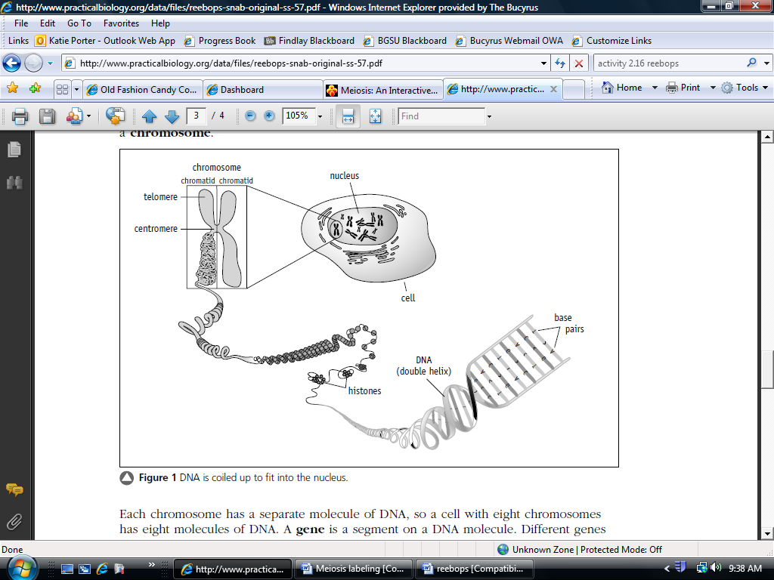

Any organism that has ‘parents’ has an even number of chromosomes, because one half of the chromosomes come from the father(sperm) and the other half from the mother(egg). These two cells combine to make a single cell, which grows into the offspring. Humans have 46 chromosomes, or 23 pairs. One chromosome in each of the 23 pairs is from the person’s father, the other from the person’s mother.

Since chromosomes come in pairs, genes do too. One gene is located on one member of a chromosome pair; the other gene is in the same location on the matching chromosome. The two different gene forms on the pair of chromosomes may be identical or different. For example, in the Reebops activity the gene for tail shape has a **T** form and a **t** form.

* **Alleles**:The different forms that make up a gene. Therefore, **T** and **t** are alleles for the tail shape gene.
* **Homozygous:** (two of the same form): tt, TT
* **Heterozygous:** (two different forms): Tt
* **Dominant:** capital letter, takes over and shows up in the presence of recessive allele (R, T)
* **Recessive:** lowercase letter, is masked(does not show up) in the presence of a recessive allele(r, t)
* **Genotype**: the 2 alleles that are put together to make up the gene (TT,Tt,tt)
* **Phenotype**: Physical characteristics(unibrow, nose hair, etc.)

1. Classify each as:
   * homozygous dominant(HD); heterozygous(HE); homozygous recessive(HR)

(a) LL-\_\_\_\_\_\_\_\_\_\_\_\_\_\_ (e) Rr-\_\_\_\_\_\_\_\_\_\_\_\_\_\_\_

(b) yy-\_\_\_\_\_\_\_\_\_\_\_\_\_\_ (f) ll- \_\_\_\_\_\_\_\_\_\_\_\_\_\_\_

(c) Ss-\_\_\_\_\_\_\_\_\_\_\_\_\_\_ (g) ss- \_\_\_\_\_\_\_\_\_\_\_\_\_\_\_

(d) RR - \_\_\_\_\_\_\_\_\_\_\_\_\_ (h) Yy -\_\_\_\_\_\_\_\_\_\_\_\_\_\_

- Are the above letters phenotypes or genotypes?

2. Use the information in the chart below to write the **genotype** (or genotypes) for each trait below.

(a) Unibrow - \_\_\_\_\_\_\_\_\_\_\_ (e) Claws - \_\_\_\_\_\_\_\_\_\_\_

(b) Straight tail- \_\_\_\_\_\_\_\_\_\_\_ (f) Fingers - \_\_\_\_\_\_\_\_\_\_\_\_

(c) Short legs - \_\_\_\_\_\_\_\_\_\_\_\_\_\_ (g) Separate eyebrows - \_\_\_\_\_\_\_\_\_\_\_

(d) Female-\_\_\_\_\_\_\_\_\_\_\_\_\_ (h) 2 eyes - \_\_\_\_\_\_\_\_\_\_\_\_

Are the above words phenotypes or genotypes?

**Genotype decoder key**

|  |  |  |  |
| --- | --- | --- | --- |
| **Characteristic** | **Genotype/ phenotype code** | | |
| eyebrow | **AA** = Unibrow | **Aa** = Unibrow | **aa** = separate eyebrows |
| body segments | **BB** = 3 body segments | **Bb** = 3 body segments | **bb** = 2 body segments |
| tail | **TT** = curly tail | **Tt** = curly tail | **tt** = straight tail |
| Nose hair | **NN** = Nose hair | **Nn** = Nose hair | **nn** = no nose hair |
| legs | **LL** = short legs | **Ll** = short legs | **ll** = long legs |
| gender | **XX** = female(pink bow) | **XY** = male(blue bow) |  |
| eyes | **EE** = 2 eyes | **Ee** = 2 eyes | **ee** = one eye |
| Digits | **HH** = Claws | **Hh** = Claws | **hh** = fingers |

**Genotype/ phenotype record table**

|  |  |  |  |  |
| --- | --- | --- | --- | --- |
| **Characteristic** | **Allele from Mom** | **Allele from Dad** | **Genotype** | **Phenotype: Use table below** |
| Eyebrow |  |  |  |  |
| body segments |  |  |  |  |
| tail |  |  |  |  |
| Nose hair |  |  |  |  |
| legs |  |  |  |  |
| gender |  |  |  |  |
| eyes |  |  |  |  |
| Digits |  |  |  |  |

**Directions:**

1. Collect a set of male and female chromosomes located in envelopes.
2. Give the mom chromosomes to 1 partner and the Dad chromosomes to the other.
3. Keeping them separated by parent/color, place the chromosomes upside down so no letters are showing. Keeping the colors separated, scramble them.
4. Now each parent is to select a gamete of the same length. The mother will chose one pink to represent the egg and the father will choose one blue to represent the sperm. These were formed by *meiosis!*

*Note: There are 2 thicker chromosomes for each parent. These are the gender chromosomes(X and Y). Follow the same procedure for them.*

1. Record each allele and the genotype on the table below.
2. Then, using the genotype decoder key, find and write the phenotype.
3. Continue with each gamete(same length paper) until all of your papers are used.
4. When you are done, put the pink papers back in the mom envelope and the blue papers back in the dad envelope.
5. Now, draw your baby Reebop on a separate sheet of paper.

**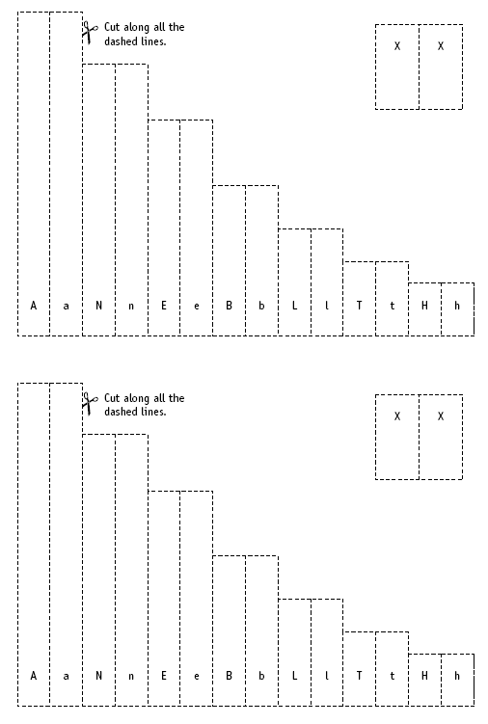Mom reebop chromosomesDad Reebop chromosomes**



**POST ASSESSMENT**

**Multiple Choice(1 pt each)**

*Identify the letter of the choice that best completes the statement or answers the question.*

1. The organism’s appearance is known as its

a. heredity. c. phenotype.

b. pedigree. d. genotype.

2. Which of the following are traits that you probably inherited?

a. your taste in clothing c. your eye color

b. your favorite music d. All of the above

3.\_\_\_\_ used plants to study the way traits are passed from parents to offspring.

a. Mendel c. Sutton

b. Punnett d. Allele

4. These may be dominant or recessive.

a. alleles c. phenotypes

b. Punnett squares d. sex cells

5.\_\_\_\_ developed a square that is used to visualize all the possible combinations of alleles in offspring resulting from a genetic cross.

a. Mendel c. Sutton

b. Punnett d. Allele

6. Use the letter "H." The trait for straight hair is dominant. The trait for curly hair is recessive.

a. What are the possible genotypes for straight hair(2 pts)?\_\_\_\_\_\_\_\_\_\_\_\_\_\_\_\_\_\_\_\_\_\_\_\_\_\_

b. What are the possible genotypes for curly hair(1 pt)?\_\_\_\_\_\_\_\_\_\_\_\_\_\_\_\_\_\_\_\_\_\_\_\_\_\_\_

c. BE CAREFUL!!! DOUBLE CHECK YOUR WORK! Complete the following:

A man that is ***heterozygous*** for straight hair and a woman who has curly hair mate.

i. Male's genotype(1pt):\_\_\_\_\_\_\_\_\_\_\_\_ Female's genotype(1 pt)\_\_\_\_\_\_\_\_\_\_\_\_

ii. Create a Punnett square for the two parents above(2 pts)

iii. List the genotypes and phenotypes of the offspring(1 pt each)

|  |  |
| --- | --- |
| **Genotypes** | **Phenotypes** |
|  |  |
|  |  |
|  |  |

d. What is the chance that the child will have curly hair(look back at your Punnett square)?

\_\_\_\_\_\_\_\_\_% chance of curly hair(1 pt)