- EXAMPLES:
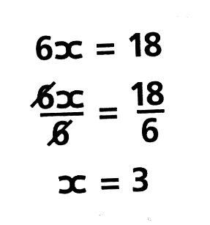 | - Divide both sides of the equation by 6 to leave just “x” on the left hand-side.
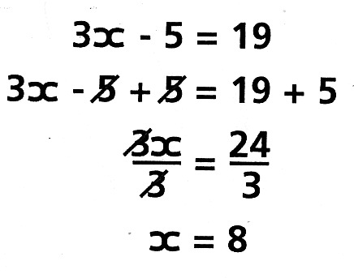 | - Add 5 to both sides of the equation to remove the -5 from the left hand-side.  - Divide both sides by 3 to leave just “x” on the left hand-side.
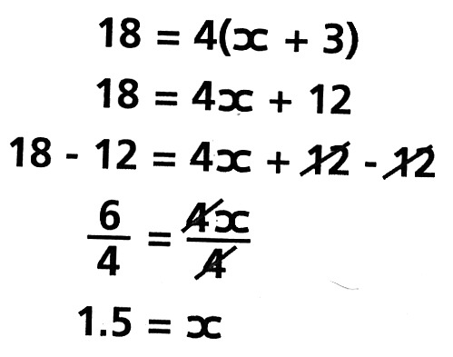 | - Multiply out the bracket.  - Subtract 12 from the both sides of the equation to remove the +12 on the right hand-side.  - Divide both sides by 4 to leave just “x” on the right hand-side.
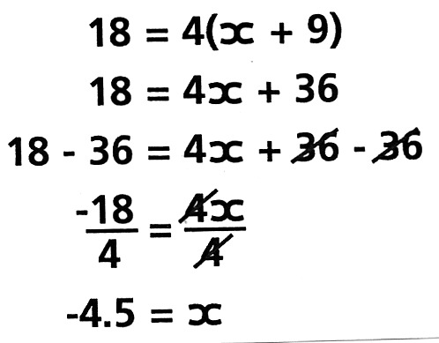 | - Multiply out the bracket.  - Subtract 36 from both sides of the equation.  - Divide both sides by 4 to leave just the “x” on the right-hand side.
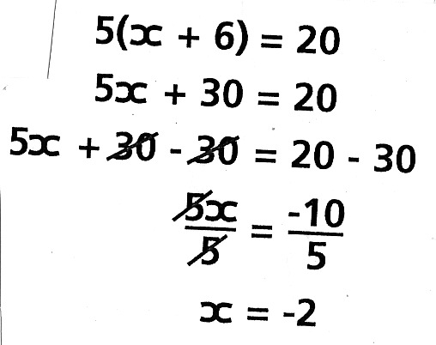 | - Multiply out the bracket.  - Subtract 30 from both sides of the equation.  - Divide both sides of the equation by 5.
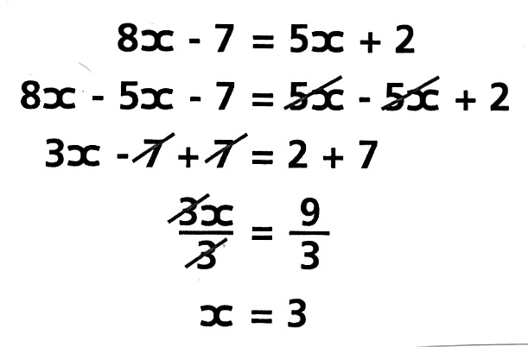 |  | - Rearrange all the x’s on the right and the constant terms on the left.  - Collect all like terms.  - Divide both sides of the equation by 3.

