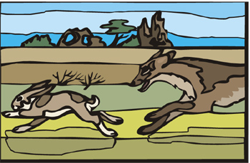 |   Sort the following animals according to the way they get their food. The basic categories are forager, grazer, filter feeder, parasite, predator, and scavenger.

clam  blue whale  flea  sponge  sheep  piranha | owl  cow  vulture  bear  louse  gorilla | striped hyena  whale shark  tiger  crow  tuna fish  great white shark | squirrel  lion  zebra  leech  monkey  oyster

Foragers

Grazers

Filter Feeders

Predators

Scavengers

Parasites

© 2005 www.bogglesworldesl.com

