Instructional Design: First Grade Ocean Unit: Sub Unit: Solids and Liquids
Rachel Chervenak
Bowling Green State University

Rationale
It is critical to teach a curriculum that is captivating to students, especially at the beginning of their educational path. Play is an important aspect of early childhood education and in the development of children. According to Rieber, Smith, and Noah (1998), play is a crucial process that helps learning throughout life. Play motivates learning and contributes to development. Today, teachers and school districts are continuously put under pressure to meet and exceed benchmarks and standards. Chiarelott (2006) states, "Since the advent of high-stakes testing and the emphasis on national and state standards as a basis for judging school effectiveness, administrators and teachers have felt considerable pressure to align the school curriculum with the state and national assessments" (p. 12). Unfortunately, with these pressures we forget about our students and how they learn- through play and exploration. With obligations such as No Child Left Behind and pressure to meet state and national standards, teachers are continuously decreasing the amount of play-based and exploration activities in classrooms. I think it is of great value to our students to incorporate play-based activities into classrooms for their development and interest.
The instructional model I am using is the 5-E Learning Cycle Model. This model allows students to use an interactive and exploratory approach to learning. Furthermore, with this model a lesson will have five phases, engagement, exploration, explanation, extension, and evaluation. All of these stages ensure that students are learning and at the same time the teacher is captivating their minds and making meaningful connections. I am using this plan for this ocean unit because it allows for structure and at the same time the ability to be flexible by changing items in a lesson. This model also fits hand in hand with the problem I have presented about curriculum and the need for play-based and exploratory learning. The 5-E Learning Cycle Model guarantees that students will have the opportunity to explore their learning (Chiarelott, 2006).

Learner Outcomes

Bloom's Taxonomy | Learner Outcomes
Evaluation | Students will be able to. . .  - Ask and answer questions about key details in a text.  - Ask and answer questions about key details in a text.  - Distinguish between information provided by pictures or other illustrations and information provided by the words in a text.  - Explain that food comes from sources other than the grocery store.
Synthesis | Students will be able to. . .  - Retell stories, including key details, and demonstrate understanding of their central message or lesson.  - Relate counting to addition and subtraction.  - Ask "what happens when" questions.  - Explore and pursue student-generated "what happens when" questions.  - Work in a small group to complete an investigation and then share findings with others.  - Sequence information.
Analysis | Students will be able to. . .  - Order three objects by length; compare the lengths of two objects indirectly by using a third object.  - Organize, represent, and interpret data with up to three categories; ask and answer questions about the total number of data points, how many in each category, and how many more or less are in one category than in another.  - Distinguish between defining attributes (e.g., triangles are closed and three-sided) versus non-defining attributes (e.g., color, orientation, overall size) ; build and draw shapes to possess defining attributes.  - Investigate that animals eat plants and/or other animals for food and may also use plants or other animals for shelter and nesting.  - Create individual conclusions about group findings.
Application | Students will be able to. . .  - With prompting and support, read informational texts appropriately complex for grade 1.  - Recognize and read grade-appropriate irregularly spelled words.  - Write informative/explanatory texts in which they name a topic, supply some facts about the topic, and provide some sense of closure.  - Write narratives in which they recount two or more appropriately sequenced events, include some details regarding what happened, use temporal words to signal event order, and provide some sense of closure.  - Demonstrate command of the conventions of standard English grammar and usage when writing or speaking.  - Demonstrate command of the conventions of standard English capitalization, punctuation, and spelling when writing.  - Apply properties of operations as strategies to add and subtract.² Examples: If 8 + 3 = 11 is known, then 3 + 8 = 11 is also known. (Commutative property of addition.) To add 2 + 6 + 4, the second two numbers can be added to make a ten, so 2 + 6 + 4 = 2 + 10 = 12. (Associative property of addition.)  - Add and subtract within 20, demonstrating fluency for addition and subtraction within 10. Use strategies such as counting on; making ten (e.g., 8 + 6 = 8 + 2 + 4 = 10 + 4 = 14); decomposing a number leading to a ten (e.g., 13 – 4 = 13 – 3 – 1 = 10 – 1 = 9); using the relationship between addition and subtraction (e.g., knowing that 8 + 4 = 12, one knows 12 – 8 = 4); and creating equivalent but easier or known sums (e.g., adding 6 + 7 by creating the known equivalent 6 + 6 + 1 = 12 + 1 = 13).  - Compose two-dimensional shapes (rectangles, squares, trapezoids, triangles, half-circles, and quarter-circles) or three-dimensional shapes (cubes, right rectangular prisms, right circular cones, and right circular cylinders) to create a composite shape, and compose new shapes from the composite shape.  - Explore that organisms, including people, have basic needs, which include aid, water, food, living space, and shelter.  - Explore that humans and other animals have body parts that help to seek, find, and take in food when they are hungry.  - Investigate that water can change from liquid to solid or solid to liquid.  - Use oral, written and pictorial representations to communicate work.  - Explore and observe that things can be done to materials to change their properties.  - Use appropriate safety procedures when completing scientific investigations.  - Identify and correctly use terms related to location, direction, and distance.  - Construct simple maps and models using symbols to represent familiar places.  - Communicate information orally or visually.  - Displaying courtesy and respect for others in group settings including.
Comprehension | Students will be able to. . .  - Read grade-level text with purpose and understanding.  - Participate in collaborative conversations with diverse partners about grade 1 topics and texts with peers and adults in small and larger groups.  - Ask and answer questions about key details in a text read aloud or information presented orally or through other media.  - Ask and answer questions about what a speaker says in order to gather additional information or clarify something that is not understood.  - Describe things as accurately as possible and compare with the observations of others.  - Demonstrate good explanations based on evidence from investigations and observations.  - Explain that wants are unlimited and resources are scarce, thereby forcing individuals to make choices.
Knowledge | Students will be able to. . .  - Describe characters, settings, and major events in a story, using key details.  - Describe people, places, things, and events with relevant details, expressing ideas and feelings clearly.  - Add drawings or other visual displays to descriptions when appropriate to clarify ideas, thoughts, and feelings.  - Produce complete sentences when appropriate to task and situation.  - Determine or clarify the meaning of unknown and multiple-meaning words and phrases based on grade 1 reading and content, choosing flexibly from an array of strategies.  - With guidance and support from adults, demonstrate understanding of figurative language, word relationships and nuances in word meanings.  - With guidance and support from adults, demonstrate understanding of figurative language, word relationships and nuances in word meanings.  - Use addition and subtraction within 20 to solve word problems involving situations of adding to, taking from, putting together, taking apart, and comparing, with unknowns in all positions, e.g., by using objects, drawings, and equations with a symbol for the unknown number to represent the problem.  - Understand subtraction as an unknown-addend problem. For example, subtract 10 – 8 by finding the number that makes 10 when added to 8. Add and subtract within 20.  - Add within 100, including adding a two-digit number and a one-digit number, and adding a two-digit number and a multiple of 10, using concrete models or drawings and strategies based on place value, properties of operations, and/or the relationship between addition and subtraction; relate the strategy to a written method and explain the reasoning used. Understand that in adding two-digit numbers, one adds tens and tens, ones and ones; and sometimes it is necessary to compose a ten.  - Explain that everybody can do science, invent things, and have scientific ideas no matter where they are.  - Identify and use symbols to locate places of significance on maps and globes.  - Identify and describe the physical features (lake, river, hill, mountain, forest) and human features (town, city, farm, park, playground. house, traffic signs/signals) of places in the community.  - Obtain information about a topic using a variety of oral and visual sources.

Blue= Common Core Language Arts Standards
Red= Common Core Mathematics Standards
Pink= Ohio Science Academic Content Standards
Orange= Ohio Social Studies Academic Content Standards

Pre- Assessment

For my sample lessons I am focusing on one of my many sub units: solids and liquids. My pre-assessment is a KWL booklet, which prior to starting and completing this unit the students will be able to write about what they know, "K", about solids and liquids. The students will also write about what they want to know about solids and liquids, "W". I am using a KWL booklet because it allows students freedom in how they want to answer their questions. Students can choose to draw pictures, write words, or write complete sentences. This pre-assessment is being used because it will effectively gather what students want to know about solids and liquids as well as what the already know. The KWL format is perfect when working with first grade because many students are at different levels of writing and understanding and a KWL booklet does not exclude any student from being able to express their answers.

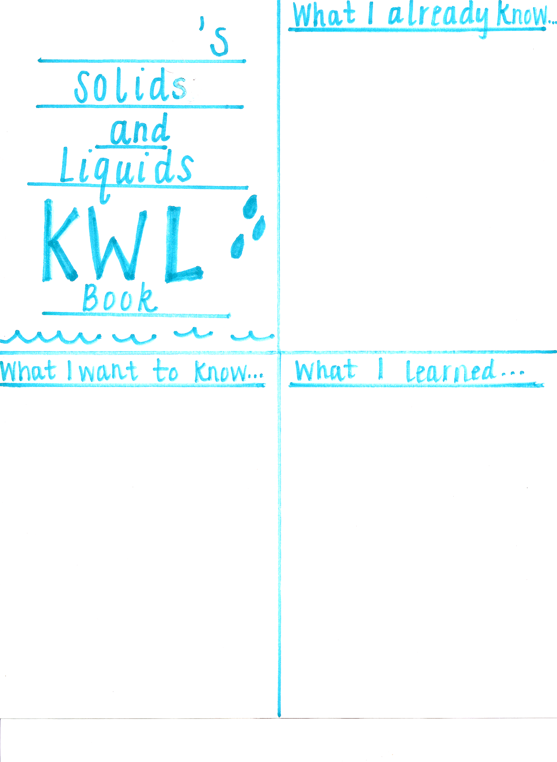
Lesson 1: Unit: Ocean: Subunit: Solids and Liquids

Liquid Race!

Grade: 1
Time: 50 minutes
Subject: Science

OHIO ACADEMIC CONTENT STANDARD(S)

- Science- Grade 1- Physical Sciences- 1- Classify objects according to the materials that are made of and their physical properties.
- Science- Grade 1- Physical Sciences-2- Investigate that water can change from liquid to solid or solid to liquid.
- Science- Grade 1- Physical Sciences- -3- Explore and observe that things can be done to materials to change their properties.
- Science- Grade 1- Physical Sciences-4- Explore changes that greatly change the properties of an object and changes that leave the properties largely unchanged.
- Science- Grade 1- Scientific Inquiry- 1- Ask "what happens when" questions.
- Science- Grade 1- Scientific Inquiry-2- Explore and pursue student-generated "what happens when" questions.
- Science- Grade 1- Scientific Inquiry- 3- Use appropriate safety procedures when completing scientific investigations.
- Science- Grade 1- Scientific Inquiry- 4- Work in a small group to complete an investigation and then share findings with others.
- Science- Grade 1- Scientific Ways of Knowing- 2- Demonstrate good explanations based on evidence from investigations and observations.

OBJECTIVES

- Students will be able to identify different liquids.
- Students will be able to make a hypothesis.
- Students will work in groups collaboratively and perform their specified role.
- Students will be able to use equipment appropriately and record their results with an accuracy of 100%.

LESSON SUMMARY

- Students will work in groups and race five different liquids to see which liquid is the quickest and at the same time explore different qualities liquids have.

RESOURCES

- Cookie trays- 5
- Role cards for every group
- Cups for liquids- 20
- Water
- Syrup
- Soap
- BBQ sauce
- Spoons- 20
- Scientific Method Worksheet
- Liquids in bags- 20
- 5 sheets of white paper
- Chart paper

PROCEDURES

A. ENGAGEMENT (10 minutes)

- Ask students, "Have you ever been in a race?"
- Take students to gym or open area to have a crab race (students move on hands and feet).

B. EXPLORE (30 minutes)
- Explain student roles as a scientist.
  - Material Manager: Will gather materials needed for their group as well as return at the end of the experiment
  - Questioner: Will ask teacher questions that their group may have
  - Illustrator: Will create a picture of their experiment (sheet of white paper will be provided for this role)
  - Reporter: Will report their findings to the class
(Groups with 5 students- 2 students will be the illustrators)
- For all of the experiments we will do each member of your group will have a different role. Your role will change for each experiment and you will only perform your role.
- "Today we are going to have a race! We are going to race liquids! But first we are going to write some characteristics of liquids on the chart before we get started."
- Write down characteristics that students give about liquids on chart paper.
- Ask, "Is syrup a liquid? What about barbeque sauce?" The liquids we are going to race are on the front table. We are going to race water, syrup, soap, and barbeque sauce."
- Give plastic bag of each liquid to each table. Let them hold the bag to get an idea of how the liquid may feel and the density of it.
- Collect liquid bags.
- "In this experiment we are going to figure out which liquid will move the fastest down a cookie sheet. "
- Pass out scientific method worksheet.
- "Write down which liquid you think will win the liquid race on your paper where is says hypothesis. Pick A, B, C, D, or E."
- "Now I want you to write the materials down. We have syrup, barbeque sauce, water, soap, spoons and a cookie sheet."
- Go through the procedures listed on the scientific methods worksheet.
- Pass out scientist role cards. Assign roles: 1- Illustrator, 2- Materials Manager, 3 Question Master, 4- Reporter
- Materials Manager collects materials needed and each table will follow the procedure and conduct their experiment.
- When students finish their experiments have the material manager bring the materials back to the front table.
- The reporter from each group will share their group's results and illustrations. (Teacher will keep track of which liquid won from each group)

C. EXPLANATION (5 minuets)

- Students need to complete the "conclusion" part on their worksheet.
- Turn into letter A. (Question Master will collect the worksheets from their table members)
- Discuss why some liquids can move quicker than other liquids (molecules are closer together in liquids such as syrup and barbeque sauce, so they move slower than liquids like water).

D. ELABORATE (5 minuets)

- Students will pretend to be molecules- liquids stand close together.
- Student will brainstorm in their groups different types of liquids.

E. EVALUATE

- Student's scientific method worksheets will be assessed for completeness. One point will be awarded for every question. The worksheet will be worth 8 points

Scientific Method:
Liquid Race!

Problem: Which liquid will move the fastest down a cookie sheet, water, barbeque sauce, syrup, or soap?

Materials:

1.____________ 2._______________ 3.________________

4. ____________ 5._______________6. ________________

Hypothesis: ________ will win the liquid race.

A. Barbeque sauce
B. Water
C. Soap
D. Syrup
E. No liquid will win, they will finish at the same time.

Procedures:
1. Put one spoonful of each liquid onto the tray.
2. Lift one end of the tray up until you see the liquids begin to move.
3. Watch closely to see which liquid gets to the bottom of the tray first.

Conclusion: ________________ won the liquid race.
Lesson 2: Unit: Ocean: Subunit: Solids and Liquids

Centers! Solids vs. Liquids & Rock Candy
Grade: 1
Time: 50 minutes
Subject: Science

OHIO ACADEMIC CONTENT STANDARD(S)

- Science- Grade 1- Physical Sciences- 1- Classify objects according to the materials that are made of and their physical properties.
- Science- Grade 1- Physical Sciences-2- Investigate that water can change from liquid to solid or solid to liquid.
- Science- Grade 1- Physical Sciences- -3- Explore and observe that things can be done to materials to change their properties.
- Science- Grade 1- Physical Sciences-4- Explore changes that greatly change the properties of an object and changes that leave the properties largely unchanged.
- Science- Grade 1- Scientific Inquiry- 3- Use appropriate safety procedures when completing scientific investigations.
- Science- Grade 1- Scientific Inquiry- 4- Work in a small group to complete an investigation and then share findings with others.

OBJECTIVES

- Students will be able to identify different solids and liquids.
- Students will be able to set up their own rock candy experiment.
- Students will work in groups collaboratively and perform their specified role.

LESSON SUMMARY

- Students will be working in centers to discover more about solids and liquids as well as setting up their rock candy experiment (mystery liquid).

RESOURCES

- Glass jars- 20
- Hot plate
- Sauce pan
- Water
- Sugar
- Measuring cups
- Popsicle sticks
- Paper clips
- String
- Chart for grouping solids and liquids
- Solids and liquids in bags with labels
- Worksheet for grouping
- Plastic wrap
- Food coloring
- Mystery observation worksheet

PROCEDURES

A. ENGAGEMENT (5 minutes)

- Ask, "Does anyone know what a mystery is?"
- "I have a mystery for you!"
- "Today we are going to make something sweet! It will change over the next week into a treat we can eat!"

B. EXPLORE (30 minutes)

- Explain centers.
- Center 1: solids and liquids grouping- students will work together in the carpeted area sorting solids and liquids onto a chart. Students will then put their results on their worksheet.
- Center 2: students will be working with me and we are going to make a liquid substance using sugar and water. We will put our string into the glass jar and let them sit for about 7 days. We will watch and observe what our liquids turn into.
- Whole class: tie string on popsicle stick and leave on your desk.
- Center time: Tables 1 and 2 will be at center 1. Tables 3, 4, and 5 will be at center 2. Each center should take about 15 minutes.
- Students will switch centers after 15 minutes.

C. EXPLANATION (10 minuets)

- Students need to complete day 1 on their observation sheet.
- Review terms liquid and solid with examples.

D. ELABORATE (5 minuets)

- Students will pretend to be molecules- liquids stand close together, solids stand far apart.
- Student will brainstorm in their groups different types of solids.

E. EVALUATE

- Student's solids and liquids worksheet will be assessed for completeness. If they completed the worksheet with less than 3 errors they will receive an S+. If the worksheet is completed with 4 errors the student will receive an S. If the worksheet is turned in with more than 4 errors the student will receive an S-.

Name:______________________

Solids | Liquids

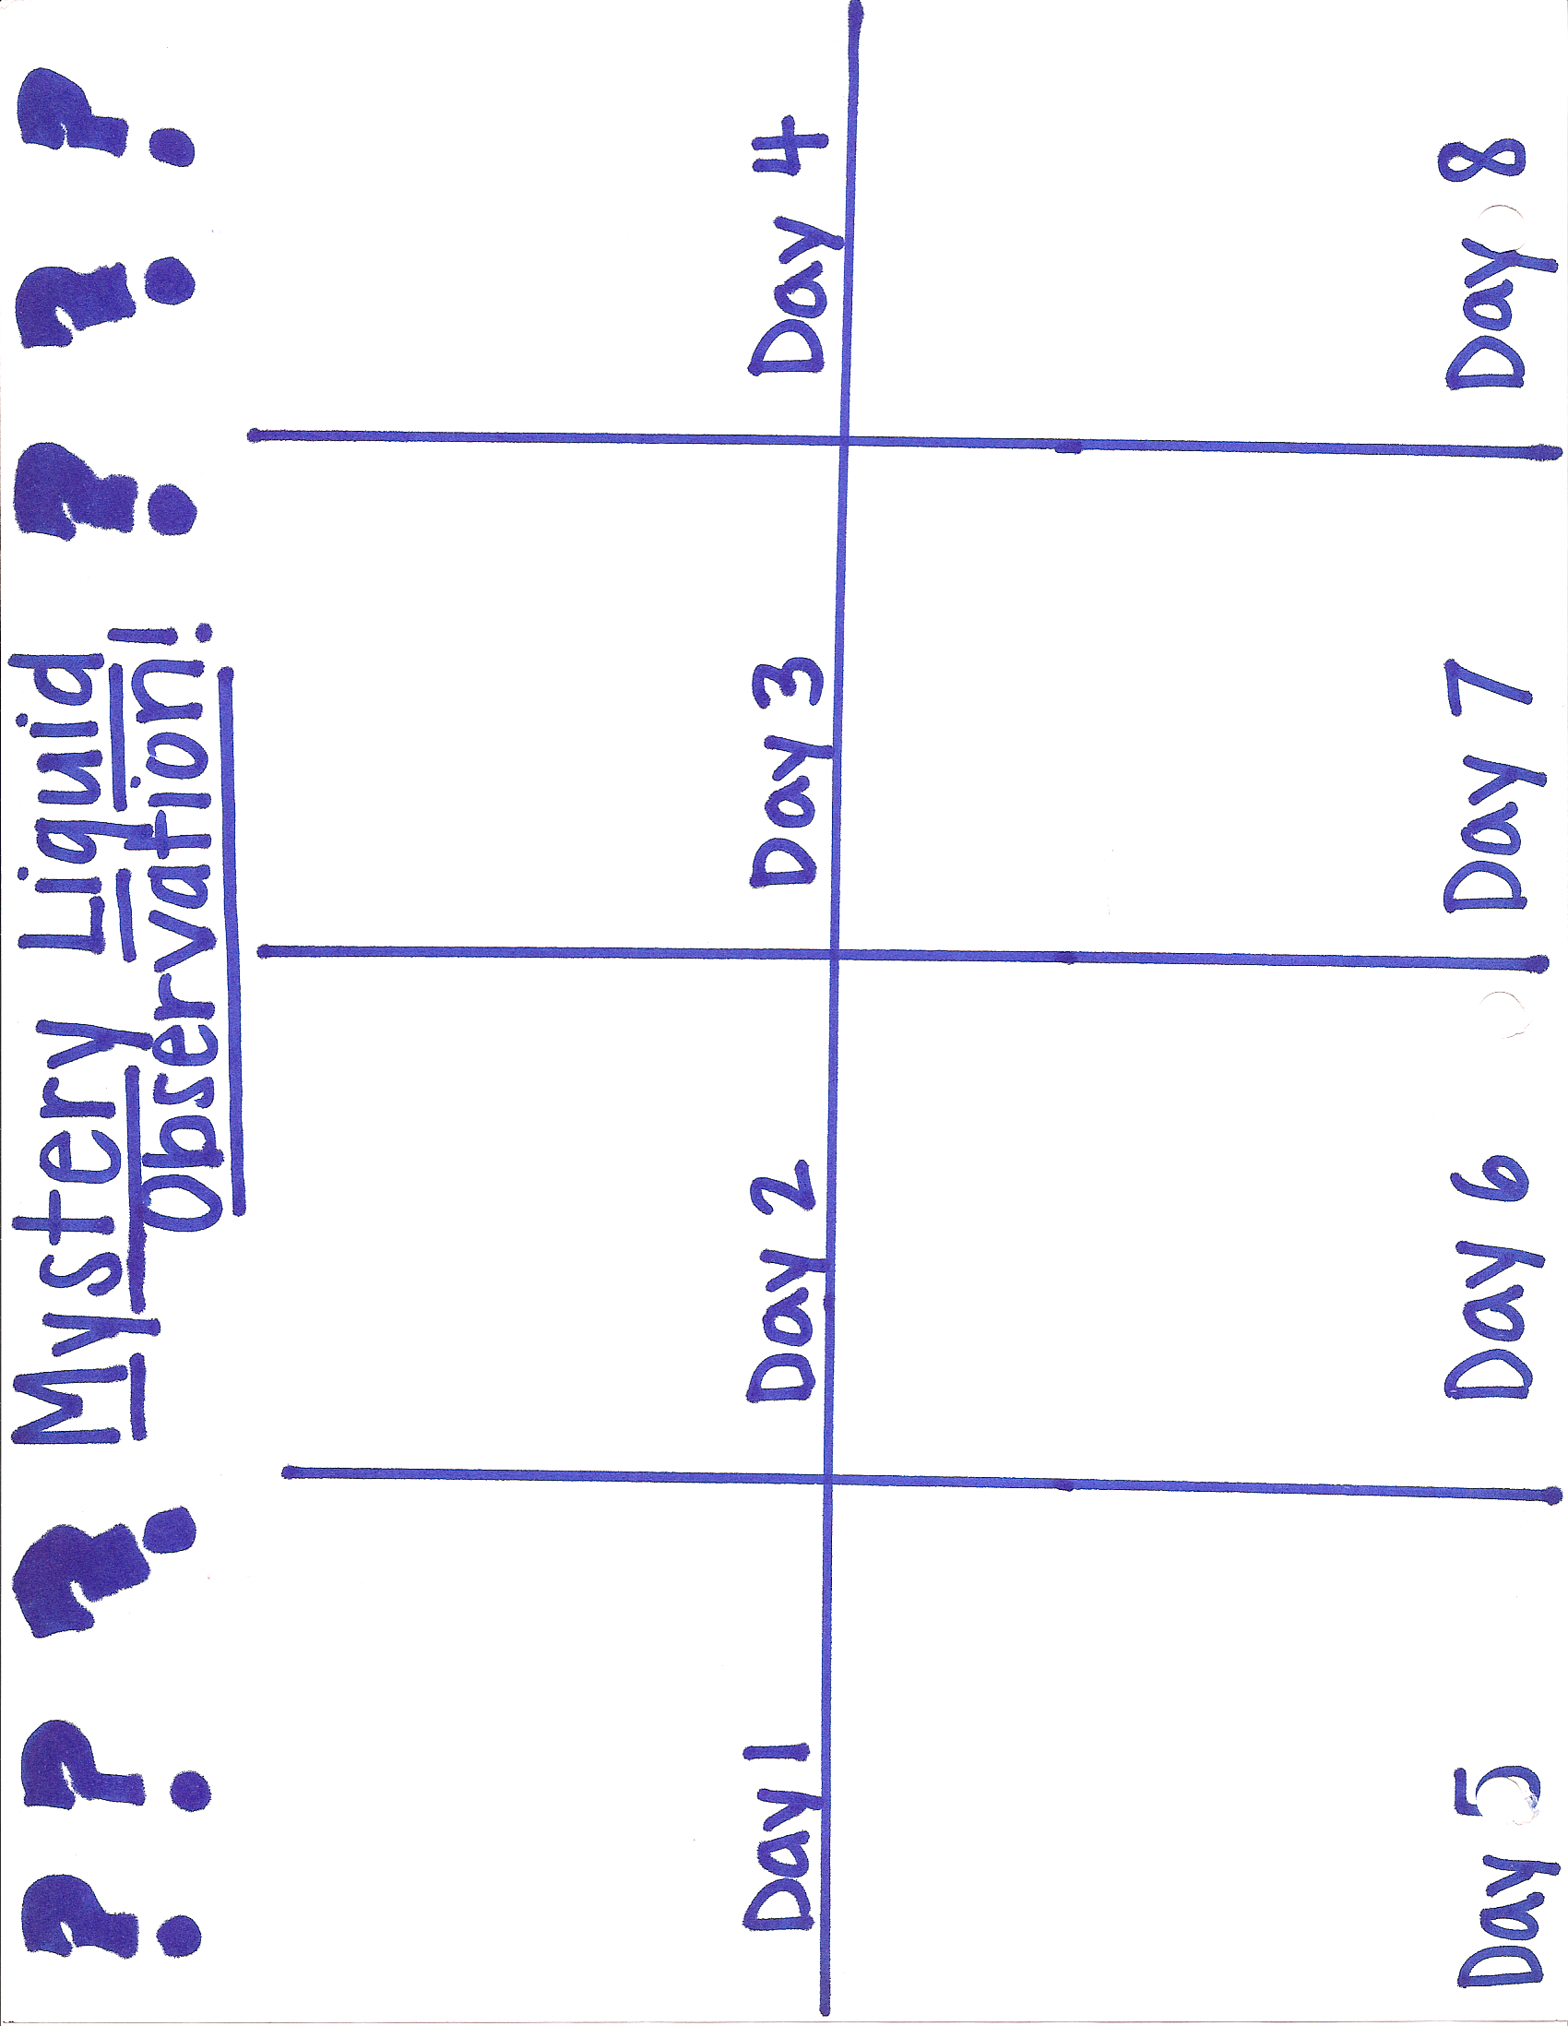

Lesson 3: Unit: Ocean: Subunit: Solids and Liquids

Ice Cream!

Grade: 1
Time: 50 minutes
Subject: Science

OHIO ACADEMIC CONTENT STANDARD(S)

- Science- Grade 1- Physical Sciences-2- Investigate that water can change from liquid to solid or solid to liquid.
- Science- Grade 1- Physical Sciences- -3- Explore and observe that things can be done to materials to change their properties.
- Science- Grade 1- Scientific Inquiry- 1- Ask "what happens when" questions.
- Science- Grade 1- Scientific Inquiry-2- Explore and pursue student-generated "what happens when" questions.
- Science- Grade 1- Scientific Inquiry- 4- Work in a small group to complete an investigation and then share findings with others.
- Science- Grade 1- Scientific Ways of Knowing- 2- Demonstrate good explanations based on evidence from investigations and observations.

OBJECTIVES

- Students will be able to identify different liquids.
- Students will be able to make a prediction.
- Students will be able to sequence the experiment into steps as a class.

LESSON SUMMARY

- Students will make their own ice cream and watch it change from a solid to a liquid. Students will also sequence the steps they used as a class as well as make a prediction about what they are making based on the ingredients.

RESOURCES

- Milk
- Vanilla extract
- Sugar
- Ice
- Bags
- Spoons
- Paper towels
- Role cards
- Prediction worksheet

PROCEDURES

A. ENGAGEMENT (5 minutes)

- Put ingredients on table. "Look at what we are using for this experiment. What do you think we are going to make?" Share answers.
- Give a hint- If I were going to be on the hot beach I would want to have this.
- Students will fill out their prediction worksheet using a picture or words.

B. EXPLORE (30 minutes)

- Assign science roles.
- Material manager needs to gather: 4- half cups of milk, 4- tablespoons of sugar, 4- ¼ teaspoons of vanilla extract, 4- bags (small).
- First- put your milk, sugar, and vanilla into the small bag.
- Second- come to front of room and get bag with salt and ice. (each student will get their own)
- Shake, roll, turn, and toss!
- What is your liquid doing? Do you know what it is? Is it cold?
- Once yours has turned into ice cream walk to the garbage and throw out your bag with the salt and ice then get a paper towel and wipe your bag off.
- Get spoon from front table. Enjoy!
- Clean up and collect materials.

C. EXPLANATION (5 minuets)

- Discuss steps to make ice cream. Write on the board.
- Reporter shares sequenced ice cream cone and illustrator's picture of the experiment.

D. ELABORATE (5 minuets)

- Students will discuss other changes they know of in liquids and solids such as ice.
- Students will pretend to be molecules!

E. EVALUATE

- Student's prediction worksheet will be assessed for completeness. If they completed the worksheet they will receive an S+. If the prediction worksheet is not completed they will receive an S-.

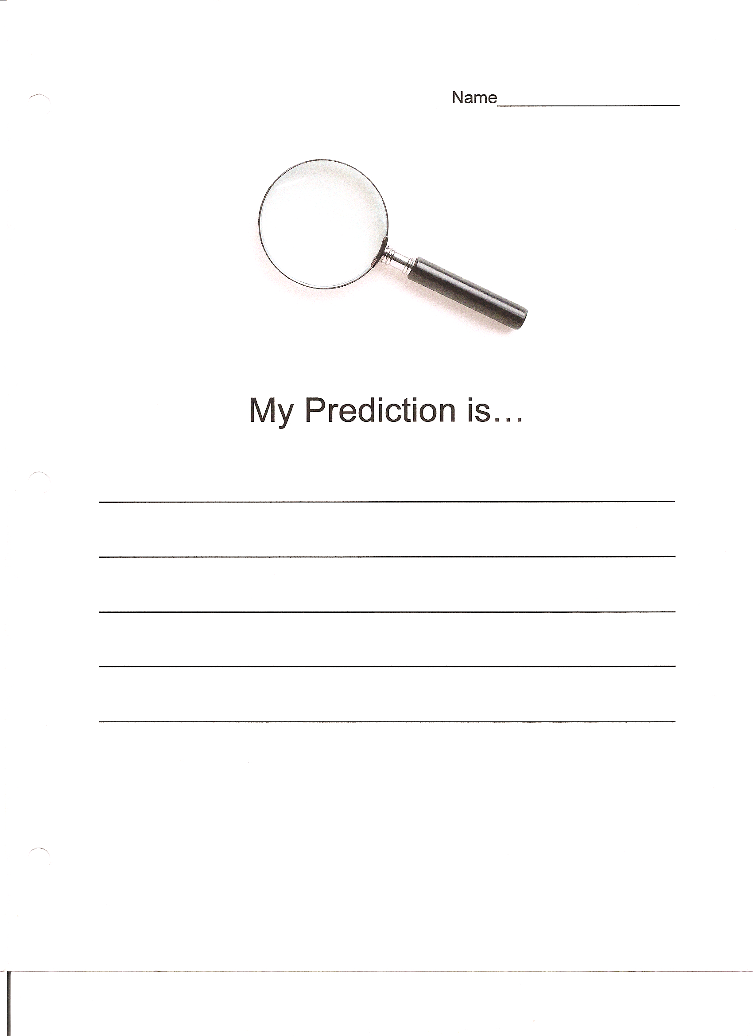
Post-Assessment

The post-assessment will be for students to complete their KWL booklet and fill in the learned section. There will also be a test, which will be read question by question to the entire class to make sure they know what the question is asking. The assessment will be ten questions that will allow the teacher to reflect upon student learning and if the students learned about liquids and solids. The KWL booklet will allow the teacher to see what the students learned that may not be a part of the test. Students will have the opportunity to share their favorite parts of learning about liquids and solids.

Name:______________
Liquids and Solids

Name 2 liquids:

1.________ 2.________

Name 2 solids:

3.________ 4.________

Write T if the statement is true or F if the statement is false.

5.____ Water is a liquid.

6.____ A rock is a solid.

7.____ A desk is a liquid.

Circle the correct answer.

8. What is ice?
a. solid
b. liquid

9. As an illustrator in my group my job it to:
a. gather materials
b. draw a picture of our experiment
c. ask questions my group may have

10. Molecules in liquids are:
a. close together
b. far apart

References
Chiarelott, Leigh. (2006). Curriculum in context: designing curriculum and instruction for teaching and learning in context. Thompson Wadsworth.
Common Core Standards. 2010.
Halberstadt, A. G., Denham, S. A., & Dunsmore J. C. (2001). Affective social competence. Social Development, 10, 79-119.
Ohio Academic Content Standards. ODE.

Reiber, L. P., & Noah, D. (1998). The value of serious play. Educational Technology, 38(6), 29-37.
Warner, L. & Parker, W. Francis. (2005). "You're it!": Thoughts on play and leaning in schools.

