Instructional Design- Chocolate Forces and Motion Sub Unit
Stephanie Fletcher
Bowling Green State University

Rationale/Statement of Purpose
As an early childhood educator, I have noticed on several occasions, that several classroom teachers push science aside when it comes time for state testing. For example, when I student taught third grade last spring, my focus from the end of February to early April was test preparation for the third grade Ohio Achievement Assessment (OAA) that measures student proficiency in reading and mathematics. Even though there were some instances where I would teach science, students would receive much more time on reading and math because these were the subjects that were tested on the OAA. I personally think it is important for teachers to balance their instruction so that students get a variety of subjects in throughout the school day. When I finally got to teach an in depth science unit on forces and motion, students explained to me that this was their favorite subject because they got to participate in hands on activities, which many learned from. On my last day of student teaching, my students gave me a book that they had each written a page in of what they enjoyed best about my teaching and several of them said they loved making their “puff mobiles” to learn about forces and motion. These were cars that they created out of paper, life savers, straws, and tape to learn how the mass of an object can affect the force it requires to move. Based on the positive student comments about my science unit and seeing frustration when they were constantly doing test preparation, tells me that if we as educators just balance our school day, then the students will be more motivated and in essence learn more. According to a recent article that I read the authors comment on a research study they did in a Midwestern state where they gave a sample of 164 elementary teachers a survey on science instruction and how it has changed since No Child Left Behind became a law when they state, “More than half of these teachers indicated they have cut time from science instruction since NCLB became a law” (Griffith, Scharmann, 2008, p. 35). In addition to this, another recent article that I read indicated that, “In light of the importance science plays in our lives and society, it is perplexing to observe the minimal attention given to science instruction, especially in the elementary grades”(Conderman, Woods, 2008, p.76). The authors of this article go on to further discuss how a lot of careers require scientific knowledge and that life would be a lot harder without some inventions scientists developed such as the cell phone, computer, and automated traffic signals (Conderman, Woods, 2008). Therefore, it is clear that a lack of science instruction at the elementary level is definitely a problem that needs to be solved and my instructional design seeks to solve this issue. My instructional design seeks to solve this issue by doing an in depth science unit that includes content on forces and motion and allows the students to contextualize their learning and relate it to their real life by having the opportunity to invent their own chocolate bar or food. This shows them the importance of science education and how scientific knowledge and inventions can assist with day to day living. In addition to this, the students take a closer look at the simple machines used to make chocolate and the forces that these simple machines require to operate. This content and sub-unit clearly seek to solve the problem of science instruction not only because the content involves science, but it also connects science to real life situations that will allow them to be successful in the 21st Century by showing them how scientific knowledge can benefit society.
For my instructional design I used the 5E model approach that was provided in chapter 8 of our text. I chose to use this model because it is not only reputable and research based, but it is also because in this instructional model, the teacher is more of a guide rather than the leader (Chiarelott, 2006). I personally believe that students construct their own learning through experiences and a good way to do this is through the 5E model since the students are more of the teacher and the classroom teacher is more of a guide to help them through the process and identify any misconceptions the students have while they are constructing their own knowledge. I also chose the 5E approach because it is hands on and it is applicable to all ages and according to our text is proven to be a successful learning model from kindergarten through college in the areas of science, mathematics, and social studies (Chiarelott, 2006). Therefore, since it is applicable to multiple age levels, it proves this model is successful and useful to the students.
My instructional design fulfills the needs of the learner because the activities in my three lessons on forces and motion connect what they are learning to real life situations. For example, in the beginning of the sub unit the students learn about the concept of the force of a push verses the force of a pull. They then work in small groups to investigate various cooking tools used to make chocolate such as a wooden spoon and piece of dollhouse furniture that resembles an oven that they may see in daily life and determine whether or not these objects require the force of a push or a pull. This activity meets the needs of the learner because it is hands on, uses objects they see in daily life, and allows them to build off their peer’s ideas. In addition to this, my instructional design also fulfills the needs of the learner because it involves active activities that allow students to move around and is not just worksheet or textbook based. It is important, especially at the elementary level, for the students to do something that is active since they have a smaller attention span than a high school student. I believe the lesson I have on inventions fulfills just that. In one activity in my instructional design, I have the students invent their own chocolate bar or food and the students then the students compile their inventions to choose what simple machine would be best to produce their chocolate invention. This is not only active, but is also motivating for the students since most of them probably enjoy chocolate. In addition to being a fun and motivating activity it also shows students how to be economically successful by inventing something and making a wise decision on what simple machine to use to produce mass numbers of their invention. Therefore, this instructional design fulfills all needs of the learners.
I believe that my instructional design also fulfills the needs of the society because as stated before, after the students invent their chocolate bar or food they have to compile all of their inventions and decide what simple machine would be best to mass produce these chocolates. Therefore it prepares them for making a successful career decision and how to become economically successful by choosing a simple machine that will quickly make the chocolates that they invent. Overall, I believe my instructional design fulfills the needs of a society because it teaches the students how to work together as a class to make a decision and social responsibilities the students may have in their future careers.
There is definitely significant value to the subject matter that is taught in my instructional design. The 5E approach that I am taking to this sub unit is by starting off with basic knowledge on forces and motion. Furthermore, my lessons are presented in a way that is inquiry based, which I feel shows that the subject matter is of value. The students start off in the 5E unit by exploring various objects that require the force of a push or a pull and are asked guided questions to arrive at new concepts. Later, the students move into discovering relationships between that activity and learning about simple machines used to make chocolate of which they will then connect to their inventions of a chocolate bar and reflect on their generalizations of what it takes to make that chocolate bar. Overall, I feel that the subject matter is significant enough to teach and will contribute to the education of young children because it allows them to construct their own knowledge through the 5E model and connects to real world situations such as simple machines used in daily life and persuading an audience to use a certain simple machine to make a chocolate bar best, which connects to real world situations of making decisions in a career.
The educational goal or anticipated results of this sub unit and instructional design is to get students to understand the importance of science and how scientists contribute to society, whether it be an invention of a chocolate bar or even a computer. The main purpose of this sub unit is to get students to understand forces and motion and how it connects to daily life such as pushing a door shut or pulling a dresser drawer open. Ultimately the goal is to get across that science is in fact important and significant enough to teach in the daily curriculum so that students may be successful in the 21st Century.

Subunit Learner Outcomes
Science
- Students will be able to create or invent their own chocolate bar after learning the history of it and how it is made. (Application)
- Students will be able to break down the simple machines used to make chocolate and identify whether it requires the force of a push or pull. (Analysis)
- Students will be able to compile their inventions and choose what simple machine would best produce their invented chocolate food product. (Synthesis)

Pre-Assessment
Since this sub unit is for third grade and they are younger students, the pre-assessment is a small activity where the students will respond to a journal prompt that relates to what their general knowledge would be on the topic of forces and motion, inventions, and simple machines. The journal prompt would be: Imagine you were asked to invent a board game about chocolate that would be sold at Toys R Us and required the force of a push and a pull in some part of the game, whether it be the actual game itself or even the game pieces. Draw your invention below and explain on the writing lines below what simple machine you would use to make this board game in addition to labeling where on the board game or game piece it would require the force of a push and the force of a pull. This measures the students overall knowledge on the topic of inventions, simple machines, and the concept of a push verses a pull.
There is no one correct answer as they can invent any board game they want. However, they must correctly label and explain how their chocolate board game invention requires the force of a push or pull. For example, if they created a chocolate board game that had a little wagon as the game piece and each time a player rolled the dice whatever number the player landed on, that child would put that amount of m&ms in his or her wagon. The student could then go on to discuss how each game piece requires the force of a pull since each game piece is a wagon and in order to move the player must pull on the wagon. After this, the student could discuss how the force of a push is required when folding up the game board. As long as they can logically explain how and where on the toy the force of a push and pull is required, then it would be counted as correct. Overall though, I do feel that this pre-assessment is definitely appropriate for the age group I am teaching because it is a fun and motivating activity, yet it relates directly to my sub unit on forces and motion and the theme of chocolate.
Chocolate Game Invention
Name:_________________________________
Directions: Read the following journal prompt and answer to the best of your ability. Be sure to look at all parts of the question.
Imagine you were asked to invent a board game about chocolate that would be sold at Toys R Us and required the force of a push and a pull in some part of the game, whether it be the actual game itself or even the game pieces. Draw your invention below and explain on the writing lines below what simple machine you would use to make this board game in addition to labeling where on the board game or game piece it would require the force of a push and the force of a pull.

____________________________________________________________________________________________________________________________________________________________________________________________________________________________________________________________________________________________________________________________________________________________________________________________________.
Lesson #1
Time Frame: 1 hour and 15 minutes
Content Standards: Grade 3
Standard: Physical Sciences
Indicator 4: Predict the changes when an object experiences force (e.g., push, pull, weight and friction)
Lesson Outcomes: (2)-Students will be able to break down the simple machines used to make chocolate and identify whether it requires the force of a push or a pull (Analysis) (This lesson will not focus on simple machines but will focus on the concepts of a push and pull relating it to cooking tools used to make chocolate that will be used in the next lesson to learn simple machines used to make chocolate.
Materials:
- Push verses Pull worksheet
- Student Journal Prompts (engage, evaluate)
- Forces and Motion song copy for each student
- Forces and Motion song written on chart paper
- Teacher pointer
- Bag of mystery cooking tools used to make chocolate
- Plastic Easter egg for each student with a handful of m&ms and scenarios

Engage: (10 minutes)
- The students will start off by responding to a journal prompt that requires them to think about the force of a push verses the force of a pull. The journal prompt will be as follows: Think about your morning routine before you come to school. Write about what objects you use to get ready such as a dresser to get your clothes or hair brush to brush your hair and think about whether these objects require you to use the force of a push or pull. Write at least three things down and be sure to respond in complete sentences. (5 minutes)
- After the students respond to the journal prompt, sing the push song. Be sure to give the students a copy of the song and point to the words on the chart paper so that they can follow along as they sing. Sing the song a couple times so that students start to understand the concept of a push and how this can be used as a force to move an object (5 minutes)
Explore: (15 minutes)
- After the song, the students will have the opportunity to work at their tables to identify a bag of mystery objects that require the force of a push, pull, or both.
- Explain to students that they are not to open the bag until told to do so.
- Pass out Push verses Pull worksheet and have the students fill this out according to the conclusions they come to as a group.
- Tell students to open the bag and start to go through the objects. Be sure to tell them to share the objects as a group. Remind students that they must fill out their push verses pull worksheets as a group and label each object with a name and what force it requires to move (push, pull, or both)
Explain: (10 minutes)
- After the students finish their worksheets, come back together as a whole class and discuss their findings.
- Ask the following guided questions to lead the discussion:
- What did all of these objects have in common? (They all require the force of a push, pull, or both to operate)
- What can these objects be used for or be used to make? Think about the theme of our unit (to make chocolate or cook)
- Give an example of one object that required the force of a push and explain how you know that or came to a decision as a group (answers will vary)
- Give an example of an object that required the force of a pull and explain how you know that or came to a decision as a group (answers will vary)
- Give an example of an object that required both the force of a push and pull and explain how you know that or came to a decision as a group(answers will vary)
Extend: (30 minutes)
- Give each student a plastic Easter egg with chocolate m&ms in each egg. Also in each egg will be a scenario of someone trying to make a chocolate food product and at some point having an issue or problem that the student must solve.
- Explain to the students that they will be writing down on the back of their scenario sheet how to solve the scenario they are given in their Easter egg.
- Tell students that they can eat their m&ms while they work.
- After students are done have each student share what they came up with.
Evaluate: (10 minutes)
- Give students a journal prompt that reads as follows: Imagine you were making chocolate chips cookies. What cooking tools would you need to bake these cookies? What type of force (push, pull, or both) would you use to use these cooking tools? Be sure to explain your answer.

Materials for Lesson #1
Push Verses Pull (Answer Key)
Name:_______________________________________
Directions: Please identify what the picture is of and label it on the line beside the picture. Then look in your baggie of mystery objects to find the object you see in the picture and write the object number that is labeled on object in the baggie where it says “object #.” Play with the objects and discuss as a group what force that object requires to operate. Then, circle the force it requires (push, pull, both).
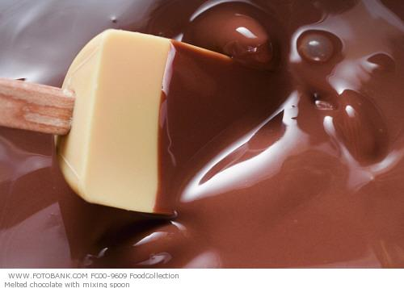 SPATULA OR SPOON
Object #: 2
Cirlce: PUSH PULL BOTH
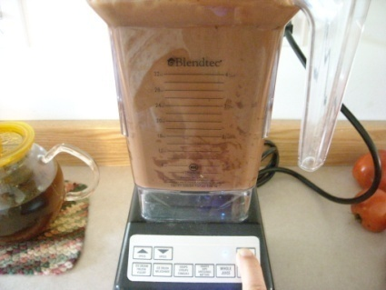BLENDER
Object #:1
Circle: PUSH PULL BOTH
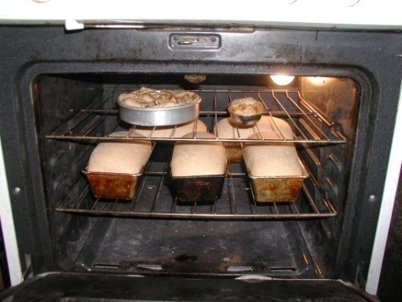 OVEN
Object #:4
Circle: PUSH PULL BOTH
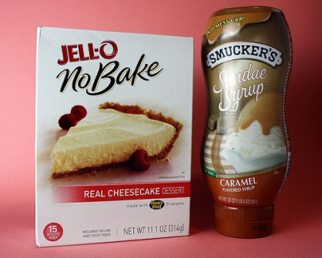 CHOCOLATE SYRUP BOTTLE
Object #: 3
Circle: PUSH PULL BOTH (If students put both they can be correct if they explain they would need to pull the lid to open it in addition to pushing the bottle to get the chocolate to come out. Either push or both can be counted as correct as long as they can explain their answer)

Push Verses Pull
Name:_______________________________________
Directions: Please identify what the picture is of and label it on the line beside the picture. Then look in your baggie of mystery objects to find the object you see in the picture and write the object number that is labeled on object in the baggie where it says “object #.” Play with the objects and discuss as a group what force that object requires to operate. Then, circle the force it requires (push, pull, both).
________________________________________
Object #: ___
Cirlce: PUSH PULL BOTH
__________________________________________
Object #:___
Circle: PUSH PULL BOTH
_____________________________________________
Object #:___
Circle: PUSH PULL BOTH
_________________________________________________
Object #: ___
Circle: PUSH PULL BOTH

Engage Phase Journal Prompt
Name:______________________________________
Think about your morning routine before you come to school. Write about what objects you use to get ready such as a dresser to get your clothes or hair brush to brush your hair and think about whether these objects require you to use the force of a push or pull. Write at least three things down and be sure to respond in complete sentences.
_______________________________________________________________________________________________________________________________________________________________________________________________________________________________________________________________________________________________________________________________________________________________________________________________________________________________________________________________________________________________________________________________________________________________________________________________________________________________________________________________________________________________________________________________________________________________________________________________________________________________________________________________________________________________________________________________________________________________________.
Evaluate Journal Prompt
Name:__________________________________
Imagine you were making chocolate chip cookies. What cooking tools would you need to bake these cookies? What type of force (push, pull, or both) would you use to use these cooking tools? Be sure to explain your answer.
__________________________________________________________________________________________________________________________________________________________________________________________________________________________________________________________________________________________________________________________________________________________________________________________________________________________________________________________________________________________________________________________________________________________________________________________________________________________________________________________________________________________________________________________________________________________________________________________________________________________________________________________________________________________________________________________________________________________________________________________________________________________________________________________________________________________________________________________________.
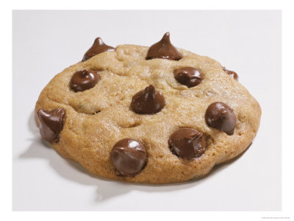
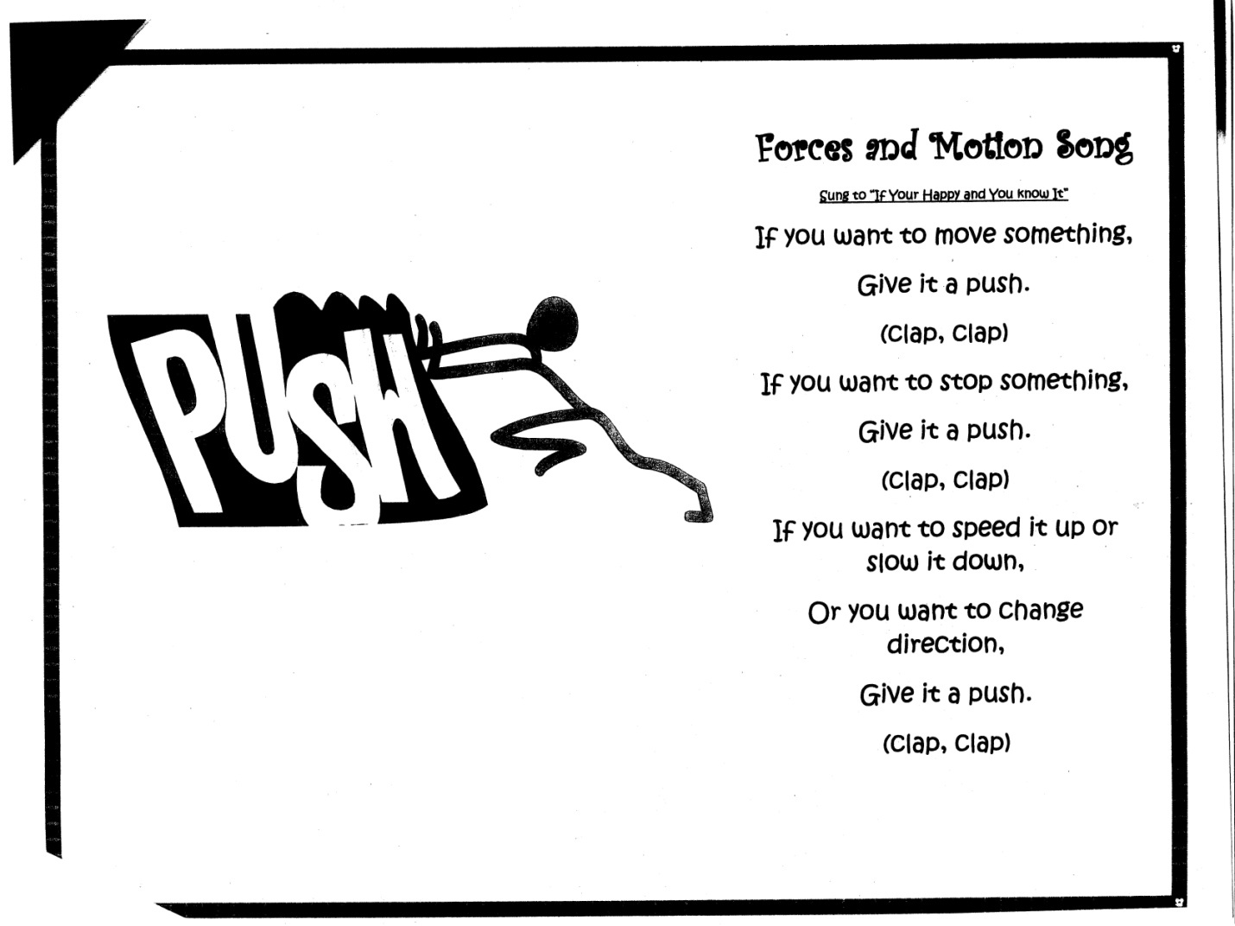

From my cooperating teacher from student teaching Mrs. Welly-Naumann

Scenarios for Easter Egg Activity Answer Key
Scenario 1: You are baking a chocolate cake and need to get your cake out of the oven. The oven door is stuck. What force will you need to use in order to open the oven door? Be sure to explain your answer and how you know what force to use. (pull, explanations will vary)
_________________________________________________________________________________________________________________________________________________________________________________________________________________________________________________________________________________________________________________________________________________________________________________________________________________________________________________________________________________________________________________________________________________________________.
Scenario 2: You are baking chocolate cupcakes and they accidentally caught on fire. To escape, you need to get out of the room. What force will you need to use to open and close the door behind you so you can escape the fire? Explain your answer. (push and pull, explanations will vary)
___________________________________________________________________________________________________________________________________________________________________________________________________________________________________________________________________________________________________________________________________________________________________________________________________________________________________________________________________________________.

Scenario 3: You are stirring brownie mix because you are making brownies. What cooking tool would you need to use to stir the brownie mix and what force does this cooking tool require? Explain your answer. (spoon or spatula names of tools and explanations will vary, push and pull)
____________________________________________________________________________________________________________________________________________________________________________________________________________________________________________________________________________________________________________________________________________________________________________________________________.
Scenario 4: You accidentally put a wrong ingredient in the mixing bowl for the brownies. Luckily, you haven’t mixed the ingredients yet, so you can take it out. What force would you need to use to take the ingredient out of the bowl? Explain your answer. (pull, explanations will vary)
__________________________________________________________________________________________________________________________________________________________________________________________________________________________________________________________________________________________________________________________________________________________________________________________________________________________________________________________________________________.

Scenarios for Easter Egg Activity
Scenario 1: You are baking a chocolate cake and need to get your cake out of the oven. The oven door is stuck. What force will you need to use in order to open the oven door? Be sure to explain your answer and how you know what force to use.
_________________________________________________________________________________________________________________________________________________________________________________________________________________________________________________________________________________________________________________________________________________________________________________________________________________________________________________________________________________________________________________________________________________________________.
Scenario 2: You are baking chocolate cupcakes and they accidentally caught on fire. To escape, you need to get out of the room. What force will you need to use to open and close the door behind you so you can escape the fire? Explain your answer.
___________________________________________________________________________________________________________________________________________________________________________________________________________________________________________________________________________________________________________________________________________________________________________________________________________________________________________________________________________________.

Scenario 3: You are stirring brownie mix because you are making brownies. What cooking tool would you need to use to stir the brownie mix and what force does this cooking tool require? Explain your answer.
____________________________________________________________________________________________________________________________________________________________________________________________________________________________________________________________________________________________________________________________________________________________________________________________________.
Scenario 4: You accidentally put a wrong ingredient in the mixing bowl for the brownies. Luckily, you haven’t mixed the ingredients yet, so you can take it out. What force would you need to use to take the ingredient out of the bowl? Explain your answer.
__________________________________________________________________________________________________________________________________________________________________________________________________________________________________________________________________________________________________________________________________________________________________________________________________________________________________________________________________________________.

Lesson #2
Time Frame: 2 hours and 35 minutes (split into three days due to field trip and simple machines activity)
Content Standards: Grade 3
Standard: Physical Sciences
Indicator 2: Describe an objects motion by tracing and measuring its position over time
Indicator 4: Predict the changes when an object experiences a force (e.g., a push or pull, weight and friction).
Lesson Outcomes: (2): Students will be able to break down the simple machines used to make chocolate and identify whether it requires the force of a push or pull. (Analysis) (This lesson uses knowledge previously learned in the first lesson to learn simple machines used to make chocolate. The students will use their knowledge on a push verses a pull to identify what force each simple machine uses.
Materials:
- Computer to play YouTube video on the making of chocolate
- YouTube video link (http://www.youtube.com/watch?v=VaWi1GK3Jzo&playnext=1&list=PLFCD3CB4E01FEFA3D)
- Simple Machines Guide
- Simple Machines Video Worksheet
- Anthony Thomas Chocolates Simple Machines Discoveries worksheet
- Rubric for evaluation of simple machine created
- Spoons, tape, cotton balls, popsicle sticks, glue, string, paper clips, hole punch, scissors (materials provided for students to create their own simple machines)
- Simple Machines journal prompt
Engage: (30 minutes)-Day 1
- Pass out the simple machines guide. Ask them the following guided questions using the simple machines guide:
- Have you ever noticed any of these simple machines used before? If so, where? (answers will vary)
- What forces do some of these simple machines require? (answers will vary)
- Explain to students that they will be watching a video about how chocolate is made. Tell them to use their simple machines guide to help them fill out their worksheet as they watch the video. The students are to list at least three simple machines they see in the video to make chocolate and what force or forces do these simple machines require in order to operate.
- Watch the video and remind students to fill out their worksheet throughout the video.
- After the video, discuss the following guided questions to reflect on the video they watched:
- What simple machines did you see in the video that you see on your simple machines guide? (answers will vary)
- What simple machines did you see in the video that required the force of a push? Explain how you knew this. (answers will vary)
- What simple machines did you see in the video that required the force of a pull? Explain how you knew this. (answers will vary)
- What simple machines did you see in the video that required both the force of a push and a pull? Explain how you knew this. (answers will vary)
Explore: (1 hour)-Day 2
- Explain to students that they will be going on a field trip to a chocolate factory where they will observe and learn more about simple machines used to make chocolate. (This of course will be planned ahead of time with permission slips signed)
- Students will take their field trip to the Anthony Thomas Chocolate Factory and take a tour.
- Group students according to how they sit at their tables and have each group of students walk around with their chaperone and have them fill out their “Anthony Thomas Chocolates Simple Machines Discoveries” worksheet.
- Once students return to school ask them the following guided questions:
- What simple machines did you find when you toured the Anthony Thomas Chocolate Factory? (answers will vary)
- What simple machine did you think helped mix the chocolates? How did you know (wheel and axil, mixer, answers will vary on how they knew)

Explain: (10 minutes)
- After asking the students guided questions after the field trip, have them take out their simple machines guide and walk through it with them to clarify any misconceptions about simple machines.
- Have students answer a journal prompt about simple machines to be sure students understand this.
- After the students are done answering their journal prompts have students share them to be sure there are still no misconceptions with the students about simple machines.
Extend: (45 minutes-day 3)
- Explain to students that they will be creating their own simple machine with materials provided to make their favorite chocolate bar.
- Explain to students that they are allowed to use their simple machines guide to help them with this activity.
- Walk around the classroom as students create these (30 minutes)
- After all of the students are done creating their simple machines, let each student share their simple machine. When each student shares their simple machine ask the following guided questions: (15 minutes)
- Why did you choose the simple machine you chose to build? (answers will vary)
- What forces does your simple machine require in order to operate? (push, pull, both?) How do you know? (answers will vary)
- Why would this simple machine make making chocolate easier? How do you know? (answers will vary)
Evaluate: (10 minutes)
- Fill out the rubric attached to this lesson for each student’s simple machine to acquire their knowledge of simple machines and how they operate.

Materials for Lesson #2
Simple Machines Guide
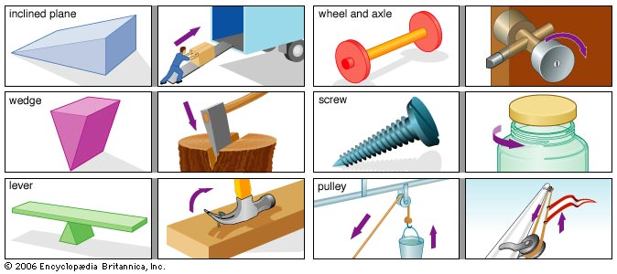
Simple Machines Video Worksheet
Name:__________________________________________
Look for simple machines in the video that are used to help make chocolate. You must identify at least 3 simple machines. Be sure to write down what force that simple machine requires to operate. You may use your simple machines guide to help you.
______________________________________________________________________________________________________________________________________________________________________________________________________________________________________________________________________________________________________________________________________________________________________________________________________________________________________________________________________________________________________________________________________________________________________________________________________________________________________________________________________________________________________________________________________________________________________________________________________________________________________________________________________________________________________________________________________________________________________.
Anthony Thomas Chocolates Simple Machines Discoveries
Name:_____________________________
Directions: As you are taking your tour of the chocolate factory look for the following simple machines. Write down what the simple machine was doing to help make chocolate and draw a picture of it next to your explanation.
Wheel and Axil:_____________________________________________________________________________________________________________________________________________________.

Pulley:____________________________________________________________________________________________________________________________________________________.

Inclined Plane:______________________________________________________________________________________________________________________________________________________.

Rubric for Evaluating Simple Machines
Circle a 1, 2, or 3 for each category:
1= needs improvement
2= meets requirements
3= student goes above and beyond requirements and it is well done

Student constructed and assembled their simple machine correctly
1 2 3
Comments:
Student provided a clear explanation of what force this simple machine requires in order to operate
1 2 3
Comments:
Student presented an overall knowledge on the purpose of their simple machine and how it helps to make their favorite chocolate
1 2 3
Comments:
Simple Machines Journal Prompt
Name:____________________________
Bob has a ton of bricks that he needs to move from one truck to another truck. What simple machine would be best to help Bob move the bricks? Explain your answer and why you chose the simple machine you chose verses other simple machines.
________________________________________________________________________________________________________________________________________________________________________________________________________________________________________________________________________________________________________________________________________________________________________________________________________________________________________________________________________________________________________________________________________________________________________________________________________________________________________________________________________________________________________________________________________________________________________________________________________________________________________________________________________________________________________________________________________________________________________________________________________________________________________________________________________________________________________________________________.

Lesson #3
Time Frame: 45 minutes
Content Standards: Grade 3
Standard: Scientific Ways of Knowing
Indicator 3: Explore through stories how men and women have contributed to the development of science.
Indicator 5: Discuss how both men and women find science rewarding as a career in their everyday lives.
Standard: Physical Sciences
Indicator 4: Predict the changes when an object experiences a force (e.g., push or pull, weight and friction)
Lesson Outcomes: (1, 3)
- Students will be able to create or invent their own chocolate bar after learning the history of it and how it is made. (Application)
3. ) Students will be able to compile their inventions and choose what simple machine would best produce their invented chocolate food product. (Synthesis) (This lesson compiles all of what they have learned about forces and motion which includes a push verses a pull and simple machines. This closing lesson will combine the knowledge the students learned in the previous two lesson so that they can invent their own chocolate bar, which will then connect to the academic content standard of finding science as a rewarding career in everyday life.
Materials:
- History of chocolate video
- So You Want To Be An Inventor? By: Judith St. George and David Small
- Rubric for evaluation
- Markers
- White poster for each student
- Various chocolate bar wrappers for each table group of students
- Notebook paper for recorders in each table group
- Invention process handout
Engage: (15 minutes)
- Start off by introducing students to the history of chocolate video (http://www.youtube.com/watch?v=vA1w1-PTJlY&feature=related ) so they can start to see how chocolate came to be what it is today.
- After the video ask the following guided questions:
- Where did chocolate come from? (from a cocoa bean in Venezuela)
- What could you use cocoa beans in exchange for back in history? (money or gold)

Explore: (10 minutes)
- Have students work in their table groups, and have each group explore different chocolate bar wrappers and have one recorder in the group write down what they notice about the chocolate bar wrapper. Point them to the nutrition facts.
- After the students explore the chocolate bar wrappers, ask the following guided questions:
- What did you notice about these chocolate bar wrappers? (answers will vary)
- What types of ingredients were in each chocolate bar? (answers will vary)
- Do any of them have anything in common aside from being chocolate? (answers will vary)
- What process did these chocolate bars have to go through to exist? (the invention process)
Explain (15 minutes)
- After this, explain to students that since the origination of chocolate, there have been inventions of different types of chocolate candies or chocolate bars and that there is a step by step invention process.
- After this, read the book “So You Want To Be An Inventor?”
- After reading the book aloud, write down the step by step invention process on the dry erase board according to the book.
- Go through the book page by page and have students give you the step by step process. After this provide students with the invention process handout from NASA website
(http://scifiles.larc.nasa.gov/text/kids/Research_Rack/tools/invention_process.html)

Extend (30 minutes)
- Explain to the students that they will be inventing their own chocolate bar and will be drawing their invention on a poster board.
- Explain to the students that they will need to create an advertisement slogan for their candy bar and they will also need to create a simple machine used to create mass numbers of their chocolate bar. In addition to this, the students will be writing out a paragraph of how they followed the invention process to invent their chocolate candy bar.
- Before students invent their chocolate bar, on the dry erase board, write what the need is (chocolate bars) and brainstorm on the white board as a class what kind of chocolate bars you could create or invent. Explain to students that they are to select 1 chocolate bar that they would like to invent.
- After this, bring the students to the computer lab and have them write down 3-5 facts on the research of chocolate bars.
- After this, bring students back to the classroom and have them start on their posters. Remind students of the directions for the poster board (picture of invented chocolate bar, picture of simple machine used to produce their invented product, an advertisement slogan, and a paragraph explaining how they followed the invention process
- Pass out coloring utensils and poster boards to the students.
- Have students share their inventions and simple machines.
- After this, vote as a class what simple machine would be best to mass produce all of these chocolates.
Evaluate (10 minutes)
- Use the rubric attached to this lesson to evaluate students on their inventions and the simple machines they chose to produce their inventions.

Materials for Lesson #3
Invention of a Chocolate Bar Rubric
Circle a 1, 2, or 3 for each category:
1= needs improvement
2= meets requirements
3= student goes above and beyond requirements and it is well done
Student thoroughly explains how they came up with the invention they did
1 2 3
Student draws a clear picture of invention on their poster board
1 2 3
Student thoroughly explains how the simple machine they chose will produce mass amount of their chocolate bar quickly
1 2 3
Student reads paragraph how they would follow the whole invention process if they were to actually sell their chocolate bars the invented
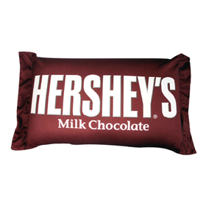
1 2 3

Invention Process Flowchart
Step 1 - Identify a Need or Want
Survey peers, family, and community members.
Step 2 - Brainstorm Solutions
Generate possible ideas/solutions by using a brainstorming strategy.
Step 3 - Select a Solution
Look at all the solutions!
Develop a list of criteria to help evaluate your solution ideas.
Evaluate each solution by using the criteria and identify the best solution.
Survey your family and friends to get their opinions and verify your chosen solution.
Name your chosen solution/invention!
Step 4 - Conduct Research
Research your invention.
Step 5 - Develop a Plan
Plan how to develop your invention.
Step 6 - Design and Build a Model
Make a sketch or drawing!
Decide on materials!
Make a model or a prototype!
Determine if the invention can be improved.
Step 7 - Test the Model
Demonstrate what the model does.
Record the test results in the Inventor's Log.
Collect feedback on your invention.
Make needed changes.
Step 8 - Manage the Invention
Share the invention.
Enter an invention contest.
Place the invention on public display.
Apply for a patent.
Start your own business to market you invention.
Step 9 - Evaluate Your Invention Process & Product
Identify strengths and weaknesses of your invention process.
Identify strengths and weaknesses of your innovation/invention.

Post Assessment
The post assessment that I chose for this unit was a comprehensive paper and pencil test that measures student growth for the entire science sub unit of my curriculum design. The post assessment is a mix of multiple choice and short answer or extended response. I feel that this is best for students because it allows the teacher to see that not only can they answer a simple question about the topic taught to them, but they can also apply it to a real life situation in an extended response. As an educator, I feel it is important to get our students to apply the concepts we teach them, because often times it is seen that students will memorize facts for a test, but they are not able to apply those facts to a real life situation. In a recent article I read on this issue it discusses that with the amount of information available now to teach it is literally impossible for the human mind to remember every piece of information learned (ISTE, 2009). Therefore, this displays that the format of my post assessment is valuable in that the students are expected to answer general questions about what is taught in addition to applying the concepts to real life situations in an extended response question format.

Forces and Motion Post Test Answer Key
Name:__________________________
Directions: Circle the best possible answer for the following question
- When opening an oven door, what type of force is used?
- Push
- Pull
- Both A and B
- When stirring chocolate pudding in a bowl what force is used?
- Pull
- Push
- Both A and B
- What simple machine is a flag pole that is flying a Hersheys flag?
- Wheel and axil
- Pully
- Wedge
Directions: Answer the next four questions to the best of your ability. Be sure to explain your answers and write at least 3-5 sentences per questions.
- Choose one simple machine and explain how that simple machine would help produce chocolate. Be sure to explain what force the simple machine requires to operate. (answers will vary)
_______________________________________________________________________________________________________________________________________________________________________________________________________________________________________________________________________________________________________________________________________________________.
- Name a simple machine you might see at home or at school and explain what force it requires to operate. (answers will vary)
____________________________________________________________________________________________________________________________________________________________________________________________________________________________________________________________________________________________________________________________________________________________________________________________________________________________.
- Describe the invention process in detail. Invent a chocolate cereal and explain how you would go through the invention process to invent your cereal.(identify a need or want, brainstorm solutions, select a solution, conduct research, develop a plan, design a model, test the model, manage the invention, evaluate your invention)
_____________________________________________________________________________________________________________________________________________________________________________________________________________________________________________________________________________________________________________________________________________________________________________________________________________________________.

- Write a step by step process of opening a Hershey chocolate bar and explain what forces you would need to use to get the chocolate bar open. (answers will vary)
_________________________________________________________________________________________________________________________________________________________________________________________________________________________________________________________________________________.

Forces and Motion Post Test
Name:__________________________
Directions: Circle the best possible answer for the following question
- When opening an oven door, what type of force is used?
- Push
- Pull
- Both A and B
- When stirring chocolate pudding in a bowl what force is used?
- Pull
- Push
- Both A and B
- What simple machine is a flag pole that is flying a Hersheys flag?
- Wheel and axil
- Pully
- Wedge
Directions: Answer the next four questions to the best of your ability. Be sure to explain your answers and write at least 3-5 sentences per questions.
- Choose one simple machine and explain how that simple machine would help produce chocolate. Be sure to explain what force the simple machine requires to operate.
_______________________________________________________________________________________________________________________________________________________________________________________________________________________________________________________________________________________________________________________________________________________.
- Name a simple machine you might see at home or at school and explain what force it requires to operate.
____________________________________________________________________________________________________________________________________________________________________________________________________________________________________________________________________________________________________________________________________________________________________________________________________________________________.
- Describe the invention process in detail. Invent a chocolate cereal and explain how you would go through the invention process to invent your cereal.
_____________________________________________________________________________________________________________________________________________________________________________________________________________________________________________________________________________________________________________________________________________________________________________________________________________________________.

- Write a step by step process of opening a Hershey chocolate bar and explain what forces you would need to use to get the chocolate bar open.
_________________________________________________________________________________________________________________________________________________________________________________________________________________________________________________________________________________.

References
Chiarelott, L. (2006). Curriculum in Context. Belmont, CA: Wadsworth Cengage Learning.
Conderman, G., & Woods, C.S. (2008). Science instruction: an endangered species. Kappa
Delta Pi, winter 2008, 76-80.
Ohio Department of Education. (2002). Academic Content Standards K-12: Science.
Columbus: Ohio Department of Education.
International Society for Technology in Eduation (ISTE). (2009, February). Readers respond.
8-9.

