Instructional Design
Earth Science (Rocks and Minerals)

By: Kamilla Houk
Bowling Green State University

Rationale
In the news there is constant talk about how American schools are falling behind the rest of the world in the subjects of math and science. In order to make up for this deficiency, the United States is on a push towards getting American school children educated in math and science. We are trying to construct classrooms where children can be innovators instead of by-standers. However, with the constant strain of No Child Left Behind, schools are struggling to meet the demands of the world. According to the Phi Delta Kappan, “Schools are spending more time on reading and math, sometimes at the expense of subjects not tested,” (Jennings, & Rentner, 2006). The Phi Delta Kappan also stated, “To find additional time for reading and math, 71% of school districts are reducing time spent on other subjects in elementary schools,” (Jennings, & Rentner, 2006).
This unit will be designed using the Basic Lesson Planning Model and the lesson plans will include both the constructivist and behaviorist approaches (Chiarelott, 2006). I will start off each topic by being the leader, but then as we progress through the lessons, they will become more student based. After I introduce each topic, I will make sure that students have mastered the content before I move on. Since this is a concept-related sequence and the students need to obtain certain knowledge before going on, then I will conduct simple formative assessments throughout each lesson. By conducting formative assessments, I’ll be able to determine if I need to supplement with different activities to ensure mastery.
The first subunit I would teach would be on minerals. Even though children are more familiar with rocks, I feel that minerals need to be taught first since a rock is made up of one or more minerals. First of all, the students have to learn the different characteristics of minerals in order to be able to classify them. After the students learn the content about minerals, then they can apply it to life by getting the opportunity to perform different tests on minerals. This allows the students then to find a mineral in nature, look at the characteristics, and classify it by their findings.
The subunit on rocks continues to build on what the students learned about minerals. The students made the connection that rocks are made up of one or more minerals. Now they get the opportunity to look at different types of rocks and observe how they are constructed. This subunit allows the children to look at the metamorphic, sedimentary, and igneous rocks, and then make a sample of each one. This is beneficial to them because they get the hands on experience to see how each type is made. In the last section of this subunit, the students then look at all the different types of rocks and identify ways that these rocks have changed their environment.
This unit will allow the children to connect nature to their classroom. Students will be able to observe and measure the different characteristics of rocks, which include size, shape, color, and texture. In addition, the study of rocks can help the students apply the knowledge they acquire to learn about the layers of the Earth. There are many aspects the students will learn about including the different kinds of rocks and the characteristics of rocks that will help them to possibly solve some of the future problems. For example, their knowledge will help them to better understand weather, erosion, and the changes on Earth’s surface. In addition, they can learn about some of the problems that the Earth has encountered before. “By studying how the Earth worked in the past, we can better understand how we are working today,” (Scanlan, 2011). As children grow up, there are many misconceptions they have about why things occur, and it is our job as educators to correct these misconceptions. Rocks and minerals need to be taught in third grade to guide students. One main misconception with rocks is that children feel that rocks and minerals aren’t important to their lives. “Almost every product we use in daily life contains or depends on minerals that have to be mined,” (Hapkiewicz, 1999). “It is estimated that every person in the United States will use more than a million pounds of rocks, minerals, and metals during their lifetime,” (Rocks and minerals). Students need to be aware of the rocks and minerals around them and how they influence their life. Without rocks and minerals, life would be hard to live, and it’s important that students realize how important they really are.
References
1. Chiarelott, L. (2006). Curriculum in context. Thomson Wadsworth.
2. Hapkiewicz, A. (1999). Naïve ideas in earth science: common physical science
misconceptions. MSTA Journal, retrieved from www.msta-mich.org.
3. Jennings, J., & Rentner, D. (2006). Ten big effects of the no child left behind act
on public schools. Phi Delta Kappan, 88, 110 – 113.
4. Ohio Department of Education, (2011). New science education standards and
model curriculum. Columbus, OH:
5. Rocks and mineral uses. (n.d.). Retrieved from www.wmich.edu/corekids.
6. Scalan, k. (2011). Why should we study rocks? Retrieved from
http://ratw.asu.edu/aboutrocks_why.html
7. Science. (2006). Orlando, Florida: Harcourt School Publishers.
Subunit One: Minerals
- Students will define the characteristics of minerals. (Knowledge)
- Students will classify minerals based on the characteristics they observe. (Application and Analysis)
- Students will identify minerals after observing their hardness, color, and streak. (Knowledge).
- Students will contrast a mineral to a rock. (Analysis and Evaluation)
- Students will administer a scratch and streak test to classify different minerals. (Application)

Subunit Two: Rocks
- Students will define the three types of rocks. (Knowledge)
- Students will create a sedimentary rock by forming layers. (Synthesis)
- Students will explain how a melted chocolate chip is similar to an igneous rock. (Evaluation)
- Students will create a metamorphic rock by using heat and pressure. (Synthesis)
- Students will summarize how the three types of rocks are different from each other. (Evaluation)
Pre-Assessment
We’ll construct a KWL chart together as a class, and I’ll hang it on the science bulletin board. I’ll see what they know (K) about rocks and minerals, and I’ll list everything they say. I’ll pay attention to any misconceptions they have about rocks and minerals. Then I’ll ask what (W) they want to find out when we study rocks. The last part, L, will be used in my post-assessment.
Lesson Plan- Day One
Time Period Objectives:
- Students will define the characteristics of minerals. (Knowledge)
- Students will contrast a mineral to a rock. (Analysis and Evaluation)
Materials Needed:
- Student textbooks
- Worksheet I created for lesson 1 in the textbook
- Paper explaining how they are to conduct their rock collection
- Paper bags for them to put their rock collections in
- Student science notebook
Procedures:
- Introductory Activity: (10 minutes)
- Ask the students if they’ve ever found a rock outside somewhere and wondered what kind of rock it was, where it came from, or why it looked the way it did. Explain to them that we are going to begin a study on the different kinds of rocks and minerals.
- I’ll have my rock collection set up that has all the rocks labeled. I’ll give the students time to look at the different rocks and tell me what they notice about some of the rocks. In addition, I’ll have them tell which ones are their favorites and why.
- I’ll explain that they’ll get the opportunity to create their own rock collection and bring it in to share.
- Developmental Activity: (20 minutes)
- I’ll have the students get out their science books from their desks and turn to the first lesson in the book page 32.
- We’ll read this lesson popcorn style. This is where I draw a popsicle stick and see what student’s name I draw. That person will then read the first paragraph. They will also get the ball when it’s their turn to read. When I say popcorn, I’ll draw another name and then the person that read already will toss the ball to the new person. I like this game because students follow along because they want to hold the ball and read.
- In the book there are pictures of different kinds of minerals. I’ll have the students look at those and explain if they think that minerals are used in their natural state.
- After we read about the Mohs Scale, I’ll let the students touch different kinds of minerals. I’ll let them pass around Talc (which is very soft, and then let them look at my diamond ring (which is hard). I’ll then ask them about various minerals and what their hardness is on the Moh’s scale.
- On the dry erase board I’ll make the heading “Ways to Identify Minerals.” I’ll then let the students come up to the board and list the different ways that there are to identify minerals.
- We’ll read about rocks and discuss how they are different from minerals. Then I’ll have them look at the picture of the rock. They’ll be able to see that there are many different minerals that make up the one rock.
- Concluding Activity: (5 minutes)
- In their science journals, the students will make a graphic organizer with the main idea being minerals and rocks. Then we’ll talk about one supporting detail they learned about rocks and one supporting detail they learned about minerals.
- I’ll ask the students to give me examples of minerals they use that are changed from their natural state.
- Key Questions:
- How can you tell if something is a mineral?
- How is a rock different from a mineral?
Summary/Closure/Evaluation
- Closure (5 minutes)
- What are some ways that your life might be different without minerals? Also ask them, what are some minerals that you use everyday?
- Give them the brown paper bag and the worksheet that talks about their rock collection. I’ll let them know that they need to find 5 rocks no bigger than a baseball and bring them in. The next day we’ll compare our rocks and look at the different characteristics.
- Evaluation (15 minutes)
- They’ll complete the lesson worksheet that I created.
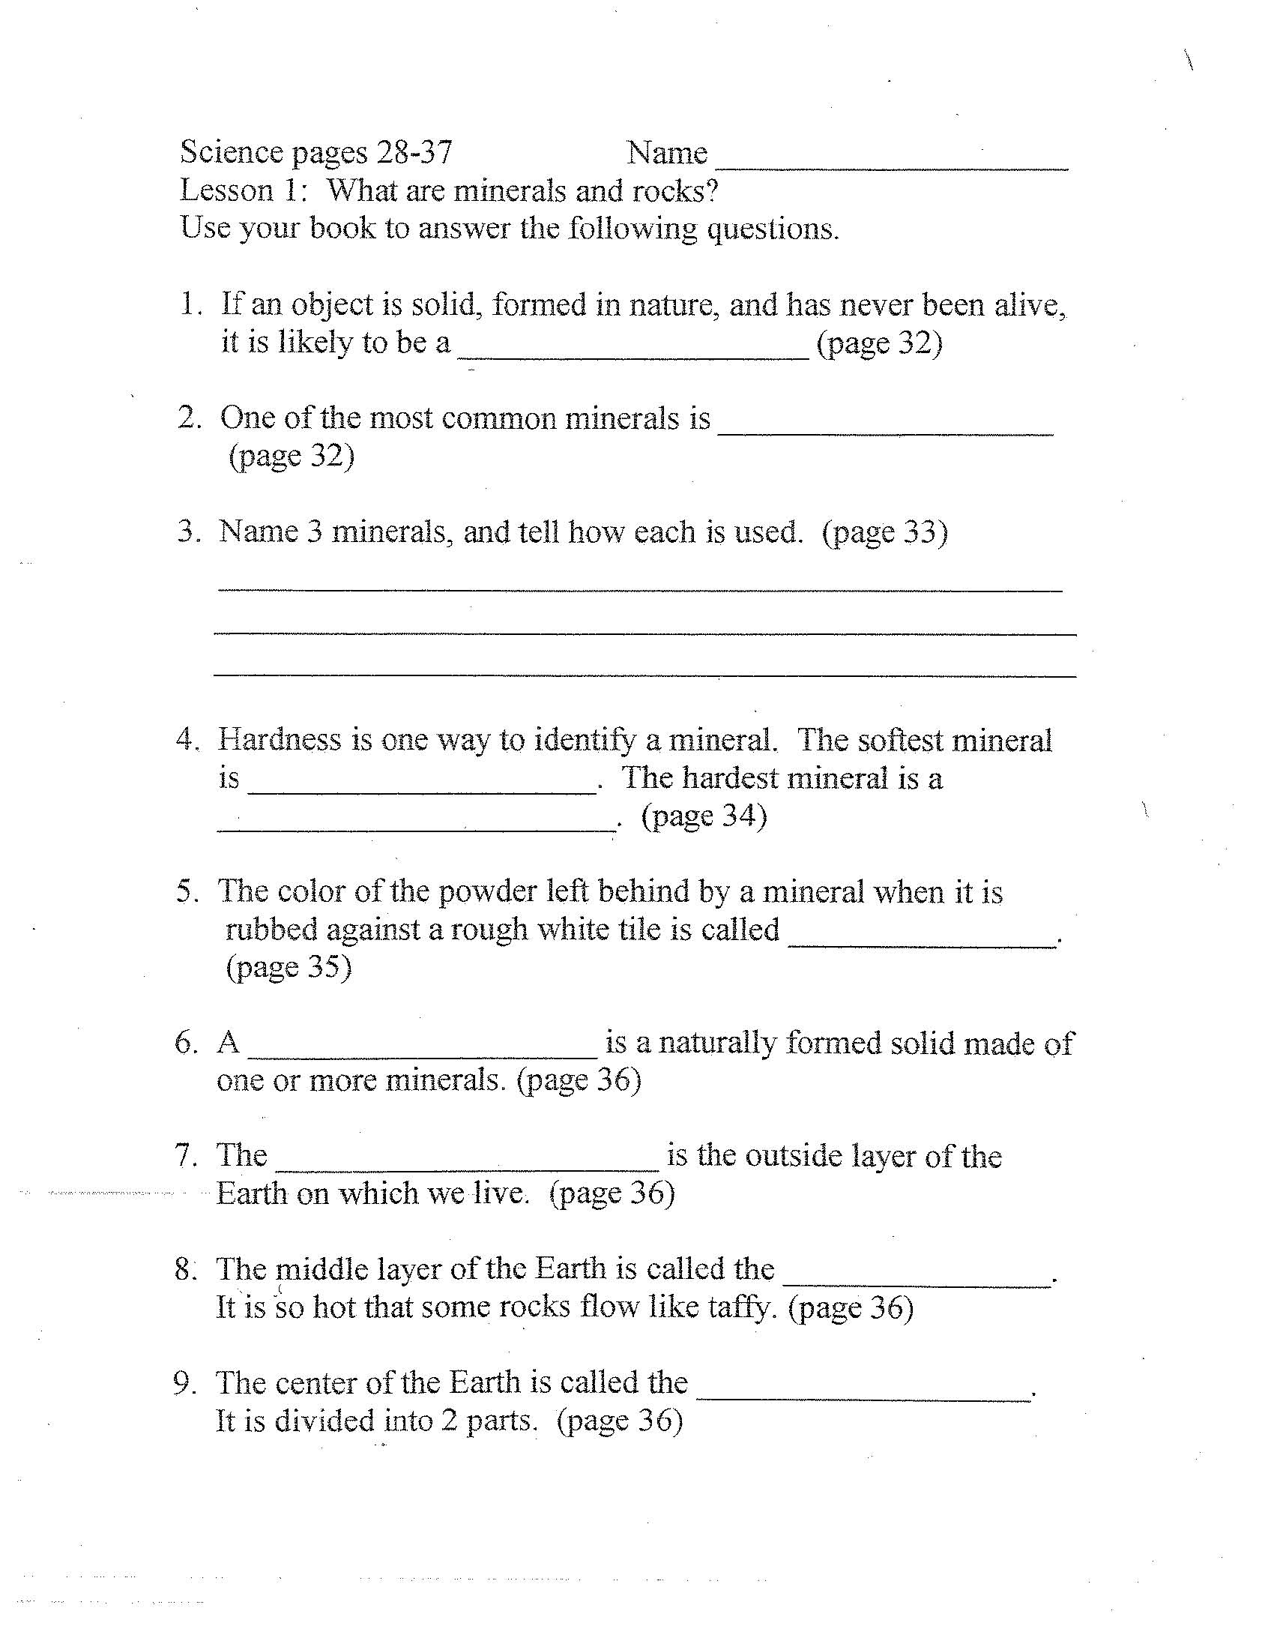

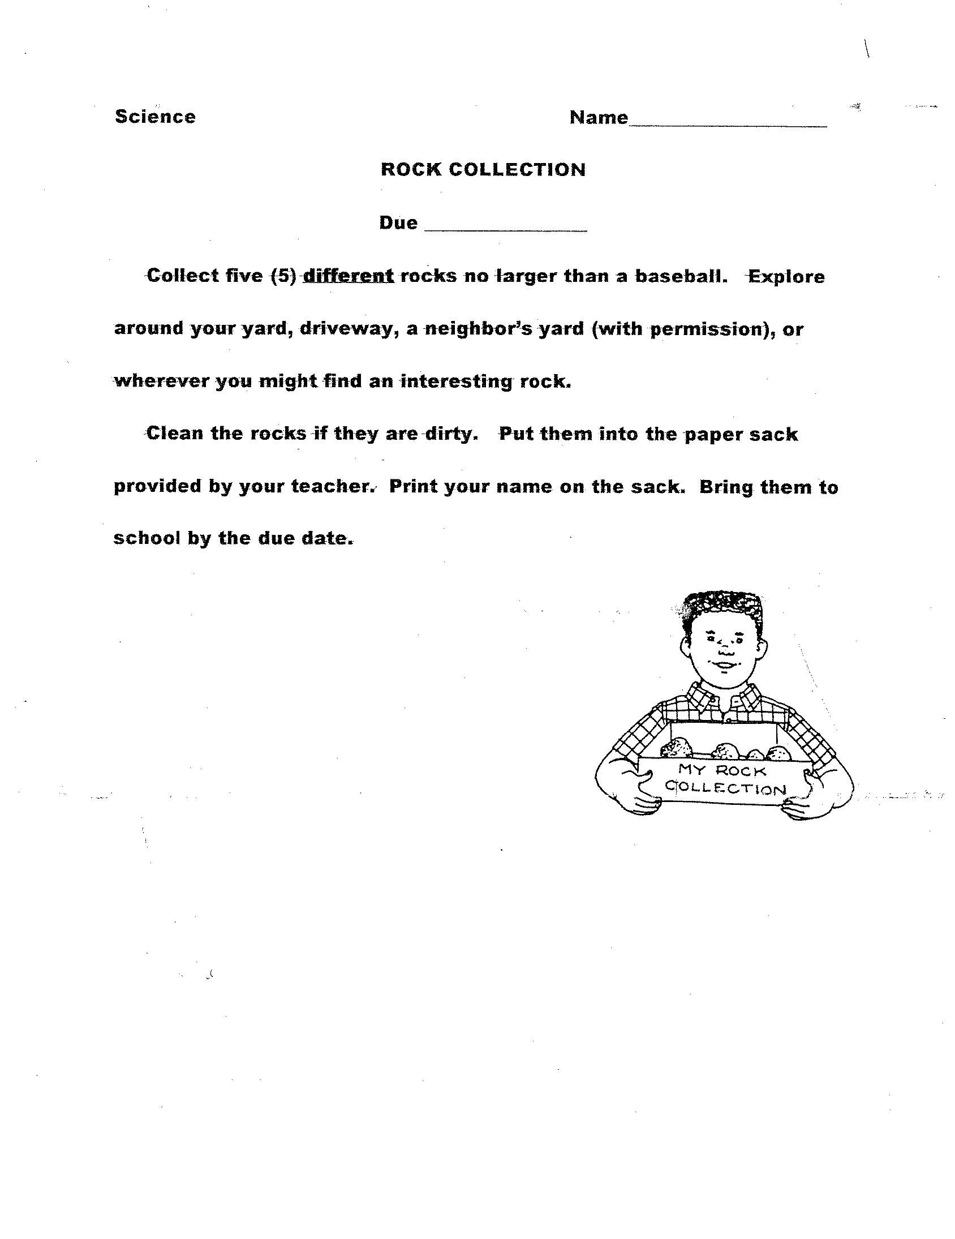

Lesson Plan- Day Two
Time Period Objectives:
- Students will classify minerals based on the characteristics they observe (Application and Analysis).
- Students will identify minerals after observing their hardness, color, and streak (Knowledge).
- Students will contrast a mineral to a rock (Analysis and Evaluation).
- Students will administer a scratch and streak test to classify different minerals (Application).
Materials Needed:
- Worksheet that turns into rock booklet
- There will be four groups and each groups needs the minerals calcite, mica, quartz, hematite, graphite, and tica.
- a penny to scratch the rocks and minerals
- science notebooks
- white tile squares
Procedures:
- Introductory Activity (5 minutes)
- We will review the different ways to identify a mineral. I’ll list the ways that the students say on the board. This will lead the students to today’s experiment about testing the streak and hardness of different minerals.
- The students will also get out their rock collections and we’ll set them out on their desks. They’ll get the chance to walk around the room and look at everybody’s rock collection.
- Developmental Activity (25 minutes)
- After everyone has looked at the rocks, then each child will get a chance to stand up and pick a rock to talk about. They can tell where they found it, and anything else they want to share.
- I will then pass out the “Rock Observations” worksheet. We’ll work through this worksheet together as a group. The students will need to draw and color a picture of the rock they have chosen. Then they need to describe the color, texture, luster, and the shape. When they are done, the worksheet will turn into a book and the students will get to hang them around the room.
- Next, the students will get to perform the scratch and streak test. I will have already divided the groups and each group will get six different minerals. In their science notebooks, we will set up a table that looks like this:
Minerals | Scratched by a penny? | Scratched by a fingernail? | Color of the Streak
Mica
Quartz
Talc
Calcite
Hematite
Graphite
- They will test each mineral and then fill in their chart with a yes or no if it was scratched by a penny or fingernail.
- When they have completed the scratch test, then I’ll give them a white square tile to complete the streak test. They’ll rub each mineral on the tile and see what color was left behind, if any.
- Concluding Activity: (10 minutes)
- As a group, we will discuss which minerals were scratched by a fingernail and a penny. Then we’ll discuss if any of them left a streak and what color.
- Ask the students to explain how the scratch and streak test can help classify minerals.
- Key Questions:
- What is the difference between a mark of powder left by a streak test and a scratch?
- How can performing a scratch test help you identify a mineral?
- Which mineral is harder: one that can be scratched by a penny or one that can be scratched by a fingernail? Explain.
Summary/Closure/Evaluation:
- Closure (5 minutes)
- Have students explain the characteristics of minerals and how they are used to classify minerals.
- Have students tell me the difference between a rock and a mineral.
- Evaluation (10 minutes)
- The students will list the six minerals they tested in order from hardest to softest. They’ll do this underneath their table that they constructed.
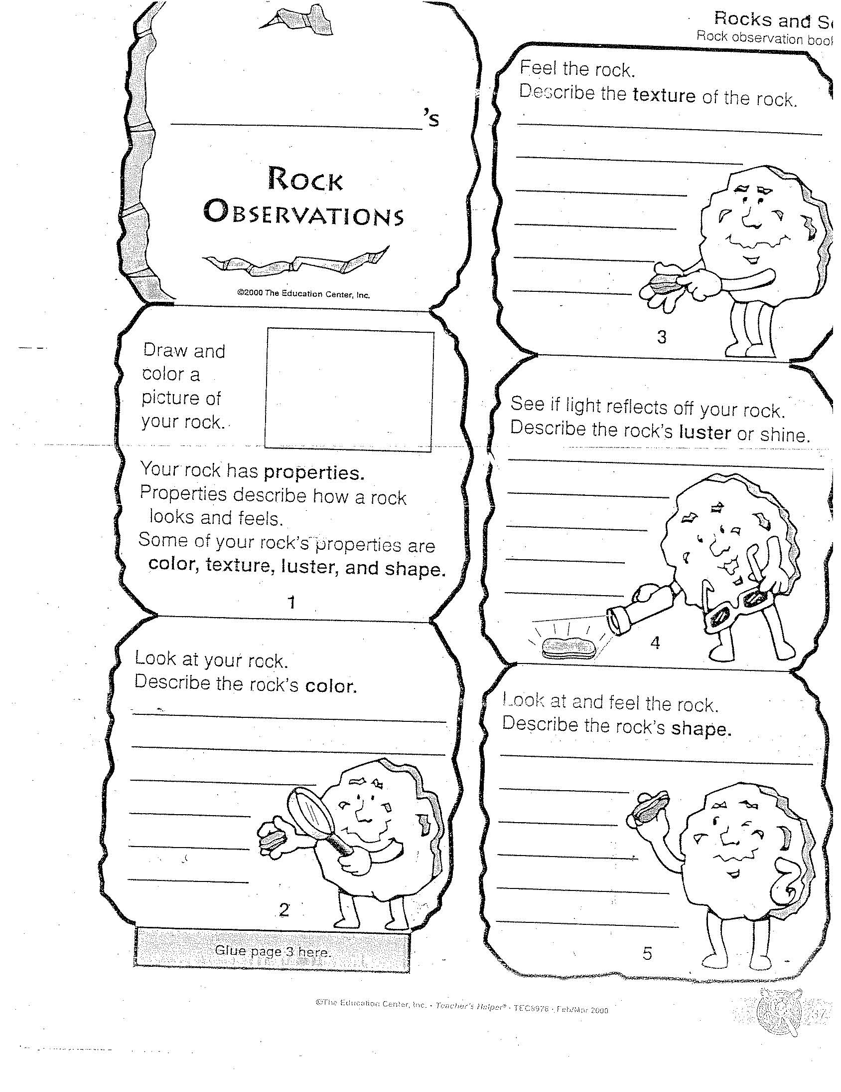

Lesson Plan- Day Three
Time Period Objectives:
- Students will define the three types of rocks (Knowledge).
- Students will create a sedimentary rock by forming layers (Synthesis)
Materials Needed:
- Chapter 1 Lesson 2 worksheet that I created
- Sedimentary, metamorphic, and igneous rock from my collection
- Each student will need:
  - wax paper
  - plastic spoon
  - cup
  - sand
  - gravel
  - glue
Procedures:
- Introductory Activity: (5 minutes)
- I’ll have them get out their rock collections again. They will compare the different rocks in their bags. I’ll ask them if all the rocks look the same? This will lead us to a discussion on how all rocks are different.
- I’ll show them an example of the three different kinds of rocks and we’ll talk about how the rocks may look different, but they are also different because they were made in different ways.
- We’ll then review how a rock is made up of different minerals.
- Developmental Activity (25 minutes)
- I’ll have the students get out their science books from their desks and turn to the second lesson in the book page 40.
- We’ll read this lesson popcorn style. This is where I draw a popsicle stick and see what student’s name I draw. That person will then read the first paragraph. They will also get the ball when it’s their turn to read. When I say popcorn, I’ll draw another name and then the person that read already will toss the ball to the new person. I like this game because students follow along because they want to hold the ball and read.
- In the book there is a picture of granite and obsidian rocks. Obsidian rock is very shiny and granite is dull. I’ll ask the students to infer why the obsidian rock is shiny. They’ll realize that it cooled quickly.
- After reading about the sedimentary rock, I’ll show the students the sand and gravel and explain that these are just some of the materials that settle into layers and are pressed together to form sedimentary rock.
- We’ll look at the pie graph in the book and discuss that 75% of the rocks on Earth are sedimentary rocks.
- After we finish reading about the three different types of rocks, then the students will get a chance to make a sedimentary rock.
- I’ll pass out all their materials to them and have them follow my directions as I make the sedimentary rock. First, they’ll take their spoon and scoop out one spoonful of sand (this is the first layer). Then they’ll scoop out a spoonful of gravel (this is the second layer). Next, they’ll put a spoonful of glue on top of the layers. They are going to mix all three materials together (this is the step when the materials are pressed together). When they are done, they’ll scoop it all out and put it on their wax paper to dry overnight.
- Concluding Activity (5 minutes)
- Ask the students to explain how their model rock is like a sedimentary rock.
- Pass around the samples of the sedimentary, igneous, and metamorphic rocks and have the students compare them.
- Key Questions:
- How many types of rocks are there?
- If you saw a rock that was glassy looking, what could you conclude about it?
- Why is there so much more sedimentary rock than other kinds of rock on the surface of the earth?
Summary/Closure/Evaluation
- Closure (5 minutes)
- Ask the students to tell me how rocks are classified.
- Ask the students to explain how the three different rocks are made.
- Evaluation (10 minutes)
- The students will complete the Chapter 1 lesson 2 worksheet that I created

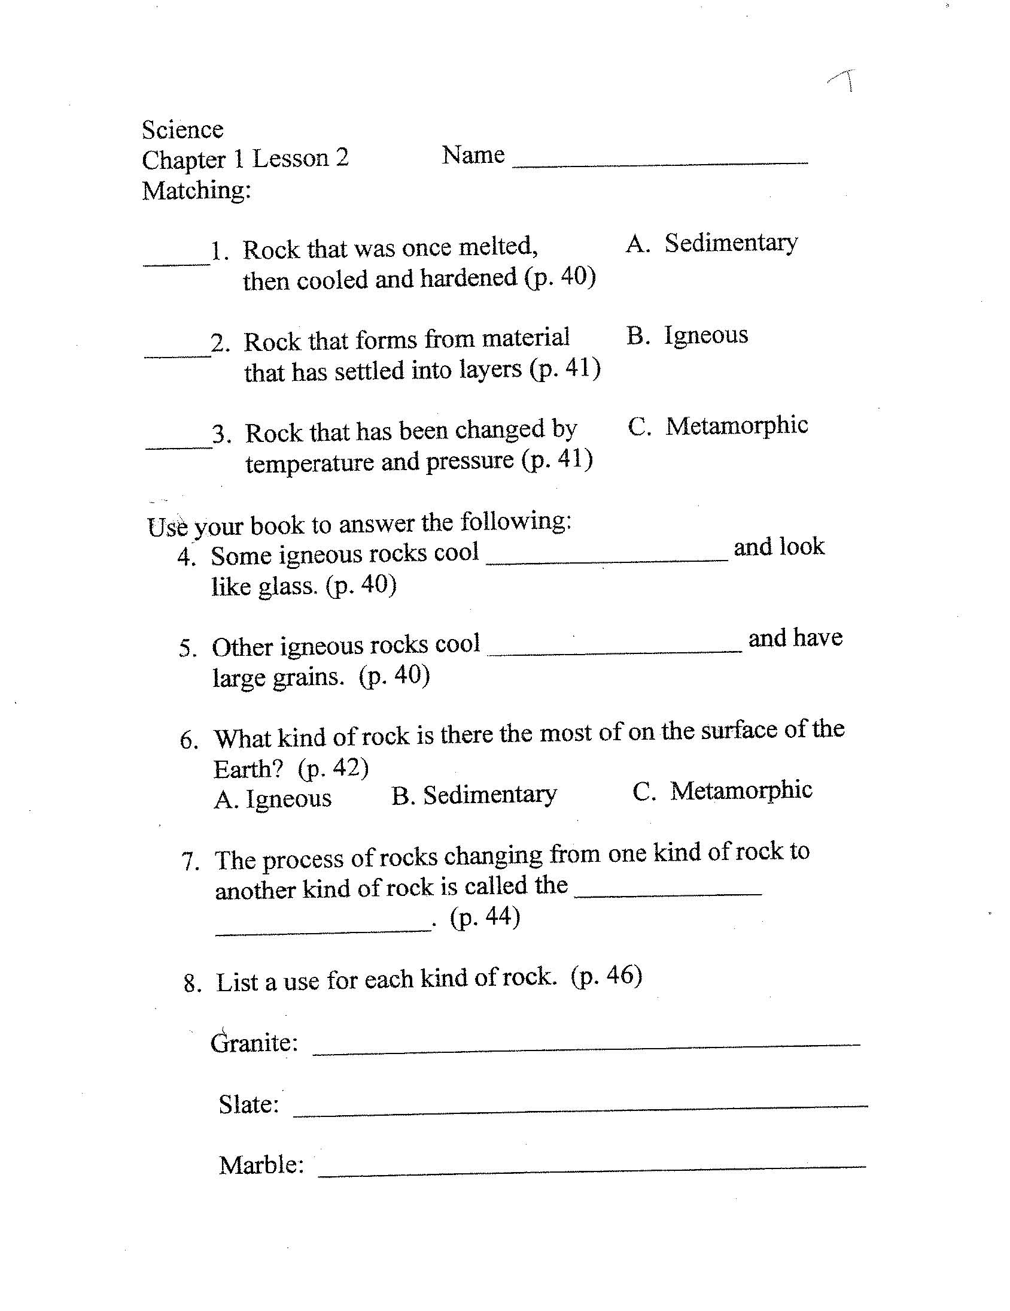

Lesson Plan- Day Four
Time Period Objectives:
- Students will explain how a melted chocolate chip is similar to an igneous rock (Evaluation).
- Students will create a metamorphic rock by using heat and pressure (Synthesis).
- Students will summarize how the three types of rocks are different from each other (Evaluation).
Materials Needed:
- hand lens
- worksheet I made about the sedimentary model rock
- worksheet I made about igneous and metamorphic model rock
- chocolate chips
- crock pot
- spoon
- wax paper
- each child will need a red, green, and blue ball of clay
Procedures:
- Introductory Activity (5 minutes)
- I’ll review with the students what a sedimentary rock is, and we’ll discuss how we made the sedimentary rock the day before.
- Ask the students to explain to me how the other types of rocks are made.
- Before the students get to class, I’ll dump a bag of chocolate chips into the crock pot.
- I’ll give each students a chocolate chip and we’ll talk about how it is like a rock. Then I’ll talk to them about how rocks can change from one type to another. I’ll explain that I am going to melt it and we’ll see how it can change into another rock.
- Developmental Activity (25 minutes)
- I will have the students go get their sedimentary rocks that they made the day before. I’ll give them their hand lens so that they can observe their rocks. We’ll talk about how they used different materials and put them into layers to create a sedimentary rock.
- I will then pass out the worksheet I created that has them list the steps they did to create their sedimentary rock. They will write a paragraph explaining the steps they did the day before when making their rock. Then they’ll draw a picture of their rock. At the end they’ll tell me what type of rock they made.
- Next, the students will get the opportunity to make a metamorphic rock. We’ll discuss how a metamorphic rock is formed by heat and pressure. They’ll all get their clay and roll them into balls. We’ll talk about how they are creating heat with their hands. Then they’ll stack all three clay balls on top of each other like a snowman. They’ll squish the clay balls all together (pressure) and see how the rock has changed.
- After making a metamorphic rock, they’ll then get to make an igneous rock. We’ll discuss how an igneous rock is made from melted rock and it is cooled and hardened. I’ll show them all the melted chocolate chips and talk about how it is like melted rock. I’ll scoop out a spoonful of chocolate onto every student’s wax paper. I’ll let them touch it (warn them it’s hot) and they can see how it’s soft. Then they’ll keep it on their desk and watch it harden.
- Concluding Activity
- When the “igneous rocks” have hardened, we’ll discuss again how they are similar to a real rock. Then they may eat their rock.
- I’ll have the students explain once again how all three rocks are made.
- Key Questions:
- How do all the sample rocks we made resemble how real rocks are made?
- If your chocolate was a real rock and it turned out to look like glass, what conclusion could you reach that would explain why it looks like that?
Summary/Closure/Evaluation:
- Closure
- The students will do an exit slip and quickly jot down how each type of rock is made.
- Evaluation
- They’ll complete the igneous and metamorphic rock worksheet that I created.
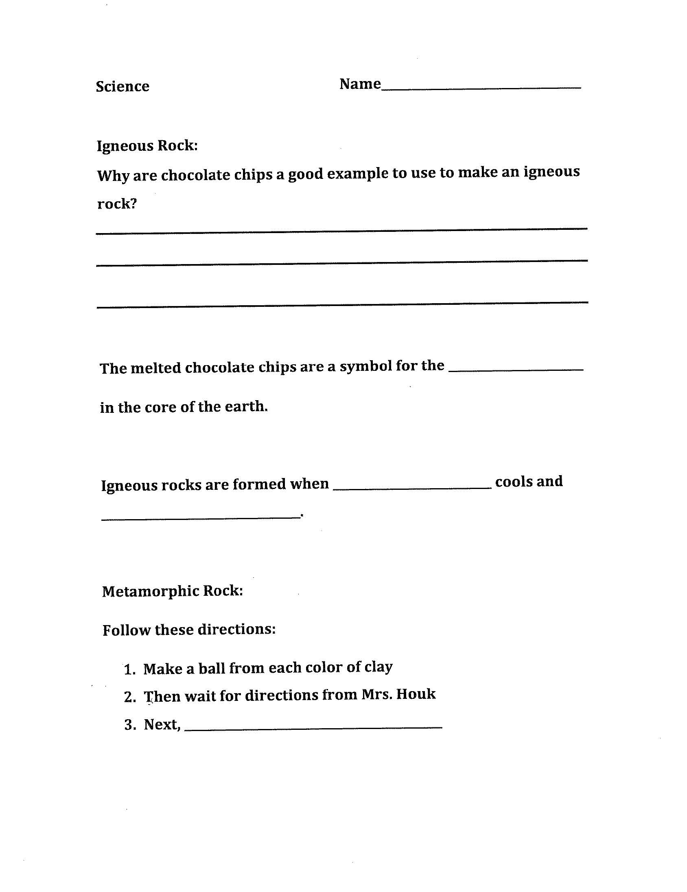

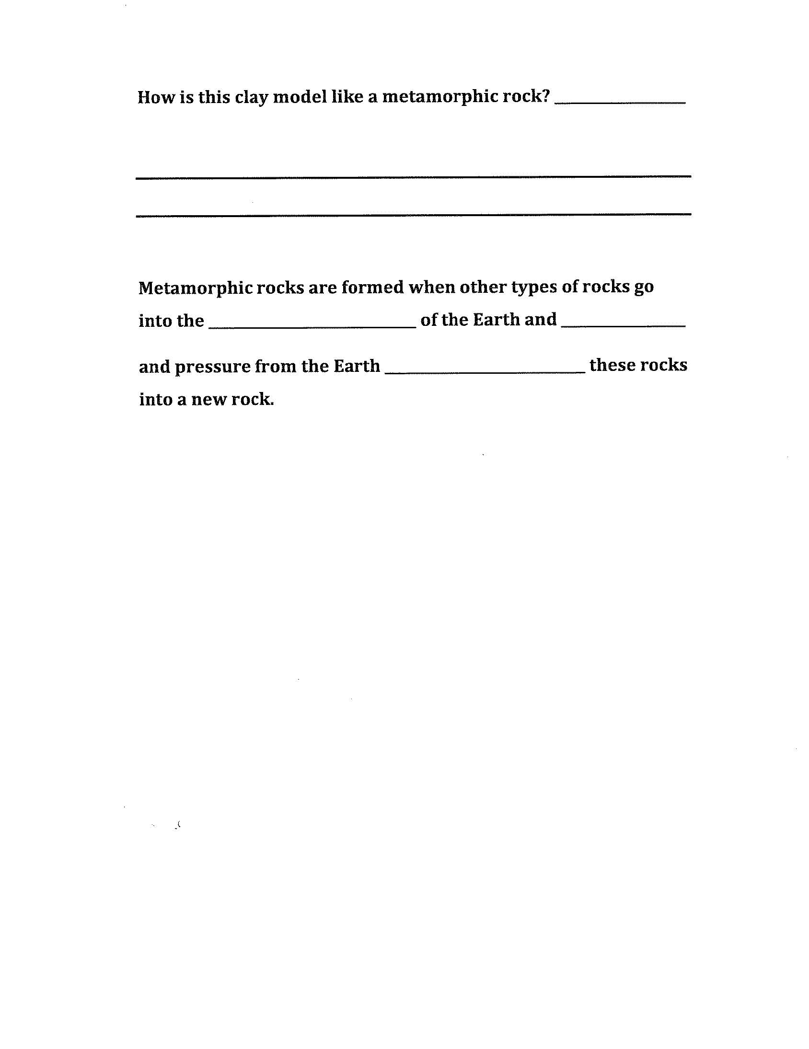
Post- Assessment of Rocks and Minerals
We’ll refer back to the KWL chart that we completed in the beginning of the unit. We’ll go to the L section and discuss what they learned. I’ll have them read back over the section when they told me what they knew. I’ll ask them if there is anything they told me earlier that they realize now is not true. Then I’ll write the correct information in the what we Learned section. In addition, I’ll have the students answer the questions that they put in the W section. Finally, the students will take turns telling me different things they learned about rocks and minerals.
I’ll then give the students this assessment that I made on my own that covers the unit. On the back of this paper, I’ll have the students write a short paragraph explaining the two different ways we as a group classified minerals. This way I can see that they understand that minerals can be classified by their hardness (scratch test) and their color (streak test).
