**Lesson One**

**Character**

|  |
| --- |
| **Concept/Skill To Be Learned:**  All fiction stories have a character |
| **Unit Outcomes:**  Students will identify the character in a story |
| * **Lesson Objective:** * To identify the characters in a story |
| **Time Allotment:** 45 - 60 minutes |
| **Materials/Resources Needed:**  Froggy Goes to School by Jonathan London  Student writing journal  Pencil |
| **Procedures:**  **Introductory Activity (5 minutes):** Introduce the students to the class pet (a frog), and use the frog puppet to get students interested in learning about the frog unit.  **Developmental Activity (30-45 minutes):**  Tell the students that we will be reading a story about an interesting character, and that a character is the person or animal that is in the story. Ask the students to think about who this story is about after taking a picture walk through the story and discussing the title, author, illustrator, and characters. Read the story Froggy Goes to School. Ask the students who the character of the story was. Have the students identify other characters in the story.  **Concluding Activity (15 minutes):**  Student draw a picture of “Froggy” in their journals and write what a character is. Have the students share their illustration and sentence with the person sitting across from them. |
| **Assessment/Evaluation Strategy: Observation, Work Sample**  Character illustration and journal entry  Observation of students sharing their journal entries  Participation and answers to whole group discussion and questioning |

**Lesson Two**

**Setting**

|  |
| --- |
| **Concept/Skill To Be Learned:**  All fiction stories have a setting |
| **Unit Outcomes:**  Students will identify the setting in a story |
| * **Lesson Objective:** * To identify the characters in a story |
| **Time Allotment:** 60-120 minutes (2 class periods) |
| **Materials/Resources Needed:**  Froggy Eats Out by Jonathan London  Shoe Boxes  Construction paper  Scissors  Glue  Plastic Frogs  Setting Song (William Tell Overture)  Pencil |
| **Procedures:**  **Introductory Activity (5 minutes):** Have students pull our their journals from the previous day and share their entries with a new friend. Briefly review characters at the carpet.  **Developmental Activity (20 minutes):**Remind the students that yesterday we talked about characters. Today we will be reading another story about the character Froggy called, Froggy Eats Out. Ask them to think about where Froggy is in the story. Read the story and ask the students about where Froggy is as you continue to read. Upon completion of the story, review all of the places where Froggy went. Tell the students that this is called the setting of a story. Sing the Setting Song once to model it, then another time to have the students sing along. Have students talk about the different settings they have been in today including the classroom to relate to their own lives. As students return to their seats have them sing the Setting Song. Help students to make a journal entry in their writing journal about what the setting of a story is.  **Concluding Activity (60 minutes):**  Have students create dioramas of their favoring “setting” to eat. Give each student a plastic “Froggy” to put in their diorama. Have students share their setting dioramas and display them in the classroom. |
| **Assessment/Evaluation Strategy: Observation, Work Sample**  Setting diorama and journal entry  Participation and answers to whole group discussion and questioning |

**The Setting Song**

**( tune of William Tell Overture)**

**Setting’s where you put yourself,**

**Setting’s where you put yourself,**

**Setting’s where you put yourself**

**In the story**

**Sample Journal Page**

**Lesson Three**

**Problem**

|  |
| --- |
| **Concept/Skill To Be Learned:**  All fiction stories have a problem |
| **Unit Outcomes:**  Students will identify the problem in a story |
| * **Lesson Objective:** * To identify the problem in a story |
| **Time Allotment:** 45 - 60 minutes |
| **Materials/Resources Needed:**  Froggy Bakes a Cake by Jonathan London  “Just-Right “ reading books  Student writing journal  Pencil  Graphic Organizer |
| **Procedures:**  **Introductory Activity (5 minutes):** Students share a setting that they went to over the weekend. Sing the setting song.  **Developmental Activity (30-45 minutes):**  Introduce the book Froggy Bakes a Cake. Picture walk through the story and have the students predict who the character of the story will be, as well as the setting of the story. Tell the students to pay attention to the trouble that Froggy gets into as he bakes his cake. Read the story. Review Froggy’s troubles by listing them on the Smartboard on a graphic organizer. Explain to the students that this is called the problem of the story, and that all fiction stories have a problem. Review the problem from the last few Froggy books shared in class (from the character and setting lessons).  **Concluding Activity (15 minutes):**  At their seats, have students read their “just-right” book that they have in their desk. Have them write down the problem in their journal and illustrate. |
| **Assessment/Evaluation Strategy: Observation, Work Sample**  Problem illustration and journal entry  Participation and answers to whole group discussion and questioning |

Problem

Solution

Problem

Solution

Problem

Solution

Froggy

Bakes a Cake

By

Jonathan London

**Lesson Four**

**Solution**

|  |
| --- |
| **Concept/Skill To Be Learned:**  All fiction stories have a solution |
| **Unit Outcomes:**  Students will identify the solution in a story |
| * **Lesson Objective:** * To identify the solution in a story |
| **Time Allotment:** 45 - 60 minutes |
| **Materials/Resources Needed:**  Froggy Bakes a Cake by Jonathan London  Pencil  “Just Right” books  Story Elements graphic organizer |
| **Procedures:**  **Introductory Activity (5 minutes):** Review the Froggy Bakes a Cake story by briefly picture walking through the story. Orally discuss the character, setting, and problem.  **Developmental Activity (30-45 minutes):**  Explain to the students that every problem has a solution in a story. Bring up the graphic organizer on the Smartboard from the previous day. Ask the students to help you complete it by filling in the solution section.  **Concluding Activity (15 minutes):**  Have the students re-read their “just-right” books and fill out a the Story Elements graphic organizer |
| **Assessment/Evaluation Strategy: Observation, Work Sample**  Graphic organizer  Participation and answers to whole group discussion and questioning |

**Lesson Five**

**Froggy’s Sleepover**

|  |
| --- |
| **Concept/Skill To Be Learned:**  Word order in sentences |
| * **Unit Outcomes:** * Students will write a sentence with correct word order |
| * **Lesson Objectives:** * To put words in order to create sentences * To finish a sentence to make a complete thought * To illustrate a sentence |
| **Time Allotment:** 30-45 minutes |
| **Materials/Resources Needed:**  Froggy’s Sleepover by Jonathan London  Sentence strips  Scissors  Crayons  Pencil  Plain Copy Paper |
| **Procedures:**  **Introductory Activity (10 minutes):** At the carpet talk about the character Froggy, and what he did in the story the previous day. Tell the students to pay attention to the character in today’s story.  **Developmental Activity (30-45 minutes each day):**  Read the story Froggy’s Sleepover by Jonathan London. Ask the students to brainstorm what they would do at a sleepover. Write down each student’s response on a sentence strip (i.e. I would take a _______on a sleepover). Give the strips to the students and have them cut the words apart to form a puzzle at their seats. Model how to do this with your own sentence strip. Have students rotate to each desk and assemble each other’s puzzles. Finally, have the students return to their own seat and reassemble their own puzzle. Students then glue their puzzles onto plain white paper and illustrate.  **Concluding Activity (15 minutes):**  Students share their sentence and illustration using the Smartboard and Elmo camera. Later pages can be collected to make a class book. |
| **Assessment/Evaluation Strategy: Observation, Work Sample**  Observation of assembly of the sentence puzzles  Correct assembly of individual puzzles  Illustration of individual sentence puzzle |

**Froggy’s Sleepover Sentence Strips**

**I would take a __________ on a sleepover.**

**I would take a __________ on a sleepover.**

**I would take a __________ on a sleepover.**

**I would take a __________ on a sleepover.**

**I would take a __________ on a sleepover.**

**I would take a __________ on a sleepover.**

**Lesson Six**

**Leapin Lilly Pads**

|  |
| --- |
| **Concept/Skill To Be Learned:**  SightWord Recognition |
| **Unit Outcomes:**  Students will read given sight words |
| **Lesson Objectives:**  To fluently read a list of given sight words fluently  To use sight words to complete a review game |
| **Time Allotment:** 30 - 45 minutes |
| **Materials/Resources Needed:**  Sight Word Assessment Sheet  Lilly Pads (laminated with a sight word on each)  Frogs on a Log CD  CD player  Froggy Poem on Pocket Chart  Word Wall Paper |
| **Procedures:**  **Introductory Activity** (10 minutes)**:** Review previous week’s sight words orally using flash cards. Highlight sight words on Frog Poem on pocket chart  **Developmental Activity (25 minutes):**  Have students come to the carpet. Introduce sight words for the week. Discuss letter patterns that have been reviewed in the Phonics Dance. Clap and chant each word and have students write each word on Word Wall paper. Highlight the new words in the Froggy Poem on the pocket chart. Spread the lilly pads around the room and have the students play “musical chairs” with the lilly pads and music (do not eliminate any students) by having students walk from pad to pad. When the music goes off they shout the word they are standing next to.  **Closing Activity (10 minutes):**  Have students return to seats and complete “On the Back” on the Word Wall paper. The teacher says a sentence and leaves out the word wall word. Students write the missing word on their paper. Review. |
| **Assessment/Evaluation Strategy: Observation, Work Sample**  Grade on On the Back paper  Participation in Leapin Lilly Pad game  Participation and answers in group discussion and questioning |

**Frog Unit Sight Words**

|  |  |  |  |
| --- | --- | --- | --- |
| little | a | jumped | like |
| see | there | go | to |

**Lily Pad Template**

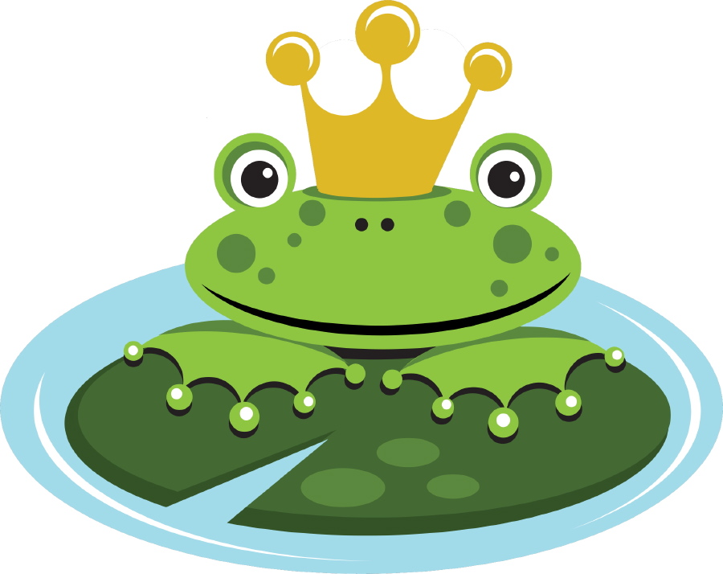

**there**

**Word Wall Paper**

|  |  |
| --- | --- |
| **Word Wall Words** | **On the Back** |
| **1.** | **1.** |
| **2.** | **2.** |
| **3.** | **3.** |
| **4.** | **4.** |
| **5.** | **5.** |

**Sight Word Poem**

In jumped the little frog

On to the little log

There sat the little frog

On that little log

I see the little frog

There on the little log

I like the little frog

On that little log

**Lesson Seven**

**Finding Frogs**

|  |
| --- |
| **Concept/Skill To Be Learned:**  Animals have adaptations to protect themselves from predators and to obtain food. |
| * **Unit Outcomes:** * Students will describe how adaptations help animals to survive. |
| * **Lesson Objectives:** * To learn about camouflage * To create a frog that blends in with the classroom environment * To explain how a camouflage helps an animal stay safe |
| **Time Allotment:** 45 - 60 minutes |
| **Materials/Resources Needed:**  Animal Camouflage book  Finding Frogs Poster  Blank Frog Patterns  Scissors  Tape  Markers  Pencil  Which Frog Has a Better Chance at Surviving? worksheet |
| **Procedures:**  **Introductory Activity (5minutes):** Using the class frog puppet, recall facts about frogs, specifically drive discussion to frog body parts.  **Developmental Activity(20-30 minutes):**  Call the students to the carpet and read, “Animal Camouflage” by Ken Robbins and read aloud. Discuss. After reading the book, hang up the Finding Frogs Poster. Have students count how many frogs they see. Discuss. Have the students recount. Discuss.Finally, show the students why they came up with the incorrect answer. Have the students color and cut out their own frog to match something in the classroom. Tape the frogs around the room. Students walk around the room and count how many frogs they can find.  **Concluding Activity (15 minutes):**  Review at the carpet which frogs were easiest/hardest to find and why. Have students complete the Which Has a Better Chance Worksheet at their seats. |
| **Assessment/Evaluation Strategy: Observation, Work Sample**  Grade on Which Has a Better Chance worksheet  Observation of students placing frogs around the room  Participation and answers to whole group discussion and questioning |

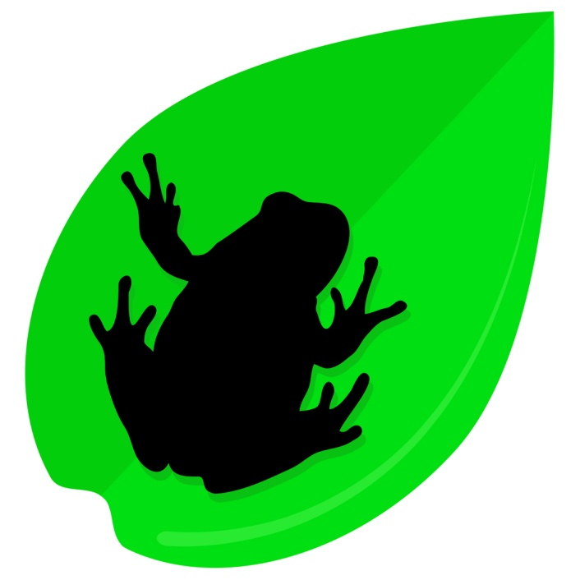**Which frog has a better chance at survival?**

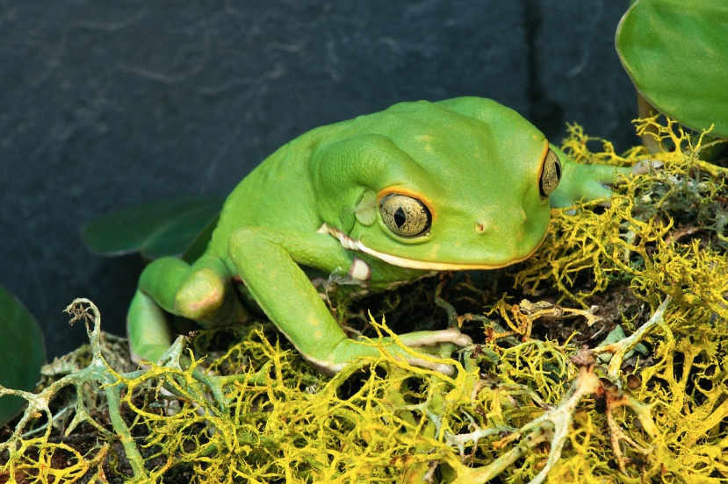

A.

B.

**The frog that will have a better chance at survival is frog _____ because_____**

**Frog Template**

**C:\Users\Owner\AppData\Local\Microsoft\Windows\Temporary Internet Files\Low\Content.IE5\SDL8BQS3\MC900020454[1].WMF**

**Lesson Eight**

**Other Animal Adaptations**

**(Beautiful Beaks)**

|  |
| --- |
| **Concept/Skill To Be Learned:**  Animals have adaptations to protect themselves from predators and to obtain food. |
| * **Unit Outcomes:** * Students will describe how adaptations help animals to survive. |
| * **Lesson Objectives:** * To conduct an experiment * To describe how animals have body parts that help them to survive |
| **Time Allotment:** 60 minutes |
| **Materials/Resources Needed:**  Beautiful Beaks book  Beans  Spoons  Clothespins  Toothpicks  Plastic cups  Paper plates  Recording sheet  Writing journal  Timer |
| **Procedures:**  **Introductory Activity (10 minutes):** Review animal camouflage by placing a black frog on your black shoe. Have the students look for it. After they discover it, explain to the students that animals have other adaptations that can help them to survive.  **Developmental Activity (30-45 minutes each day):**  Read Beautiful Beaks to the students. Show them different kinds of beaks that birds have. Explain the experiment to the students: They will be timed for one minute using each of the tools provided. Each tool (clothespin, toothpick, and spoon) represent a type of bird beak. Students use each tool to try to pick up as many beans from the cup and put it on the plate during the one minute. After each minute of using the tool, the students will record how many beans they were able to pick up with each tool. When each tool has been used, work together to analyxe the data. Students will find that the spoon was the best “beak” for picking up beans. Refer back to the Beautiful Beaks book. Ask the students which “beak” would be best for stabbing a fish, cracking a nut, or scooping up tiny animals. Refer back to the book to show the students examples of each type of bird beak in real life.  **Concluding Activity (15 minutes):**  Have students draw a picture of a new type of bird with one of the beaks they examined. Students will write a sentence about what type of food their bird could successfully eat with the type of beak it has. |
| **Assessment/Evaluation Strategy: Observation, Work Sample**  Participation in the experiment  Participation and answers to whole group discussion and questioning  Journal picture and response |

**Beautiful Beaks Recording Sheet**

|  |  |  |
| --- | --- | --- |
| **Beak Type** | **Number of Beans Picked Up** | **Best Beak** |
| **Spoon** |  |  |
| **Clothespin** |  |  |
| **Toothpick** |  |  |

**Lesson Nine**

**Sticky Tongue Frog Craft**

|  |
| --- |
| **Concept/Skill To Be Learned:**  Following directions |
| * **Unit Outcomes:** * Students will follow directions to create a frog craft |
| * **Lesson Objectives:** * To follow directions to create a frog craft |
| **Time Allotment:** 60 minutes |
| **Materials/Resources Needed:**  Large paper plates (2 per student)  Googly eyeballs-large (2 per student)  Tongue patterns/pink construction paper  Green paint  Scrap construction paper |
| **Procedures:**  **Introductory Activity (10 minutes):** At the carpet, review what the students have learned about frogs and their body parts. Use the frog puppet to name the parts and how the parts help them to survive.  **Developmental Activity (30-45 minutes):**  End the discussion with the frog’s sticky tongue. Have students explain how the sticky tongue helps the frog to obtain food. Tell the students that they will be making paper frogs with long tongues and writing silly stories about what the frog catches with his tongue. Show the students the sample frog with a diamond ring stuck to his tongue. Explain that you wanted a diamond ring so that is what you chose to stick to the frog’s tongue. Have the students follow directions to paint and assemble the paper plate frog then attach their “wanted” item to the frog’s tongue.  **Concluding Activity (30 minutes):**  Students share their frog and tell the item that their frog “caught” with its sticky tongue. |
| **Assessment/Evaluation Strategy: Observation, Work Sample**  Completed frog craft  Participation and answers to whole group discussion and questioning |

**Frog Craft Sample**

**C:\Users\Owner\AppData\Local\Microsoft\Windows\Temporary Internet Files\Low\Content.IE5\D7AHY6AC\MC900019118[1].WMF**

**Lesson Ten**

**Sticky Tongue Stories**

|  |
| --- |
| **Concept/Skill To Be Learned:**  Writing stories with character, setting, problem, and solution |
| * **Unit Outcomes:** * Students will write a story with character, setting, problem, and solution |
| * **Lesson Objectives:** * To brainstorm ideas for story writing * To write a rough draft of a story independently * To edit and make corrections with teacher assistance * To produce a final draft of a story * To illustrate a story |
| **Time Allotment:** 120-180 minutes (2-3 class periods) |
| **Materials/Resources Needed:**  Large Chart Paper  Markers  Pencil  Writing Paper  Computer or Word Processor |
| **Procedures:**  **Introductory Activity (10 minutes):** At the carpet discuss how the students made paper plate frogs with an item stuck to the tongue the previous day. Tell the students that they will be writing silly stories about their frogs.  **Developmental Activity (30-45 minutes each day):**  Model creating a brainstorming web prior to story writing. Model writing a story about the model frog with the diamond ring. Include character, setting, problem, and solution. Have the students return to their seats and create a web about their own frog and how it caught its item on its tongue. Students review webs with the teacher or aide, then begin to write their own rough draft. As students complete rough drafts they will edit with a teacher or aide, then type good copies on a computer or word processor. Students illustrate stories and staple together to create books.  **Concluding Activity (60 minutes):**  Students share their stories with the class. Class members will comment on others’ stories using the words character, setting, problem, solution (i.e. I liked your setting because…) |
| **Assessment/Evaluation Strategy: Observation, Work Sample**  Completed stories  Participation in giving comments to others |

**Lesson Eleven**

**Frog Habitats**

|  |
| --- |
| **Concept/Skill To Be Learned:**  Animals live in different habitats |
| * **Unit Outcomes:** * Students will describe characteristics of habitats |
| * **Lesson Objectives:** * To describe the habitat of a frog * To create a frog habitat * To research other animals that live in the same habitat as a frog |
| **Time Allotment:** 60-120 minutes (2 class periods) |
| **Materials/Resources Needed:**  habitat books  Froggy’s Day Out by Jonathan London  Poster Board  Markers  Pencil  Note cards  Writing Paper |
| **Procedures:**  **Introductory Activity (10 minutes):** At the carpet, review what the students have learned about frogs and their body parts. Discuss how the body parts help them to survive in the pond environment. Read Froggy’s Day Out and talk about Froggy’s home in the story.  **Developmental Activity (30-45 minutes each day):**  Have the students tell some things about their home. Tell the students they will hear a story about a frog’s homes, and that animal homes are called habitats. Read the story and work together to create a web with pond habitat in the middle. Work together to list information about ponds on the web. Explain to the students that they will be learning about other habitats in small groups. Divide the students into small groups and give each group a different habitat book. Use the jigsaw method to have students each write a fact about their habitat on a note card then work together to illustrate a poster of the habitat.  **Concluding Activity (30 minutes):**  Students share their posters and facts with the class. |
| **Assessment/Evaluation Strategy: Observation, Work Sample**  Participation on the habitat poster  Individual fact notecards  Observation of students working together in small groups  Participation and answers to whole group discussion and questioning |

**Lesson Twelve**

**Froggy’s Baby Sister/Life Cycles**

|  |
| --- |
| **Concept/Skill To Be Learned:**  Life Cycles |
| **Unit Outcomes:**  Students will identify and describe the stages of a life cycle |
| **Lesson Objectives:**  To describe the stages of the life cycle of a frog  To compare the life cycle of a frog to a human  To follow directions as they are given to complete a project |
| **Time Allotment:** 45 - 60 minutes |
| **Materials/Resources Needed:**  Froggy’s Baby Sister by Jonathon London  Life Cycle of a Frog Spinner  Life Cycle Posters of Frogs and Humans  Scissors  Brad  Markers  Pencil |
| **Procedures:**  **Introductory Activity:** Review previous day’s Froggy Story using class frog puppet  **Developmental Activity (20-30 minutes):**  Have students come to the carpet and read, Froggy’s Baby Sister aloud. Discuss.  After reading the book, show the students the Frog Life Cycle Poster. Discuss how the poster (non-fiction) differs from the story (fiction). List student responses on the board on a T-chart.  Have students color, cut out, and assemble the Life Cycle of a Frog Spinner as the teacher models. Students talk to at least three friends in the classroom and explain what they know about the life.  Cycle of a Frog sharing their spinners as they describe each step of the cycle.  **Concluding Activity (10 minutes):**  Regroup at the carpet to review life cycles and to clarify any misconceptions the students may  Have. |
| **Assessment/Evaluation Strategy: Observation**  Participation and Answers to whole group discussion and questioning  Observation of students sharing spinners |

**Lesson Thirteen**

**Froggy Fluency Poem**

|  |
| --- |
| **Concept/Skill To Be Learned:**  Reading Fluency |
| * **Unit Outcomes:** * Students will read with fluency |
| * **Lesson Objectives:** * To identify “hunks” and “chunks” (phonemes) within context * To read with fluency * To identify sight words in context |
| **Time Allotment:** 45 - 60 minutes |
| **Materials/Resources Needed:**  Tiny Tim Poem  Highlighter  Poetry Folder |
| **Procedures:**  **Introductory Activity (5minutes):** Using the class frog puppet review the “hunks and chunks” studied in class during the phonics dance during Circle Time (sh, th, ch, ck) at the carpet.  **Developmental Activity (15-30 minutes):**  Have students return to their seats. Place the poem on the Smartboard so that all students can see. Read the poem to the students and discuss the rhyming words and patterns. Have the students chorale read the poem with you. Discuss what fluent readers sound like, and point out punctuation marks and words that should be emphasized. Pass copies of the poem out to the students and allow them time to circle sight words, then highlight hunks and chunks. Have the students read the poem to at least three friends in the classroom. Students have each person they have read to put a smiley face at the bottom of their poem paper.  **Concluding Activity (10 minutes):**  As students return to their seats, review once again what fluency means. Have the students rate themselves on the back of their poem with a smiley face, medium face, or sad face. |
| **Assessment/Evaluation Strategy: Observation**  Observation of students reading to others  Participation and answers to whole group discussion and questioning  Listening to students read the poem one-on-one at a later time |

**Tiny Tim**

C:\Users\Owner\AppData\Local\Microsoft\Windows\Temporary Internet Files\Low\Content.IE5\0BU418MO\MC900022693[1].WMFI have a little frog  
His name is Tiny Tim,  
I put him in the bathtub,  
To see if he could swim,  
He drank up all the water,  
And gobbled up the soap!  
And when he tried to talk  
He had a BUBBLE in his throat!

**Lesson Fourteen**

**“og” Word Family**

|  |
| --- |
| **Concept/Skill To Be Learned:**  Word Families |
| * **Unit Outcomes:** * Students will read words in the “og” word family |
| * **Lesson Objectives:** * To identify rhyming words * To read words in the “og” family with fluency * To write and spell “og” words correctly |
| **Time Allotment:** 45 - 60 minutes |
| **Materials/Resources Needed:**  Note cards with “og” printed on each-1 per student  Clothespins with initial consonants and blends printed on each  “og” word family paper |
| **Procedures:**  **Introductory Activity (10 minutes):** Using the class frog puppet play a rhyming game with the students at the carpet, “I say, You say”. Have the puppet say an “og” word, have student raise their hand and say a word that rhymes.  **Developmental Activity (15-30 minutes):**  Write the words on the board that the students generated from the game. Ask them to tell you something that the words have in common (all have “og”). Explain that this is called a word family. The words all rhyme and have the same ending. Show the students the note cards and clips. Clip one of the clips onto the note card and determine if it makes an “og” word. If it does, write it on the word family paper. If it does not try a new clip. Model two or three more clips. Pass two to three clips and a note card to each student as well as a word family paper. Have the students return to their seats and use their clips. As they finish they may move to a new student’s desk to try his or her clip. When complete have them read their list of words to three friends.  **Concluding Activity (15 minutes):**  Review the list of words that the students have created. Have the students turn the paper over and write a silly sentence using at least two of the “og” words (i.e. The frog sat on a log in the bog). Students illustrate and share their silly sentences. |
| **Assessment/Evaluation Strategy: Observation, Work Sample**  Observation of students reading word lists to others  Participation and answers to whole group discussion and questioning  Completed silly sentence and word family paper |

**Frog Word Family Paper**

C:\Users\Owner\AppData\Local\Microsoft\Windows\Temporary Internet Files\Low\Content.IE5\QCIXMHY3\MC900133545[1].WMF

**____og**

**____og ____og**

**____og ____og**

**____og ____og**

**____og ____og**