Instructional Design
Brooke Inselmann
Rationale
The instructional design subunit I am doing covers probability. Students really enjoyed learning about probability this year and I feel that it’s very important for them to understand probability. It is used in many situations and will be helpful in real life. As students move through school and grow up in the community they need to think about their actions and what the consequences of these actions will be. It's important to know how to use probability when they make decisions in their life. Probability is a whole lot more than just selecting a color chip from a bag or a blue pair of socks instead of a white pair of socks from a drawer. For example, when determining the probability that it might rain or for determining the probability that they will win or lose a ball game can both be useful. Probability is the chance that something might happen. When you calculate the probability of an event you look at chances of getting what you want against all the possible things that can happen. By teaching probability students will get a good understanding of the different types of probability and how to correctly utilize them in real life situations. The way I have organized my lesson can be best compared to the basic planning model. I wrote out the basic part of the lesson and how I teach it. I often incorporate some of the 5E plan into mine but don’t find it necessary to write out each of the five parts for the E. I do incorporate problem based learning and project based learning into my teaching but not necessarily on a daily basis. It’s important that my students learn to problem solve and work things through on their own but I feel it’s first important to give them materials they’ll need to be successful at doing that.

Unit Outcomes

Pre-assessment:
Students will show their prior knowledge of probability by completing the probability “Are You Ready?” assessment.

Lesson One:
Students will use informal measures of probability to determine the likelihood of an event happening.

Lesson Two:
Students will determine the experimental probability of a situation

Lesson Three:
Students will determine the theoretical probability of a situation

Lesson Four:
Students will use manipulatives to calculate the experimental and theoretical probability

Lesson Five:
Students will find the probability of independent and dependent events.

Lesson Six:
Students will solve probability problems to review for their upcoming quiz

Post-assessment:
Students will show their understanding of probability by completing the “Probability Post-assessment”

** All “know it notes” and scanned worksheets are from the Holt McDougal Mathematics Course 2 Book ** This is the book my students used this year and I pulled several ideas from it for my instructional design. I like how things are set up in the book and it is very user friendly. There is also a website that goes along with it for games, activities, worksheets, and extension problems.

Probability : Are You Ready?

Directions: Answer the following questions the best you can. This will help both you and I see what you know about probability already and what we’ll need to work on.

- spinning a number less than 3 on a spinner with 8 equal sections marked 1 through 8 is
LIKELY, UNLIKELY, IMPOSSIBLE, CERTAIN, AS LIKELY AS NOT (circle one)

- Nathan inspects new light bulbs at a factory. Of the first 56 bulbs he inspected 49 were acceptable. What is the experimental probability that the next bulb will be acceptable?

- What is the theoretical probability of randomly choosing an orange crayon from a bag of 4 black crayons, 6 blue crayons and 12 orange crayons?

- A student picks a raffle ticket from a box and then picks a second raffle ticket without replacing the first raffle ticket. Is this dependent or independent?

- Write one situation that you could find the experimental probability of.

- Write one situation that you could fine the theoretical probability of.

Probability - Day 1 Lesson

Class: 7th grade math Intervention

Objective: Students will use informal measures of probability to determine the likelihood of an event happening.

Lesson Procedure:

Warm up and Problem of The Day (15 minutes)
- Post Warm Up on the SMARTboard
- Students each need notebook paper to do the warm up on
- Go over answers to the warm up by asking for student volunteers to share their answer and explain how they got it. Teacher will intervene if necessary
- Post Problem of the Day on the SMARTboard
- Students will solve it on the same piece of notebook paper
- Go over answer to the Problem of the Day, students should correct their answers as the teacher does it on the board

Instruction (25 minutes)
- Read the objective that is written out on the SMARTboard so students know what we’re doing for the day
- Pass out know-it-notes for probability day 1
- Give students time to write out the important definitions for probability (students may look up definitions in their textbook)
- Teacher will go over the definitions, write the correct definition on the SMARTboard, and give an example of each when applicable
- Teacher will show a copy of notes on the SMARTboard to work through with the students
- Example 1: students will determine the probability of rolling an odd number on a number cube. As the teacher I will assist them in figuring out the answer if needed.
- Example 2: We will not do example two. I have found this only confuses students and is not necessary when working out problems.
- Example 3: I will ask the question “what is the probability that the teacher will conduct an experiment” after reading the scenario aloud. We will talk about how changing parts of the scenario would change the probability. I will call on one student to write the answer on the SMARTboard. We will discuss the answer and fix is accordingly.
- Students will do Check It Out on their notes. They will have to complete this correctly in order for them to receive their homework assignment. If after 4 minutes students haven’t had theirs checked I will help them in a small group.

Wrapping it up (10 minutes)
- Students will get their homework assignment from me if they haven’t already gotten it.
- I will write the assignment on the board and give students time to write it in their planners
- I will remind students that their homework is due at the beginning of class tomorrow. If they finish before the end of class today they may turn it in the tray.
- I will tell students we will be continuing probability tomorrow, if they have questions over today’s lesson they may see me in study hall or before or after school.
- Students will use the rest of the time to work on the assignment.
- If they finish early they know to work on extra credit or an early finisher from the side of the room.

Evaluation: I will use a combination of assessment methods to evaluate student understanding on today’s lesson. The questions I ask during the lesson and the answers students give in return allow me to see if they understand what I am covering. The homework assignment will also serve as an evaluation method for today’s lesson. I will collect it tomorrow at the beginning of class and grade it to see if students did it correctly or are still struggling. For those who are struggling I will meet with them during classtime or study hall to reteach the concept.

Probability – day 1 classwork

Warm Up
Write each fraction in simplest form.
- 4/8 2. 48/64 3. 30/45 4. 9/81 5. 15/21

Problem of the Day
You roll a regular pair of number cubes. How likely is it that the product of the two numbers you roll is odd and greater than 25? Explain.

KNOW IT NOTES FOR DAY 1
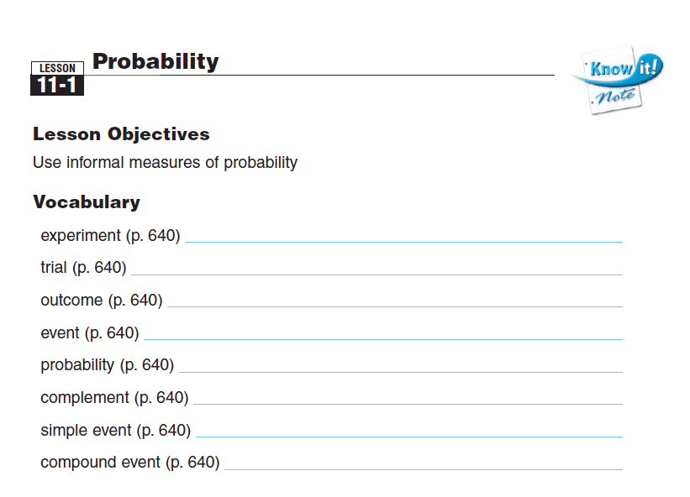
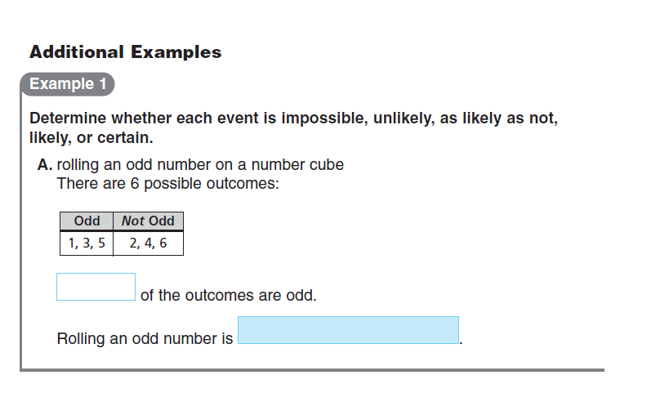
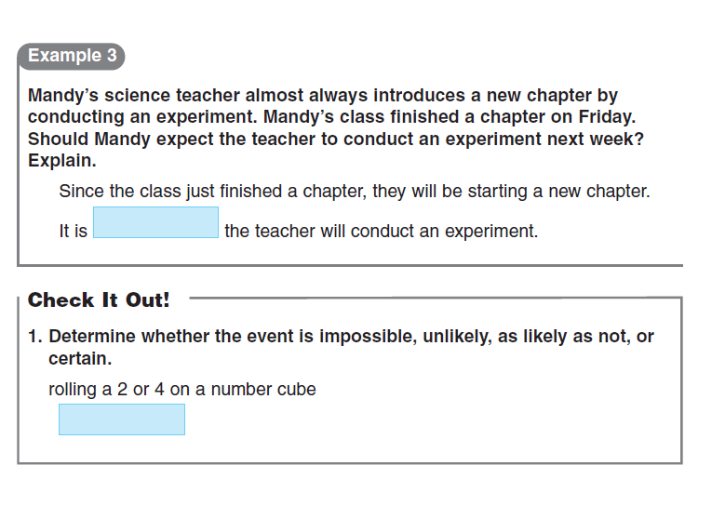

Name __________________________ Date _________________

Probability – day 1 assignment

Determine whether each event is impossible, unlikely, as likely as not, likely, or certain.

- Rolling an even number on a number cube labeled 1 through 6
____________________

- Picking a card with a vowel on it from a box of cards in which each letter of the alphabet is written on a card
____________________

- Spinning a number greater than 2 on a spinner with 10 equal sections marked 1 through 10
____________________

- Drawing a red marble from a bag of black, blue, and green marbles
____________________

- Flipping a coin and getting heads or tails
____________________

Probability – day 2 Lesson

Class: 7th grade math intervention

Objective: Students will determine the experimental probability of a situation

Lesson Procedure:

Warm up and Problem of The Day (15 minutes)
- Post Warm Up on the SMARTboard
- Students each need notebook paper to do the warm up on
- Go over answers to the warm up by asking for student volunteers to share their answer and explain how they got it. Teacher will intervene if necessary
- Post Problem of the Day on the SMARTboard
- Students will solve it on the same piece of notebook paper
- Go over answer to the Problem of the Day, students should correct their answers as the teacher does it on the board

Instruction (25 minutes)
- Read the objective that is written out on the SMARTboard so students know what we’re doing for the day
- Students will need to take out notebook paper for notes
- Define experimental probability on the SMARTboard and have students write it out on their notebook paper
- Show students how to set up an experimental probability ratio (probability equals number of times the event occurs over total number of trials)
- Give students a situation (write it on the SMARTboard) Tanya made saves on 15 out of 25 shots. What is the experimental probability that she will make a save on the next shot?
- Draw a popsicle stick to have a student volunteer come to the board and write the top part of the ratio (which would be 15) then draw another popsicle stick to have a student write the bottom part of the ratio (which is 25).
- Do another example similar to the first but have students write their answer as a fraction (ratio), decimal, and percent. Write on the SMARTboard Cam hit the bull’s-eye in darts 8 times out of 15 throws. What is the eperimental probability that cam’s next throw will hit the bull’s-eye?
- Draw a popsicle stick and have that student write the fraction to represent the experimental probability (8/15)
- Draw a popsicle stick and have that student write the decimal to represent the experimental probability (.53)
- Draw a popsicle stick and have that student write the percent to represent the experimental probability (53%)
- Put an example on the SMARTboard for students to solve with the person next to them. During archery practice, Mike hits the target on 12 our of 20 tries. What is the experimental probability that he will hit the target on his next try? Write your answer as a fraction, decimal, and percent. (7/10, .7, 70%)
Wrapping it up (10 minutes)
- Students will get their homework assignment from the front tray once their group answers were correct.
- I will write the assignment on the board and give students time to write it in their planners
- I will remind students that their homework is due at the beginning of class tomorrow. If they finish before the end of class today they may turn it in the tray.
- I will tell students we will be continuing probability tomorrow, if they have questions over today’s lesson they may see me in study hall or before or after school.
- Students will use the rest of the time to work on the assignment.
- If they finish early they know to work on extra credit or an early finisher from the side of the room.

Evaluation: I will use a combination of assessment methods to evaluate student understanding on today’s lesson. The questions I ask during the lesson and the answers students give in return allow me to see if they understand what I am covering. I watch to see who volunteers and who acts shy when I pull sticks. This gives me an idea of who knows it and who hasn’t payed any attention. The homework assignment will also serve as an evaluation method for today’s lesson. I will collect it tomorrow at the beginning of class and grade it to see if students did it correctly or are still struggling. For those who are struggling I will meet with them during classtime or study hall to reteach the concept.

Probability - day 2 classwork

Warm Up
1. A jar contains 6 red, 8 blue, and 10 white marbles. Would you be more likely to pull out a red or blue marble?

2. Attendance at a city council meeting is at 100%. Mr. Lloyd is a council member. How likely is it that Mr. Lloyd is at the meeting? Determine if the event is impossible, unlikely, as likely as not, likely, or certain.

Problem of the Day
The probability of Liana making a free throw was 2/3. If she made 24 of her free throws, how many did she miss?

Name ___________________________ Date ______________________

Experimental Probability – day 2 assignment

Find the experimental probability of each situation. Write your answer as a fraction.

1. Sally is playing basketball. She scores on 11 out of the 15 baskets she shoots.
a. What is the experimental probability that Sally will get a basket on the next shot? ________________________
b. What is the experimental probability that Sally will not get a basket on the next shot? ________________________

2. Jamie is playing baseball. He gets a hit 7 out of 9 times at bat.
a. What is the experimental probability that Jamie will get a hit his next time at bat? ________________________
b. What is the experimental probability that Jamie will not get a hit his next time at bat? ________________________

3. Kelly is practicing for an archery tournament. She hits the target 7 out of 11 times.
a. What is the experimental probability that Kelly will hit the target on the next shot? _________________________
b. What is the experimental probability that Kelly will not hit the target on the next shot? _________________________

Find the experimental probability. Write your answer as a fraction, as a decimal, and as a percent.

4. A batter gets 6 hits in 12 times at bat. What is the experimental probability that she will get a hit in her next time at bat? ________________________________

5. A goalie blocks 16 out of 20 shots. What is the experimental probability that he will block the next shot? ___________________________________

Probability – day 3 lesson

Class: 7th grade math intervention

Objective: Students will determine the theoretical probability of a situation

Lesson Procedure:

Warm up and Problem of The Day (15 minutes)
- Post Warm Up on the SMARTboard
- Students each need notebook paper to do the warm up on
- Go over answers to the warm up by asking for student volunteers to share their answer and explain how they got it. Teacher will intervene if necessary
- Post Problem of the Day on the SMARTboard
- Students will solve it on the same piece of notebook paper
- Go over answer to the Problem of the Day, students should correct their answers as the teacher does it on the board

Instruction (25 minutes)
- Read the objective that is written out on the SMARTboard so students know what we’re doing for the day
- Pass out 11.4 review for mastery to use a notes today (worksheet will be shown on the SMARTboard so students can follow along)
- Have students highlight the definition of theoretical probability
- Show students how to set up a theoretical probability ratio (probability equals number of times the event can occur over total number of equally likely outcomes)
- Read aloud the situation, One of the games at a carnival is the Wheel of Letters. Find the probability that the wheel will stop on each letter. Write your answer as a fraction, as a decimal, and as a percent.
- Have students highlight the important information in the problem like I will do on the SMARTboard.
- Read through all of the scenarios and questions 1-5 and call on students to come to the board to solve the problem.
- For numbers 6-9 I will call four students to the board and have them solve the problem for students to see. Students will explain how they got the answers and how they did it in their calculator.
- While students are working on the problems I will be walking around the room to make sure other students who didn’t get called up to the board are working on them on their own.
- Once all students are comfortable with the information (I will know by checking their papers) I will assign them something to do with their partner they sit with.

Wrapping it up (10 minutes)
- Students will read the 2nd scenario and answer questions 10-15 with their partner.
- Once students have showed me their worksheet and their answers are correct they will be given their assignment. (theoretical probability worksheet)
- I will write the assignment on the board and give students time to write it in their planners
- I will remind students that their homework is due at the beginning of class tomorrow. If they finish before the end of class today they may turn it in the tray.
- I will tell students we will be continuing probability tomorrow, if they have questions over today’s lesson they may see me in study hall or before or after school.
- Students will use the rest of the time to work on the assignment.
- If they finish early they know to work on extra credit or an early finisher from the side of the room.

Evaluation: I will use a combination of assessment methods to evaluate student understanding on today’s lesson. The questions I ask during the lesson and the answers students give in return allow me to see if they understand what I am covering. The homework assignment will also serve as an evaluation method for today’s lesson. I will collect it tomorrow at the beginning of class and grade it to see if students did it correctly or are still struggling. For those who are struggling I will meet with them during classtime or study hall to reteach the concept.

Probability - day 3 classwork

Warm Up
1. Two coins are tossed. What is the probability of getting two heads?

2. Give the probability that the roll of a number cube will show 1 or 4.

3. Give the expected number of rolls that will results in a 2 if a number cube is rolled 42 times.

Problem of the Day
The name of the U.S. state is spelled out with letter tiles. Then the tiles are placed in a bag, and one is picked at random. What state is spelled out if the probability of picking the letter O is 1/2? 3/8? 1/3?

USING THIS AS NOTES ON DAY 3
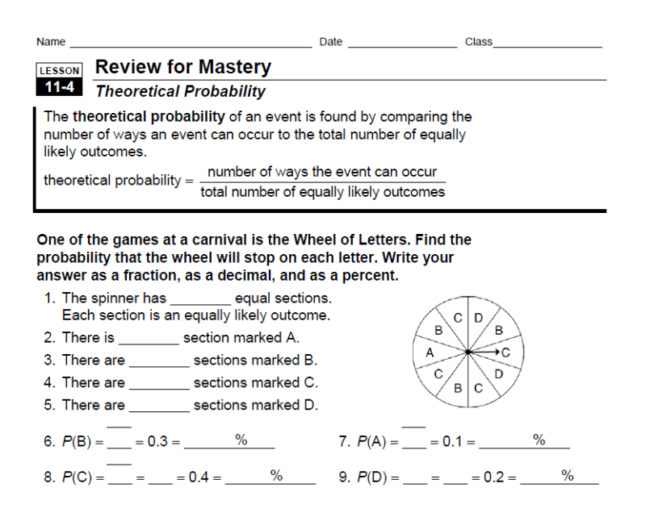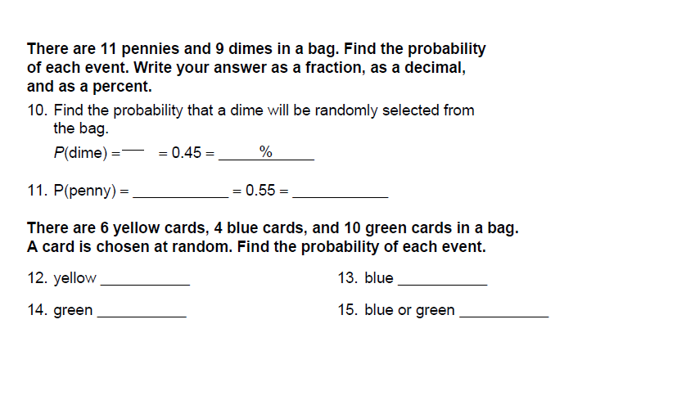

Theoretical Probability Practice

A set of cards has 15 cards with stars, 20 cards with squares, and 10 cards with circles. Find the probability of each even when a card is chosen at random.

- Square __________

- Star ____________

- Circle ___________

- NOT a circle ___________

- Square or circle ___________

Find the probability of each event. Write your answer as a fraction, decimal, and percent. Round to the nearest hundredth.

- Rolling a number greater than 3 on a fair number cube.

___________________________________________

- Spinning a number that is a multiple of 3 on a spinner with 20 even sections numbered 1-20.

____________________________________________

- Randomly choosing 1 of the 4 letter “A” cubes from a bucket of 50 letter cubes.

____________________________________________

- Spinning a number less than 9 on a spinner with 100 even sections numbered
1-100.

_____________________________________________

- Randomly choosing a pink jelly bean from a jar of 6 orange jelly beans, 5 pink jelly beans, 3 yellow jelly beans, and 2 purple jelly beans.

_____________________________________________

Probability - Day 4 Lesson

Class: 7th grade math Intervention

Objective: Students will use manipulatives to calculate the experimental and theoretical probability

Lesson Procedure:

Instruction/Lab Time (45 minutes)
- Inform students that we will be doing an experiment today dealing with experimental and theoreticap probabilty.
- Remind students that experimental probability of an event is the ratio of the number of times the event occurs to the total number of trials. I will set up the ratio on the board for students to see.
- Remind students that theoretical probability of an event is the ratio of the number of ways the event can occur to the total number of equally likely outcomes. I will set up the ratio on the board for students to see.
- Explain that students will be doing a hands on experiment today to calculate probability of an event.
- Put students in groups of two. (use popsicle sticks to partner them up)
- Pass out materials needed in each group (letter cards ABCD and number cards 123, and 2 cups)
- Pass out instructions for the experiment to each group (attached)
- Give students time to draw a frequency table to record their results in before reading through the instructions together
- SEE ATTACHED EXPERIMENT PLAN FOR PROCESS
- Once students finish their experiment they may work on the weekly extra credit assignment.
- No homework tonight!

Evaluation: I will walk around and observe what students are doing in their groups. I will ask questions such as “what happened the first time you drew a card?” Students will turn in their frequency tables once they finish their experiment and I will look over them to see if their results are reasonable. If not I will talk to them to see if they understood the activity.

Probability – day 4 Lab

- Fold the slips of paper with the letters A, B, C, and D in half and put them in your cup.

- Predict the number of times you expect to choose A when you repeat the experiment 12 times. Record this prediction next to the letter A on your frequency table.

- Repeat step 2 for letters B, C, and D.

- Without looking choose a slip of paper, note the result on your frequency table by making a tally next to the letter drawn, and replace the slip.

- Repeat step 4 eleven more times. Be sure to mix the slips in the cup between trials. Record each trial on your frequency table using tally marks.

- Look at how many times you chose A, B, C, and D individually. How does the number compare to the prediction you made?

- What is the experimental probability (what actually happened) of choosing A?

- What is the theoretical probabilit (what should have happened) of choosing A?

STOP HERE! MAKE SURE YOUR FREQUENCY TABLE IS FILLED IN AND ALL OF THE ABOVE QUESTIONS ARE ANSWERS CORRECTLY. SHOW YOUR WORK TO MRS. INSELMANN BEFORE YOU MOVE ON!

- Fold the slips of papers with numbers 1, 2, 3 in half and put them in your second cup. NOT with the letters.

- In this activity you will be choosing one slip of paper from each cup without looking.

- Predict the number of times you think you will choose A-1, A-2, A-3, B-1, B-2, B-3, C-1, C-2, C-3, D-1, D-2, D-3 when you complete the experiment 24 times.

- Choose a slip of paper form each bag, note the results, and replace the slips.

- Repeat step 4 twenty three more times and record your answer in your frequency chart using a tally mark.

- How many times did you choose A-1, A-2, A-3, etc? How does this number compare to the prediction you made?

- Find the experimental probability and theoretical probabilty of choosing A-1, B-1, C-1, and D-1.

STOP HERE! MAKE SURE YOUR FREQUENCY TABLE IS FILLED IN AND ALL OF THE ABOVE QUESTIONS ARE ANSWERS CORRECTLY.

Once all of your classmates are done we will go over the following discussion questions. If you have time, you should preview them and prepare and answer in your group.

- In the first experiment, how is the experimental probaility of choosing A based on the combined results of everyone in the class different from the experimental probaility of choosing A based on the results of your individual group?

- How many times would you expect to choose A in your group if you repeat the experiment 500 times?

- In the second experiment, what do you think the theroretical probability of choosing A-1 is? Why?

- How many times would you expect to choose A-1 if you repeat the expriement 600 times?

- Explain the difference between theoretical and experimental probability.

Probability – day 5 Lesson

Class: 7th grade math intervention

Objective: Students will find the probability of independent and dependent events.

Lesson Procedure:

Warm up and Problem of The Day (15 minutes)
- Post Warm Up on the SMARTboard
- Students each need notebook paper to do the warm up on
- Go over answers to the warm up by asking for student volunteers to share their answer and explain how they got it. Teacher will intervene if necessary
- Post Problem of the Day on the SMARTboard
- Students will solve it on the same piece of notebook paper
- Go over answer to the Problem of the Day, students should correct their answers as the teacher does it on the board

Instruction (20 minutes)
- Read the objective that is written out on the SMARTboard so students know what we’re doing for the day
- Pass out Know It Notes for probability of independent and dependent events
- Students will have 5 minutes to define the two words at the top of the paper
- I will call on students to share their definitions with the class. If inapropriate definitions are given I will intervene as needed.
- I’ll start by discussing independent and dependent with an example. Independent people (such as myself) are on their own and have the skills to survive on their own. Dependent people (students) still have supervision from their parents/guardian and don’t have the skills to survive on their own.
- I will tell students to think about the situations that we are going to go over. If the outcome wouldn’t be affected then it’s independent (ok on it’s own). If the outcome is affected then it’s dependent (needs something else).
- I will go over examples 1-3 on the SMARTboard and ask for student input while working through the examples.
- Once notes are complete I will assign the check it out questions to students. They will be able to choose a partner and complete them together.
- When students finish their check it out questions I will check to make sure their notes were filled out correctly and their answers to check it out are right.
- Students will then be given an assignment to complete with their partner. They should have time to finish it in class.

Wrapping it up (15 minutes)
- Students who need more help with their check it out problems will form a small group with me in the back. Once they finish I will give them their next worksheet.
- I will write the assignment on the board and give students time to write it in their planners
- I will remind students that their homework is due at the beginning of class tomorrow. If they finish before the end of class today they may turn it in the tray.
- I will tell students we will be doing a review game tomorrow to prepare for a quiz over probability.
- Students will use the rest of the time to work on the assignment.
- If they finish early they know to work on extra credit or an early finisher from the side of the room.

Evaluation: I will use a combination of assessment methods to evaluate student understanding on today’s lesson. The questions I ask during the lesson and the answers students give in return allow me to see if they understand what I am covering. The homework assignment will also serve as an evaluation method for today’s lesson. I will collect it tomorrow at the beginning of class and grade it to see if students did it correctly or are still struggling. For those who are struggling I will meet with them during classtime or study hall to reteach the concept.

Probability - day 5 classwork

Warm Up
A 1-6 number cubed is rolled!

1.What is the probability that an even number will be the result of a roll?

2. What is the probability that the number will be prime?

Problem of the Day
I have two coins in my pocket that total 30 cents. One of the coins is not a nickel. What are the coins?

NOTES FOR DAY 5

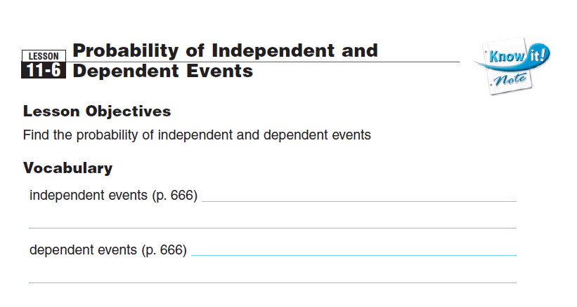
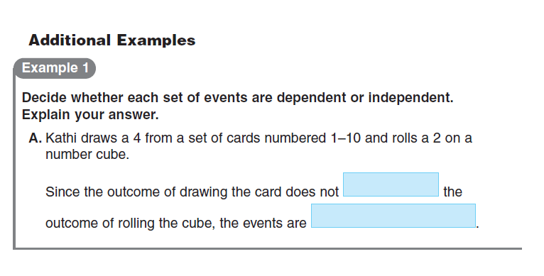
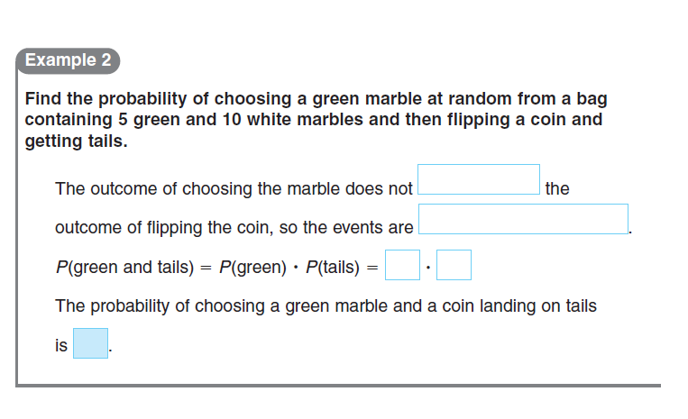

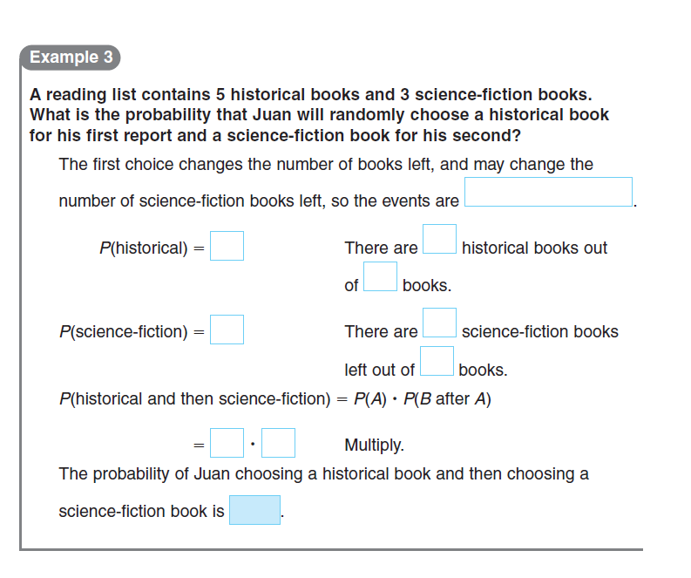

Probability – day 6 review

Class: 7th grade math Intervention

Objective: Students will solve probability problems to review for their upcoming quiz

Lesson Procedure:

Introduction (5 minutes)
- I will put students in groups of four
- I will tell students we are playing a review game to prepare for the upcoming quiz over probability
- I will read the directions to the game aloud and tell them they need to all participate in their group, work out the problems on notebook paper, and raise their hand quickly when they have the answer.

Review Game (40 minutes)

I will put students in groups of four. They will sit at desks with their group. I will read 1 question aloud at a time. Each group should work the problem out on notebook paper. Once they get what they think is the correct answer they should raise their hand quickly. The first group to raise their hand AND have the correct answer will get a point on the board. At the end of class the group with the most points wins. All group members of the winning group will receive 5 bonus points on their quiz tomorrow!

**FOR THE PROBLEMS THAT DON’T SAY WHICH TYPE OF PROBABILITY TO USE, I WILL ASSIGN ONE.**

- There are 4 red cards and 8 black cards in a bag. How likely is it that you will randomly draw a blue card?

- A bag contains blue, green, yellow, and red marbles. The probability of drawing a yellow marble is 3/20. What is the probability of NOT drawing a yellow marble?

- A goalie in an ice hockey game blocked 15 out of 21 shots on goal. What is the experimental probability that he will block the next shot on goal?

- There are 10 orange counters and 15 red counters in a bag. What is the probability of picking an orange counter from the bag?

- Liz tosses a coin. She also spins a spinner evenly divided into fourths and numbered 1–4. What are the possible outcomes?

- If you roll a number cube 12 times, about how many times would you expect to roll a 5 or 6?

- Sam draws an orange counter from one bag and a red counter from another bag. Is this independent or dependent?

- Each letter of the words SEVENTH GRADE is written on a card and placed in a bag. What is the probability of picking a vowel on the first pick, replacing the card, and then picking a consonant?

- A bag has 9 red marbles and 6 green marbles. Find the probability of drawing a green marble, replacing it, and drawing another green marble.

- A spinner has 8 equal sections labeled 1 through 8. The probability of spinning a number that is greater than or equal to 6 is 3/8. What is the probability of spinning a number that is not greater than or equal to 6?

- The probability of randomly drawing a red card from a bag that contains red, blue, and green cards is 3/10. What is theprobability of not drawing a red card?

- Sally works at a snack bar. Of the first 25 hot dogs ordered one day, 19 were ordered with sauerkraut. If the snack bar expects to sell 150 hot dogs on any day, how many would they expect to be ordered with sauerkraut?

- If Kathy hit the dartboard 9 out of 15 times and Toby hit the dartboard 14 out of 20 times, who has the greater experimental probability of hitting the dartboard on his or her next try?

- There are 15 girls and 9 boys in Anne’s yoga class. One of them is randomly selected to demonstrate a yoga position. Find the probability of each event.
1. Selecting a boy 2. Selecting a girl

- randomly drawing a card with an even number from a shuffled deck of 52 cards with four 13-card suits (diamonds, hearts, clubs and spades), each of which has 9 number cards labeled 2-10 and 4 other cards

- randomly choosing a vowel from a bag of 100 Scrabble tiles that has 12 E’s, 9 I’s, 8 O’s, 4 U’s and 2 Y’s.

- randomly choosing a classical CD from a collection of CDs consisting of 35 jazz CDs, 20 classical CDs, 25 rock CDs, and 5 country music CDs

- tossing three fair quarters and having all three of them land on heads.

- A boy chooses a sock from a drawer of socks, then chooses a second sock without replacing the first.

- picking a red checker from a bag of 9 black checkers and 6 red checkers, replacing it, and picking another red checker

- Randy has 4 pennies, 2 nickels, and 3 dimes in his pocket. If he randomly chooses 2 coins, what is the probability that both are dimes?

- picking a black checker from a bag of 9 black checkers and 6 red checkers, replacing it, and picking a red checker

Wrap it up (5 minutes)
- I will remind students of the upcoming quiz
- I will tell them if they think they need extra help or extra practice to come see me during study hall
- They should write QUIZ in their planner for tomorrow and remember to study their corrected homework assignments

Evaluation:
I will observe students during the game to see if they understand the questions. I will be circulating around the classroom to help when students struggle. Today’s game will help prepare them for the quiz. The quiz will be their final probability grade (post-assessment). That will serve as the assessment so I know whether they are retaining the information from the last 5 lessons or not

Probability Post-Assessment
- A bag contains 9 blue marbles and 4 green marbles. Which shows the
likelihood of choosing a blue marble?
A. likely
B. unlikely
C. as likely as not

- Lucy places six cards that are labeled 1 to 6 face down on the table and mixes them up. What is the likelihood that her friend Harry will draw an even numbered card?
A. impossible
B. as likely as not
C. certain

- Jill rolls a 6-sided number cube and spins a spinner with two equal sections. How many outcomes are possible?
A. 6
B. 12
C. 8

- Sarah draws a blue counter from one bag and a red counter from another bag. Is this independent or dependent?

- A bag has 10 red marbles and 14 green marbles. Find the probability of drawing a green marble, replacing it, and drawing another green marble.

- Each letter of the words SUMMER BREAK is written on a card and placed in a bag. What is the probability of picking a vowel on the first pick, replacing the card, and then picking a consonant?

- There are 12 girls and 15 boys in a Math class. One of them is randomly
selected to do a problem on the board. Find the probability of each event.
1. Selecting a boy 2. Selecting a girl

- Sally has 5 pennies, 3 nickels, and 6 dimes in his pocket. If he randomly chooses 2 coins, what is the probability that both are dimes?

- Randomly choosing 1 of the 4 letter “F” cubes from a bucket of 50 letter cubes. Write your answer as a fraction, decimal, and percent.

- Create your own probability question! Be sure to show how to get the correct answer

