**Instructional Design:**

**6th Grade Resource Room Math**

**Finding Perimeter & Area**



**By: Karen Berg**

**Rationale:**

Students need to have an understanding of basic math computation skills. Once the students have this understanding, they can then apply these skills. Students are able to apply their math skills when finding perimeter and area of objects. They need to know their basic math skills, and then apply their newly learned knowledge of how to calculate perimeter and area. With a CTL curriculum, applying these skills in a project-based setting and engaging the students would most benefit their learning (Chiarelott 2006).

Students will be assessed on their application of how to apply formulas to find perimeter and area. If students can show their process and understanding, they will be successful in mastering the content. In special education, students may make mistake on their calculators, so mastering the process is what needs to be assessed. Therefore, students will be allowed to use calculators as needed. Students will be given formative assessments as a means of on-going assessments to check their understanding of the material.

This unit will meet Ohio Mathematics Content Standards. Students will also be challenged and be given the opportunity to work with peers. Students can collaborate on their project and learn how to work cooperatively in a group. The Instructional Design is organized with the 5-E Learning Cycle Model. This will allow teachers time to teach the skills, provide practice of the new skills, and then let the students have time to explore. The final unit project allows the teacher to facilitate and help the students reach their final goal.

Chiarelott, L. (2006). *Curriculum in Context: Designing Curriculum for Teaching and Learning in Context*. Belmont, CA: Thomson Wadsworth.

**UNIT INTENDED LEARNING OUTCOMES**

**Measuring Two-Dimensional Objects, Perimeter, & Area**

* Students will estimate area by counting square units inside a shape.
* Students will solve informal measurement problems in which shapes are measured by counting squares.
* Students will solve informal measurement problems in which shapes are measured by counting squares.
* Students will count squares to find area.
* Students will estimate population with square units based on a map.
* Students will apply measurement concepts to the field of architecture.
* Students will design a floor plan.
* Students will use the triangular unit for measurement and informal computation of area.
* Students will estimate the area of irregular shapes using areas of regular shapes.
* Students will apply a formula to find the area of squares and rectangles.
* Students will apply a formula to calculate the area of triangles and parallelograms.
* Students will apply area formulas to irregular shapes.
* Students will find the perimeter of shapes.
* Students will apply concepts about perimeter to shapes other than rectangles.
* Students will identify the relationship between area and perimeter.
* Students will identify the difference between area and perimeter.
* Students will identify and apply concrete rules about the comparison of area and perimeter.
* Students will find the area of irregular shapes.
* Students will find the area of shapes within other shapes.
* Students will recognize patterns when solving problems.

**Finding Perimeter and Area Pre-assessment**

***Directions:***  Before you complete the unit, rate yourself a star (🟊) if you know how to complete the following math skills, a check (🗸) if you know a little about it, and a dash (−) if you do not know it at all.

Estimate area by using square units

Calculate area of a square

Calculate area of a rectangle

Calculate area of a triangle

Calculate area of a parallelogram

Find the perimeter of a shape

Compare/Contrast the area and perimeter of a shape

**Lesson Plans (following the 5 E’s Model):**

**Lesson 1**

**Concept/Skill:** Estimating Area and Counting Square Units

**Time Period:** 3 days

**Lesson Objectives:**

* Students will estimate area by counting square units inside a shape.
* Students will estimate the area of irregular shapes using areas of regular shapes.
* Students will solve informal measurement problems in which shapes are measured by counting squares.
* Students will solve informal measurement problems in which shapes are measured by counting squares.
* Students will count squares to find area.

**Procedures:**

*Engagement –* Day 1

* Pre-assessment – student complete independently, teacher reads aloud
* On SmartBoard, teacher shows a layout of a garden. Class discusses how to use estimation to plan a garden. Discuss different types of plants in a garden, size and space of plants, overall layout.

*Exploration* – Day 1

* Complete Worksheet: Measuring Square Units (worksheets below)

*Explanation* – Day 2

* Students are given a large sheet of construction paper, ruler, and color tile squares. They are to cut a shape for their garden and draw 1 inch by 1 inch square grid on the paper (this will need to be demonstrated prior to students doing independently). Use the tile square select 5 different types of plants for their garden, each color square represents a plant. Students are to layout the garden as they would like, can be separated equally or have more/less of the different plants.
* At end, students are to take a picture of their garden with their laptop and email it to the teacher.

*Extension* – Day 3

* Complete Worksheet:
* One by one teacher will open each student’s emailed picture. Each student will go up to the SmartBoard and explain their garden, measurements, and rational for layout. Other students may ask questions and give feedback.

*Evaluation* – Days 1-3

* Homework will be given as a skills reinforcement each day. It will be checked and returned the following day.
* Formative Assessment – Mini-quiz covering skills will be given at the end of class on Day 3.

**Materials/Resources:**

* Calculators
* Construction paper
* Ruler
* Color square tiles
* Worksheets
* Laptops

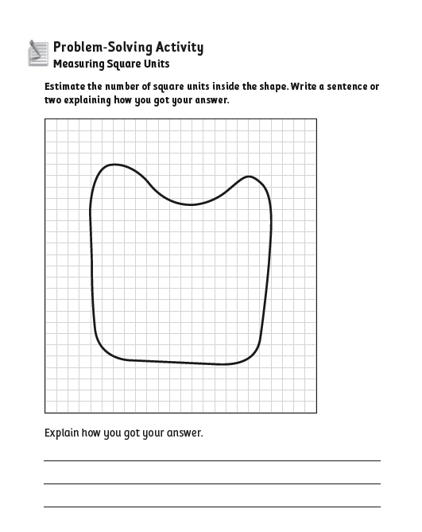

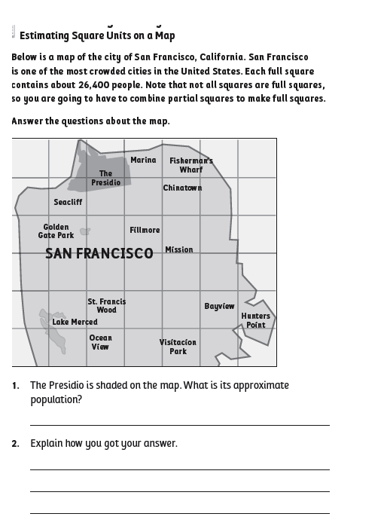

**Lesson 2**

**Concept/Skill**: Applying Formulas to Find Area of Squares, Rectangles, Triangles, and Parallelograms

**Time Period**: 3 days

**Lesson Objectives**:

* Students will apply a formula to find the area of squares and rectangles.
* Students will apply a formula to calculate the area of triangles and parallelograms.
* Students will apply area formulas to irregular shapes.

**Procedures**:

*Engagement –* Day 1

* Teacher will teach formulas for finding area and student will follow an Interactive SmartBoard lesson. Teacher will complete examples on the SmartBoard.
* Teacher will hand out whiteboards and markers. There will be practice problems on the SmartBoard. Students will complete the problems on their whiteboards. Each problem will give a student the opportunity to come up to the SmartBoard and do practice problems. The class will check their whiteboards with the answers being put up on the SmartBoard.

*Exploration* – Day 2

* Prior to students entering the room, the teacher will rearrange the desks in an unorganized manner. Students will enter the room and be told to find a seat. The teacher will lead a discussion about the shape of the room, desks, tables, shelves, etc. Students can measure and find the area of the room. They can take measurements of other items in the room (i.e. desks, tables, shelves, etc.) and design new functional layouts for the room. Students will use grid paper to design their layout.

*Explanation* – Day 2

* Complete Worksheets: (worksheets below)
  + Area Formulas for Squares and Rectangles
  + Area Formulas for Triangles and Parallelogram

*Extension* – Day 3

* Students will work in groups of 3. Each group will need to identify 10 objects in the classroom and/or school building. They will need to measure the object in inches and calculate the area of the object. The information will be recorded on a piece of paper.

*Evaluation* – Days 1-3

* Homework will be given as a skills reinforcement each day. It will be checked and returned the following day.
* Formative Assessment – Mini-quiz covering skills will be given at the end of class on Day 3.

**Materials/Resources**:

* Calculators
* Whiteboards
* Markers
* SmartBoard
* Rulers

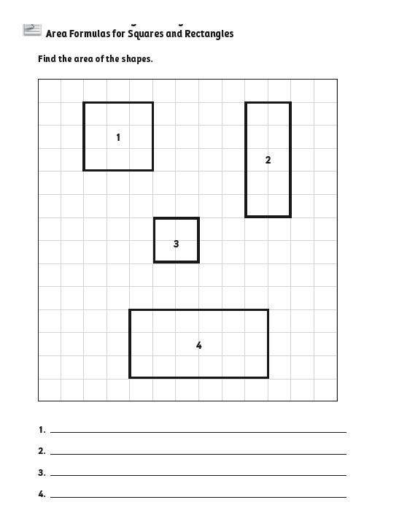

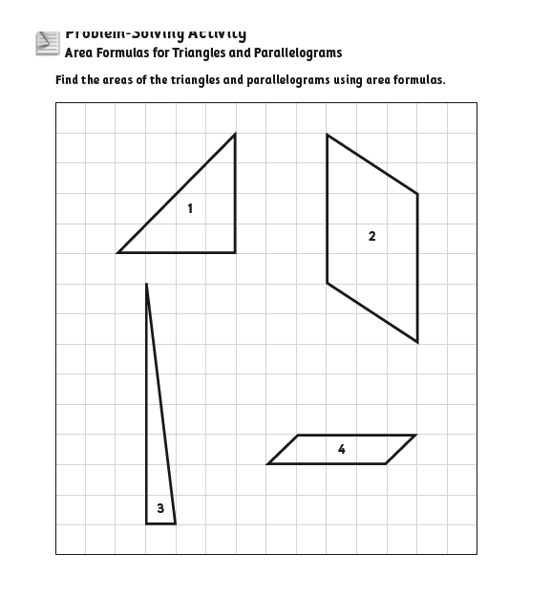

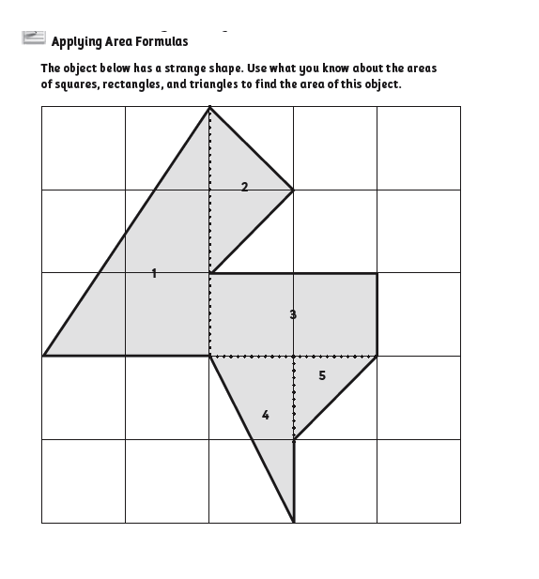

**Lesson 3**

**Concept/Skill**:

**Time Period**: 3 days

**Lesson Objectives**:

* Students will find the perimeter of shapes.
* Students will apply concepts about perimeter to shapes other than rectangles.
* Students will identify the relationship between area and perimeter.
* Students will identify the difference between area and perimeter.
* Students will identify and apply concrete rules about the comparison of area and perimeter.

**Procedures**:

*Engagement –* Day 1

* Teacher will explain that Perimeter is the space around an object. It is like a line or border around the object. The teacher will then take a piece of string and measure around an object to show perimeter. Then the students can select objects for the teacher to use the string to determine the perimeter.

*Exploration* – Day 1

* Teacher will teach formulas for finding Perimeter and student will follow an Interactive SmartBoard lesson. Teacher will complete examples on the SmartBoard.

*Explanation* – Day 2

* Complete additional practice problems on the SmartBoard to find area and perimeter. Students will come up the SmartBoard to complete the problems.
* Complete worksheet: Perimeter (worksheets below)

*Extension* – Day 3

* Students will go to: [www.StudyIsland.com](http://www.StudyIsland.com) and log in. They will complete the lesson for Perimeter and Area and take the 20 question quiz. If the student earns a blue ribbon, they will be able to play the games on the topic. If not, they will be given remediation in a small group with the teacher. Then they will retake the online quiz.

*Evaluation* – Days 1-3

* Homework will be given as a skills reinforcement each day. It will be checked and returned the following day.
* Formative Assessment – will be the results from the Study Island quizzes.

**Materials/Resources:**

* Calculators
* SmartBoard
* Laptops
* rulers

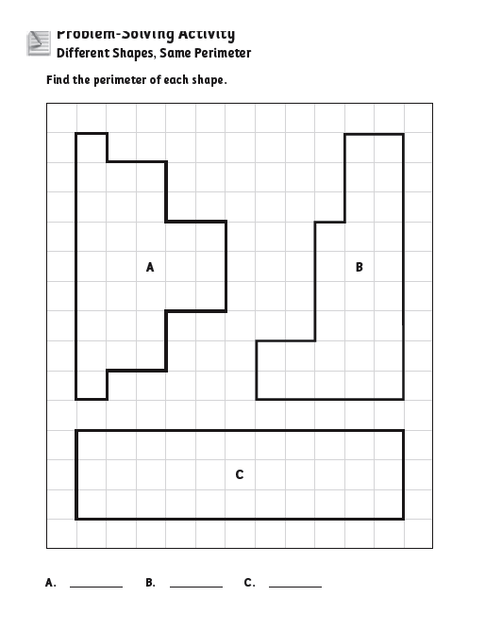

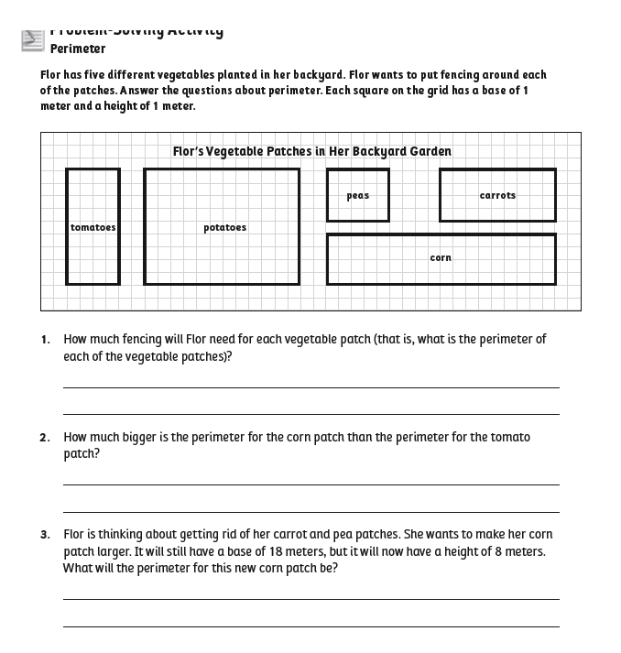

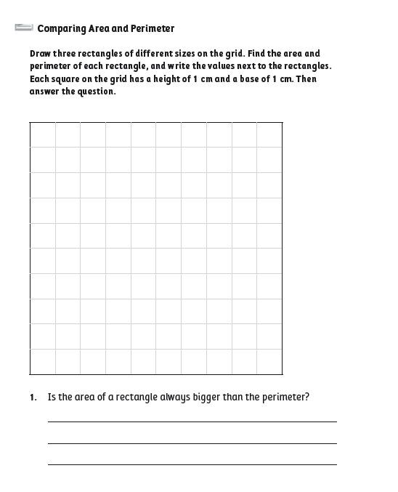

**Lesson 4**

**Concept/Skill**: Area and Perimeter Unit Project

**Time period**: 4 days

**Lesson Objectives**:

* Students will find the area of irregular shapes.
* Students will find the area of shapes within other shapes.
* Students will recognize patterns when solving problems.

**Procedures**:

*Exploration* – Day 1

* Teacher will show examples of floorplans for houses and floor plans for individual rooms (images obtained from Google Images). Discuss with students functional room space, shape, size, etc. What type of items are needed in each room (i.e. the kitchen needs a refrigerator, stove, sink, and cabinets).

*Exploration* – Day 1

* Explain the Unit Project, ideas from: <http://mste.illinois.edu/courses/ci302sp02/students/kjudd/unitplan/unitplan.htm>

Students are able to work with a partner and build a one-floor dream home. The students are given land with the dimension of 50 ft by 100 ft.

The students can plan to have anything in their home. If a student want three cars, or a pool they must take in consideration the dimension as well as the amount of area each item will have. Students will be given a poster board to put all of this information. Before putting info on poster board, inform students to thin of the things they want in their home. Please start with a pencil and a large eraser... just in case you change your mind.

Some general guidelines.

Each home must at least have: (these requirements should be written on the board)

-at least 6 different rooms (bath, bed, kitchen, living room, closet, dining room / family room (entertainment room)   
-each bedroom should have a closet   
-If you want more than 2 cars you will need to have a garage to fit at least one car   
-if you have dog, there must be a doghouse   
-any other pets, you must say where it's home will be   
-you want a backyard of at least 300 square feet (in case you decide later to get a pool)   
  ALL ROOMS MUST HAVE THE DIMENSIONS LABELED!!!

Each room must have enough space so that necessary things can fit in it.   
(a bathroom must be able to fit a bathtub, sink and toilet)   
When introducing the lesson to the children, remind them even though they are not required to find the dimensions of each item, it must be enough space for the item to fit in the room.

Students must identify at least fit 3 different items in each room (if you want more things, make sure you say where things will be and everything fits!!!) Closets can have the same items.

Examples:   
~ a bedroom could have a bed, a TV, a night stand   
~  a closet might have a pair of shoes, hanger, a storage bin.   
 ***Again remind students that everything must fit in any given room... a closet must be wide enough so that the hanger can fit width-wise   
Nice but not necessary

a backyard pool   
a foosball table   
a big screen TV   
houseplants   
a Jacuzzi   
a swing in the backyard   
a place to grow plants, vegetables in the yard

The students will have work on this project in class. They may ask questions that might have not been answered through the unit.

*Explanation* – Day 2

* Group workday: Teacher will meet with each group individually to discuss any individual questions and check group’s progress.

*Extension* – Day 3

* Groups continue to work on project and put together the finishing touches. Groups will also need to practice how to present their project to the class.

*Evaluation* – Day 4

* Post-assessment
* The day the project is due students will have about 5 minute to present it to the class.

**Materials/Resources**:

* Posterboard
* Rulers
* Colored pencils
* Calculators

Worksheets obtained from:

Woodward, J. and Stroh, M (2009). *TransMath*. Voyager Learning a division of Cambium Learning, Inc.

**Finding Perimeter and Area Post-assessment**

***Directions:***  Complete the following problems. Remember to label your answers.

**Estimate area by using square units**

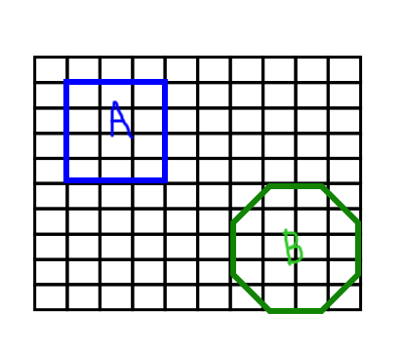

Estimate Shape A:

Estimate Shape B:

**Calculate area of a square**

Area =

3 inches

**Calculate area of a rectangle**

8 feet

Area =

2 feet

**Calculate area of a triangle**

4 ft

Area =

5 ft

**Calculate area of a parallelogram**

Height = 3 yd

Base = 6 yd

Area =

**Find the perimeter of a shape**

Perimeter:

Side = 12 inches

**Compare/Contrast the Area and Perimeter**

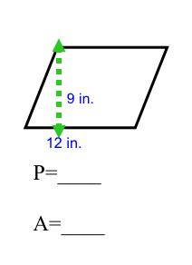

***Calculate and find the Perimeter and Area, then circle the answer:***

1. Perimeter and area are the same.
2. Perimeter is larger than the area.
3. Area is larger than the perimeter.

10 in.