Instructional Design Project

EDTL 7100

June 17, 2011

Elizabeth Eckel

Rational

Often times, teachers teach required concepts to their students once during the school year. Once the concept is “mastered” the teacher moves onto other required standards, without revisiting the previously taught skills. This is a problem because children may lose the ability to display and apply their knowledge of these competencies across the curriculum. Incorporating a cross-curricular unit is a way to sustain proficiency of subjects and to meet the needs of learners in the classroom. All skills should be revisited throughout the year to ensure reinforcement and to allow students extra opportunities to display their understanding of learned skills. Cross curricular units also provide the teacher with optimal possibilities for variety while covering the required state standards or courses of study during the school year.
This instructional design project is features a cross-curricular unit on plants. While science standards are the main focus, there are many other math, language arts, health, and social studies concepts that will be incorporated and reviewed throughout this unit. Because this is mainly a unit focused on a science concept, the lesson plans will follow a combination of the 5-E Model and the Basic Lesson Planning Model. Chiarelott (2006) states:
Although the basic lesson planning model is highly serviceable and adaptable to any number of content areas and contexts, more specific models have been developed for particular content areas and types of learning experiences. One of these, the 5-E Learning Cycle Model, has been successfully used in science. (p. 90)
The 5-E Model is made up of five steps: engagement, exploration, explanation, extension, and evaluation. All five of these steps are crucial to science lessons, which is one reason for combining these two models. This unit is intended for kindergarten students, with limited attention spans. According to Chiarelott (2006), “the 5-E lesson would probably cover several days” (p. 91). By integrating vital parts of the 5-E Model into a basic lesson plan model, teachers can achieve the effectiveness of science teaching without compromising their time management and the comprehension of young learners. Students are still receiving the benefits of the 5-E model without the complicated extensions of the lessons.

References

Chiarelott, L. (2006). Curriculum in context: Designing for teaching and learning in context.
Belmont, CA: Wadsworth

Student Learner Outcomes
(Taken from Toledo Diocese Kindergarten Course of Study)
*Words in [ ] following the outcomes are Bloom’s Classifications
Science

Students will…
- Explore differences between living (biotic) and non-living things. [Understanding]
- Discover that stories (e.g., cartoons, movies, comics) sometimes give plants and animals characteristics they really do not have (e.g., talking flowers). [Understanding]
- Describe how plants usually resemble their parents. [Remembering]
- Compare variations among individuals of the same kind of plant. [Analyzing]
- Observe features of plants that help them live in different kinds of places. [Evaluating]
- Investigate the habitats of many different kinds of local plants. [Analyzing]
- Use the five senses to make observations about the natural world.[Applying]
- Draw pictures that correctly portray features of the item being described.[Understanding]
- Measure the lengths of objects using non-standard units of measurement (e.g., teddy bear counters and pennies). [Applying]
- Interact with living things and the environment in ways that promote respect. [Applying]

Math

Students will…
- Understand and use non-standard units to measure length; e.g., hand spans, paper clips. [Applying]
- Understand and use standard units to measure length; inches.[Applying]
- Explain the need for standard units of measure. [Evaluating]
- Recognize the attributes of length, weight.[Remembering, Understanding]
- Explore measuring length, using uniform objects; e.g., paper clips for length. [Applying]
- Select an appropriate unit and tool for the attribute being measured.[Understanding, Applying]
- Identify what attribute was used to sort a group of items already sorted. [Understanding]
- Collect and sort data about everyday situations and familiar objects. [Applying]
- Represent data in a floor or table graph using objects and pictures; e.g., bar and picture graphs. [Applying]
- Sort and classify objects by attributes such as size, color or shape and organize data into categories in a simple table or chart.[Analyzing]
- Read and interpret information on charts and graphs. [Understanding, Analyzing]
- Select an appropriate representation of a mathematical idea or situation; e.g., picture/drawing.

Health

Students will…
- Know the foods in the five food groups and eat from each every day. [Remembering]

Social Studies

Students will…
- Describe the immediate surroundings of home (e.g., streets, buildings, fields, woods, or lakes). [Understanding]
- Identify key natural resources that are used in the student’s daily lives. [Remembering, Understanding]

Language Arts

Students will…
- Use books or observations to gather information, with teacher assistance, to explain a topic or unit of study. [Applying]
- Recall information about a topic, with teacher assistance. [Remembering]
- Print capital and lowercase letters, correctly spacing the letters. [Applying]
- Leave spaces between words when writing. [Applying]
- Show characteristics of early letter name-alphabetic spelling. [Applying]
- Use some end consonant sounds when writing. [Applying]
- Place punctuation marks at the end of sentences. [Applying]
- Name or label objects. [Applying]
- Write from left to right and from top to bottom. [Applying]
- Use resources (e.g., a word wall) to enhance vocabulary. [Applying]
- Identify and discuss the sequence of events in informational text.[Evaluating]
- Identify favorite books and stories and participate in shared oral reading.[Evaluating]
- Understand new words from the context of conversations or from the use of pictures within a text. [Understanding]

Art

Students will display… [Creating]
- Visual Awareness
  - The student perceives: line, shape, value, color, texture, relationships (likenesses and differences within art elements, few and many, positions, repeat pattern)
- Production: Media/Techniques
  - Drawing (uses crayon, chalk, pencil, markers, makes various lines, makes shapes)
  - Cutting and gluing
    - Cuts simple paper shapes
    - Cuts on a line
    - Folds paper and cuts shape on fold
    - Tears free-form paper shapes
    - Uses minimum amount of glue
  - Maintains Materials (conserves art supplies using least amount necessary, returns materials to proper places, uses proper cleaning procedure for art supplies)

Objectives Cited from: http://www.cyss.org/schools/CofS/Cos.html
Pre-Assessment

The pre-assessment for this subunit will be rather informal. The majority of information will be gathered through observation, answers given during class discussions, and review of prior assessments for math and language arts. The students will also be filling in the K and W part of a KWL chart about plants at the beginning of this unit. What they Know about plants already and what they Want to know about plants along with questions asked during introductions to lessons will also be used as a pre-assessment. Children are expected to be familiar with language arts and math concepts reviewed in this cross-curricular unit. Because of this pre-assessing concepts for math, language, social studies, and health will be done throughout other units, respectively. Plant concepts (science objectives) may be new to students and are the main focus of the post-assessment to follow.

Lesson One: Plant Parts

Concept/Skill to be learned:
- All plants have parts
Lesson Objective:
- Students will be able to identify the four plant parts: roots, stem, leaves, flower.
Time: 35-45 minutes
Materials/Resources:
- 4 real flowers or plants (with roots attached)
- Smartboard -OR- Projector
- Computer with Internet access
- United Streaming video: Plant Parts and their Uses
http://player.discoveryeducation.com/index.cfm?guidAssetId=7803FFC1-5A19-4E5A-B859-57945E789CD7&blnFromSearch=1&productcode=US
- Plant Parts handout found at:
http://www.learningtreasures.com/science/plants/parts_of_a_plant.pdf
- Chart paper -OR- white/chalk board
- Marker/chalk
- Supplies for students: pencil, scissors, glue, crayons
Procedures:

Introductory Activity / Engagement and Exploration (5-10 minutes):

Pass a real flower or plant (preferably with roots attached) around to each table. After each student has had a turn to handle the plants/flowers ask the following questions:
~What did your table look at?
~ How do you know it is a plant/flower?
~What do you notice about your table’s plant flower?
~How are the plants/flowers alike? Different?
~What parts do you see on your plant/flower?

Developmental Activity / Explanation (20 minutes):

Explain to the students that all plants have parts. Show the United Streaming video Plant Parts and their Uses to the class. After the video is complete, list on the board or chart paper plant parts and what they are used for (students volunteer information they learned through the video).

Concluding Activity / Extension (10 -15 minutes)

Pass out the worksheet and have the students label the parts of the plant. They can use the word wall to assist their spelling, or they can phonetically spell out the words.
Assessment / Evaluation Strategy: Observation, Work sample

Students will be assessed based on their contributions to class discussions and if they have completed the handout correctly.

Lesson Two: Leaves

Concept/Skill to be learned:
- Plants have leaves
Lesson Objectives:
- Students will be able to gather, sort, and categorize different leaves.
- Students will create leaf rubbings.
Time: 30-40 minutes
Materials/Resources:
- Access to an outside yard, park, etc. where the students can find leaves (weather/season permitting)
- Real leaves (enough for each student to have 5-8)
- Bags to carry leaves in, one for each student
- White paper
- Supplies for students: crayons, pencils
Procedures

Introductory Activity / Engagement / Exploration (5 minutes):

Take the students outside and ask them to find as many leaves as they can. (Have backup leaves prepared for the kids that cannot find as many as 5-8 for themselves. If no leaves are available at this time of the year or if the weather is bad, scatter the leaves you brought around the classroom and have the kids collect them inside.) Students should put leaves in their bags.

Developmental Activity / Explanation (15 minutes):

Take the students inside and have them sort their leaves. Ask:
~How do you know these are leaves?
~How can you sort your leaves?
~Why did you choose to group these leaves together?
~Who has a leaf that would fit into this group? Why does it work there?
Remind students of the characteristics of leaves and of what the job of a leaf is.

Concluding Activity /Extension (10-15 minutes):

Ask the students to pick their favorite 5-8 leaves. Invite kids to share their leaves with others or use the ones that you picked. Show / demonstrate how to make a leaf rubbing. Students will carry on and create their own leaf rubbings. If there is time, ask students to write a sentence about leaves, their project, their favorite leaf, etc.
Assessment/Evaluation Strategy: Observation, Work sample

Students will be assessed based on their contributions to class work / discussions and on completion of their leaf rubbing project.

Lesson Three: Plant Parts We Eat

Concept or Skill to be Learned:
- We eat parts of plants.
Lesson Objective:
- Students will sort parts of plants that we eat into their respective categories (root, seed, stem, leaf, flower, fruit)
Time: 25-30 minutes
Materials / Resources:
- White/chalk board
- Plants mini bulletin board set food pictures (this set can be found at: http://www.creativeteaching.com/p-497-plants-mini-bulletin-board-set.aspx)
- Book: We Can Eat the Plants by: Rozanne Lanczak Williams
- Each food item for each student:
  - 1 rice cake, plain, covered with a thin layer of peanut butter, 1 celery stick (child size, 4 inches long), 4 mini carrots, sliced length wise in half, handful of sunflower seeds. Photo of the finished product can be viewed at: http://www.littlegiraffes.com/plants.html (half way down the page, on the right)
- Paper plates / napkins
Procedures

Introductory Activity / Engagement (5 minutes):

Ask students if they like to eat plants. See what their responses are. Tell students that they do eat plants. Then list some plant parts that we eat (carrots, celery, lettuce, broccoli, etc.) and ask who likes to eat those. Pass out a food picture from the bulletin board set to each student.

Developmental Activity / Exploration / Explanation (10 minutes):

Put labels of the parts of plants (seeds, roots, stem, leaves, flower, fruit) on the board. Start with one and read what foods go under that label. For example, tell the students that examples of flowers are broccoli and cauliflower. When their picture is called, have the students come to the board and place their picture under the label. Repeat for all labels.

Concluding Activity / Extension (10-15 minutes):

Tell the students they will be making a snack using parts of plants. Pass out the plates and napkins and the following to each child: 1 rice cake, plain, covered with a thin layer of peanut butter,1 celery stick (child size, 4 inches long), 8 mini carrot slices, and a handful of sunflower seeds. Instruct the children to arrange their food to look like a sunflower. See photo at:
- http://www.littlegiraffes.com/plants.html. Read the book We Can Eat the Plants by: Rozanne Lanczak Williams while the children eat their snack. Challenge the students to eat the correct plant part to match what part you are reading about in the story. (For example, on the page that says, “We eat roots,” they should eat a carrot.
Assessment / Evaluation Strategy: Observation of student participation / performance
Students will be assessed on their sorting during whole group activity.
Lesson Four: Sunflowers

Concept / Skill to be Learned: Names of plant parts
Lesson Objectives:
- Students will follow directions and make a sunflower craft
- Students will correctly label the sunflower craft
Time: 35-45 minutes
Materials / Resources:
- Book: This is the Sunflower by: Lola M. Schaefer
- For each child: 1 paper plate, WITH one hole punched toward the bottom, yellow crepe paper cut in 2” strips, 1 green pipe cleaner, 2 small green pipe cleaner pieces, 4x10” strip of green construction paper, two 4” pieces of brown yarn, 1 plant part label strip *(see page following)
- Crayons
Procedures

Introductory Activity/Engagement (5-10minutes):

Read the story This is the Sunflower by Lola M. Schaefer. Ask the students to name the parts of plants and discuss the story. Tell the students they will be making their own sunflowers.

Developmental Activity (25-30 minutes):

Pass out the materials to the students in the way you see fit (all at once or one at a time, as needed). Instruct the children whole group on how to make the sunflower craft and label it:
Have students color the center, flat part of the plate brown. Next the students glue the crepe paper pieces to the rim of the plate, overlapping so the white part cannot be seen. Through the hole in the plate, thread the green pipe cleaner and twist to secure. Next, cut two leaves from the green construction paper, and punch a hole in each leaf. Attach each leaf to the pipe cleaner stem with a small piece of pipe cleaner. Tie the yarn to the bottom of the stem, resembling roots. **(See following picture of completed example).

Concluding Activity (5 minutes):

Glue or tape a label to each featured plant part.
Assessment / Evaluation Strategy: Work Sample

Student’s art project is labeled correctly.

**Sample picture of finished project
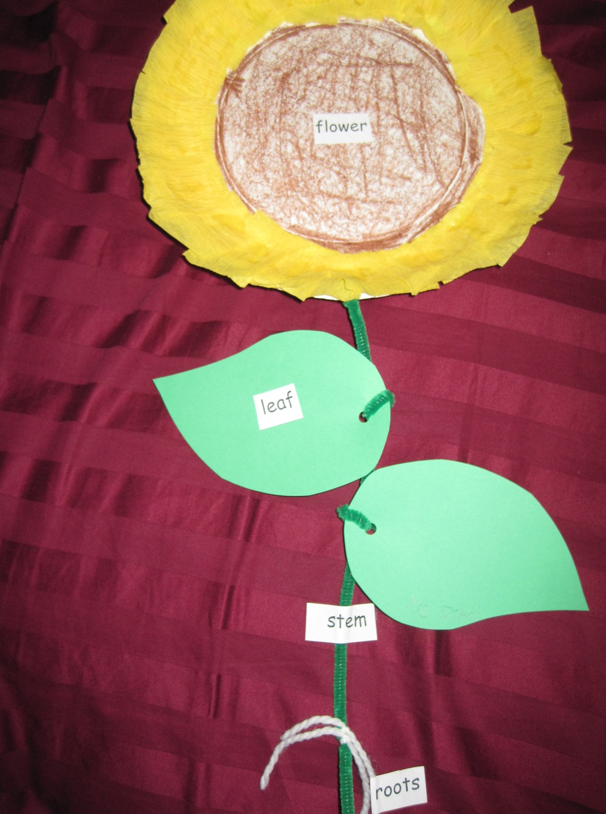

*Plant part labels for sunflower project
flower leaf roots stem
flower leaf roots stem
flower leaf roots stem
flower leaf roots stem
flower leaf roots stem
flower leaf roots stem
flower leaf roots stem
flower leaf roots stem
flower leaf roots stem
flower leaf roots stem
flower leaf roots stem
flower leaf roots stem

Lesson Five: The Giving Tree
***Lesson is based on a lesson found at the flowing source:
http://www.halcyon.com/marcs/trees.html

Concept / Skill to be Learned: We use trees for many things
Lesson Objectives:
- The students will identify 3-4 ways how trees are used
- The students will write and illustrate one way the tree helped the boy in the story.
Time: 30-45 minutes
Materials / Resources:
- Misc. materials / products that are made from / come from trees (paper, magazines, wood, apples, tissues, syrup, gum, carpet, masking tape, etc.) and materials that are not made from plants (paper clip, a penny, a plastic toy, a shell, a rock, a glass jar, a marble, a cd, a metal or plastic fork).
- Two large hula hoops
- Book: The Giving Tree by: Shel Silverstein
- Paper
- Pencils and crayons
Procedures

Introductory Activity / Engagement / Exploration (10 – 15 minutes):

Place the two large hula hoops in the center of the floor. Have the students sit in a circle around the hoops and randomly distribute the items you have selected to use that are either or are not made from trees/plants. Assign labels to the hoops: Made from Plants / Not Made from Plants. Call students one at a time to place their item in the hoop where they think it belongs. After all students have had a turn, reveal / discuss the results.

Developmental Activity (10 minutes):

Read the story: The Giving Tree by: Shel Silverstein. Discuss / reiterate the things the boy received from the tree. Ask:
~Can trees really talk? Why not?
~What did the boy get so far?
~What might she give him next? What would he use it for?
~Can we really get these things from trees?

Concluding Activity / Extension (10-15 minutes):

Pass out the paper to the students and have them write one or two sentences about what the tree gave to the boy that we can really get from trees. Have them illustrate their work as well. Give example prompts if necessary: -The tree gave the boy..., -We get ____from trees…, etc.
Assessment / Evaluation Strategy: Work Sample

Student correctly identified one thing we can get from trees/plants in his/her writing.
Post-Assessment

After wrapping the entire unit (not just the subunit lessons above) students will (as a large group) fill in the L part of the KWL chart and state what they have Learned about plants. They will also be assessed individually, either through one-on-one hands-on methods assessment and by completing handouts. The following are criteria that will be used to determine if the student’s have mastered the objectives of this subunit.
Whole group:
Student contributed at least one idea to the L part of the KWL chart
- The idea is related to plants
- The idea answered one of the “What I want to know” questions
- The idea was not previously on the KWL chart

Individual:
One on one with the teacher
- Student can verbally name 4 plant parts, while pointing to the corresponding parts on a diagram
- Student can name two things we get from plants

Worksheets/Writing Samples
- Student completes handouts/writing samples correctly

If students can complete all of the above with little or no teacher assistance, it will be determined that they have mastered this plant subunit. All of the concepts learned in this subunit will be revisited before the school year is through. Students will be able to maintain mastery of the topics covered and will be introduced to more material that will expand on what was previously covered.

