Instructional Design
3rd Grade Science
Animals
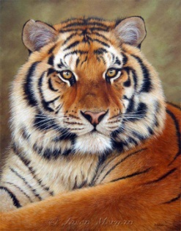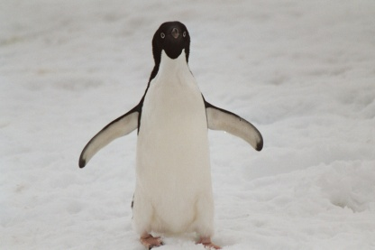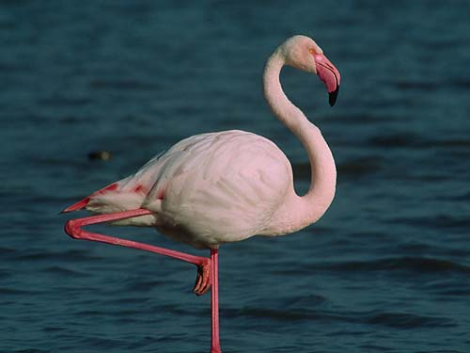

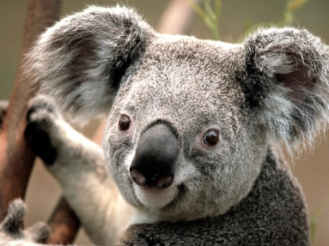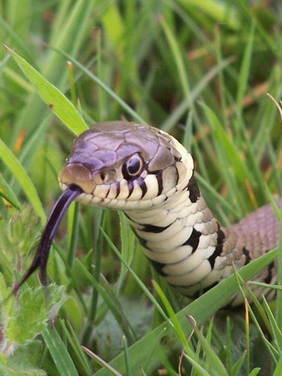

By:Mandy Slabaugh

3rd Grade Science
Rationale
Surveys have been conducted nationally that indicate that the United States is falling behind in math and science. While many argue that teachers are not adequately prepared, especially in the elementary grades, the general consensus is that the problem is much larger than teachers not being fully prepared. The United States has been forced to improve and accelerate science education. While the main focus in the classroom is reading and math, science is instrumental in increasing our reasoning and logical thinking skills.
This science unit will be using concept-related sequencing with a focus on the class relations pattern. By using concept-related sequencing the students will be able to concentrate on one area at a time without becoming confused. Allowing the students to work on one category at a time will help to create the base that is needed to expand their learning. This unit design supports the contextualized teaching and learning theory because it emphasizes that students’ experiences must be connected to the content being discussed. This unit engages students in active learning by creating experiments that will allow them hands on experiences.
This unit will begin with what animals need. This is the logical starting point because the foundation, for animals, is already there. They will learn how to classify the different animals as well as be able to explain the differences between them. The students will recognize that animals have similar needs. They will be able to describe an animal’s habitat and explain why it is important. Following animals’ needs will be mammals, birds, amphibians, fish, and reptiles. They will now go into individual detail about each animal. The students will discover more characteristics that are associated with all of them.
This unit provides the students the opportunity to showcase what they have learned throughout this unit. The students will be able to research an animal of their choice then present their animal to the rest of the class through their blabberize.

3rd Grade Science

Subunit 1: Animals needs
- Students will observe and describe the habitats of organisms – (Bloom’s Comprehension)
- Students will relate animal structures to their specific survival functions – (Bloom’s Comprehension)
- Students will recognize that animals have similar needs: food, water, oxygen, and living space – (Bloom’s Knowledge)
- Students will classify animals according to their characteristics (e.g., body coverings, body structure, and habitats) – (Bloom’s Analysis)
- Students will describe how animals change their physical environments to meet their needs – (Bloom’s Synthesis)
- Students will describe how changes in an organism's habitat are sometimes beneficial and sometimes harmful – (Bloom’s Synthesis)
- Students will identify some inherited traits of animals – (Bloom’s Application)

Subunit 2: Mammals and Birds
- Students will observe and identify characteristics among mammals and birds that allow each to survive – (Bloom’s Application)
- Students will analyze how adaptive characteristics help members of a species survive – (Bloom’s Analysis)
- Students will compare the life cycles of mammals and birds including birth to adulthood – (Bloom’s Analysis)
- Students will record and organize observations (e.g., journals, charts and tables) – (Bloom’s Application)

Subunit 3: Amphibians, Fish, and Reptiles
- Students will observe and identify characteristics among amphibians, fish and reptiles that allow each to survive – (Bloom’s Application)
- Students will analyze how adaptive characteristics help individuals within a species survive – (Bloom’s Analysis)
- Students will compare the life cycles of amphibians, fish, and reptiles including birth to adulthood – (Bloom’s Analysis)
- Students will record and organize observations (e.g., journals, charts and tables) – (Bloom’s Application)

Types of Animal

Animals Needs

- ___________

- ___________

- ___________

- ___________

Mammals

Birds

Amphibians

Fish

Reptiles

Covered with
__________________________

__________________________

__________________________

__________________________

__________________________

Breathe with
__________________________

__________________________

__________________________

__________________________

__________________________

How born
__________________________

__________________________

__________________________

__________________________

_____________

_____________

Live where
__________________________

__________________________

__________________________

__________________________

__________________________

Lesson Plan Day #1
Animal needs
Lesson Outcomes:
- Students will recognize that animals have similar needs: food, water, oxygen, and living space
- Students will classify animals according to their characteristics (e.g., body coverings, body structure, lifecycles and habitats)
Time Allotment: 30 minutes
Materials/Resources Needed:
- Pre-assessment worksheet
  - Worksheet modified from the Workbook Harcourt Science
- Science textbook (Harcourt Science)
- Pencil
Procedures:
- Students will participate in the pre-assessment before the lesson begins (5-10 min)
- Have students open textbooks to pg A32 and talk about fast facts to spark students interest in topic (5-10 min)
  - Ask students to name as many different kinds of animals they can name
  - Tell students Even though there are many kinds of animals, they all need the same types of things to live and grow
    - Ask students what are those needs?
- Ask questions to access prior knowledge about animal needs (5-10 min)
  - What needs do homes meet for people? How is this similar to the needs that are met by an animal’s home? Where do you get the food and water you need to live? Where do animals get their food and water?
- Read more about animal shelters in the science background (10 min)
  - Many animals, such as beavers, termites, bees, and wasps, build their shelters using materials from the environment. When animals build their shelters they change the environment in which they live. These changes may be beneficial or harmful to other living things in the area. For example, when a beaver constructs a dam, the dam slows or blocks the flow of water in a stream. The still water behind the dam may provide a good home from many insects and fish. The dam may also cause the stream to overflow its banks and wash away the soil in which many plants and animals make their homes. Humans build homes that also affect the environment in which people live. Building new homes often displaces both plants and animals in the area.
  - Ask students to describe the ways in which the homes they live in have changed the environment.
Assessment/Evaluation Strategy:
- Observe students by questioning what they know or think they know about animal needs
- Review pre-assessment worksheet

Lesson Plan Day #2
Animal needs

Lesson Outcomes:
- Students will classify animals according to their characteristics (habitats)
- Students will observe and describe the habitats of animals
Time Allotment: 30 minutes
Materials/Resources Needed:
- Pencil
- Classify worksheets Workbook WB16-WB17
  - Worksheets found in the Workbook Harcourt Science
- Animal pictures TR33-TR34
  - Pictures found in the Teaching Resources Workbook Harcourt Science
Procedures:
- Ask students what it means to classify – make sure students know what it means to classify (5-10 min)
- Have students look at classify worksheet and identify each animal and discuss the questions on the worksheet as a class (5-10 min)
- Give each student a set of 6 animal picture cards with a worksheet (15-20 min)
  - Have the students pay close attention to the types of homes the animals live in
  - Have the students describe each animal home they observe on their worksheets
  - If students do not get this completed they are to finish for homework

Assessment/Evaluation Strategy:
- Observe students by asking questions
- Walk around observing students working on animal homes worksheets while asking them questions on what they are finding

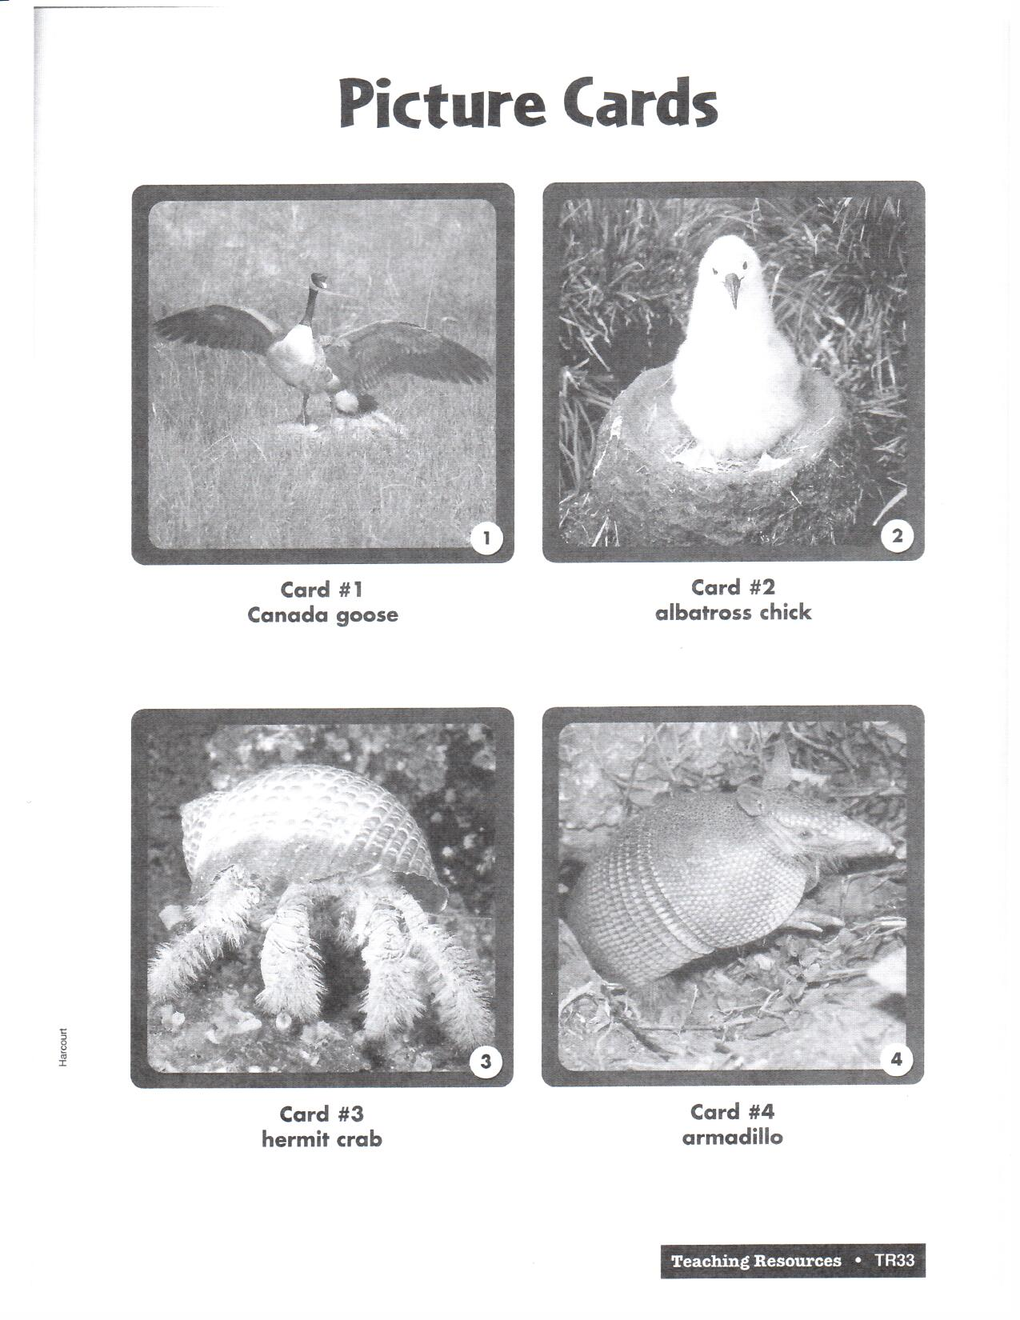
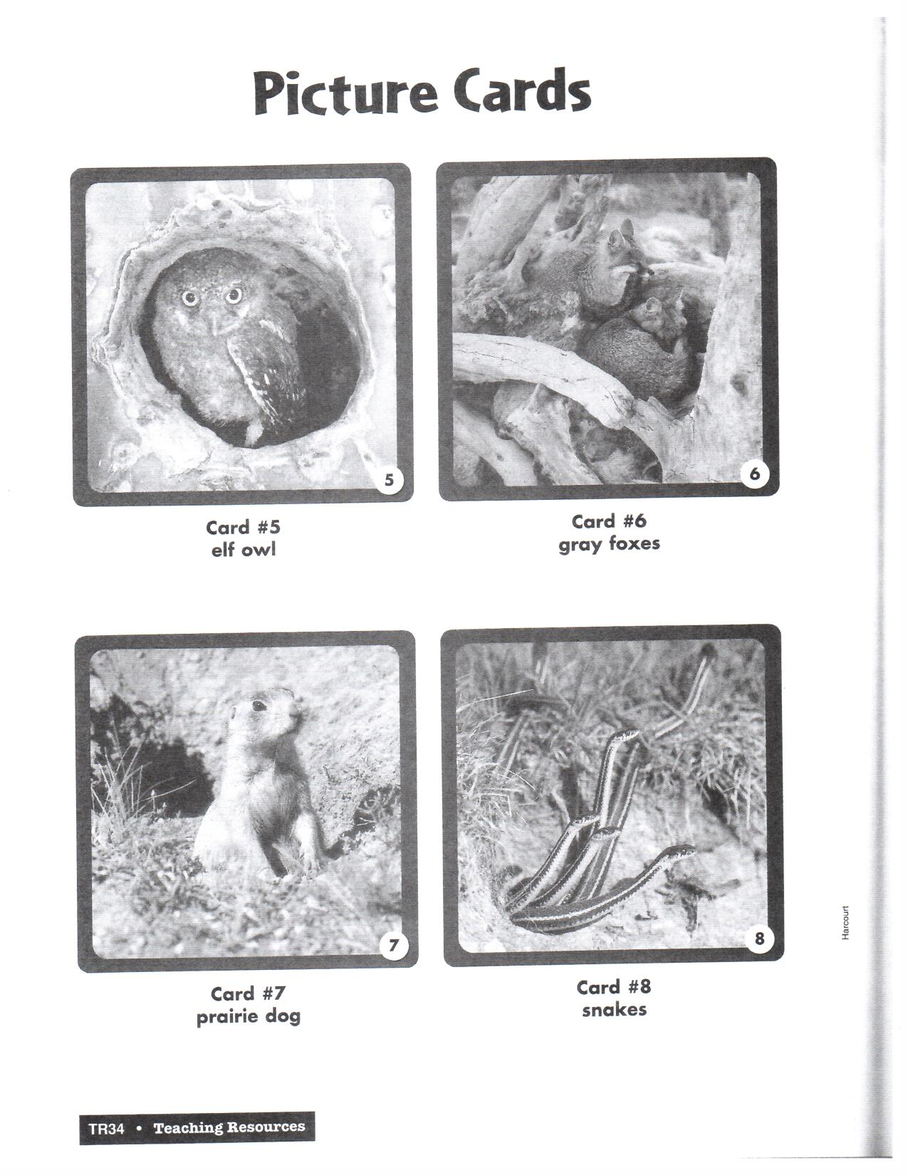

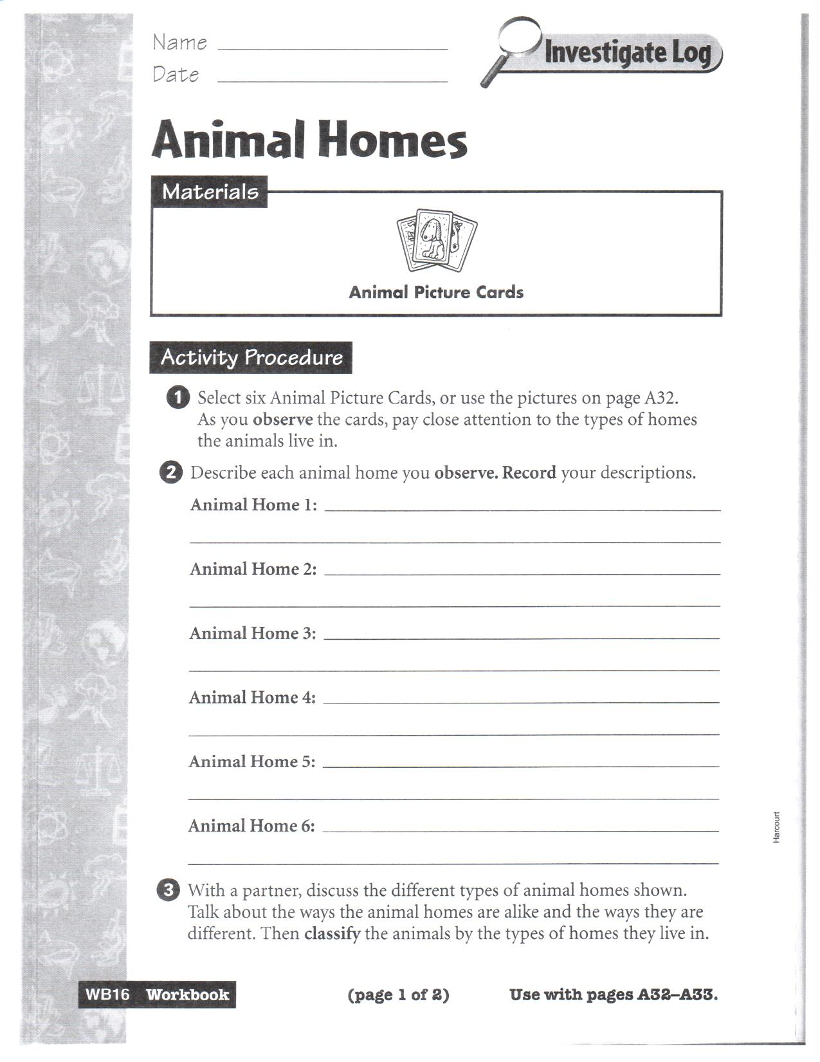
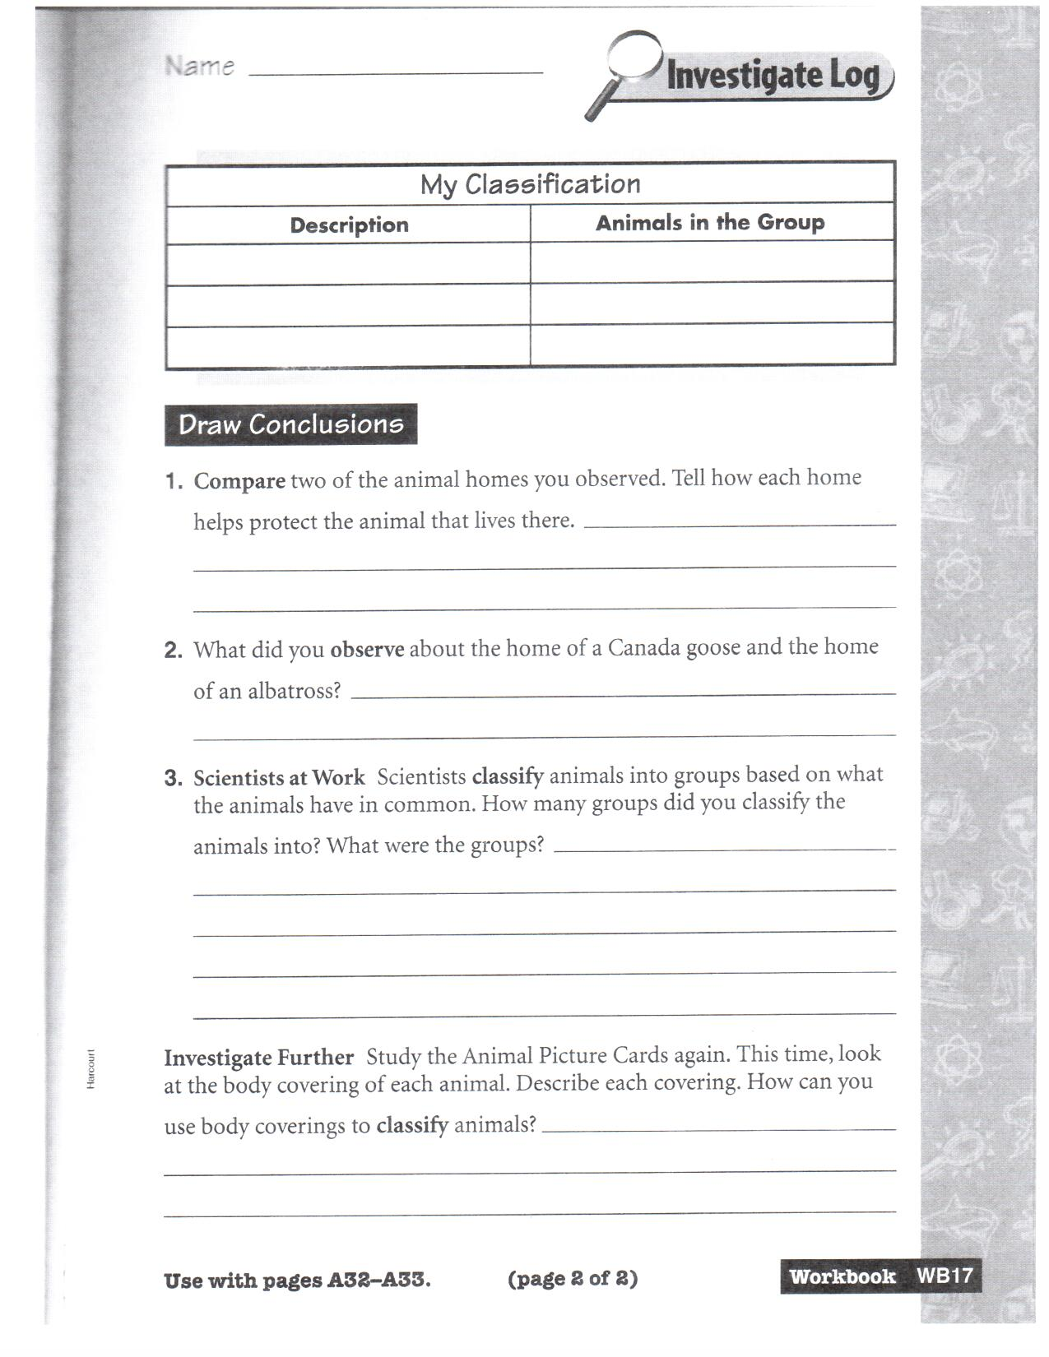
Lesson Plan Day #3
Animal needs

Lesson Outcomes:
- Students will recognize that animals have similar needs: food, water, oxygen, and living space
Time Allotment: 30 minutes
Materials/Resources Needed:
- Animal homes worksheet
- Pencil
- Science textbook (Harcourt Science)
Procedures:
- Place students into groups of 2 and have them discuss the different types of animal homes. Have them finish the worksheet together while discussing what the homes have in common and what are the differences (15 min)
- Have students open their books to pg A34 – A36 (15 min)
  - Discuss what the animals need air, water, food, and shelter
  - go over science idea questions as we read over the lesson
    - What are four needs of animals?
    - Remind students that oxygen is a gas. How do animals get oxygen?
    - Do all animals that live in the water get their oxygen in the same way? Explain.
    - How do animals get the food they need?
    - Do all animals meet their need for food in the same way? Explain.
Assessment/Evaluation Strategy:
- Walk around while students are working in groups to observe them discussing their answers with each other
- Observe students by asking questions from lesson

Lesson Plan Day #4
Animal needs

Lesson Outcomes:
- Students will observe and describe the habitats of organisms
- Students will relate animal structures to their specific survival functions
- Students will describe how animals change their physical environments to meet their needs
- Students will describe how changes in an animal’s habitat are sometimes beneficial and sometimes harmful
Time Allotment: 30 minutes
Materials/Resources Needed:
- Science textbook (Harcourt Science)

Procedures:
- Have students open textbooks to pg A37
  - Read the inside story “Beavers Build Shelters” then ask questions related to story
    - What is a beaver’s home called?
    - What materials do beavers use to build a lodge?
    - What characteristics of the beaver are used to cut down the materials to make their lodge?
    - How does a lodge provide shelter to a beaver?
    - List all the changes you can think of that the beaver makes as he builds his shelter.
    - How do you think these changes affect the beaver, the plants, and other animals living in the area?
  - Go over the science idea questions after reading about animal shelters
    - Why do animals need shelter?
    - What are some examples if shelters used by animals?
    - How do those shelters affect the environment?
    - How does the environment affect those animals and their habitat?
Assessment/Evaluation Strategy:
- Observe students by asking questions from lesson to determine if they are understanding what is being taught

Lesson Plan Day #5
Animal needs

Lesson Outcomes:
- Students will recognize that animals have similar needs: food, water, oxygen, and living space
- Students will classify animals according to their characteristics (e.g., body coverings, body structure, lifecycles and habitats)
- Students will observe and describe the habitats of animals
- Students will relate animal structures to their specific survival functions
- Students will describe how animals change their physical environments to meet their needs
- Students will describe how changes in an animal’s habitat are sometimes beneficial and sometimes harmful
- Students will identify some inherited traits of animals
Time Allotment: 30 minutes
Materials/Resources Needed:
- Science textbook (Harcourt Science)

Procedures:
- Have students open science textbooks to pg A38 “Animal Traits” and look at pictures. Ask students the following questions (15min)
  - What are some traits a bird inherits from its parents? How do these traits differ from the traits a lion inherits from its parents?
  - Why does a young jellyfish not look like a polar bear?
  - What does “traits” mean?
  - After reading ask previous questions again
- Review summary on pg A39 (15min)
  - How do animals that live in water get air?
  - Describe how beavers change their surroundings to meet their needs.
  - What are four things that animals need?
  - Why will a young lion cub grow to look like an adult lion and not like a sea horse?
  - Which of the following is not a need of all animals?
    - A. food; B. water; C. air; D. soil

Assessment/Evaluation Strategy:
- Observe students by asking questions from lesson to determine if they are understanding what is being taught

Lesson Plan # 6
Mammals and Birds
Lesson Outcomes:
- Students will observe and identify characteristics among mammals and birds that allow each to survive
- Students will analyze how characteristics help members of a species survive
- Students will record and organize observations (e.g., journals, charts and tables)
Time Allotment: 60 minutes
Materials/Resources Needed:
- Science textbook (Harcourt) pg A40-A41 “Fur Helps Animals”
- Glue
- 2 metal cans per group
- Cotton batting
- Hot water
- 2 thermometers per group
- Classroom clock
- Worksheet WB21
  - Worksheet found in the Workbook Harcourt Science
Procedures:
- Before experiment is preformed ask students
  - What animals can you name that have fur? In what other ways are these animals similar?
  - What animals can you name that have feathers? What other traits do these animals have?
  - Tell students – When it’s cold outside, you might put on a jacket or a sweater to keep warm. Animals can’t do that. In this experiment you will find out how fur helps keep animals warm.
- Place students in groups of 2 to work on this experiment
- Spread glue around the outside of one can. Then put a thick layer of cotton around the can. Wait for the glue to dry. Then use your fingers to fluff the cotton.
- Be careful with the hot water. It can burn you. Teacher will fill both cans with hot water
- Place thermometers in each can, and record the temperature of the water.
- Check the temperature of the water in each can every 10 mins for a period of 30 min. Record the temperatures on the chart.
- Have groups finish worksheet WB21 together
- As whole class do “Investigate Further”
  - How do you think your results would be different if you used ice-cold water instead of hot water? Make this change and do the investigation again as whole group
- Discuss findings with the students
Assessment/Evaluation Strategy:
- Walk around while students are working in groups to observe them doing the experiment and ask questions about what they are doing
- Observe through discussion whether or not the students understand the importance of fur
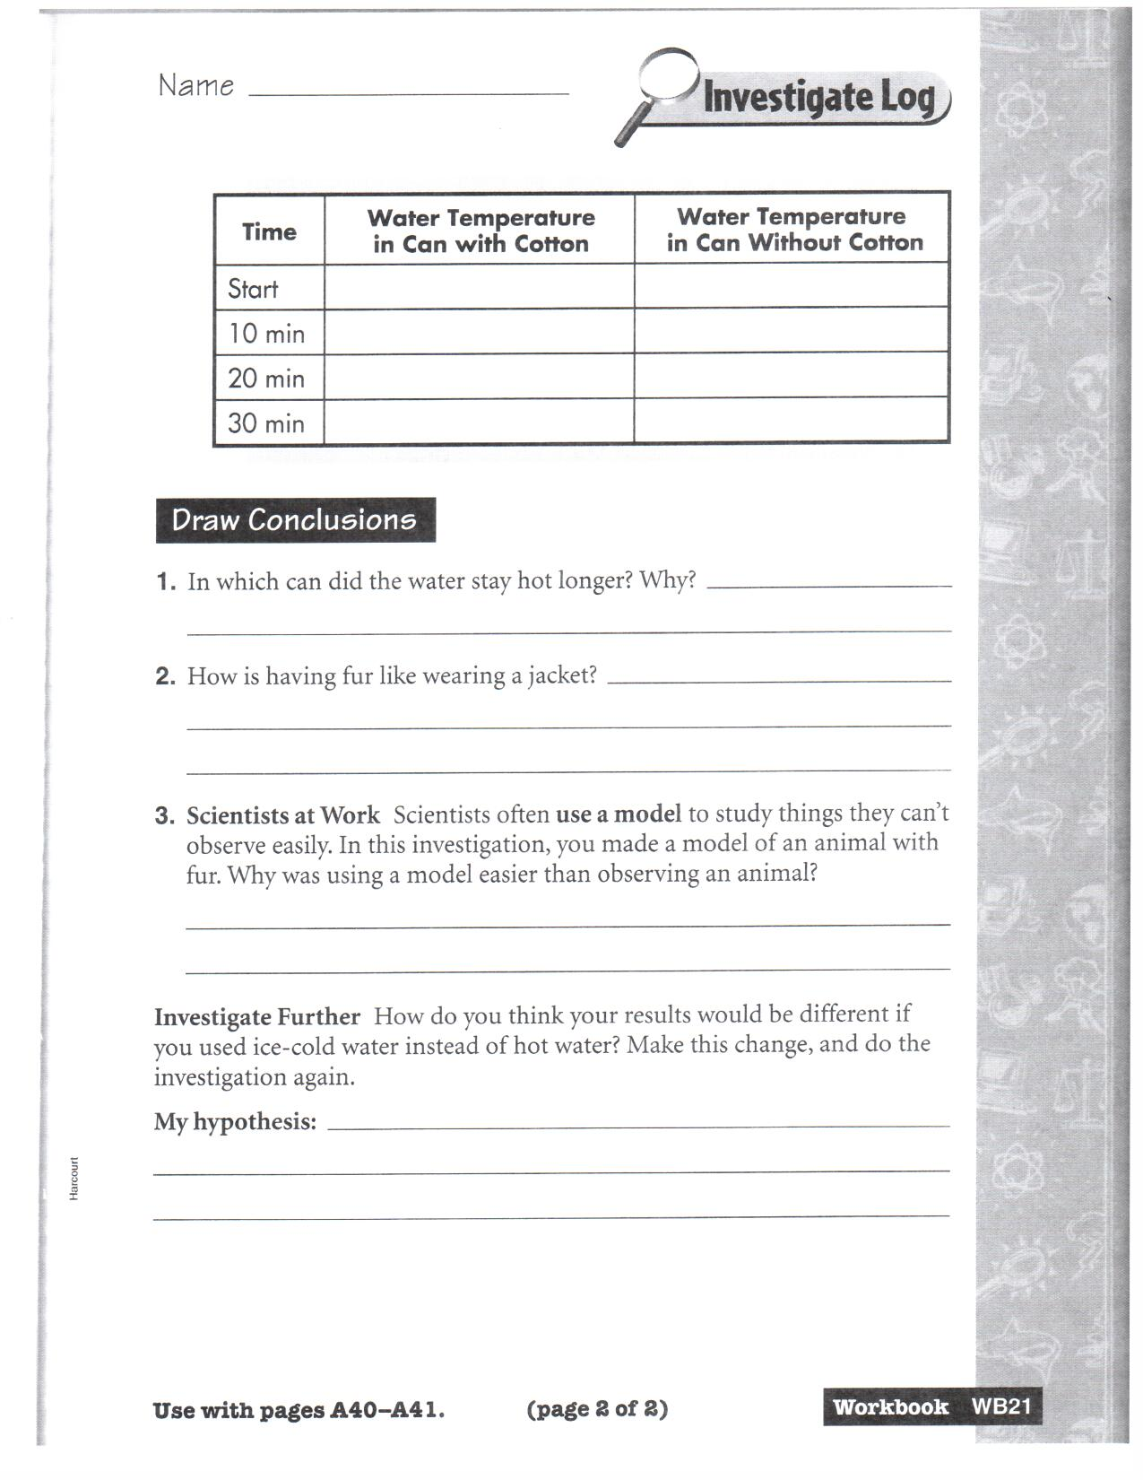
Lesson Plan # 7
Mammals and Birds

Lesson Outcomes:
- Students will observe and identify characteristics among mammals and birds that allow each to survive
- Students will analyze how adaptive characteristics help members of a species survive
Time Allotment: 30 minutes
Materials/Resources Needed:
- Science textbook (Harcourt) pg A42-A43
Procedures:
- Have students open science textbooks to pg A42-A43 “Mammals” before reading ask students questions (15min)
  - Review what “traits” mean
  - What are four traits mammals inherit from their parents?
  - After reading ask previous questions again
- Read The inside story “Keeping warm” pg A42 after reading the inside story ask students the following questions
  - Why does the polar bear’s fur look white?
  - How does black skin benefit the polar bear?
  - Why is fat important to a polar bear?
- read types of mammals pg A44 then ask students the following questions
  - Name three traits used to place mammals in groups
  - What are some traits that are used to classify mammals into groups?
  - What trait do you think all bats have in common?
Assessment/Evaluation Strategy:
- Observe students by asking questions from lesson to determine if they are understanding what is being taught

Lesson Plan # 8
Mammals and Birds

Lesson Outcomes:
- Students will observe and identify characteristics among mammals and birds that allow each to survive
- Students will analyze how adaptive characteristics help members of a species survive
- Students will compare the life cycles of mammals and birds
Time Allotment: 30 minutes
Materials/Resources Needed:
- Science textbook (Harcourt)
Procedures:
- Have students open science textbooks to pg A45 and read “Birds” after reading ask students questions (15min)
  - Review what “traits” mean
  - What are five traits of birds?
  - Use bar graph to answer following questions
    - How can a bar graph help you compare traits among different things?
    - Which bird is the largest? How can you tell?
    - Which bird is the smallest? How can you tell?
- Read Types of Birds on pg A46
  - Ask: What can you tell about a bird from the shape of its beak or feet?
- Review summary on pg A47 (15min)
- Name a mammal that lives in the water. How does is breathe?
- How is the birth of a mammal different than that of the bird?
- What two features of birds are most often used to classify them? Why?
- A bat can fly, but a bat is a mammal. What traits do you think bats have that make them mammals instead of birds?
- Which trait is shared by birds and mammals?
    - A. have feathers; B. have fur; C. breathe with lungs; D. give birth to live young
Assessment/Evaluation Strategy:
- Observe students by asking questions from lesson to determine if they are understanding what is being taught

Lesson Plan # 9
Amphibians, Fish, and Reptiles

Lesson Outcomes:
- Students will compare the life cycles of amphibians, fish, and reptiles
Time Allotment: 30 minutes
Materials/Resources Needed:
- Discovery education video
Procedures:
- Before video access students prior knowledge about amphibians, fish and reptiles (5-10min)
  - Tell what you know about fish. How do these animals differ from birds and mammals
  - What amphibians and reptiles can you name? What characteristics do these animals have/share?
- Students will watch video “Amphibians, fish and reptiles” from Discovery education (25min)
- After video discuss the video
Assessment/Evaluation Strategy:
- Observe students by asking questions from lesson to determine if they are understanding what is being taught

Lesson Plan # 10
Amphibians, Fish, and Reptiles

Lesson Outcomes:
- Students will observe and identify characteristics among amphibians that allow each to survive
- Students will analyze how adaptive characteristics help individuals within a species survive
- Students will observe the life cycles of amphibians from
Time Allotment: 30 minutes
Materials/Resources Needed:
- Science textbook (Harcourt)
Procedures:
- Using this main idea: Amphibians are animals that begin life in the water and move onto land as adults
  - Where do tadpoles live?
  - Where does an adult frog live?
  - Why do amphibians have moist skin?
- Have students open science textbooks to pg A50 “Amphibians” after reading ask students questions (15min)
  - Name three traits of an amphibian?
- Read “Frogs grow and change” and “Frog Metamorphosis” pg A51 then ask the following questions
  - What body parts do young frogs have that adult frogs do not have?
    - Why do they need these characteristics?
  - What word is used to describe the changes in a frog as it develops?
  - Where does a frog lay its eggs?
  - How does the way a tadpole breathes differ from the way an adult frog breathes?

Assessment/Evaluation Strategy:
- Observe students by asking questions from lesson to determine if they are understanding what is being taught

Lesson Plan # 11
Amphibians, Fish, and Reptiles

Lesson Outcomes:
- Students will observe and identify characteristics among fish that allow each to survive
- Students will analyze how adaptive characteristics help individuals within a species survive
- Students will observe the life cycles of fish
Time Allotment: 30 minutes
Materials/Resources Needed:
- Science textbook (Harcourt)
Procedures:
- Have students open science textbooks to pg A52 “Fish” after reading ask students questions (15min)
  - What are two traits of fish?
  - How are sharks and rays similar?
  - What are two differences between the bass and the shark?
- Read “The bodies of fish” pg A53 then ask the following questions
  - What are three ways a fish’s body is just right for life in water?
  - What is the function of gills?
  - How does the body covering of the yellow tang differ from that of the shark and the ray shown on pg A52?
- Ask students questions using this main idea: Fishes have structures that help them move easily through water.
  - How is the body of a fish suited to movement through water?
  - How do fish use their fins?
- Read “Fish Young” pg A54 after reading ask students the following questions
  - What are two ways fish produce young?
  - How is the behavior shown by the stickleback fish similar to the behavior of many birds?
- Ask students questions using this main idea: Young fish are hatched from eggs.
  - The young of some fish, such as the guppy, come out alive from the mother’s body. Why?
  - Where do the eggs of most fish develop?
  - Why do the eggs of many fish never hatch?
Assessment/Evaluation Strategy:
- Observe students by asking questions from lesson to determine if they are understanding what is being taught

Lesson Plan # 12
Amphibians, Fish, Reptiles

Lesson Outcomes:
- Students will observe and identify characteristics among reptiles that allow each to survive
- Students will analyze how adaptive characteristics help individuals within a species survive
- Students will observe the life cycles of reptiles
Time Allotment: 30 minutes
Materials/Resources Needed:
- Science textbook (Harcourt)
Procedures:
- Have students open science textbooks to pg A55 “Reptiles” after reading ask students questions (15min)
  - What are three traits of reptiles?
  - What is the advantage of the eggs having a tough, leathery shell?
  - What similarities do reptiles have with fish?
  - What is a difference between reptiles and fish?
- Read more about reptiles: Reptiles are animals whose internal body temperatures are influenced by their surroundings. The fact that their body temperature is affected by their surroundings explains why reptiles are not found in extremely cold environments.
- Read “Types of Reptiles” pg A56 after reading ask students questions
  - Why does the crocodile keep its nose above the water?
  - How does a turtle meet its need for shelter?
  - What do the habitats of all the reptiles shown here have in common?
  - What might happen to these animals if the climate got suddenly colder?
- Ask students questions using this main idea: There are three main groups of reptiles
  - What are the three groups of reptiles?
  - What difference between lizards and snakes is the easiest to see?
  - What is the main difference between turtles and tortoises?

Assessment/Evaluation Strategy:
Observe students by asking questions from lesson to determine if they are understanding what is being taught

Lesson Plan # 13
Animals

Lesson Outcomes:
- Students will observe and describe the habitats of organisms
- Students will observe and identify characteristics among mammals, birds, amphibians, fish and reptiles that allow each to survive
- Students will compare the life cycles of mammals, birds, amphibians, fish and reptiles
- Students will identify some inherited traits of animals
Time Allotment: 30 min
Materials/Resources Needed:
- Science textbook (Harcourt)
- Animal Blabberize research worksheet
  - Worksheet created personally
- Books about animals for students to research
Procedures:
- Review summary pg A57
  - What happens during the metamorphosis of a frog?
  - List three features that help fish live and move in water.
  - What do gills do?
  - Why do many amphibians stay near the water for their whole lives?
  - Which trait is shared by most fish, amphibians, and reptiles?
    - A. fins; B. scales; C. eggs; D. legs
- Pass out Animal Blabberize worksheet to students
  - Go over with students what they are going to be doing with this research project
    - Tell them they are going to have several days to research an animal of their choice. Go over worksheet with students so they know what they are looking for in the books.
  - Have students write several animals down they would like to research
  - Draw sticks to determine who chooses animal first and get book
    - Continue to do this until all students have an animal
    - Allow students time to look over the books they choose
Assessment/Evaluation Strategy:
- Observe students by asking questions from lesson to determine if they are understanding what is being taught

Animal Blabber

Animal________________________________

- Name 3 characteristics of the animal and write why they are important?
________________________________________________________________________________________________________________________________________________________
__________________________________________________________________________________________________________________

- Describe the animal’s habitat.
________________________________________________________________________________________________________________________________________________________
What is unique about their habitat?
________________________________________________________________________________________________________________________________________________________

- Describe the animal’s life cycle.
________________________________________________________________________________________________________________________________________________________
- What does the animal eat?
________________________________________________________________________________________________________________________________________________________
Lesson Plan # 14 - 16
Animals

Lesson Outcomes:
- Students will observe and describe the habitats of animal’s
- Students will observe and identify characteristics among mammals, birds, amphibians, fish and reptiles that allow each to survive
- Students will identify some inherited traits of animals
- Students will record and organize observations (eg., journals, charts, and tables)
Time Allotment: Spans 3 day for 30 minutes each day
Materials/Resources Needed:
- Science textbook (Harcourt)
- Worksheet for writing animal facts
- Books
Procedures:
- Students fill out Animal Blabberize worksheet
- When finished filling out worksheet have them start to write out information for speech
Assessment/Evaluation Strategy:
- Observe students to make sure they are completing worksheet
- Walk around helping students find answers in books
  - Do not give answers but give clues and ask questions to have them figure out what they are asking.

Lesson Plan # 17 - 19
Animals

Lesson Outcomes:
- Students will observe and describe the habitats of organisms
- Students will observe and identify characteristics among mammals, birds, amphibians, fish and reptiles that allow each to survive
- Students will compare the life cycles of mammals, birds, amphibians, fish and reptiles including birth to adulthood
- Students will identify some inherited traits of animals
- Students will record and organize observations (e.g., journals, charts and tables)
Time Allotment: Spans 3 day for 30 minutes each day
Materials/Resources Needed:
- Science textbook (Harcourt)
- Worksheet for writing animal facts
- Books
Procedures:
- Have students write facts into speech form
- Once finished with speech have students practice what they wrote so they can record their speech into the computer to be added to their animal picture
- If students have practiced speech for a day or two have them start recording into microphone onto the computer
Assessment/Evaluation Strategy:
- Observe students to make sure they are completing worksheet
- Walk around helping students find answers in books
  - Do not give answers but give clues and ask questions to have them figure out what they are asking.

Animal Blabberize
______________________________________________________________________________________________________________________________________________________________________________________________________________________________________________________________________________________________________________________________________________________________________________________________________________________________________________________________________________________________________________________________________________________________________________________________________________________________________________________________________________________________________________________________________________________________________________________________________________________________
Lesson Plan # 20
Animals

Lesson Outcomes:
- Students will classify animals according to their characteristics (e.g., body coverings, body structure, and habitats)
- Students will observe and describe the habitats of animals
- Students will observe and identify characteristics among mammals, birds, amphibians, fish and reptiles that allow each to survive
- Students will identify some inherited traits of animals
- Students will record and organize observations (e.g., journals, charts and tables)
Time Allotment: 60min
Materials/Resources Needed:
- Computer and microphone
Procedures:
- Have students practice speech
  - If speech is finished have them find a partner and have them read their speech to them until they have been recorded by the teacher
- Record students individually into computer

Assessment/Evaluation Strategy:
- Use speech to determine if students followed what needed to be completed from worksheet

Lesson Plan # 21
Animals

Unit Outcomes:
- Students will communicate scientific findings to others through a variety of methods (e.g., pictures, written, oral and recorded observations)
Time Allotment: 60min
Materials/Resources Needed:
- Computer lab – Post-assessment
Procedures:
- Have students log into their computers
- Make sure everyone is on the schools homepage
  - Have them following along as you show them what they need to type and what their computer screen should look like
- In the address bar have them type www.blabberize.com
  - Have students click on the log in
  - Have the students sign in under mslabaugh@edgertonls.org with password thirdgrade
  - At the top of the page click on the make button
  - Find a picture box will pop up and click browse
  - Find slabaugh folder and open it
  - Find your animal then double click to open
  - Picture will appear on page
  - Click the arrow button to go to the next screen
  - Now the students will be able to cut out the mouth of their animal
  - Using the dots cut out the mouth section you want to be able to move
  - When done click on arrow button
  - Add recording by clicking on the arrow for something you’ve already recorded
  - Upload audio box will appear click on browse
  - Find the slabaugh folder again and find your name and double click to open
  - Your voice should now be attached to your animal
  - Now play your animal blabberize
  - Click OK after reviewing your animal
  - Save blabberize
    - Title – your animals name
    - Describe – third grade
    - Tag – third grade
    - Click private then save
- Your Blabberize is now saved

Assessment/Evaluation Strategy:
- Use Blabberize to evaluate if students were able to complete worksheet

Lesson Plan # 22
Animals

Unit Outcomes:
- Students will compare the life cycles of mammals, birds, amphibians, fish and reptiles
- Students will describe the habitats of animals
- Students will identify characteristics among mammals, birds, amphibians, fish and reptiles
Time Allotment: 60min
Materials/Resources Needed:
- Computer
Procedures:
- Show students the animal creations they created
Assessment/Evaluation Strategy:
- Observe animal blaberizes

