Table 1. Partial accounting of high impact

experiences during the 09-10 academic yr.

|  |  |
| --- | --- |
| **High Impact Experience** | **09-10** |
| Summer Student-Faculty Research | 76 |
| Exploratory Research  (1 credit) BI, NS, PS only | 98 |
| Advanced or Thesis-Level Research (all disciplines) | 302 |
|  |  |
| Summer Apprenticeships, Performance Workshops | # |
|  |  |
| Disciplinary/Programmatic Internship, Practicum  (3-9 credits) | 126 |
| Exploratory Internships  (1-3 credits) | 42 |
| RCIA Internships, Levine (funded) | 55 |
| Internships Abroad | 27 |
|  |  |
| Study Abroad | 359 |

Table 2. Outcomes of student-faculty research in the natural sciences. Over the last 15 years, students have co-authored 216 papers in peer-reviewed journals (below). Presentations at regional, national, and international meetings have not been tallied.

|  |  |  |
| --- | --- | --- |
| *ACS Applied Materials & Interfaces* | *Ergonomics* | *Journal of Phycology* |
| *American Journal of Applied Physiology: Regulatory, Integrative, Comparative Physiology* | *Evolution* | *Journal of Plant Sciences* |
| *American Journal of Psychiatry* | *Evolution & Human Behavior* | *Journal of Research in Personality* |
| *American Journal of Psychology* | *Evolutionary Psychology* | *Journal of Separation Science* |
| *Analytical Chemistry* | *FASEB Journal* | *Langmuir* |
| *Animal Behavior* | *Green Mountain Geologist* | *Medicine, Science, Sport, & Exercise* |
| *Annals of Behavioral Medicine* | *GSA Today* | *Memory* |
| *Annals of Botany* | *Hormones & Behavior* | *Memory & Cognition* |
| *Applied Psychology, Nutrition & Metabolism* | *Insectes Sociaux* | *Metabolism: Clinical & Experimental* |
| *Applied Cognitive Psychology* | *International Journal of Dance Science, Medicine, & Education* | *Molecular Ecology* |
| *Applied Spectroscopy* | *International Journal of Psychophysiology* | *Motivation & Emotion* |
| *Auk* | *International Journal of Sports Medicine* | *Motivation & Emotion* |
| *Behavior Genetics* | *International Journal of Sports Nutrition & Exercise Metabolism* | *Northeastern Geology & Environmental Sciences* |
| *Behavioral & Brain Sciences* | *Journal of Applied Physiology* | *Nova Hedwigia* |
| *Behavioral Ecology* | *Journal of Avian Biology* | *Oecologia* |
| *Biofilms* | *Journal of Botany* | *Oikos* |
| *Biological Conservation* | *Journal of Chromatography* | *Perception* |
| *Biological Rhythm Research* | *Journal of Clinical Psychology* | *Personality & Social Psychology Bulletin* |
| *Biology Letters* | *Journal of Cognition & Development* | *Pharmacology, Biochemistry, & Behavior* |
| *Biology of Reproduction* | *Journal of Consumer Psychology* | *Proceedings of the Human Factors Society* |
| *Brain & Cognition* | *Journal of Dance Medicine & Science* | *Protoplasma* |
| *Chemistry of Materials* | *Journal of Experimental Biology* | *Psychiatry Research* |
| *Child Psychiatry & Human Development* | *Journal of Experimental Botany* | *Psychological Inquiry* |
| *Cognition & Emotion* | *Journal of Experimental Child Psychology* | *Psychological Science* |
| *Congressus Numerantium* | *Journal of Experimental Social Psychology* | *Psychology, Public Policy, & Law* |
| *Depression & Anxiety* | *Journal of Natural Products* | *Psychophysiology* |
| *Developmental Dynamics* | *Journal of Nonverbal Behavior* | *Quarterly Journal of Experimental Psychology* |
| *Environmental Ergonomics* | *Journal of Personality* | *Self & Identity* |
|  | *Journal of Personality & Social Psychology* | *Synthetic Communications* |

Table 3. Distribution of 870 credit-bearing

internships across the disciplines (05-10).

**Major or Number of**

**Rubric Enrollments**

______________________________

IN-100 146 (17%)

MB 200 (23%)

EX 69 (8%)

GO 60 (7%)

FL 59 (7%)

AR 56 (6%)

EN 50 (6%)

PS 40 (5%)

ES 28 (3%)

AH 27 (3%)

______________________________

*Other: TH, MU, ED, BI, AM, EC, PY,*

*MA/CS, HI, DA, GW*

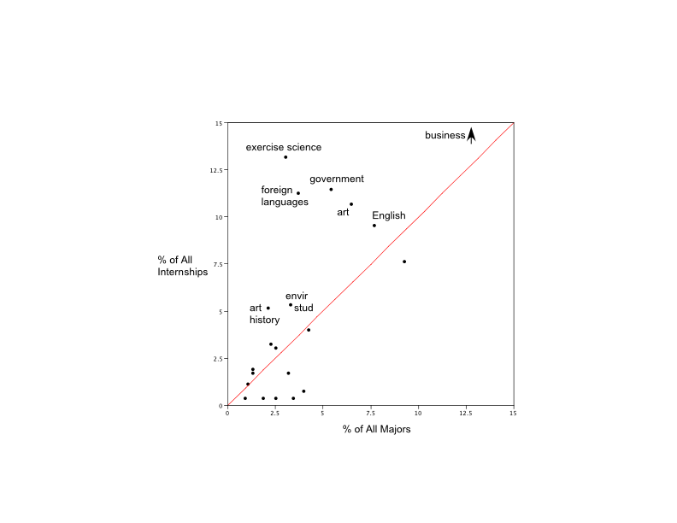 Figure 1. Distribution of credit-bearing internships

relative to size of major. Majors identified above the

diagonal support a disproportionate number of internships.

% of internships in major

% of students in major

Table 4. Career and post-baccalaureate outcomes of credit-bearing and RCIA internships. Numbers show percentage of students reporting in the affirmative.

|  |  |  |  |  |  |  |
| --- | --- | --- | --- | --- | --- | --- |
|  | | **Credit-Bearing Internships** | |  | **RCIA Internships** | |
| Moderate, Large, or Very Large Gain | Large or Very Large Gain |  | Moderate, Large, or Very Large Gain | Large or Very Large Gain |
| **Career & Post-Bacc Outcomes** | Clarification of career path | **75.4** | 41.6 |  | **79** | 52 |
| Understanding of the preparation, methods, and work in your field | **78.4** | 56.9 |  | **79** | 58 |
| Understanding of how professionals work on real problems | **87.4** | 69.9 |  | **88** | 64 |
| Understanding of how professionals in your field think | **87.3** | 63.5 |  | **95** | 69 |
| Learning technical skills and techniques in your field | **76.2** | 54 |  | **79** | 60 |

**Credit-bearing RCIA**

**Internships Internships**

I plan to pursue another internship

in this area… 26.5% 36.8%

I plan on pursuing a career in a

field related to my internship 71.4% 65.8%

experience…

I have been offered a job with the

organization in the future… 18.4% 23.7%

Change in % of students who have

considered post-undergraduate +17.1% -6.9%

education before and after the (to 95.7%) (to 84.4%)

experience…

Table 5. Learning and curricular outcomes of credit-bearing and RCIA internships. Numbers show percentage of students reporting in the affirmative.

|  |  |  |  |  |  |  |  |
| --- | --- | --- | --- | --- | --- | --- | --- |
|  | | **Credit-Bearing Internships** | |  | **RCIA Internships** | | * |
| Moderate, Large, or Very Large Gain | Large or Very Large Gain |  | Moderate, Large, or Very Large Gain | Large or Very Large Gain |
| **Outcomes Related to Skidmore's Goals for Student Learning** | Readiness for more demanding research | **69.3** | 33.9 |  | **47** | 35 | *Demonstrate advanced learning and synthesis…* |
| Ability to read and understand primary literature | **50** | 32.8 |  | **77** | 56 |
| Ability to integrate theory and practice | **67.2** | 57.8 |  | **37** | 21 | *Integrate and apply knowledge and creative thought…* |
| Ability to analyze data and other information | **65.7** | 31.3 |  | **86** | 56 | *Gather, analyze, integrate, and apply varied forms of information…* |
| Learning ethical conduct | **68.8** | 42.2 |  | **86** | 51 | *Examine one's own values and their uses as ethical criteria in thought and action…* |
| Skill in how to give an effective oral presentation | **38.1** | 27 |  | **93** | 70 | *Communicate effectively…* |
| Skill in writing | **42.2** | 26.6 |  | **63** | 33 |
| Self-confidence | **69.8** | 46 |  | **91** | 72 | *Embrace intellectual integrity, humility, and courage…* |
| Learning to work independently | **73.5** | 51.6 |  | **86** | 53 | *Think critically, creatively, and independently…* |

*\* from Skidmore College - Goals for Student Learning and Development*

**Credit-bearing RCIA**

**Internships Internships**

I plan to pursue further research, a thesis,

or coursework in this area… 51% 36.9%

Change in % of students who have considered +12.8% -10.2%

graduate school before and after the experience… (to 42.8%) (to 37.7%)