Huang Ho and Indus Valley River Civilizations
Grade Level Band: 6-8
Grade Level: 6

Benchmark: History- Early Civilizations
Grade Level Indicator: 4. Compare the geographic, political, economic, and social characteristics of the river civilizations in the Tigris and Euphrates (Mesopotamia), Nile (Egypt), Huang Ho and Indus valleys before 1000 B.C. including: location, government, religion, agriculture, cultural and scientific contributions.

Huang Ho River Civilization
(also known as Huang He or Yellow River)

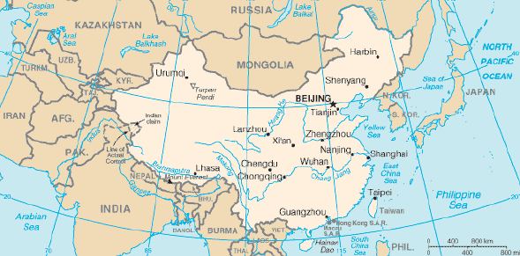
http://kingproehl.wordpress.com/huang-he-valley/
Map of China
The Huang Ho River civilization is also commonly referred to as the Huang He or Yellow River civilization. This civilization, along with many other Chinese Empires, began around 4000 B.C. The Huang He River stretches for approximately 3,000 miles across China, earning its’ alternate name of Yellow River from the rich yellow silt it carries from Mongolia to the Pacific Ocean. Although two major rivers, the Huang He River and the Chang Jang River, only 10% of the land in this area is fertile enough to grow crops. Additional drawbacks of this area include the mountain ranges and river valleys, which hindered travel and trade with areas outside of the civilization. As a result, the civilization relied on the production of their own food.

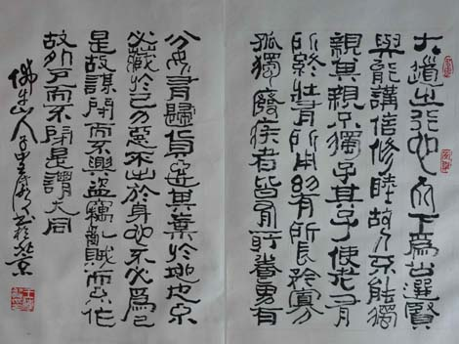
Zhou Literature
(Artifact: Book)
Literature from the Zhou (second) Dynasty was very important to Chinese people. While most Zhou writings of the early empire have been destroyed, some have survived. The “Book of History” includes an actual history of Zhou, while the “Book of Change” is a manual of diviners, or dynasties. The “Book of Songs” is thought to be the most notable of the classic works. This book tells about conditions for the early Zhou Dynasty. Finally, the Zhou “Book of Rites” provides rules of etiquette including many aspects such as politics, laws, morality, philosophy, history, sacrifice, art, daily life, calendars, and geography. This book coupled with two other books make up the “Three Rites,” which have a great impact on Chinese culture.
Picutre: http://history.cultural-china.com/en/173History594.html
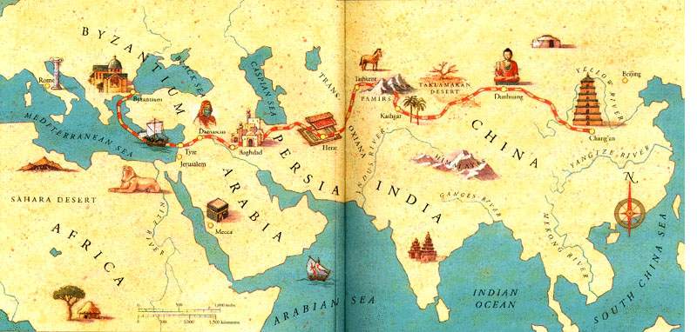
http://library.thinkquest.org/13406/sr/
Early Trade
(Artifact: Piece of Silk)
The Silk Road was a 7,000 mile long trade route connecting the Yellow River Valley to the Mediterranean Sea, including China, Central Asia, Northern India, and the Parthian and Roman Empires. Silk trade in China grew under the Han Dynasty, contributing to the building of Silk Road and resulting in increased trade. When the Roman Empire rose, trade grew because the Chinese gave silk to the Roman-Asian governments as gifts. As Han expanded into Central Asia, the trading relationships between the Chinese and the Indians grew stronger. The Chinese traded their silk in return for precious stones and metals from the Indians, such as jade, gold, and silver. The Indians also traded silk with the Roman Empire.

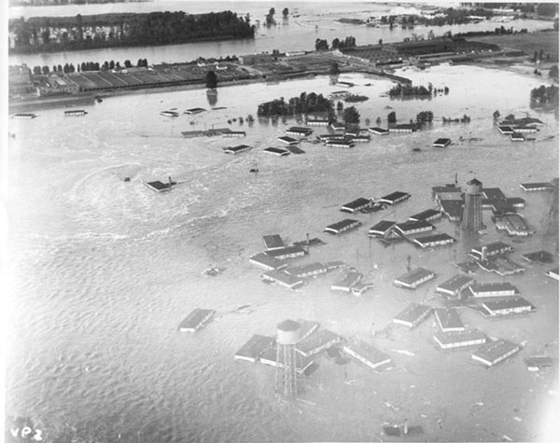
Flooding
(Artifact: Flood Insurance Policy)
The banks of the Huang He River served as the location of the earliest civilization in China. While the river provided many benefits for agriculture, travel and trade, its’ frequent flooding caused problems for the inhabitants. The banks along the river are low, causing it to flood each year and earning it the nickname River of Sorrow. Homes had to be rebuilt each year following the annual flood, until people eventually learned flood control techniques such as building on higher ground.
http://www.nwcouncil.org/history/floods.asp

Indus River Valley Civilization

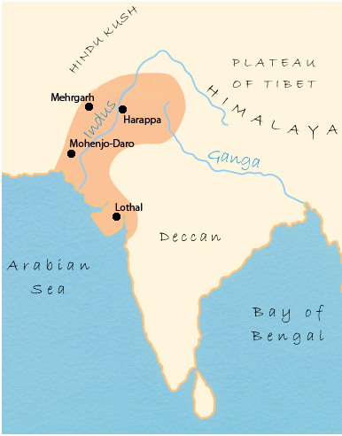
Map of Indus River Valley
The Indus River Valley civilization region started around 2,500 B.C. and covered a large area over what is present day India, Pakistan, Bangladesh, Nepal, Sri Lanka, and Bhutan. The two largest cities in this civilization were Harappa and Mohenjo-Daro. Other large cities were Mehgarh and Lothal, with many smaller cities and settlements all along the river. There were many benefits to the location of this civilization because of its’ location along a river, as well as being bordered on one side by the Arabian Sea. These water sources provided benefits in agriculture, transportation, trade, and in times of war because they had fewer sides to protect. The civilization was surrounded by mountains, which also provided benefits during an attack and helped to prevent diseases outside the civilization from entering.
Picutre: http://www.rivervalleycivilizations.com/indus.php

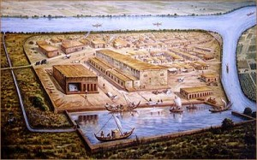
Agriculture
(Artifact: Plant Seeds)
Cities in the Indus River Valley were supported by an advanced agricultural system. Crops present in this area and used for food included wheat, rye, peas, and possibly rice. Cotton was also a prominent part of the agriculture, as was the raising of livestock. Fish from the rivers provided an additional source of food. Water from the rivers allowed for large irrigation systems. Most technologies in the Indus River Valley civilization were based on agriculture, as crops were indigenous to the river valley.
Picture: http://nrsattiraju.blog.co.in/2008/07/11/the-indus-valley-civilization-trade-and-transportation/

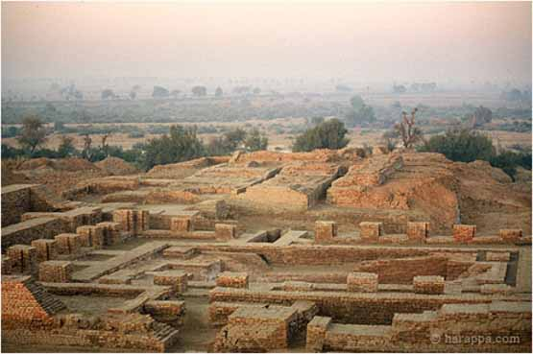
Buildings
(Artifact: Ruler)
The civilization’s towns contained straight streets, providing a grid-like layout. The people of the Indus River Valley civilization were great builders, paying attention to details and ensuring precision in their buildings and homes. Objects that scientists believe to be giant fresh water reservoirs have since been discovered. It is believed that the cities contained water systems similar to modern plumbing, providing fresh water for even the smallest homes or homes on the outermost parts of the city. They also had an early version of a sanitation system, including buildings for bathing and using the restroom.
Picture: http://www.crystalinks.com/induscivilization.html

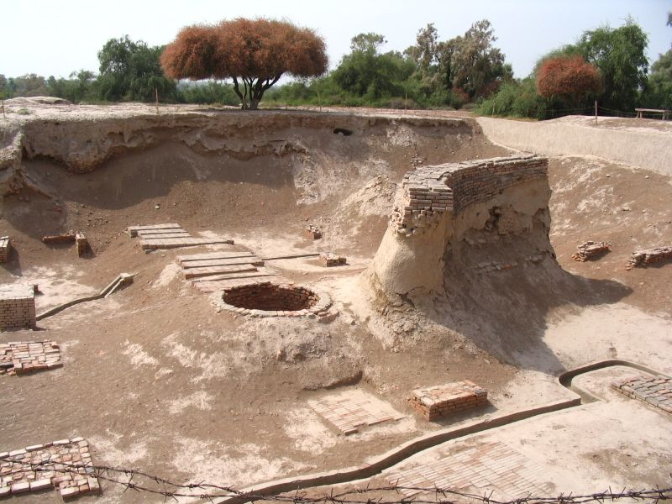
Lost Civilization
(Artifact: Magnifying Glass)
It is unknown what caused the end of the Indus River Valley civilization, but it is believed that the cities disappeared around 1500 B.C. Some theories for the disappearance of the civilization include effects of continuous flooding or inability to grow crops. These are mere suggestions and no one knows for sure what happened to the civilizations or where they went. Traces of the abandoned cities were discovered in the late 1850s when British construction workers removed bricks from dirt mounds found in the valleys. A British general named Cunningham visited one of the sites and became convinced that artifacts found were of ancient origin. He eventually became head of the Indian Archaeological Survey and ensured a full-scale excavation of the early civilization.
Picture: http://factoidz.com/the-indus-valley-civilization/

Resources
Huang Ho River Civilization
- http://history.cultural-china.com/en/173History594.html
- http://www.rivervalleycivilizations.com/yellow.php
- http://china.mrdonn.org/rivers.html
- http://www.socialstudiesforkids.com/articles/geography/huangheriver.htm
- http://library.thinkquest.org/13406/sr/
- http://teachers.henrico.k12.va.us/staffdev/bostain_k/FC/Huang%20He%20River%20Valley.html

Indus River Valley Civilization
- http://www.rivervalleycivilizations.com/indus.php
- http://history-world.org/indus_valley.htm
- http://india.mrdonn.org/indus.html

