Huang Ho and Indus Valley
By: Renee Bidlack

Grade Level Band: 6-8
Grade Level: 6
Benchmark: History: Early Civilizations
Grade Level Indicator: Compare the geographic, political, economic and social characteristics of the river civilizations in the Tigris and Euphrates (Mesopotamia), Nile (Egypt), Huang Ho and Indus valleys before 1000 B.C. including: Location, Government, Religion, Agriculture and Cultural and scientific contributions.

The Indus Valley and Huang Ho Civilizations are two very exciting river civilizations to study. The Indus Valley Civilization contains the two complex cities of Harappa and Mohenjodaro. It is thought that they developed about 4,500 – 5,000 years ago. The Huang Ho (also referred to as Huang He) River Valley was home to the earliest settlements in China.

The Huang Ho and Indus Valley artifact box is a wonderful resource for teachers to use to build students background knowledge about these Early Civilizations. Students can then use the artifact box as a reference and to review the information before an assessment. This artifact box includes:
Map: A map of the Early River Civilizations is included to show students where the Indus Valley and Huang Ho Civilizations are located. Students will also be able to see the locations of all the other River Civilizations. This map will help to build students’ background knowledge, and can also be tied into using the 5 themes of Geography (map skills and location).

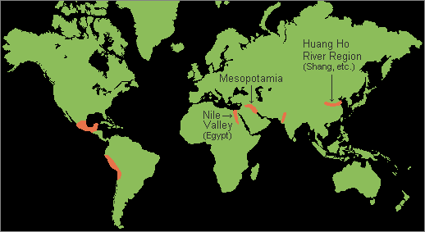

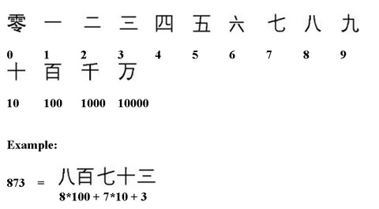
Early Chinese Number System: The Huang Ho began to develop an interesting number system. Their number system is based on the power of ten. Teachers could connect this part of their culture to the students' math class. This number system will challenge students to connect our current system of numbers to an early civilization.

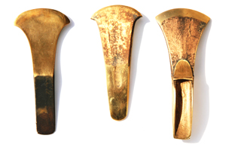
Bronze tools: The Chinese in the Huang Ho Valley often used bronze tools for farming and bronze weapons in their Armies. Bronze was also used by the people of the Indus civilizations. Indus people also began to use copper and iron, too.

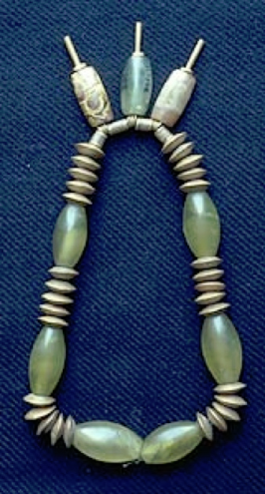
Story of a boy: After studying the artifacts and remains of the Indus Civilizations, this fictional story was created to attempt to help people understand the people who lived there. This story is about a boy who follows his father, a bead trader, around learns from him. I think it would be beneficial for students to hear this story and create images of the civilization in their head. They could even write their own story based on a river civilization.

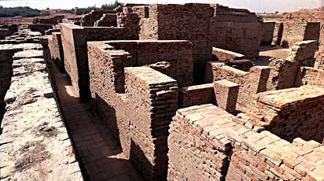
Brick houses: The ancient cities of the Indus Valley have begun to be excavated and it if found that the cities were built of brick. The houses and common areas were all made of brick and had complex water draining systems that were advanced for their time.

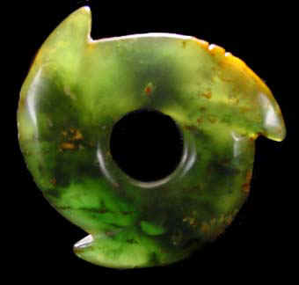
Jade: Jade has always been very important in the Chinese culture. Many important things have been carved from it. Jade stands for beauty, grace and purity. Jade artifacts have been found along the Huang Ho river, dating back 5,000 years.

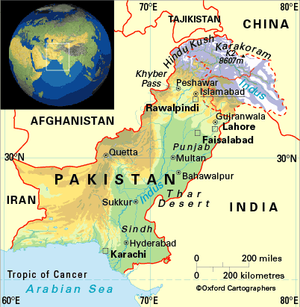

Pakistan: The Indus Valley Civilization was almost entirely located in the present-day country of Pakistan. Students could research Pakistan and make connection between present-day life and the life of the Indus Civilization.

Resources

http://www.sscnet.ucla.edu/southasia/History/Ancient/Indus2.html

http://www.drben.net/ChinaReport/Sources/Geography/Rivers/Yellow_River-Huang_He-History_Of.html

http://web.me.com/kbolman/The_Indus_Valley/Indus_Valley_Maps.html

http://www.rivervalleycivilizations.com/indus.php

http://www.thegillfarm.com/huang-ho.html

http://web.mac.com/kbolman/The_Indus_Valley/This_is_a_story.html

http://chineseculture.about.com/cs/history/a/JadeCulture.htm

