David Andrés Henao.
Bitácora 1
This was our first virtual class. Like I said in the previous bitácora, I had had experiences with many online games, but this was my first time in SL. Overall, the experience was very enriching, but it did have some bad moments. For example, we started the activity really late. This was in part due to most people having technical issues or not having read the instructions. Anyway, when we did start, it was obvious that people had no idea what to do. No one knew the groups and several people had severe technical issues. Now, at this point the virtual class was looking like more problem than it was worth, but Harold managed to form groups on the spot and got the class flowing. At this point, the advantages and good things about a virtual class started to become apparent.
When we started the activity, my group didn’t really know what to do. However, after we started, the activity really got rolling.
[12:00] andreapr92: yes
[12:00] mforerog: yes
[12:01] RocioCurrea: ok
[12:01] Ladysilla: ok
[12:01] Savi0r: it can connect people who are far away
[12:01] RocioCurrea: yeah
[12:01] Ladysilla: yes
[12:02] andreapr92: yes i agree with you david
[12:02] Paulaf7: With ICT's you can interact in real contexts.
[12:02] andreapr92: but it is a disadvantage
[12:02] andreapr92: isn't it?
[12:02] RocioCurrea: no
[12:02] RocioCurrea: why?
[12:03] Ladysilla: We can speak with native people and improve our speaking
[12:03] Savi0r: yea
[12:03] Akiles Thespian: andrea???
[12:03] andreapr92: yes
[12:03] Akiles Thespian: everything ok?
[12:03] andreapr92: i'm sorry
[12:03] andreapr92: i didn't
[12:03] andreapr92: read
[12:03] andreapr92: all the sentences
[12:03] Allieblanche: No
[12:03] andreapr92: sentence
[12:03] andreapr92: i'm sorry
[12:04] andreapr92: yes it is
[12:04] Allieblanche: I´m lost
[12:04] Akiles Thespian: No worries, please do the task in the station an wait for me!!
[12:04] andreapr92: an advantage
[12:04] RocioCurrea: yeah all right Akiles :)
[12:04] andreapr92: ok
[12:04] Savi0r: We can interact with real people
[12:04] RocioCurrea: ok
[12:04] Akiles Thespian: Alison
[12:04] Ladysilla: yes
[12:04] Allieblanche: Ok thanks
[12:04] Allieblanche: Teacher
[12:04] Akiles Thespian: Stay in this group, do the task with them
[12:04] Allieblanche: ok thanks
[12:04] Savi0r: Even if they
[12:04] Ladysilla: other advantages group 3
[12:04] Ladysilla: ??
[12:04] andreapr92: I agree with
[12:04] andreapr92: paula
[12:04] Savi0r: are strangers
[12:05] RocioCurrea: we have 3 advantages
[12:05] andreapr92: about we can interact with real contents
[12:05] Ladysilla: now the disadvantages?
[12:05] RocioCurrea: yeah
[12:06] Paulaf7: Yeah, well all of them are similar
[12:06] andreapr92: So, the advantages taht we have so far
[12:06] andreapr92: ar. e
[12:06] andreapr92: we can interact with all people
[12:06] andreapr92: in an esay way
[12:06] RocioCurrea: and with native people
[12:06] Ladysilla: yes
[12:06] andreapr92: and we can be update in this way we can interact with real contents
[12:07] Paulaf7: contexts
[12:07] andreapr92: yes
[12:07] andreapr92: contexts
[12:07] andreapr92: excuse
[12:07] andreapr92: me
[12:07] Paulaf7: it's ok
[12:07] andreapr92: I write
[12:07] andreapr92: very fast
[12:07] andreapr92: :)
[12:07] Paulaf7: Well guys, any other advantage?
[12:07] RocioCurrea: no
[12:08] Ladysilla: no
[12:08] andreapr92: maybe with this ICTs
[12:08] mforerog: what about the disadvantages?
[12:08] andreapr92: we can
[12:08] Savi0r: One disadvantage could be the lack of face to face interactions
This was our first station, and I feel like this is when we really “got it”. We were interacting in the game and we were discussing and mediating in a new reality. Even if our answers were mostly short and we didn’t really go too deep because we were still struggling with the game and the confusion of the activity, this to me was the best moment of the activity and the moment that really displayed the potential of this kind of ICT. While we were answering the questions, I could feel how much more relaxed and confident we were getting with the game, and how I participated more than I would in a real life classroom.
Then, we changed stations.
[12:11] andreapr92: i am next to you
[12:11] andreapr92: we have to create a
[12:12] andreapr92: an acronym
[12:12] Ladysilla: yes
[12:12] RocioCurrea: jajaja I
[12:12] andreapr92: jajaj
[12:13] Ladysilla: Interactions
[12:13] Savi0r: Incredibly creative teaching? I don't know
[12:13] andreapr92: Communicative
[12:13] andreapr92: maybe
[12:13] Paulaf7: jajajaj that's a good one David
[12:13] Ladysilla: yes very good david
[12:14] Akiles Thespian: andrea, andrea, everything ok
[12:14] Akiles Thespian: ??
[12:14] andreapr92: Iyes
[12:14] andreapr92: everything is ok
[12:14] andreapr92: i'm thinking
[12:14] Akiles Thespian: good, we will change stations in a minute, i will tell you when
[12:15] andreapr92: about this acronym
[12:15] andreapr92: ok
[12:15] Paulaf7: guys another possibilities?
[12:15] Ladysilla: wait we are thinking
[12:15] mforerog: instead of incredibly it could work interactive?
[12:15] Savi0r: OFC
[12:15] andreapr92: Imagination communicative teaching
[12:15] andreapr92: ?
[12:16] andreapr92: or intellectual
[12:16] andreapr92: creative teaching
[12:17] andreapr92: waht do you think about these acronym ?
[12:17] Savi0r: Those work
[12:17] andreapr92: so?
[12:17] Ladysilla: interesting communicative teaching
[12:18] Paulaf7: I vote for Incredible communicative teaching
[12:18] Akiles Thespian: andrea, andrea
[12:18] andreapr92: i like that
[12:18] mforerog: ok
[12:18] Ladysilla: ok me too
[12:18] Akiles Thespian: andrea
[12:18] andreapr92: tell me
[12:18] andreapr92: tell me akiles
[12:18] Akiles Thespian: ok, go to station 4 now, use the other exit
[12:18] andreapr92: but
[12:18] andreapr92: wai
[12:18] Ladysilla: STATION 1
[12:20] monbueller: have u guys played this before?
This station was more like a “relaxation” station, and the activity was mostly targeted to make us feel comfortable with each other and maybe have some laughs. All of the acronyms we came up with were funny, but I felt like this station really focused on the “game” aspect of second life and the interaction that these environments promote.
[12:21] andreapr92: we have to do this
[12:21] Paulaf7: Badelll
[12:21] andreapr92: wheer is paula
[12:21] andreapr92: ?
[12:21] Akiles Thespian: monica, r u there?
[12:21] Paulaf7: I'm here!
[12:21] andreapr92: where
[12:21] andreapr92: I think that
[12:21] Akiles Thespian: This group needs to go to station 2!!!
[12:22] MorriganBlau: ok...
[12:22] Akiles Thespian: Except if you come from station 4
[12:22] georgelesponts: we come from station 4
[12:22] andreapr92: this method i won't implement in my language classroom
[12:22] andreapr92: beacuse
[12:22] Ladysilla: no we come from station 4
[12:22] Akiles Thespian: then you staty george
[12:22] andreapr92: the students are so passive
[12:22] MorriganBlau: george whats was your previous statin?
[12:22] MorriganBlau: what*
[12:22] georgelesponts: no...this is my previous station...lets go to number to morrigan
[12:23] andreapr92: Guys
[12:23] andreapr92: what do you think about this?
[12:23] Savi0r: I think it defeats the whole purpose of th ICT
[12:24] andreapr92: why?
[12:24] Savi0r: You can easily do this in a real world classroom
[12:24] Savi0r: And it would be the same
[12:24] Ladysilla: this execise is very structural because you just have to complete information
[12:24] andreapr92: yes
[12:24] andreapr92: i agree with you
[12:24] andreapr92: yes
[12:24] Savi0r: Besides, the student wouldn't have any help
[12:24] mforerog: yea that is true, if we are going to use this tool it should be something different as foe example second life,no?
[12:25] andreapr92: The students will be passvie students
[12:25] Savi0r: And he or she may feel intimitated
[12:25] Savi0r: Exactly
[12:25] andreapr92: yeah
[12:25] Paulaf7: I agree
[12:26] Anes Kanya: Anes Kanya: JAJAJAJA I hear Shakira singing
[12:26] andreapr92: What other reasons
[12:26] Ladysilla: besides this exercises doesn't motivate students
[12:26] andreapr92: yes
[12:26] Akiles Thespian: andrea
[12:26] Akiles Thespian: andrea
[12:26] andreapr92: this exercise
[12:27] Akiles Thespian: andrea
[12:27] andreapr92: tell me
[12:27] andreapr92: akiles
[12:27] Akiles Thespian: we will change stations in a second, wait here
[12:27] monbueller: i'm here again
[12:27] andreapr92: ok
[12:27] andreapr92: in this exercise
[12:27] andreapr92: the students
[12:27] andreapr92: can not interact
[12:28] andreapr92: with their partner
[12:28] Ladysilla: the exercise is not in a real context
[12:28] andreapr92: yes
[12:28] Ladysilla: it's very important the context for the students to know when to use this adjectives
[12:28] Paulaf7: they don't interact with their classmates
[12:28] andreapr92: students
[12:29] andreapr92: hacve to have context
[12:29] andreapr92: in order to do the exercise
[12:29] andreapr92: right?
[12:30] Ladysilla: no they can do the exercise
[12:30] andreapr92: we have to go to the other station
[12:30] andreapr92: don't we?
[12:30] andreapr92: but harold
[12:30] Akiles Thespian: monica. move please
[12:30] Ladysilla: but then they do not know when to use thie adjective
This station was really interesting, because we had to reflect about the way many language teachers conceive the use of technology in the classroom. My first two French teachers would just use the video-beam to project a page of exercises and wouldn’t use the technology for much else. In my opinion, this valid as a way to save time when doing grammar exercises, but this isn’t the way teachers should view technology in a classroom. Both of my teachers were very young too, so if anyone knows how to use the new technologies in a language classroom, it should be them. Then, we went to the final station.
[12:32] andreapr92: i think that it depends
[12:32] andreapr92: of the ICTs
[12:33] andreapr92: for some people using seond life and virtual environments
[12:33] andreapr92: will be funny
[12:33] andreapr92: and the motivation
[12:33] andreapr92: and this Icts can motivate the students
[12:34] mforerog: I agree, it is different so it will motivate students
[12:34] andreapr92: yes
[12:34] Savi0r: Some students may feel motivivated by studying in a game. But it depends on each student
[12:34] Paulaf7: I agree with David
[12:34] Ladysilla: yes thats truth
[12:35] andreapr92: yeas i agree with david
[12:35] andreapr92: other factor is the knowledge that you have of this Icts
[12:35] Akiles Thespian: andrea
[12:35] Akiles Thespian: andrea
[12:35] Akiles Thespian: andrea
[12:35] andreapr92: tell me
[12:36] andreapr92: tell meeeee
[12:36] Ladysilla: the students would be more motivated to learn because ICTs are new and interesting for them
[12:36] andreapr92: :)
[12:36] Akiles Thespian: after this you will finish and go to the chapel on your right side in the middle of this area
[12:36] andreapr92: yes
[12:36] andreapr92: ok
[12:36] andreapr92: akiles
[12:36] Ladysilla: the students would be more motivated to learn because ICTs are new and interesting for them
[12:36] andreapr92: we have to use
[12:37] Ladysilla: what??
[12:37] andreapr92: Icts which are new
[12:37] andreapr92: and we have to keep in mind to use them according to
[12:37] andreapr92: the age of the student
[12:37] Ladysilla: yes
[12:38] andreapr92: e.g. we can use twitter
[12:38] andreapr92: or facebook
[12:39] andreapr92: teaching a foreign language
[12:39] andreapr92: and it is new , interesting, and practical for them
This station was really interesting because everyone was already comfortable with the game and the way we interacted in it. Thus, all of our responses seemed to be natural and “relaxed”, unlike the first station. Everyone was joking and you can tell from the log that we were really having fun learning in SL. This is what really got to me, the fact that despite all of the complications we were really enjoying ourselves while actually learning. This is the essence of what I learned during our virtual class and, to me, what this course is all about.

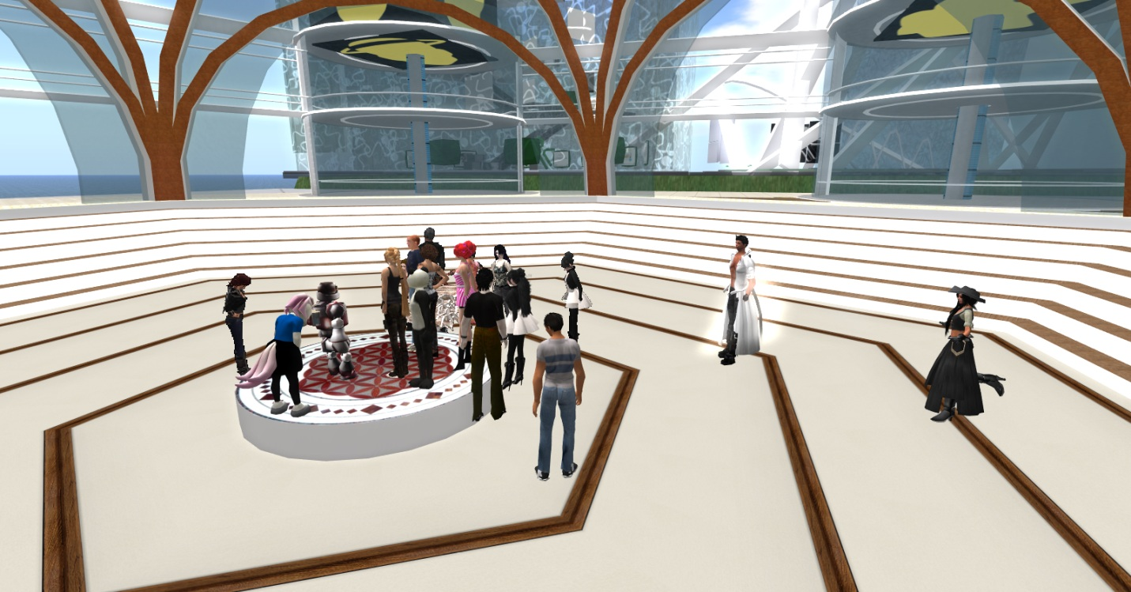
This was the end of the class.

Bro,
This wasa nice way to present your bitácora. I find remarkable the pros and cons you identified and the aspects that got you engaged! Nice job!!!
4.5/5.0
Harold

