BITACORA 1
SECOND LIFE
HARRYFOX
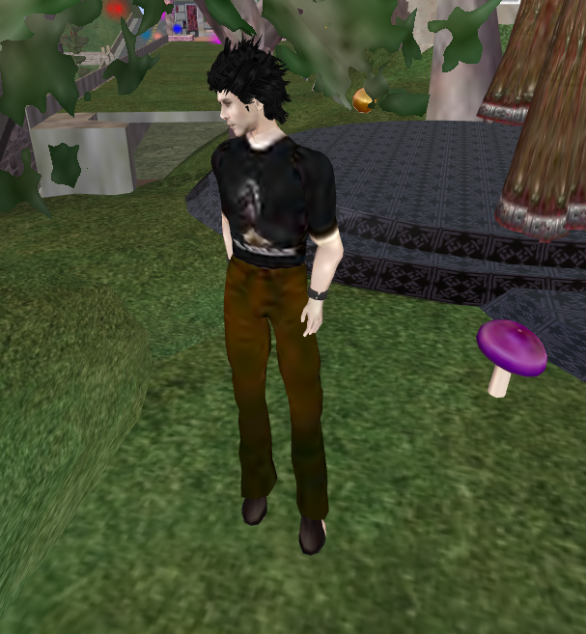
This is the first avatar I created after watching the tutorial for a couple of times. It was completely different but at the time I did not know how “Second life” worked, I did not know how to take pictures. I was completely lost.
The second time I wanted to login in Second Life I could not do it as Harryfox, so I created another Avatar Susyfox
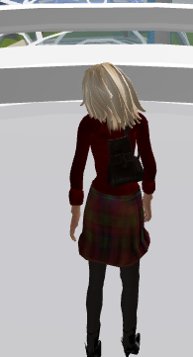 | 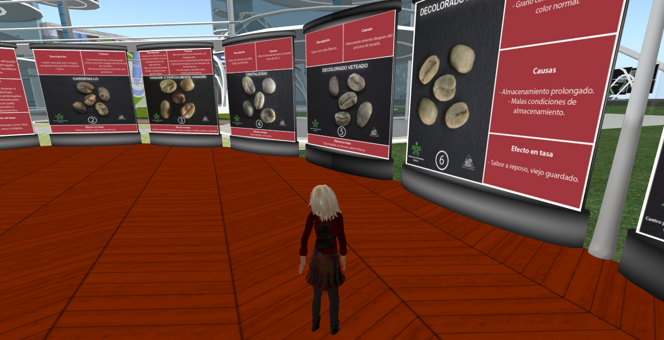

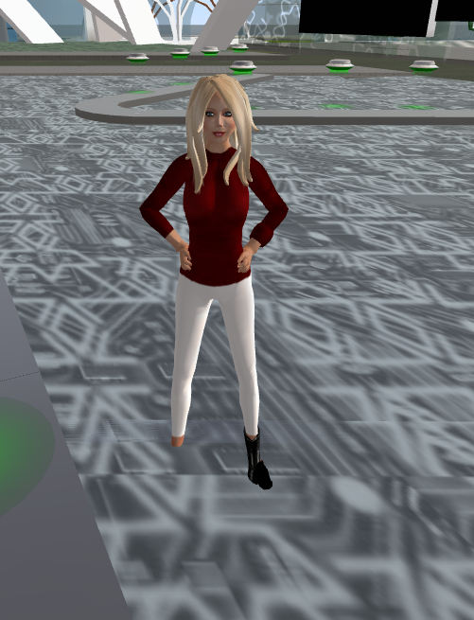 | With her I visited the Sena Island.  I was trying to change her appearance and her  clothes but as you can see I was just learning  to do it. This time I explored the island and  some other places. I talked to people, I learnt  to sit on things and I practiced how to move  my avatar around easily.

CLASS IN SECOND LIFE
By the day we met in Second Life, I could get in with my first avatar; I already knew how to fly and how to change my appearance. However, something happened and I fell somewhere and got lost… I was trying to look for my classmates but I could not find them. I had to get off line and on again in order to get to the meeting point.
When I saw so many people lost I thought the activity was not going to work, so I was just waiting for Akiles to give any instruction. I knew the names of the people of my group, so I was asking around trying to find them and that way it was going to be easier to go to the stations.
When we finally got in groups and went to the stations, everything felt much better. We answered all the questions even though we did not write them anywhere and I felt the time we had was just perfect.
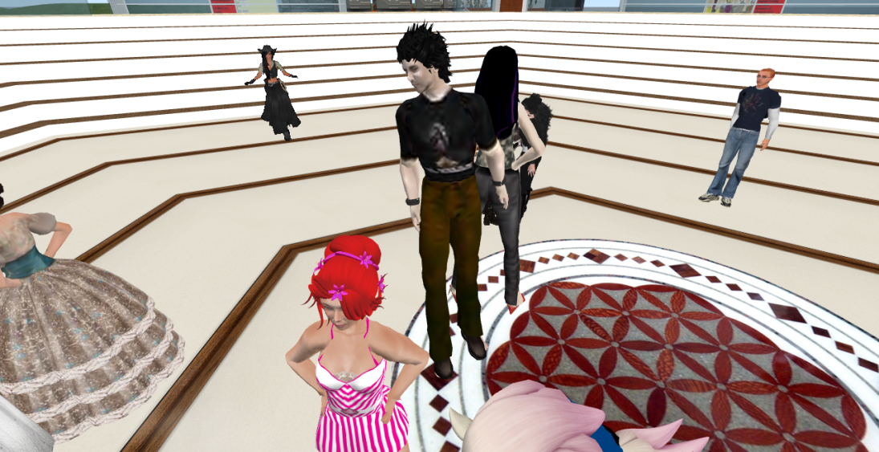
That class was unique. I found really interesting the opportunity to know this kinds of tools; they are totally available for everyone.
I did not know who was who and my classmates did not know who I was, but that was not important at the time. We did what we were supposed to.
It was amazing to see how this kind of activities can be so motivating for students.
It is absolutely fabulous all what you can do to your avatar and all the places you can visit!
It was awesome to be in my house but at the same time I was with my teacher and my classmates somewhere else!
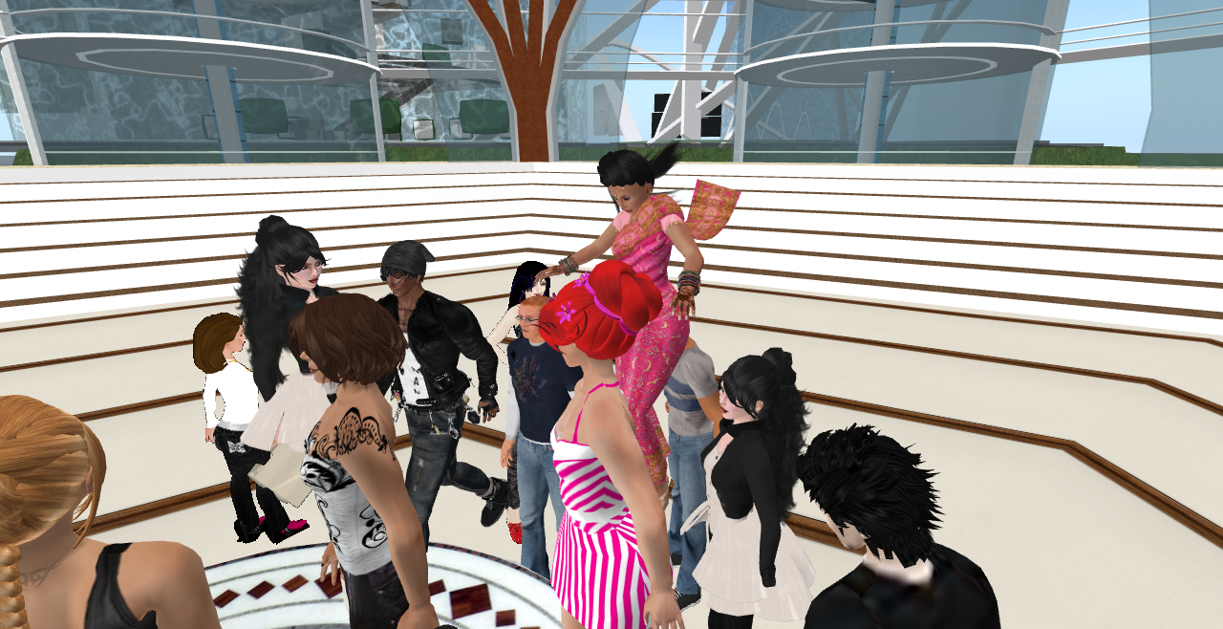
Susan,
I liked your reflections here. I think you are pointing to good and not so good points that are natural to the experience itself. Very good.
4.2/5.0
Harold

