Alison Blanco Pedagogy and Didactic 1
Bitácora 0
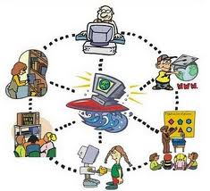
First of all, I have to say that at the beginning of this class I did not have any idea about the program of this class because now this class changed most of the topics and goals if we compared it with the last one. However, looking at the schedule I feel more comfortable and with good motivation because some of the topics are related to another class that I am taking too. So, I have lot of expectations of this class, but I think the most important is how I can apply other methods at the time of teaching and also learning. Although, I think this class will be important in my academic life because I really want to be a teacher and I think I can learn a lot of methods I will apply for sure in my daily classes, different to the traditional ones.
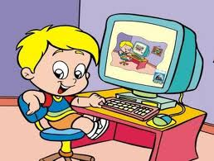

Well, I like teach and sometimes I do it, as a monitor of the head teacher of some children, and I think these kinds of experiences are the best ones for being good at something and because you can learn every time more and more. However, I have never used ICTs in my classes because as I said before I used to teach children, but I know I can find some programs in order to teach them and improve their skills.
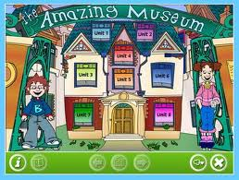
Nevertheless, last semester I worked as a teacher of kids too, as an extra teacher. In that place the students have three times at a laboratory (computer room) peer semester and I had the opportunity to take them to that place, obviously I had already prepared the class. So, I tried to find the most suitable web pages in which they could improve their English, in most of the cases some games.
However, in some cases I told them to go wherever they wanted, but the only requisite was that the web page had to be in English.
I though that rule was good because the students go thought something they really like it and also they practice English, so the process of learning will be fun and better, but it is important not forget that it depends on the ages.
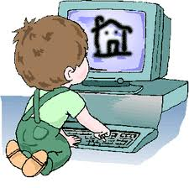
I think that ICTs are good in the classroom because as the life change in a very fast way and the technology have been changed our life and it is part of us each day more and more; we can make some connections between technology and our daily life. So, we can take all the advantages and exploit them to the maximum. Moreover, I think we can learn a second language in a different way, in a fun way, in which learn does not imply something boring or tedious something that innovate the way of learning and maybe motivate the students to do it.
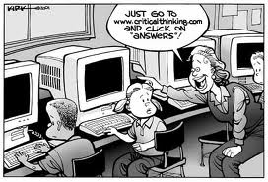
However, it is important not forget that these new ways of learning can help us in different ways, but also it has some disadvantages and most of them have problems they are not completely safe. So, we have to take into account some advices and be careful of what we are going to do, where and with whom. Additionally, it is important know the needs and goals of the class and take into account that using ICTs will not warranty the learning of something because we often need other important elements such as: external support, interaction, prior knowledge, among others in order to have a better process of learning.
To sum up, I have to say that I have had some personal experiences with ICTs and I think it helps me a lot in some ways to improve my English. I used to use them with frequently and my friends from other countries help me a lot too, but maybe that would not have been possible without the help of some technological tools and the interaction with others.

