Unit Outcomes:

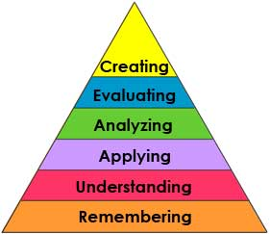  New Version | In 1956, Benjamin Bloom headed a group of educational psychologists who developed a classification of levels of intellectual behavior important in learning. During the 1990's a new group of cognitive psychologists, lead by Lorin Anderson (a former student of Bloom), updated the taxonomy to reflect relevance to 21st century work.
Remembering: can the student recall or remember the information? | define, duplicate, list, memorize, recall, repeat, reproduce state
Understanding: can the student explain ideas or concepts? | classify, describe, discuss, explain, identify, locate, recognize, report, select, translate, paraphrase
Applying: can the student use the information in a new way? | choose, demonstrate, dramatize, employ, illustrate, interpret, operate, schedule, sketch, solve, use, write.
Analyzing: can the student distinguish between the different parts? | appraise, compare, contrast, criticize, differentiate, discriminate, distinguish, examine, experiment, question, test.
Evaluating: can the student justify a stand or decision? | appraise, argue, defend, judge, select, support, value, evaluate
Creating: can the student create new product or point of view? | assemble, construct, create, design, develop, formulate, write.

Taken from: http://www.odu.edu/educ/roverbau/Bloom/blooms_taxonomy.htm

1. Analyze literary elements
2. Apply Critical Reading Strategies
Using a Purpose
Analyzing Philosophical Assumptions
Recognizing signal words
Breaking down long sentences
Paraphrasing
Adjusting Reading Rate
Critiquing Author’s style, voice, purpose
Clarifying understanding
Summarizing
Analyze Author’s perspective
Evaluate contextual influences
Draw Inferences
Challenge and Question Perspectives
Analyze implicit and explicit messages
Analyze patterns and organization
3. Compare Literary Works
4. Use recursive writing process to write in a variety of forms
Argumentation
Exposition
Reflective Essay
5. Express, develop, and support responses to various texts
Discuss connections of Literary Themes to contemporary life
Evaluate the sociological impact on literature
6. Prepare, organize, and present literary interpretations

