Self-Organizing & Autonomous Systems
  - The importance of understanding underlying principles for industrial, service and societal innovation through applied research

Issue
Our society is confronted with (system) problems which require sophisticated management that takes account of complexity, dynamics and ambiguity. Solutions, based on traditional industrial concepts such as the assembly line, do not always achieve the intended effects, furthermore, these type of solutions tend to generate a host of unwanted and unexpected effects; consider the unintended effects of the carbon based economy (CO₂ and pollution). This suggests that a more comprehensive, systems approach to these problems is warranted. From a systems point of view, the interaction between the ‘identified’ system and its environment needs to be considered, and not only static but also dynamic to have some understanding of (un)intended consequences.
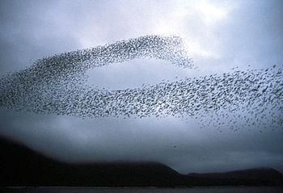
The study of a specific class of systems, autonomous systems, seems to hold promising insights that can forward our understanding of complex, dynamic and ambiguous technical, societal and ecological problems. One of these insights is the concept of self-organization. In the field of cybernetics and artificial intelligence, adaptation of the system is often attributed to the concept of self-organization. The internet, social media networks such as Facebook and twitter are considered to contain examples of these self-organizing systems. Which underlying mechanisms are responsible for self-organization is not often clarified. For some specific emergent behaviors such as swarming (see Figure 1), which are considered examples of self-organization, the mechanisms are clear, examples are snowflakes, and ant colonies.
Figure 1 Auklet flock
Wikipedia defines self-organization as the process where a structure or pattern appears in a system without a central authority or external element imposing it through planning. This globally coherent pattern appears from the local interaction of the elements that make up the system, thus the organization is achieved in a way that is parallel (all the elements act at the same time) and distributed (no element is a central coordinator).
Self-organizing systems have very interesting properties, they adapt to their environment through assimilation (changing bits of the environment) and accommodation (changing bits of the system), are robust, contain redundancy, learn, are self regulatory, and sometimes considered self healing. It is these properties of self-organizing and autonomous systems (SOAS) that have engendered TNO’s interest in formulating a research agenda in order to better fulfill its mission: TNO connects people and knowledge to create innovations that boost the sustainable competitive strength of industry and well-being of society.
In order to be able to appreciate the added value of SOAS for innovation to be facilitated by research organizations such as ours, we performed a quick scan of the internet (the world) using a host of related SOAS keywords to identify organizations that deal with SOAS. We have identified various organizations that explicitly proclaim this intention. Most of these organizations do this from a mono-disciplinary point of view and are focused on one of three broad types of systems: man-made systems, social systems and biological systems. For practical purposes we have excluded systems formulated in terms of particle physics on the one hand and in terms of cosmology at the other extreme. We have found less than 10 organizations that claim a multi-disciplinary approach: such as the Santa Fe Institute,, the Center for the Study of Complex Systems (CSCS), and the BarabasiLab. This observation can be explained in at least two ways. First, a multi-disciplinary approach is not to be considered as being practical and/or beneficial. Alternatively, a multi-disciplinary approach is appreciated as being practical and/or beneficial, but only a relative small group of people share this conviction. It will be clear that we are of the latter conviction and assume that SOAS insights obtained in one disciplinary field could be transposed and applied in other fields.
To make this assumption more explicit consider the following (see Table 1). In our first iteration of SOAS principles we have attempted to make explicit how SOAS principles are applied in the three broad types of systems we have initially identified. We are aware of the fact that this categorization can be considered arbitrary, nevertheless explicit formulation is a required first step in getting to grips with the equivocality of the used concepts.
Table 1 Comparison of systems, system goals and SOAS principles
System → | Man-made | Social | Biological
Goals → | Master complexity & Flexibility & Robustness & Efficiency | Efficiency & Survival | Survival
principles↓
Adaption [Accommodation] | Accommodates to variation in values of known and unknown environmental variables through designed self-learning heuristics | Depending on the point of view of the observer, either by design or through evolution | Accommodates not only to “known” but also to new environmental variables in the next generation through natural selection; evolution
Adaption [Assimilation] | A new context can change the appreciation of the system behaviour. Ideally, the system should adapt to this appreciation change. | System behavior does change the environment and is appreciated | System behavior changes the environment and is integral to the evolution principle
Learning | Self-learning heuristics are a priori designed and implemented | New heuristics are learnt through trial and error or by design | New heuristics can be learnt but require minimal intelligence, otherwise by random mutations
Robustness | To protect against failures, self-healing principles are implemented | Through multiple interacting subsystems and/or “over” engineering | Through multiple interacting subsystems
… | ? | ? | ?
The table illustrates that on face value the principles are applied in all systems, but do not necessarily have the same connotation. This confounding is often encountered in multi-disciplinary approaches and requires explicit identification of the mechanisms to become apparent. This suggests that a language needs to be developed/adopted that supersedes these cross system/discipline distinctions. This language would then facilitate identifying “generic” principles of SOAS and of particular interest to us, how these can be applied in addressing emergent system behavior of complex systems.

The TNO Approach
How do we achieve making these principles practically available?

Reducing Equivocality
First of all, it has to be clear what is meant when referencing to a system (elements, and their relationships internal and external and the emergent system behavior). The equivocal use of terms such as system, adaption, self organization and autonomy generate much confusion and ambiguity, not only between disciplines but also within. Furthermore, we are not interested in systems per se, but to be more precise, we are interested in their emergent behavior and ultimately in influencing this behavior. Having said that, perhaps a behavioral point of view can be of assistance. In our view behavior is the state changing mechanism (whether internal or external states).
TNO is developing a generic behavioral change framework to make sense of behavior of entities (see Figure 2), whether these are individuals, groups, organizations or systems.
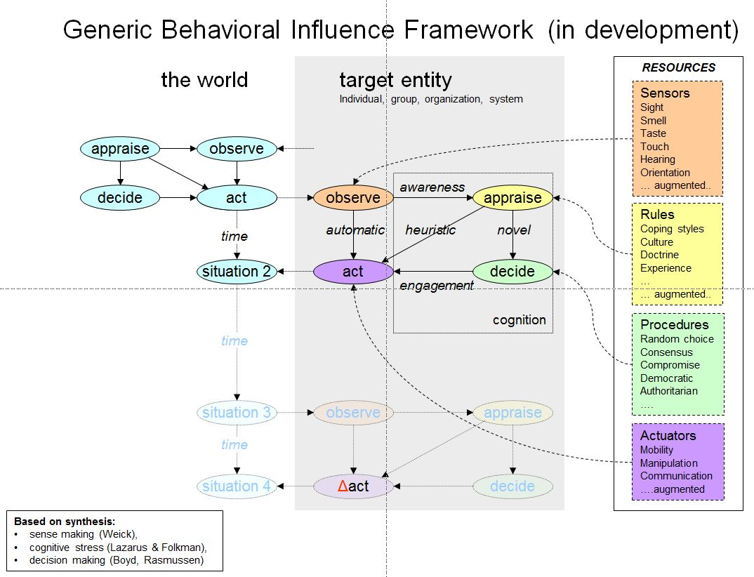
Figure 2 Generic behavioral Influence framework
We identify three paths by which behavior can manifest itself, automatic, heuristic and novel. The entities, by definition, observe, appraise, decide and act. Decision making will be greatly dependent on the level of intelligence of the entity. The assumption is that an entity observes changes in its environment and can react to these changes and thus change the environment (interact) through three pathways. The most simple of systems, such as a thermostat are only capable of automatic responses. Adaptation (to new environments) is only possible through mutations that manifest themselves in next generations. Systems with appendable memories are capable of heuristic behavior selection. Systems with a minimal consciousness can learn novel behaviors. This representation of behavior generation allows us to correlate inputs from the environment with perceptions (what is observed) which rules become salient (how this is appraised) and consequent behavior (acts). We furthermore assume that novel behavior becomes heuristic behavior if in future similar situations the same heuristic is used. For entities like human beings this can be a conscious activity. For man made sophisticated systems, new heuristics are introduced by an external entity. The advantage of this generic framework is that it allows for comparison between different entities in how behavior emerges and thus facilitates identifying similar and dissimilar patterns, better yet, networks of associated factors. The framework in itself is not a falsifiable theory, it is more akin to a language which allows for the formulation of testable hypotheses.
We need confirmation and criticism, we invite you to participate in this endeavor.

Organizing the TNO effort
Secondly, with this framework in mind, we are trying to identify the relevant principles or at the very least indicate where to look for these. TNO is organized in three major disciplinary networks; Technical Sciences, Behavioral & Societal Sciences and Earth, Environmental and Life Sciences. At the projects level of our organization, SOAS insights are developed and applied, but do not achieve the cross discipline utility that is potentially possible.
For this purpose a small multi disciplinary TNO research team (Mathematical, Social, Biological, and Computer Sciences) is setup. This team has made an inventory of key concepts associated with self-organizing and autonomous systems based on various knowledge bases (literature, internet, white-papers, TNO reports, etc.). These concepts are related to each other in a meaningful manner by the use of concept mapping based on the generic behavioral influence framework. Through this process we are attempting to identify which principles of SOAS are used in the three disciplinary fields. Furthermore, we are looking for similarities and dissimilarities. In our initial appreciation we find that there are differences, but also commonalities.
We will validate our approach by inviting prominent self proclaimed SOAS experts to criticize our approach.
To reiterate, our approach needs confirmation and criticism. Again we invite you to participate in this complex endeavor.
Thirdly, we are collecting and reformulating existing roadmaps of designated (complex)systems so that we can identify obstacles that inhibit the desired development of these systems that could be mitigated by SOAS principles and insights.
Finally, stakeholders of complex societal issues will be asked to participate in three business cases studies to identify which of their complex, dynamic and ambiguous problems of designated systems could be dealt with by developing practical applications based on the (to be) found principles. This will than culminate in research agenda for TNO on SOAS.

Expected results
We expect that to some extent relevant principles of self organizing and autonomous systems can be identified.
We hope to demonstrate that a generic behavioral model can be very useful in identifying system mechanisms and defining the system parts and how these interact with its environment. We will also demonstrate that a network representation of a system and its environment is a prerequisite for insight, this allows for representing and filtering of complexity without the loss of relational knowledge. Furthermore, network science and statistics do help identifying hubs, boundary spanners, peripherals etc. Mathematics has dealt with these for a good many years, it is only since the last decade that these techniques are applied in a more practical than formal sense and have become readily available to non-mathematicians.
It is not only the reduction of equivocality that will facilitate the application of SOAS principles but also the organization of involved actors. We hope to convince our stakeholders that combining various points of view and people is a prerequisite to make sense of system behavior, particularly if behavioral change is desired.
In the following sections we will try to clarify how principles of self organization can be insightful and applied to four real world problems.

Self-organizing in logistic systems (man-made system)
Currently, centralized systems for product flow planning in logistics cannot deal properly with unexpected circumstances in the environment (such as temporary transport service disruptions due to road accidents), and customer needs that are stronger than in the past (such as shorter delivery times, higher schedule reliability and increased sustainability). Therefore, we are witnessing to a paradigm shift towards decentralized Self-Organizing and Autonomous Systems (SOAS), that are able to adapt themselves to unexpected circumstances in the environment external to the system and take optimal decisions “on the fly”. The expected benefits of introducing SOAS in logistics consist of:
- improved performance of logistic processes in terms of shorter delivery times, higher schedule reliability, delivery flexibility and information readiness
- reduced costs due to lower inventory levels, higher utilization of resources, optimized load factors, reconfigurable technologies, efficient control methods.
An example of SOAS system consists of an intelligent cargo equipped with sensors and RFID tags that is able to dynamically configure a suitable path to transport itself from a place of origin A to a final destination B. Technologies such as ubiquitous computing, multi agent systems, positioning systems, RFID readers and tags, and wireless sensor networks are currently available to realize SOAS system. However, important challenges remain open and need to be addressed, such as:
- how to use and combine these technologies from a technical perspective in order to have intelligent cargos travelling autonomously in self-organizing logistic networks
- to what extent human intervention should be replaced by automated processes and what level of decentralization should be reached in SOAS systems
- what data/information should be available and used by SOAS systems
- how to lower the costs of the available technology (for example, the sensors and RFID tags that intelligent cargos should be equipped with) in order to actually introduce SOAS system in the market.

Self-organizing principles in wireless networks (man-made system)
In order to avoid increasing high costs for network operators, more self-organizing methods are needed to improve manageability, enhance network performance and diminish human involvement.The rapid growth of wireless communication has led to parallel operation of Radio Access technologies (Figure 3) as 2G, 3G, WLAN, LTE. All these technologies have different operational demands, which makes manageability of the current mobile network extremely complex. Also, operators need to be very flexible in order to constantly adapt to new technologies and to rapid growth of the number of customers and their increasing data demands.
Self-Organizing Networks (SON) have already been designed to provide self-optimization, self-configuration and self-healing for a single access technology,. In the ‘self-optimization’ phase, operational algorithms and parameters are changed locally in response to changes in networks, traffic and environmental conditions. Furthermore, newly added base stations are self-configured in a ‘plug-and-play’ fashion, which means that the radio parameters or resource management algorithms associated with the configuration are adjusted automatically. In case of site or cell failure, ‘self-healing’ methods aim to resolve the loss of coverage/capacity. This is done by appropriately adjusting the parameters and algorithms in surrounding cells.
Figure 3 Self organizing mobile network for a single Radio Access Technology
However, the degree of self-organization is still in a preliminary phase. In an ideal case, the operator merely needs to feed the self-organization methods with a number of policy aspects, like its desired balance in the trade-offs that exist between quality and cost targets. This has to be valid for the whole mobile ecosystem, so for the range of Radio Access technologies (2G, 3G, WLAN, LTE). Ideally the system can not only reconfigure itself but also expand itself, corresponding to the policy desires of the operator.

Self-organizing autonomous systems for a reduction of antibiotic resistance (biological system)
The increase antibiotic resistant bacteria as a result of widespread (mis)use of antibiotics in medical care as well as agriculture is a severe concern in society,. Antibiotic resistant bacteria poses a direct health risk, as it may result in the inability to control infections in patients and ultimately death. Recent studies have revealed that antibiotic resistant bacteria can be transmitted via the food chain to humans, directly linking use of antibiotics in food production chain to medical care. Since no novel antibiotics will become available for medical use in the coming decades, urgent action is required to stop further development and spread of antibiotic resistance development.
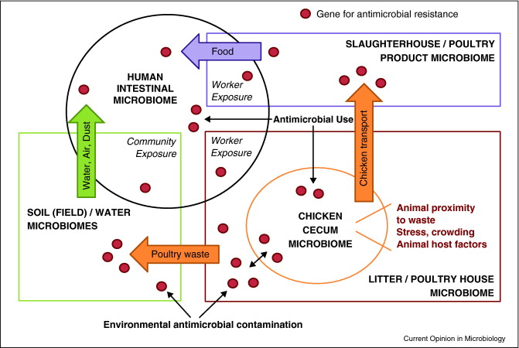
Antibiotic resistance arises, and is transferred, within microbial communities in the gut and airways of humans and animals. These microbial communities are structured networks of many different bacterial species with diverse functions that jointly operate in the host ecosystem. The use of antibiotics results in selective pressure on single functions in the complex ecosystem. Bacterial species can achieve significant competitive advantage when the functional limitations can be overcome. Antibiotic resistance can arise through rapid mutations in bacterial genes in a few cells and then be spread rapidly among siblings and related strains. The current approach is the application of different antibiotics when the first fails. The weakness in this approach is that antibiotic resistance properties may develop for these new antibiotics, further contributing to multi-resistance.
Figure 4 Ecological impact of antibiotic use on the microbiomes in the chicken cecum, poultry house environment, local soil and water environments, processing plant environment, and human intestine .
The development and spread of antibiotic resistance is a clear example of autonomous self organization. Antibiotic resistance emerges at the global level of the system solely from numerous interactions among the lower-level components of a system. Emergence of antibiotic resistance in the ecosystem coincides with a narrowing of functionality towards survival under the strong selective pressure of the antibiotic, thereby resulting in a collapse of ecosystem stability. Application of principles of self organizing autonomous systems enables us to gain more sustainable control over infectious microorganisms and reduce antibiotic resistance development. Rather than to combat the strength of these biological systems, SOAS enables us to identify weaknesses in the networks coinciding with resistance development. These principles can subsequently be used to develop more sustainable strategies for treatment.
It is important to note that relationship between disease and health in humans and animals, and the environment in which we are operating is a key aspect of the Government of the Netherlands Top-Sector Health Issues.

Self-organizing emergent groups in disaster (social system)
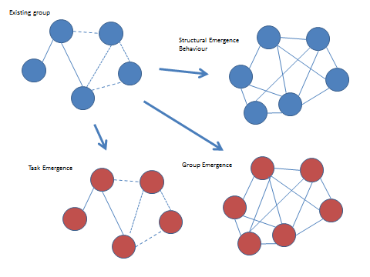
Research on emergent behavior has been a significant topic within disaster studies. Emergent behavior in disaster is an example of collective behavior. Quarantelli presents a typology of emergent groups in crisis settings. These type of groups perform new tasks (or functions) in old structures (Task Emergence), or new structures evolve executing old tasks (Structural Emergence Behavior), and in the last category describer new groups that have emerged performing new types of tasks (Group Emergence). See Figure 5 for an overview.
Figure 5 Three categories of emergent behaviour in groups
Emergent behavior can be specified as self-organizing behavior and the group showing this behavior can be described as an autonomous self-organizing system, where group members form the ‘nodes’. In his paper Quarantelli describes that a necessary condition for emergence is a perceived need to act on urgent matters. Sufficient conditions are 1) a supportive social climate; 2) relevant pre-crisis social relationships and 3) specific but necessary resources. The social climate includes shared norms, values and beliefs of the participants in the situation that somehow indicates that there should be collective action. Facilitating social relationships usually includes familiar ties that pre-exist in the situation. Resources have to do not only with material things and people, but also with relevant knowledge. Thus the possibility of initiating new behaviors or developing new groups is dependent on whether the existing social context can provide the means for acting in ways different from old. Conversely, if there is a perceived need and a facilitating social context, then emergence can occur.
Emergent groups are very relevant in crisis response mitigation processes. They might not always function efficiently, but often they effectively execute relevant tasks. Participating citizens may help themselves and others in the first minutes after an incident, time in which emergency services are mostly not present yet. In later phase the may alleviate the load on the emergency services (in large emergencies) by executing less crucial, but relevant crisis mitigation tasks. Lastly, participating citizens may support emergency services in the execution of their tasks. It is therefore relevant to investigate details about the necessary and sufficient conditions for these self-organizing groups in crisis: Communities with appropriate conditions for emergence, may prove to be more resilient during crisis.

Initial Appraisal of the cases
The presented cases hint at commonalities but also differences.
The man-made systems are focused at improving system behavior and cost reduction. Their focus is on applying a subset of SOAS principles to achieve the performance and cost goals by means of automation and reducing the need for human intervention. The social system case suggests that self organization is a given, but we need to identify the mechanisms, in particular manageable factors that are underlying if we want to be able to facilitate or inhibit emergent system behavior, e.g. resilience in crisis situations. The biological system case suggests that biological systems have different system goals (survival) than constructed systems.
It seems that the nature of the system goals (efficiency vs survival) does affect the focus on the kind of principles identified. For social systems we see a certain duality emerge, some social systems are constructed and have as goal efficiency, others evolve and have a survival goal, it is not always possible to make clear distinctions, this is dependent on the point of view taken by the observer.
The cases all have in common the notion of adaptation to their environment, however the mechanisms do appear to be different. This confirms our initial assumption that, depending on the disciplinary field and the issues to be dealt with, different interpretations of SOAS principles can be identified.
What is particularly striking is the matter of point of view held by the various disciplines. It seems to us that the paradigm held by the biological sciences is the most advanced and specific when dealing with adaption, whether within an organism or across generations. This point of view is particularly focused on the interaction between the system and its environment. The social sciences are also focused on this interaction but do not achieve the comprehensiveness of the biological approach. On the other hand, human behavior is of a far greater diversity. The technological sciences are particularly focused on internal structure and less focused on adaptation, as if only the desired emergent system behavior is of interest and other consequences are not part of the equation.

Impact
Even though society has become more complex, dynamic and ambiguous, our tools and methods also have increased greatly in sophistication. The more we can see, the more we can appreciate complexity and the more likely we are forced to tread lightly when intervening in these complex systems. One does not control complex systems, only to some limited extent one can control specific inputs and outputs and implement new connections between elements. Perhaps a tentative conclusion is, that all complex systems that adapt and survive are self-organizing, those that do not become extinct. Furthermore, we foresee that the major driver of the “evolution” of man made systems is the advancement of technology.
The problem TNO is faced with, is that these advancements are achieved in ‘relative’ isolation, within the boundaries of disciplines or even sub-disciplines. What we also tentatively conclude that a cross-disciplines language is a prerequisite for the cross-disciplines adoption of insights. It seems that the representation of this complexity in the form of factor and/or actor networks and associated concepts is the language that will reduce equivocality and increase sense-making within and across fields. Furthermore, this suggests that facilitation of interaction between disciplinary fields could potentially lead to “break through” innovations. In other words, facilitating new connections between sciences and scientists (at the elements level of the system) by means of a research agenda generates innovative insights and business at the system level. This completely corresponds with the TNO mission:
TNO connects people and knowledge to create innovations that boost the sustainable competitive strength of industry and well-being of society.

http://en.wikipedia.org/wiki/Swarm_behaviour
http://en.wikipedia.org/wiki/Snowflake
http://en.wikipedia.org/wiki/Ant_colony
http://en.wikipedia.org/wiki/Self-organization
http://www.tno.nl/content.cfm?context=overtno&content=overtno&item_id=30.
http://www.santafe.edu/
http://cscs.umich.edu/
, http://www.barabasilab.com/
Equivocation is a logical fallacy whereby an argument is made with a term which changes semantics in the course of the argument.
http://cmap.ihmc.us/
Becker, M., Kuladinithi, K., Timm-Giel, A., and Gorg, C.: Historical Development of the Idea of Self-Organization in Information and Communication Technology. Book chapter in “Understanding Autonomous Cooperation and Control in Logistics”, Springer, 2007.
Timm, I., Knirsch, P., Kreowsky, H.J., and Timm-Giel A.: “Autonomy in Software System”. Book chapter in “Understanding Autonomous Cooperation and Control in Logistics”, Springer, 2007.
Windt, K., and Hülsmann, M.: Changing Paradigms in Logistics – Understanding the Shift from Conventional Control to Autonomous Cooperation and Control. Book chapter in “Understanding Autonomous Cooperation and Control in Logistics”, Springer, 2007.
Willcock C. (Coordinator), Self-Management for Unified Heterogeneous Radio Access Networks (SEMAFOUR), Objective ICT-2011.1.1 Future Networks January 17th, 2012
Berg, vd J.L., Litjens R., et al. Self-Optimisation and selfConfiguRAtion in wirelESs networks (SOCRATES)
J. Ramiro (editor), K. Hamied (editor), ‘Self-Organizing Networks: Self-Planning, Self-Optimization and Self-Healing for GSM, UMTS and LTE’, John Wiley & Sons, 2011
Septimus, E. J., & Kuper, K. M. (2009). Clinical Challenges in Addressing Resistance to Antimicrobial Drugs in the Twenty-First Century. Clin Pharmacol Ther, 86(3), 336-339. American Society of Clinical Pharmacology and Therapeutics. Retrieved from http://dx.doi.org/10.1038/clpt.2009.122
Piddock, L. J. (2012). The crisis of no new antibiotics-what is the way forward? The Lancet infectious diseases, 12(3), 249-53. doi:10.1016/S1473-3099(11)70316-4
Leverstein-van Hall, M. a, Dierikx, C. M., Cohen Stuart, J., Voets, G. M., van den Munckhof, M. P., van Essen-Zandbergen, a, Platteel, T., et al. (2011). Dutch patients, retail chicken meat and poultry share the same ESBL genes, plasmids and strains. Clinical microbiology and infection : the official publication of the European Society of Clinical Microbiology and Infectious Diseases, 17(6), 873-80. doi:10.1111/j.1469-0691.2011.03497.x
http://www.government.nl/issues/health-issues
Stallings, R.A. & Quarantelli, E.L. (1985). Emergent citizen groups and emergency management. Public Administration Review.
Drabek, T.E. & McEntire, D.A. (2003). Emergent phenomena and the sociology of disaster: lessons, trends and opportunities from the research literature. Disaster Prevention and Management, 12(1), 97-112.
Quarantelli, E.L. (1995). Emergent behaviors and groups in the crisis time of disasters. Preliminary Paper # 226. University of Delaware: Disaster Research Center.

