Interview Schedule - Self Organising Automatic systems
Version 1.0, 11 April 2012

Questions to be addressed

Introduction
- What is your discipline? (computer science, biology,…..) and what are the disciplines of your collaborators within your organization?
- In which domain are you active? (logistics,…..)
- How do you describe self-organization?
- The history and future of SOAS in your org?

Specification of SOAS
- Is network representation/theory a viable “universal” language?
- What framework(s) do you use? Factors/Actors? Interactions? Variables/concepts?
- What are for you generic principles?
- What are specific principles?
- How do you deal with issues of resolution, keeping in mind system behaviour?
- Is our distinction in man-made, social and biological systems to the point?
- Is our list valid (complete, useful, etc.)?
- Is our approach valid?

Application
- Which issues do you resolve with principles of SOAS?
- Does this generate revenue for your organization? (grants, funding,…..)
- What are the benefits of SOAS for you, your organization, your customers, society?
- What breakthroughs do you expect to facilitate with SOAS?

Collaboration / Combination of domains
- With which network(s) do you collaborate? Who are the parties (1st order nodes)?
- Do you use examples of different (domains/disciplines) for your issues/problems? How do you do this?
- Is SOAS sufficiently generic to be applied in multiple domains?
- What would be (is) the benefit of a multi-disciplinary approach?
- How do you deal with equivocality? Apply an uniform language? Which one?

Other
- How do you convey SOAS insights to non-adepts?
- What metaphors do you use to illustrate SOAS?
- Which three publications would you advise?
- Who would you suggest we interview?
- Can you give us a quote?

Appendix – Definition, Tables & Figures

Definition self-organization: Wikipedia defines self-organization as the process where a structure or pattern appears in a system without a central authority or external element imposing it through planning. This globally coherent pattern appears from the local interaction of the elements that make up the system, thus the organization is achieved in a way that is parallel (all the elements act at the same time) and distributed (no element is a central coordinator) .

System → | Man-made | Social | Biological
Goals → | Efficiency | Efficiency & Survival | Survival
principles↓
Adaption [Accommodation] | Accommodates to variation in values of known environmental variables through designed heuristics | Depending on the point of view of the observer, either by design or through evolution | Accommodates not only to “known” but also to new environmental variables in the next generation through natural selection; evolution
Adaption [Assimilation] | Systems behavior does change its environment but is not often considered | System behavior does change the environment and is appreciated | System behavior changes the environment and is integral to the evolution principle
Learning | New heuristics are incorporated by outside source, engineered | New heuristics are learnt through trial and error or by design | New heuristics can be learnt but require minimal intelligence, otherwise by random mutations
Robustness | Through “over” engineering | Through multiple interacting subsystems and/or “over” engineering | Through multiple interacting subsystems
… | ? | ? | ?

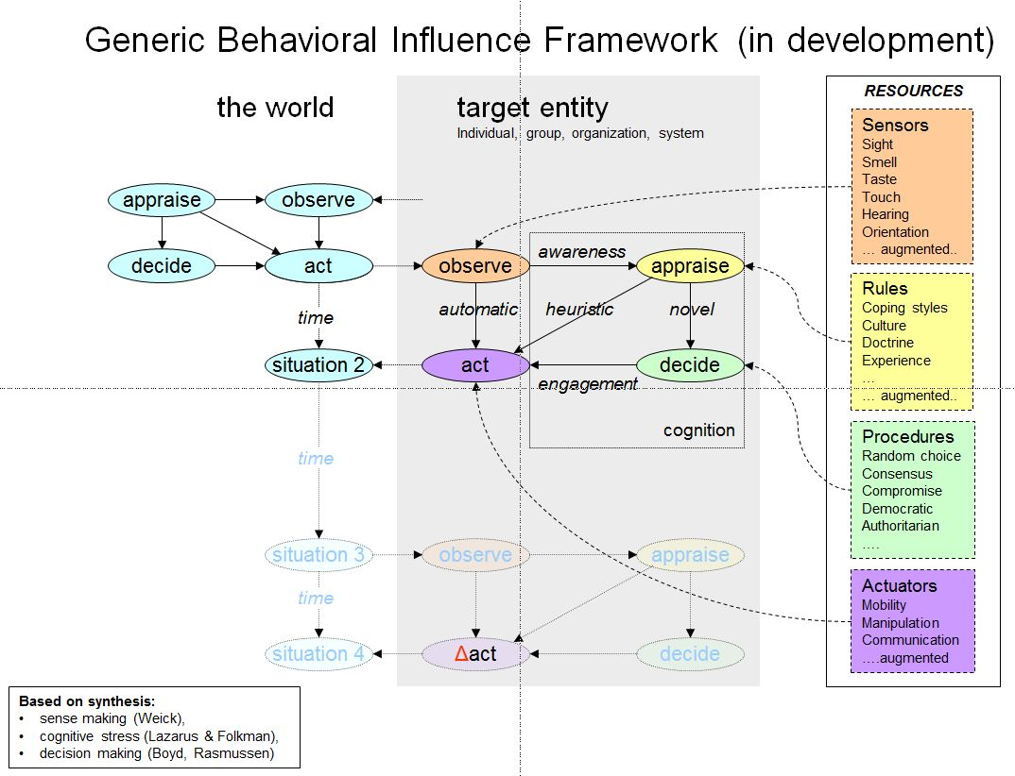
TNO is developing a generic behavioural change framework to make sense of behaviour of entities (see 2), whether these are individuals, groups, organizations or systems. This framework supports the understanding of self-organising systems.
- What framework(s) do you apply in understanding / describing the behaviour of soas?

Application domains
In what domains are principles of self-organisation relevant?
In what domains are principles of self-organisation promising?
What problems can be solved?

http://en.wikipedia.org/wiki/Self-organization

