Background Statement:
The Middle States Commission on Higher Education (MSCHE) is an organization that accredits colleges and universities in Delaware, the District of Columbia, Maryland, New Jersey, New York, Pennsylvania, Puerto Rico, the U.S. Virgin Islands, and several locations internationally. The purpose of MSCHE is to identify, maintain, and endorse educational excellence. The accreditation process, which takes place every ten years, examines universities as a whole, rather than specific departments within the institution (MSCHE, 2006). Lehigh University has four colleges, which produce diverse mission statements, student populations, and resources. The review supports Lehigh’s goal of promoting academic success for faculty and staff, regardless of the college.
One of the steps in the accreditation process is for MSCHE to return every five years to review the progress that is being made. The outside reviewer identifies if the mission and vision of the university is being upheld and prepares the administration team for their next review. This is called the Periodic Report Review (PRR). The PRR is an iterative process of analyzing the universities programs based on the MSCHE recommendations. The review begins with the design and development of new programs that support student learning. Implementation of the programs follows this step. Ultimately, evaluation of whether the program worked or not is assessed. If the program succeeds, Lehigh’s team leaders analyze the next steps for the program. If the program fails, an analysis of why is reviewed. Each recommendation for the PRR requires a report be written including either information. My role, as a member of the internal review team, is to make sure the programs did in fact follow MSCHE’s version of the ADDIE model for each program. After my review, and outside reviewer from MSCHE reads the reports via an online collection system.
However, a new change in the writing process has occurred for the 2012-2013 PRR report. Authors of recommendations 1-56 must report their findings in a new online system called Compliance Assist (CA). CA claims to be user friendly, unfortunately, it is not. Several authors have complained about how difficult it is to navigate. Due to this need, the administrative team has decided to hold a one-day, on campus, workshop for the authors. The large volume of participants prompted the decision to conduct the workshop three times. Each session will consist of authors who recommendations are related. Therefore, session one will be comprised of authors 1-29, session two for authors 30-39, and the final session for authors 40-56.
The Deputy Provost has charged me with the following task: create the introductory section of the PRR CA author’s workshop. The end task for the learners is to understand their user log in and password, uploads important documents, and how to write their report within CA. The task analysis provided below will be presented to the Deputy Provost (DP) in the following weeks as my outline for the workshop. My intention is for the DP to visualize how the introduction section of the workshop will segue into the content sections he presents. My second intention is for the workshop to be implemented by others. After this reporting period, I will no long be on the committee and want to ensure a new member can easily conduct this workshop again.

Topic: How to use the Middle States Commission on Higher Education (MSCHE) Periodic Review Report: Compliance Assist website

Statement of Needs: The Compliance Assist (CA) website is the designated log in site where Lehigh University authors are to report the findings for recommendations 1-56. This is a new system, which demands committee members to learn the program. A one-day, on campus, training is required for authors of the MSCHE PRR report. There will be three, 1-hour sessions:
- Session 1: Authors 1-29
- Session 2: Authors 30-39
- Session 3: Authors 40-56

Target group or Population: The target group is the authors of PRR 1-56. This group consists of 45 participants who hold various positions on campus.

Delivery system: The workshop will be held in a computer lab at Linderman Library. The lab has a sufficient amount of computers, a projector for the instructor, as well as wireless printers for the participants. The presentation will be given through PowerPoint and real time demonstrations in CA.

Goal(s): The projected goals of the workshop is to instruct Lehigh Universities PRR 1-56 authors on how to log in, upload their documentation, and write the report for the outside reviewer.

Performance Objectives:
- The MSCHE author will be able to independently log in to the Compliance Assist website via presenter observation from the administrator log in page.
- The MSCHE author will be able to independently upload documentation on the Compliance Assist website. Assessment of the objective will be collected by a screen shot of their submission during the workshop.
- The MSCHE author will be able to independently write their report findings on the Compliance Assist website will be assessed by a print out of their submission at the end of the workshop.

Instructional Strategy: The instructional strategy for the presenter is clustered into five parts:
- Introduction/Housekeeping
- “How to Log In”
  - Assessment and branches
- “How to Upload a Document”
  - Assessment and branches
- “How to Write in CA”
  - Assessment and branches
- End of workshop

Assessment and Branching: The assessments for the objectives are
- Authors independently log in will be authentically assessed by observation on the presenters User Login Page.
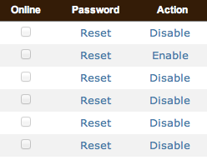
A check mark will indicate successful log in from the participants. If participants are successful, branch to the yes column and continue with next phase. A blank box will indicate needs additional support. Branch to the no column and assist user, one on one, with log in and password
- Upload documentation will be assessed via screen shot
Success of the objective shows a document with each participant’s name. If found, move to yes column and continue. No documentation will indicate they have not passed this objective. If this is found,” branch to the no column and provide individual support to the authors.
- Independently write a PRR report will be assessed via document print out at the end of the session. The document should include information in at least one of the following sections: Findings, Recommendation, Background Statement, Description of Tangible Progress, or Needs Section. If found, move to yes column and finish workshop. If not, branch to the no column and work with author until they are successful.

Formative and Summative Assessment: Formative assessment is constant throughout the training session. As the presenter is giving the instructional tasks of how to navigate through CA, responses from the author will indicate where to take the direction. The flow could expedite the training, or break it down into even smaller tasks. As the authors are working on the report, the presenter will be walking around the lab offering support and feedback. The summative assessment, essentially, is the print out report. The report, along with the observations, will determine when additional one on one training is necessary.

Task Analysis and Flow Chart: The task analysis and flow chart mimics an information processing analyses for procedures. According to Smith and Ragan (2005), application of procedures involve the following steps:
- Establish whether a procedure is appropriate.
- Recall the steps of the procedure.
- Apply the steps in order, with stopping points for assessment, if required.
- Confirm assessments match the objectives.

Task Analysis:
- Prepare computers for workshop
  - Turning on all monitors so they are ready for the participants
  - Place handouts for participants at their computer
  - Download a “trial uploading document” in each My Documents folder on the computers
- Welcome the participants to the workshop
  - Explain the purpose of the workshop: Learn about CA website
  - Explain the objectives of the workshop: Log in, uploading, and writing review
  - Discuss the final results: Independently use the CA website after the training
  - Review the handouts at their computer
- Begin with “How to Log In” slide
  - Participants will open Safari
  - Participants will type the web address for CA
  - Participants will enter their log in and password information.
  - Assess success via presenter log in page. If there is a checkbox by participants name, continue. If there is no checkbox, assist the participant.
- Explain the following section, “How to Upload a Document”
  - Participants will review the main page tabs.
  - Participants will open the Add an Announcement page
  - Participants will locate the trial document in the My Documents folder
  - Participants will click “Upload Document” tab
  - Participants will attach document and hit submit
  - Wait for the “Success” screen to appear before leaving the screen
  - Click “Save document” then press “Update”
  - Participants will attach a personal document that correlates to their recommendation number
    - Assess for success via screen shot. If there is a document by participants name, continue. If there is no document, assist the participant with completion.
- Explain the following section, “How to Write in CA”
  - Return to Main Page
  - Click on Institution Page
  - Open Academic Affairs tab
  - Review Edit button
  - Review difference between Save vs. Update
    - Deputy Provost reviews content writing and essential needs for the PRR
  - Authors are given time to write their report and explore the new edit functions
    - Assess for success via print out of report. If there is a document printed with participants name, end training. If there is no document, assist the participant until completion.

The same procedures were used when creating the Cmap flowchart. Different symbols and colors are used throughout the process meant to indicate specifics steps or change. For example, in my CMap, step three is represented by squares, and circles symbolize step four. The circles have yes/no decision points with branches indicating the next steps for the instructor. The branches, denoted by dotted lines, assist with checking for learning as the objectives are being met. The color blue indicates the presenter’s role, and white box with blue shadows indicates the DP role.
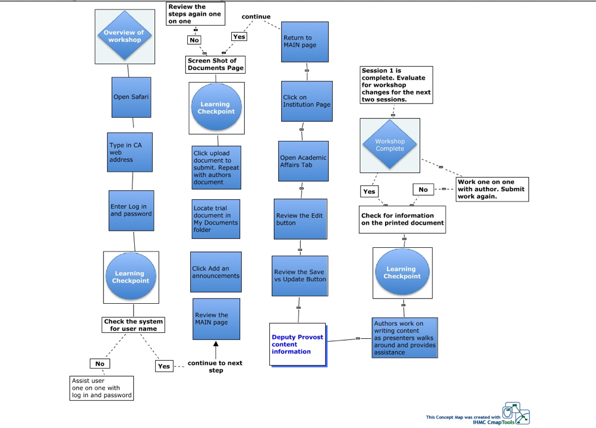

Reference:

Middle States Commission on Higher Education. (2006). Characteristics of
excellence in higher education: Requirements of affiliation and
standards for accreditation (12th ed.). Philadelphia, PA: Middle States
Commission on Higher Education.

Smith, P. L., & Ragan, T. J. (2005). Instructional Design (3rd ed.). Hoboken,
NJ: John Wiley & Sons Inc.

Resources:

CMap flowchart: http://cmapspublic3.ihmc.us/rid=1KJNZH02W-XGCB43-WB6/Final_Project_MStotz.cmap

