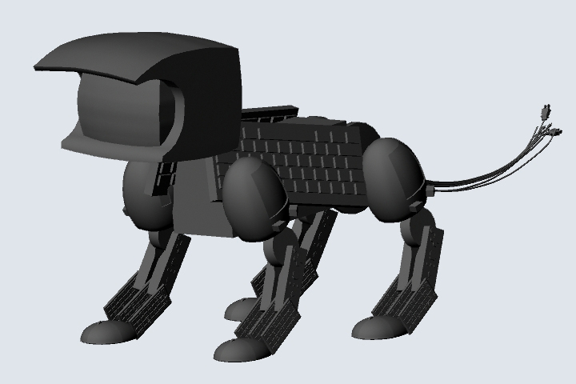

Ashley Linder: Independent Research Proposal

Introduction

When I entered the digital animation program, I was excited by the immediate nature of the medium. Work created digitally has a malleability that no other medium can replicate. The artist can experiment with color and placement, pose and structure without worry of damaging the piece. It provides a unique opportunity to revisit past work without losing the original piece.

This provides new and exciting opportunities as technology grows and advances. Due to the availability of 3D printers, digitally created artwork is no longer limited to being presented two dimensionally. Through the design and manipulation of PLA plastic, the form can be printed in the round to create an actual three dimensional object based on a digital blueprint.

I chose this particular model to renovate to illustrate my growth and progress as a digital designer.

Process

I will take and revise a character model I have already created. I will redesign each component and find new and interesting ways to fit the pieces together. I plan to create an articulated figure who can move all four legs, his tail, and his head. I will print all the parts in plastic, and the joints will be either printed pieces or magnetic constructs. Pending a successful assemblage of the model, I will submit a short motion capture sequence of my articulated model moving. Perhaps a walk cycle or a jump from a low place to a high place.

I will reopen the file in Maya and redesign all the parts so that they will print and fit together on their own. As it is, they are floating polygons, not connected to one another. I will research and sketch moving joints and do test prints to be sure they work. I will scan some components to be sure they have a high level of detail. After I have remodeled my figure and inserted all the joints, I will print out the pieces and assemble the model. I don't intend to paint or in any other way color my model, as I fear that would interfere with his movements.

Expected Results

I expect to find new ways to assemble my model that will hide the jointing and bring potential of movement to my figurine. Having an articulated figurine will help with my animation skills as well as my understanding of 3 dimensional space. If successful, the motion capture sequence of my figure in motion will illustrate my newfound understanding of 3D rendering softwares and their potentials.

Timeline

3/29 - DUE: Articulated leg joint design. Turn in all sketches and screen caps.

4/5 - DUE: Articulated head movement. Turn in all sketches and screen caps (cumulative).

4/12 - DUE: Articulated tail movement. Turn in all sketches, test prints, and screen caps (cumulative).

4/26 - DUE: Assembled articulated model. Turn in all sketches, test prints, and screen caps (cumulative). Motion capture movie (pending successful completion of the model)

Exploration: Past and Present—Revisiting Old Work to Produce New and Innovative Results

In my investigation, I will be exploring different forms of joinery in an attempt to create an articulated form. I will create a character model in the 3D design software program Autodesk Maya, then add different kinds of joints that would allow for the figure to move. I will then print the pieces in PLA plastic and assemble them. What I’m hoping to find is a unique way to join two printed pieces that allows for maximum movement. Pending the success of the print, I will create a short motion capture of my articulated character.

