Introduction: Size, Orbit, etc. | How Fast is Earth Moving? | Continental Drift | Oceans | The Atmosphere | Clouds | Magnetosphere | Moon
Axis Tilt,  Seasons | How is its Mass Determined? | Inside  the Earth | Water Cycle | Greenhouse Effect | Why is the Sky Blue? | Activities,  Web Links | Geologic Time Chart

THE EARTH'S ATMOSPHERE
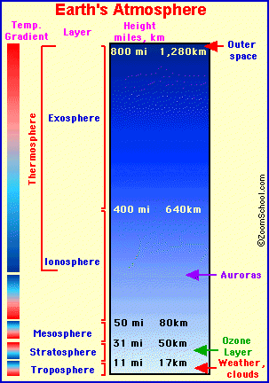
The Earth's atmosphere is a thin layer of gases that surrounds the Earth. It composed of 78% nitrogen, 21% oxygen, 0.9% argon, 0.03% carbon dioxide, and trace amounts of other gases. This thin gaseous layer insulates the Earth from extreme temperatures; it keeps heat inside the atmosphere and it also blocks the Earth from much of the Sun's incoming ultraviolet radiation.
The Earth's atmosphere is about 300 miles (480 km) thick, but most of the atmosphere (about 80%) is within 10 miles (16 km) of the surface of the Earth. There is no exact place where the atmosphere ends; it just gets thinner and thinner, until it merges with outer space.
Air Pressure:
At sea level, the air pressure is about 14.7 pounds per square inch. As your altitude increases (for example, if you climb a mountain), the air pressure decreases. At an altitude of 10,000 feet, the air pressure is 10 pound per square inch (and there is less oxygen to breathe).
The Layers of the Atmosphere:
Thermosphere: The thermosphere is a thermal classification of the atmosphere. In the thermosphere, temperature increases with altitude. The thermosphere includes the exosphere and part of the ionosphere.
•Exosphere: The exosphere is the outermost layer of the Earth's atmosphere. The exosphere goes from about 400 miles (640 km) high to about 800 miles (1,280 km). The lower boundary of the exosphere is called the critical level of escape, where atmospheric pressure is very low (the gas atoms are very widely spaced) and the temperature is very low.
•Ionosphere: The ionosphere starts at about 43-50 miles (70-80 km) high and continues for hundreds of miles (about 400 miles = 640 km). It contains many ions and free electrons (plasma). The ions are created when sunlight hits atoms and tears off some electrons. Auroras occur in the ionosphere.
•Mesosphere: The mesosphere is characterized by temperatures that quickly decrease as height increases. The mesosphere extends from between 31 and 50 miles (17 to 80 kilometers) above the earth's surface.
•Stratosphere: The stratosphere is characterized by a slight temperature increase with altitude and the absence of clouds. The stratosphere extends between 11 and 31 miles (17 to 50 kilometers) above the earth's surface. The earth's ozone layer is located in the stratosphere. Ozone, a form of oxygen, is crucial to our survival; this layer absorbs a lot of ultraviolet solar energy. Only the highest clouds (cirrus, cirrostratus, and cirrocumulus) are in the lower stratosphere.
•Tropopause: The tropopause is the boundary zone (or transition layer) between the troposphere and the stratosphere. The tropopause is characterized by little or no change in temperature altitude increases.
•Troposphere: The troposphere is the lowest region in the Earth's (or any planet's) atmosphere. On the Earth, it goes from ground (or water) level up to about 11 miles (17 kilometers) high. The weather and clouds occur in the troposphere. In the troposphere, the temperature generally decreases as altitude increases.
Formation of the Atmosphere:
The Earth's atmosphere was formed by planetary degassing, a process in which gases like carbon dioxide, water vapor, sulphur dioxide and nitrogen were released from the interior of the Earth from volcanoes and other processes. Life forms on Earth have modified the composition of the atmosphere since their evolution.
Web Links about the Earth's Atmosphere
Label the layers of the Earth's atmosphere - a printout
The atmosphere from NASA

