Jenny Kimmey Stevens

June 17th, 2012

Instructional Design

**Rationale**

Geometry is an important foundation in the Mathematics across all grade levels. The study of geometry provides the student with a vehicle for enhancing logical reasoning and deductive thinking for modeling abstract problems (<http://www.muchmoremath.com/geometry.html>). Most people are unaware that Geometry is all around us! For example, if you like baseball, then you have seen an example of geometry at work. The angle of a pitch and the angle where the bat meets the ball make the difference between a high popup to the infield and a deep shot for a home run. Pool games are all about geometry. You need to know your angles so you can bank shots across the table and understand where your cue ball will rest at the end of the shot (Donovan, 2012.) Geometry is so important and unfortunately, it can be very difficult for some students. First Grade students are expected to master basic Geometric skills by the end of First Grade. Some of these skills include identifying two and three dimensional shapes and the attributes of each shape. There are vocabulary words that can be difficult within this curriculum. Some of these words include attributes, defining, non-defining, open, and closed. In order to be successful with the First Grade curriculum, students must be able to define these words as well as use them to demonstrate understanding. This instructional design gives First Grade students the opportunity to master the required skills as indicated by the Core Content Standards and the curriculum design.

First Grades students begin the year with basic shape knowledge. Most students are able to identify the basic shapes (square, rectangle, triangle, circle, etc.). This instructional design requires high lever level thinking and uses multiple indicators of Bloom’s Taxonomy. Bloom’s Taxonomy is demonstrated throughout this unit when students identify defining and non-defining attributes of shapes (memory/recall), sort shapes by their attributes (application), and build, draw, and construct shapes when given attributes (synthesis). The levels in this curriculum are designed to build upon one another (Chiarelott, 2006).

My instructional design covers a three day sub-unit, Three Dimensional Shapes. My students will be engaged in both whole group and small group activities and opportunities to use the SMART Board. My lesson plans mimic the 5-E Learning Cycle Model. Each lesson plan incorporates the five phases as indicated in our text (Chiarelott, 2006). This particular model was chosen because this model provides ample opportunities to investigate, explore, expand and self-assess for each lesson.

(References are at the end)

**Unit Learning Outcomes**

**Unit One-Shapes**

* I can identify basic shapes (memory/recall).
* I can explain how shapes are different or alike (comprehension)
* I can draw a shape (application).

**Unit Two-Two Dimensional Shapes**

* I can identify and make two dimensional shapes (memory/recall and application).
* I can create new shapes using two dimensional shapes (application and synthesis).

**\*\*Unit Three-Three Dimensional Shapes\*\***

* I can identify three dimensional shapes (memory/recall).
* I can create new shapes using three dimensional shapes (application and synthesis).

**Unit Four-Defining and Non-Defining Attributes**

* I can identify defining attributes of different shapes (memory/recall).
* I can sort shapes by their attributes (comprehension).
* I can build shapes to show attributes using manipulatives (synthesis).
* I can draw shapes to show attributes (application).
* I can construct and draw a shape when given attributes (evaluation).
* I can identify non-defining attributes of different shapes (memory/recall).

**Pre-Assessment**

The Pre-Assessment Tool that I have created is a game to be used on the SMART Board. The game is called “Geometry Hoops” (http://exchange.smarttech.com). For this game, I would divide my class into two teams (it could be boys vs. girls or Tables 1-3 vs. Tables 4-6). I would then ask one student at a time to come to the front of the classroom to answer a question. For this game, I would use my clipboard to pre-assess whether or not the student is able to answer questions correctly. Not every student will be able to come to the SMART Board to answer a question. Therefore, each student would have a dry erase board. The students who are not at the SMART Board would write down their answer on the dry erase board. I would circulate the classroom to check for understanding. Photographs of “Geometry Hoops” is below as well as the checklist I would use.

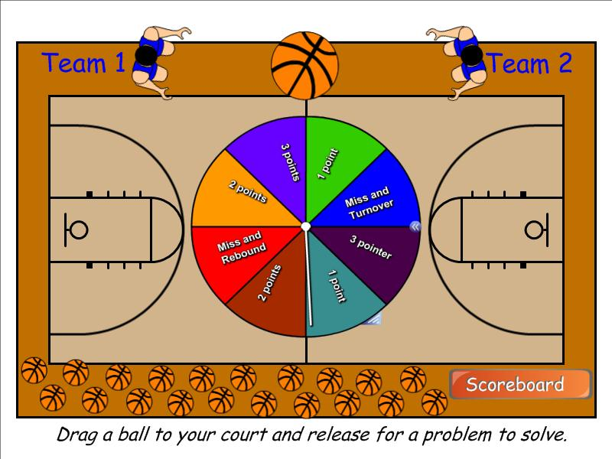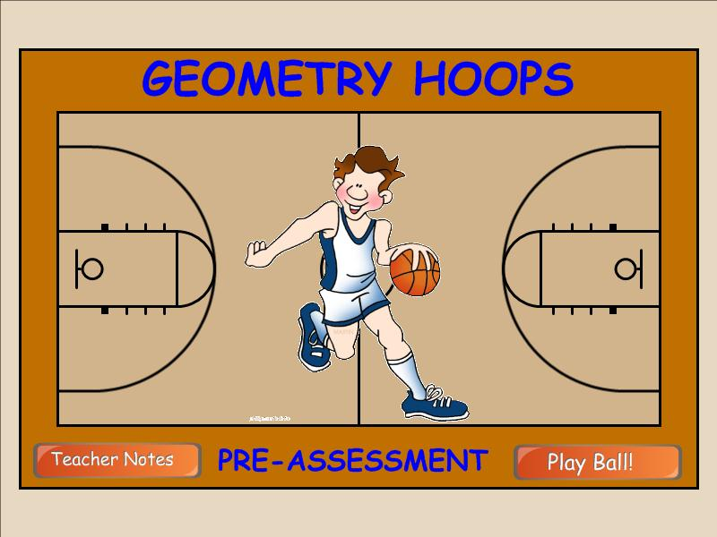

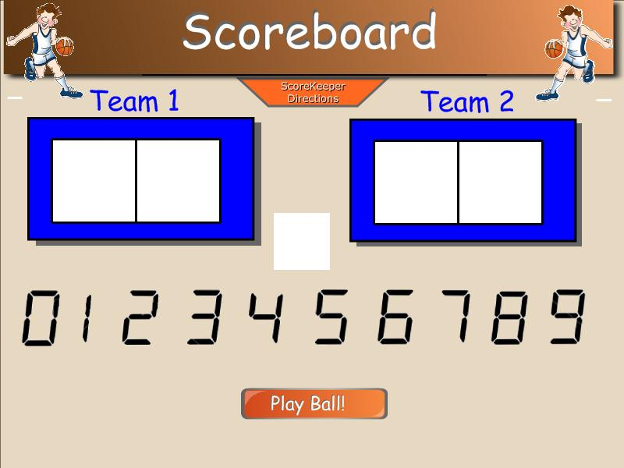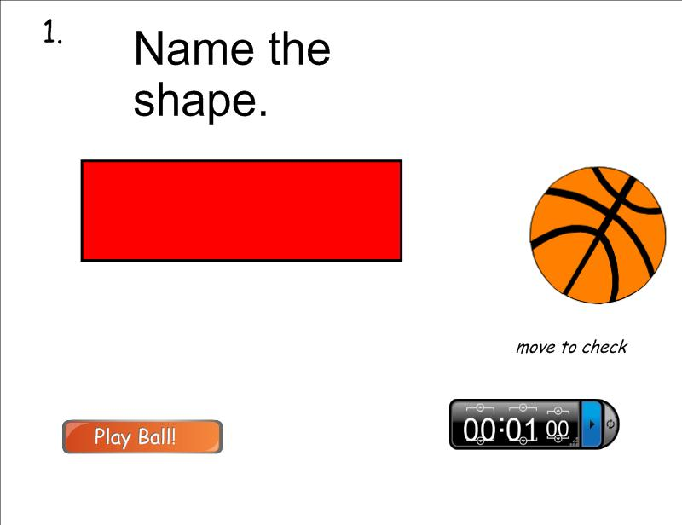

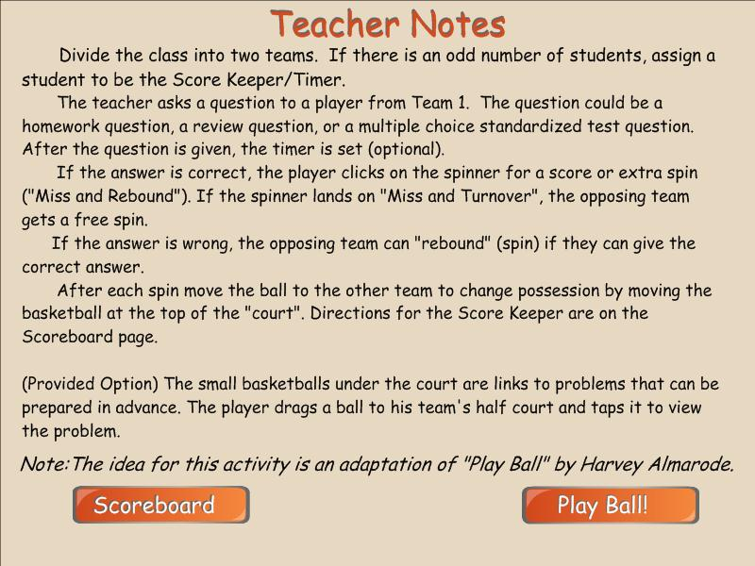

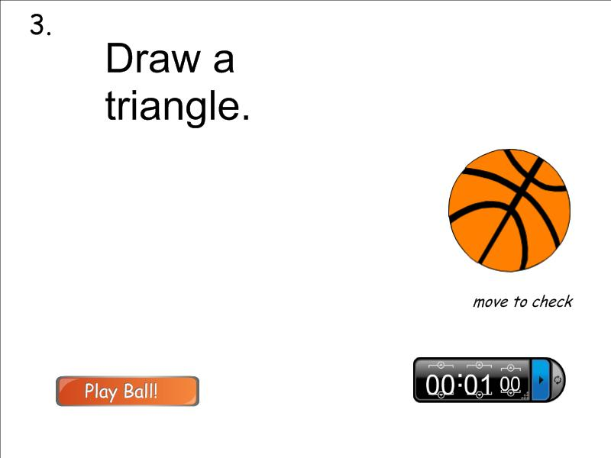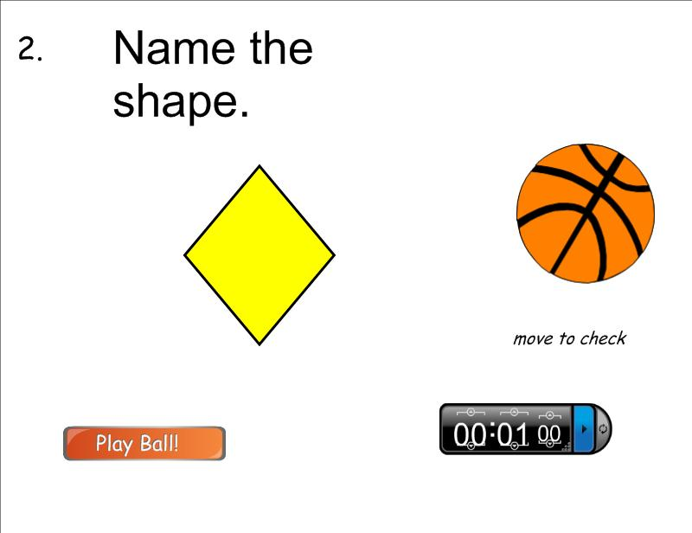

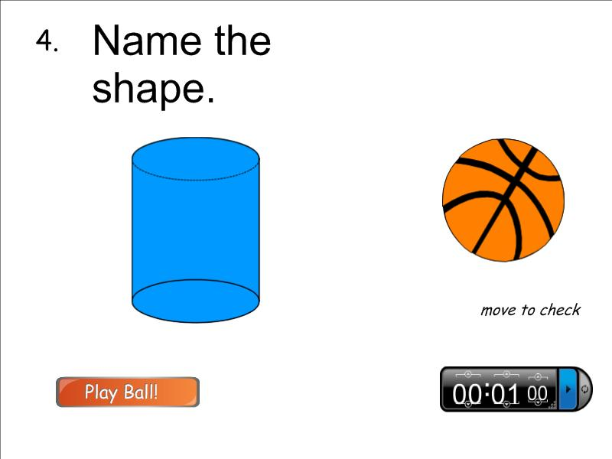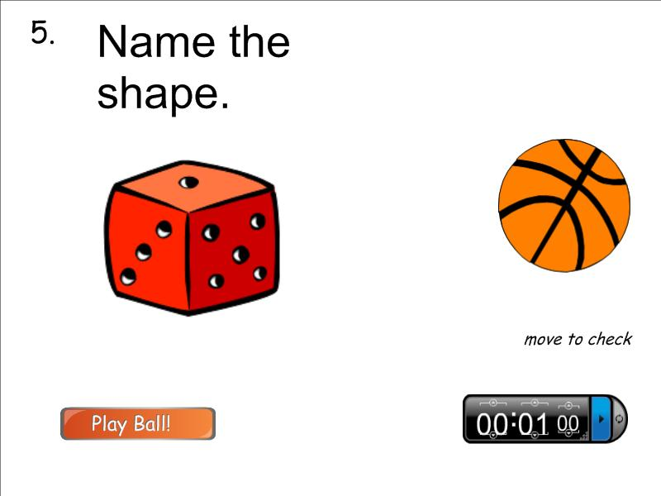

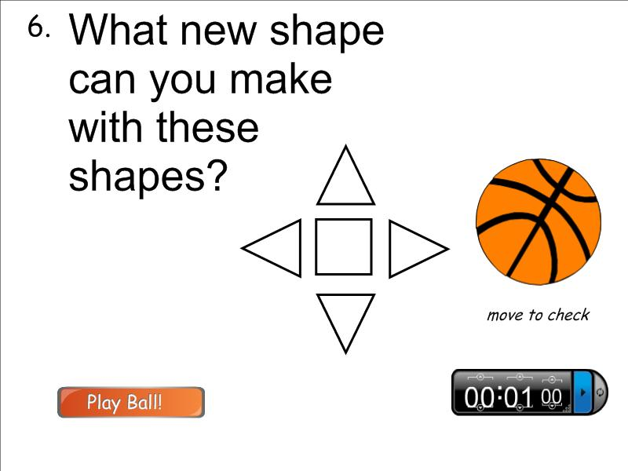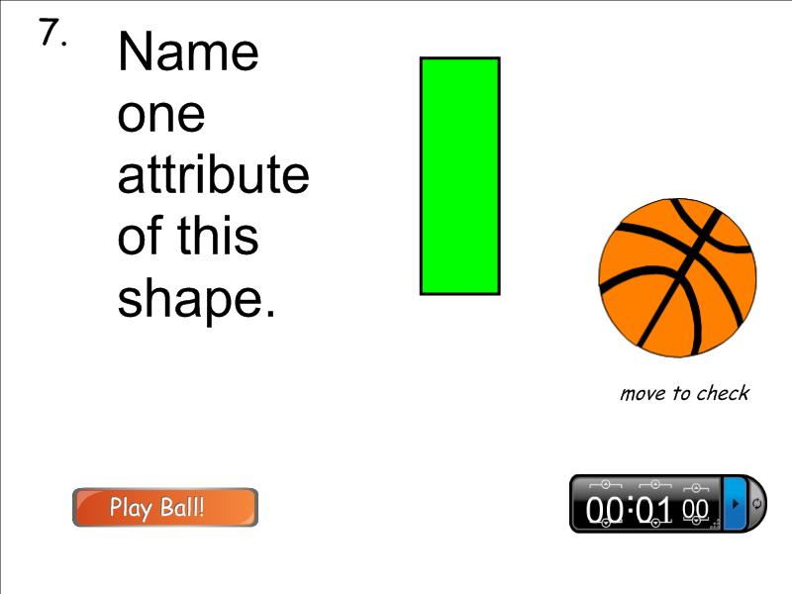

This is the checklist that I would use as documentation while playing “Geometry Hoops”. Checklists are very clear. A checkmark means yes, the student gets it and a minus mark means that the student is not quite there. Checklists are wonderful tools for both pre and post assessments.

|  |  |  |  |  |  |
| --- | --- | --- | --- | --- | --- |
| I can… | Identify shapes. | Explain how shapes are alike or different. | draw a shape. | identify 2D and 3D shapes. | Identify defining and non-defining attributes. |
| Kolin |  |  |  |  |  |
| Sophia |  |  |  |  |  |
| Courtney |  |  |  |  |  |
| Abigail |  |  |  |  |  |
| Lucas |  |  |  |  |  |
| Lance |  |  |  |  |  |
| Mckenzie |  |  |  |  |  |
| Donovan |  |  |  |  |  |
| Abby |  |  |  |  |  |
| Eryan |  |  |  |  |  |

**Lesson Plans**

**Lesson 1 (Taken from Everyday Math Unit 7 Lesson 5)**

1. **Concept To Be Learned:** Identify Three Dimensional Shapes
2. **Lesson Objective:** I can identify three dimensional shapes. (memory/recall).
3. **Procedures:**

**Phases: Description of Activity**

* **Engagement (5 min.):** Call students to the carpet-be sure they sit in their assigned spots. Hold up the basketball. Ask the students if they can identify what you are holding up. After several students have answered (you will receive ball or basketball), tell the students that this is a sphere. Yes, it is a basketball, but the name of the shape is a sphere. Next, hold up the cereal box. After several students have answered (you will receive cereal, Lucky Charms, rectangle, etc.) Tell the students that yes, it is cereal and it does have rectangles, but this cereal box is a rectangular prism. Hold up the sphere, pyramid, rectangular prism, cube, cylinder, and cone. Explain that these objects are called three dimensional shapes. Ask if a student knows what three dimensional means (call on several students). If the correct answer was not stated, explain that three dimensional shapes means that the shape is not flat, that you could walk around the shape and it stays the same. Explain to the children that today they will be working with the sphere, cylinders, and rectangular prisms. Next, put on Brain Pop Jr. “Solid Shapes”. Tell the children that this will warm up their brains.
* **Exploration (30 min.):** After Brain Pop Jr. ask the students to sit in a circle (sit on the carpet with them). Ask the students how they would describe the ball. Some expected answers would be that it is round, smooth, and has no flat sides. Point out that the ball or sphere has no corners. Show the students that the sphere can roll. Ask the students to list the names of objects that are shaped like spheres (pass the ball around the circle). Next, hold up a can. Ask the students how they would describe the can. Some expected answers would be that it has a curves side and two flat sides, the flat sides are circles, and the can will sit on either of its flat sides. Point out that the can or cylinder has no corners either. Show the students that the cylinder can roll. Ask the students to list the names of objects that are shaped like cylinders (pass the cylinder around the circle). Next, hold up the cereal box. Ask the students how they would describe the box. Some expected answers are that all of the sides are flat and it is made up of rectangles. Ask the students to list the names of objects that are shaped like rectangular prisms (pass the box around the circle). Hold up the rectangular prism, explain to the students that the outside or the “skin” of any of these three dimensional shapes is called its surface. Ask a student to point to the flat sides of the rectangular prism and the cylinder. Tell the students that these sides are called faces. Ask the students how many flat faces each shape has (the sphere has 0, rectangular prism has 6, cylinder has 2). Point to each face as the class counts together. Ask the students the shapes of the flat faces (all of the flat faces of the rectangular prism are rectangles; the flat faces of the cylinder are circles). Point to a corner of the rectangular prism. Explain that a corner is a point at which at least three flat faces meet. A cylinder does not have any corners because its flat faces do not meet. Ask how many corners the rectangular prism has (8 corners). Point to each corner as the class counts.
* **Explanation (10 min.):** Tell the students to return to their seats and get out their Math Journals. Tell the students to write the word cylinder, sphere, and rectangular prism in their journals. Next to each word, tell the students to draw a picture of what each shape is. Their drawing can be a plain picture, like our shapes, or a picture showing a real life object. Draw this example on the board:

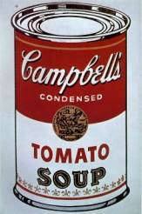cylinder or cylinder

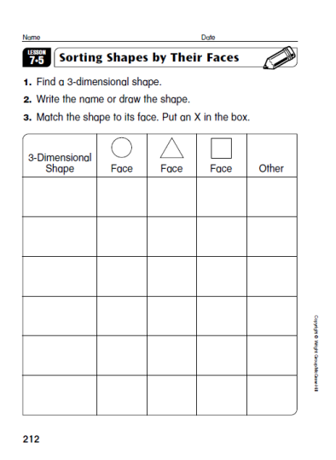

* **Extension (15 min.):** Pass out Math Master

pg. 212 and a cylinder, sphere,

and rectangular prism. Explain to the

students will label the shape (write names of

shapes on board with a picture) and write how

many circle faces, triangle faces, or square

faces each shape has. Demonstrate for the

students. As students are working, circulate the room and help those in need. When students are finished, collect their papers to save for the lesson the following day.

* **Evaluation (5 min):** After the students have completed their work, pass out the “I can…” checklist. Read aloud each question to the students and explain where they should mark their X. The students are familiar with this checklist and will be able to do it properly and honestly. The checklist is below.

|  |  |  |  |
| --- | --- | --- | --- |
| Name _______ | I can do that by myself! | I can do that with a little help. | I need more time to practice! |
| **1.** I can tell you the name of something that is shaped like a sphere. |  |  |  |
| **2.** I can tell you the name of something that is shaped like a cylinder. |  |  |  |
| **3.** I can tell you the name of something that is shaped like a rectangular prism. |  |  |  |

1. **Materials and Resources**
   * Cereal box, basketball, soup can
   * Student Math Journals
   * Computer and SMART Board
   * Wooden blocks (sphere, cylinder, rectangular prism)
   * Worksheets are listed above

**Lesson 2 (Taken from Everyday Math Unit 7 Lesson 6)**

1. **Concept To Be Learned:** Identify Three Dimensional Shapes
2. **Lesson Objective:** I can identify three dimensional shapes. (memory/recall).
3. **Procedures:**

**Phases: Description of Activity**

* **Engagement (15 min.):** Ask the students to come to the carpet. Hold up the shapes from the previous lesson (sphere, cylinder, rectangular prism). Review the names and list some real life objects that are those shapes. Next, hold up the cone shaped wooden block. Ask the students if they can name a real life object that is shaped like a cone. The student might mention ice-cream cones, party hats, cone-shaped drinking cones, and traffic cones. Ask the students how a cone is different from a circle or a triangle. Review the difference between two and three dimensional shapes. Tell the students that they will learn more about three dimensional shapes. Put on the short clip (9 min.) “The Number Crew: Shape Sorting” on Discovery United Streaming. Lead a short discussion after the clip.
* **Exploration (20 min.):** Ask the students to sit in a circle. Hold up the pyramid, cone, and cube. Ask the students to describe each shape. Expect answers such as the pyramid has all flat faces or sides, the flat faces of the pyramid come to a point and all are triangles, and the pyramid has the same number of flat faces as corners. The cone has one flat face shaped like a circle and one curved surface. The curved surface of the cone comes to a point. The cube has six flat square faces and eight corners. Please mention that a cube is a special rectangular prism whose faces are all squares of the same size. Pass the shapes around the circle.
* 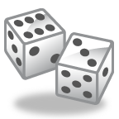**Explanation (15 min.):** Tell the students to return to their seats and get out their Math Journals. Tell the students to write the word cube, pyramid, and cone in their journals. Next to each word, tell the students to draw a picture of what each shape is. Their drawing can be a plain picture, like our shapes, or a picture showing a real life object. Below is an example:

cube or cube

* 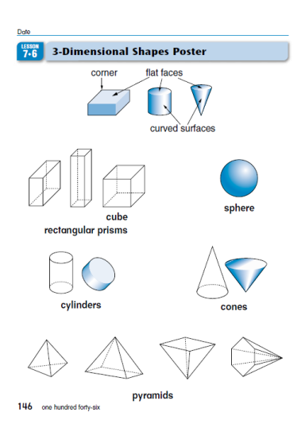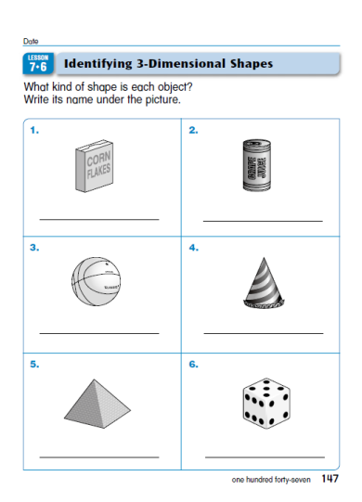**Extension (15 min.):** While at their seats, direct the student’s attention to Math Journal 2 pg. 146. Discuss the shapes poster. Ask questions, such as which shapes come to a point? (cone and pyramid) Which shapes have all flat surfaces? (pyramid, rectangular prism, and cube) Which shape has no flat surfaces? (sphere) Which shapes have both flat and curved surfaces? (cylinder and cone) What do a cone and a pyramid have in common? (they both have a flat face and they both come to a point) How are cones and pyramids different? (a cone has a curved surface and one flat face; a pyramid has several flat faces but no curved surface) The poster is below:

Next, pass out Math Journal 2 pg. 147. The students are to complete it independently, while referencing the Shapes Poster. The journal page is above.

* **Evaluation (5 min):** After the students have completed their work, pass out the “I can…” checklist. Read aloud each question to the students and explain where they should mark their X. The students are familiar with this checklist and will be able to do it properly and honestly. The checklist is below.

|  |  |  |  |
| --- | --- | --- | --- |
| Name _______ | I can do that by myself! | I can do that with a little help. | I need more time to practice! |
| **1.** I can tell you the name of something that is shaped like a cube. |  |  |  |
| **2.** I can tell you the name of something that is shaped like a cone. |  |  |  |
| **3.** I can tell you the name of something that is shaped like a pyramid |  |  |  |

1. **Materials and Resources**
   * Student Math Journals
   * Computer and SMART Board
   * Wooden blocks (sphere, cylinder, rectangular prism, cube, cone, pyramid)
   * Worksheets are listed above

**Lesson 3**

1. **Concept To Be Learned:** Identify Three Dimensional Shapes
2. **Lesson Objective:** I can create new shapes using three dimensional shapes. (application and synthesis)
3. **Procedures:**

**Phases: Description of Activity**

* **Engagement (20 min.):** Call the students to the carpet. Hold up the wooden blocks from previous lessons. Review the names, the number of sides and corners, how many faces each shape has, and the names of shapes in real life (cereal box, party hat, soccer ball, etc.). After a short review, put on “The Number Crew: Geometry” on Discovery United Streaming (15 min.)
* **Exploration (25 min.):** Tell the students that today they will be creating new shapes using three dimensional shapes. Demonstrate to the students (using the wooden blocks, build to create a new shape). Ask the students to return to their seats. Pass out the wooden blocks and tell the students to begin. Encourage them to work at a voice level 1 (whisper voice level) with their tables. Circulate the classroom while the students are working. (Use Checklist listed in Assessment to assess whether or not the student has met the learning target)
* **Explanation (15 min.):** Once the students have built several new shapes, ask them to put the blocks back in the bins and to get out their Math Journals. Write this question on the SMART Board, “What new shapes did you build? How did you build them?” The students are to respond in their journal. Encourage them to use complete sentences. Circulate the room and help those in need. Remind the students that they should be thinking about what they found while they were exploring.
* 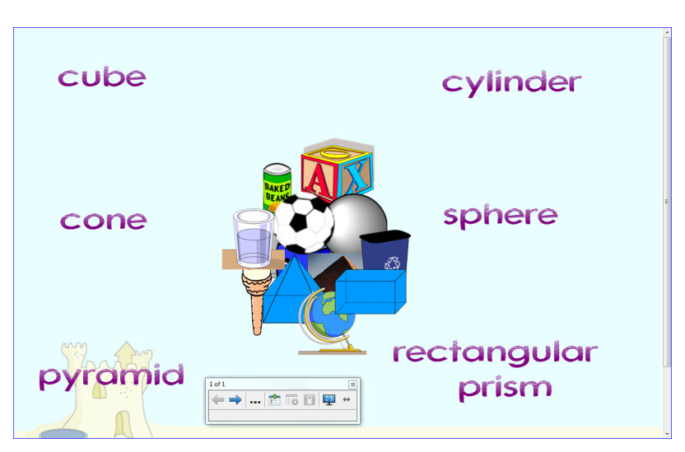**Extension (15 min.):**  Call the students back to the carpet. Explain to them that they are going to look at real life objects on the SMART Board and decide which type of three dimensional shapes that they are. Below is what this would look like:



* **Evaluation (5 -10 min):** After the SMART Board activity, ask the students to return to their seats and get out their Math Journals. Pose this question on the board, “How does Mrs. Stevens know that you can make new shapes using 3D shapes?” The students are to write their answer in their journals. Explain to the students that they are thinking about what they learned today and they are evaluating or telling Mrs. Stevens that they learned today and how.

1. **Materials and Resources**
   * Student Math Journals
   * Computer and SMART Board
   * Wooden blocks (sphere, cylinder, rectangular prism, cube, cone, pyramid)

**Post-Assessment**

The post-assessment for this sub unit is the checklist that was used for the pre-assessment. Each day, the teacher will keep track of whether or not the students have “hit” the learning target. The teacher will use the checklist by observing the students during whole group and small group activities as well as their student work. Below is the checklist that would be used:

|  |  |  |
| --- | --- | --- |
| I can… | Identify 3D shapes. | Compose new shapes using 3D shapes. |
| Kolin |  |  |
| Sophia |  |  |
| Courtney |  |  |
| Abigail |  |  |
| Lucas |  |  |
| Lance |  |  |

This type of checklist was chosen because my school encourages checklists or observations in place of paper and pencil tests for First Graders.

References

Brain Pop Junior: Brain Pop Jr. is a wonderful website that provides short clips to introduce a topic. It also has interactive games and activities for both students and parents (http://www.brainpopjr.com).

Chiarelott, Leigh (2006). *Curriculum in Context.* Thomson Wadsworth.

Discovery United Streaming: United Streaming is a wonderful website that provides short factual clips about topics. (http://my.discoveryeducation.com/).

Donovan, Shawn (2012). Why is Geometry Important? Retrieved June 9, 2012 from <http://www.life123.com/parenting/education/geometry/why-is-geometry-important.shtml>.

Wright Group/McGraw Hill. (2009). EverydayMathematics. New York, NY: Wright Group/McGraw Hill.

Much More Math: Much More Math is a wonderful website that provides facts and information about Mathematics (http://www.muchmoremath.com/geometry.html).