Instructional Design Project

Michelle Ingle
BGSU
June 2012

Rationale
Michelle Ingle

Teachers everywhere have the same problem-TIME. There is never enough time to meet all the needs, to cover all the material, to do all the documentation, to form relationships with the students. Time is an issue in every classroom! The problem that I have seen in my school district over the last couple of years definitely centers around time. Three years ago our district voluntarily became a part of the Ohio Improvement Process (OIP). According to Lloyd, McNulty and Telfer (2009) Ohio’s OIP is a strategy for developing a true statewide system of support that can be used to redefine expectations for how people operate collectively and strategically across all levels of the education system. All teachers in our district are responsible for implementing each step of the OIP plan in their classroom. Our OIP plan involves having students do writing, problem solving, and formative assessments at regular intervals in every subject taught in our district. While most of the staff can see the benefits of having goals that every teacher implements, there is also a great deal of frustration because of all the time that the OIP plan requires. Through this unit, I want to incorporate all the parts of the OIP plan into my reading instruction which will not only save time, but also lead to contextualized teaching. Contextual teaching and learning has powerful, deep roots in progressive education. (Chiarelott, 2006) Implementing a progressive philosophy with a child-centered design increases students’ self-understanding, personalizes and individualizes learning, and provides academic experiences that take students’ needs and interests into account (Ornstein, 2009).
For this unit I used the 5-E Learning Cycle Model for several reasons. First, I wanted a model where the students’ prior knowledge was taken into account. Although this is a sixth grade lesson, some elements of plot have been taught in earlier grades. This type of model allows the students to use whatever prior knowledge they have as they work through these lessons. Secondly, the phases implemented in the 5-E Learning Cycle Model align with the parts of the OIP plan that I am incorporating into these lessons. The Explanation phase was the perfect place to implement writing, formative assessments were used in the Evaluation phase, and problem solving could be implemented throughout the model. Finally, in this model the teacher acts as a facilitator as the students work on their own or in small groups, and this is the style of teaching I want to use most often because it causes the students to become more involved in their education.
Each part of this unit is designed to use contextualized instruction that students can relate to their world. Reading is a skill that is used by all people no matter what their age, occupation, or economic status. The common core standards contain a quote that states texts can provide insight into dilemmas and social realities of the world while also representing the thoughts and actions of human beings. Life therefore shapes literature and literature shapes life. (Ohio Department of Education, 2011) Reading is needed for life! Therefore this unit is designed to teach not only the standards specific to this grade level, but skills that students can apply to their lives both now and in the future.

References
Chiarelott, L. (2006). Curriculum in context. Belmont, CA: Thomson Wadsworth.
Lloyd, J., McNulty, B., & Telfer, D. (2009, May). The ohio improvement process: Flavor of the day or impetus for sustainable improvement?. Retrieved from http://www.taccweb.org/joint2010/103-Ohio-Improvement-Plan-Telfer.pdf
Ohio Department of Education. Center for Curriculum and Assessment, (2002). Academic content standards. Columbus, OH: State Board of Education.
Ornstein, A. C., & Hunkins, F. P. (2009). Curriculum: Foundations, principles, and issues. (5th ed.). Boston, MA: Allyn & Bacon.

Michelle Ingle
Unit Learner Outcomes

Subunit One: Plot
- Students will identify the problem and solution to the problem in the story. (Knowledge)
- Students will describe how a story’s plot unfolds. (Knowledge)
- Students will identify the features of setting and explain their importance in the text. (Knowledge & Comprehension)

- Students will analyze the techniques authors use to describe characters to better understand the text. (Analysis & Comprehension)

- Students will identify the main and minor events of the plot and explain how each event builds on to the next. (Knowledge & Comprehension)

- Students will diagram the rising action, climax and falling action of a story on a graphic organizer. (Analysis)

- Students will use situations focusing on the problems of preadolescents and adolescents to develop new perspectives in their own lives. (Application)

- Students will choose a resolution to the problem in the text before finishing the story and justify why it would be the best solution. (Evaluation)

- Students will summarize the text using important ideas and details. (Synthesis)

Name__________________
Date_________________

Pre assessment

List everything you know about each of these terms that have to do with plot. (Possible answers highlighted)

- setting- where the story takes place. Setting includes time, place and environment.

- main characters-the characters that are most dominate in the story. These characters have the most important parts in the story-the story would not be the same without them.

- rising action-main events in the story that happen before or lead up to the climax.

- falling action-main events in the story that happen after the climax and conclude the story.

- climax-the turning point or the peak of the story. (the big wow event)

- problem-a complication or conflict experienced by a character in the story.

- resolution-the way that the problem in the story is solved.

Day One: Elements of Plot
- Concept Learned - Day one is an introduction to the elements of plot. This will help the students understand each element in depth so that they can apply the information.
- Unit Objectives
Students will identify the features of setting and explain their importance in the text. (Knowledge & Comprehension)
Students will summarize the text using important ideas and details. (Synthesis)

- Procedures
A written pre assessment of the elements of plot should be given a day or two before starting this unit.
Engagement – (15 min) Divide the class into groups of four or five students. Give each group a set of index cards with the elements of plot written on them. (setting, main characters, main and minor events, rising action, falling action, climax, problem, resolution) Using their prior knowledge, students should write on the back of the index card a description of the word or phrase on the front of the card.
Exploration – (15 min) When all groups are finished, bring the class together and adding input from each group, write the main aspects of each element on the board. Students should take notes in their reading notebook by listing each element and its definition or description.
Explanation/Extension – (15 min) Give each student a copy of PLOT ACROSTIC. Each student should write an acrostic poem that summarizes the elements of plot structure. Poems should be finished as homework if not completed in class. (After collecting the poems, display them on the classroom bulletin board so students have a chance to read their classmates’ poems.)
Evaluation – (5 min) As a culmination of today’s lesson, do the snowball activity before switching classes.
Snowball Activity- Ask students to write a number from 1-10 on a piece of scrap paper that they feel shows how much they know about the elements of plot. After each child has written their number, have them crumble the piece of paper in a ball and bring it with them to the front of the room. Have all the students stand in a circle and on the count of three throw their “snowball” into the circle. Ask the students to pick up a snowball (it does not have to be their own), and based on the number that they picked up put themselves in order from 1-10 across the front of the room. Have the students read off the number they have going down the line from the ones to the tens. Not only does this give the teacher an idea of how confidence the students feel about their knowledge in this area, but it also helps the students to see where they fall in the continuum compared to their classmates. This formative assessment would be used to guide the next day’s lesson.
- Materials
Index cards with elements of plot
Student reading notebooks
PLOT ACROSTIC handout (Van Zile, Napoli & Ritholz, 2012)
Paper/pencils

- I Can Statements used for this lesson
I can list the descriptions of the elements of plot.
I can write a poem describing plot.

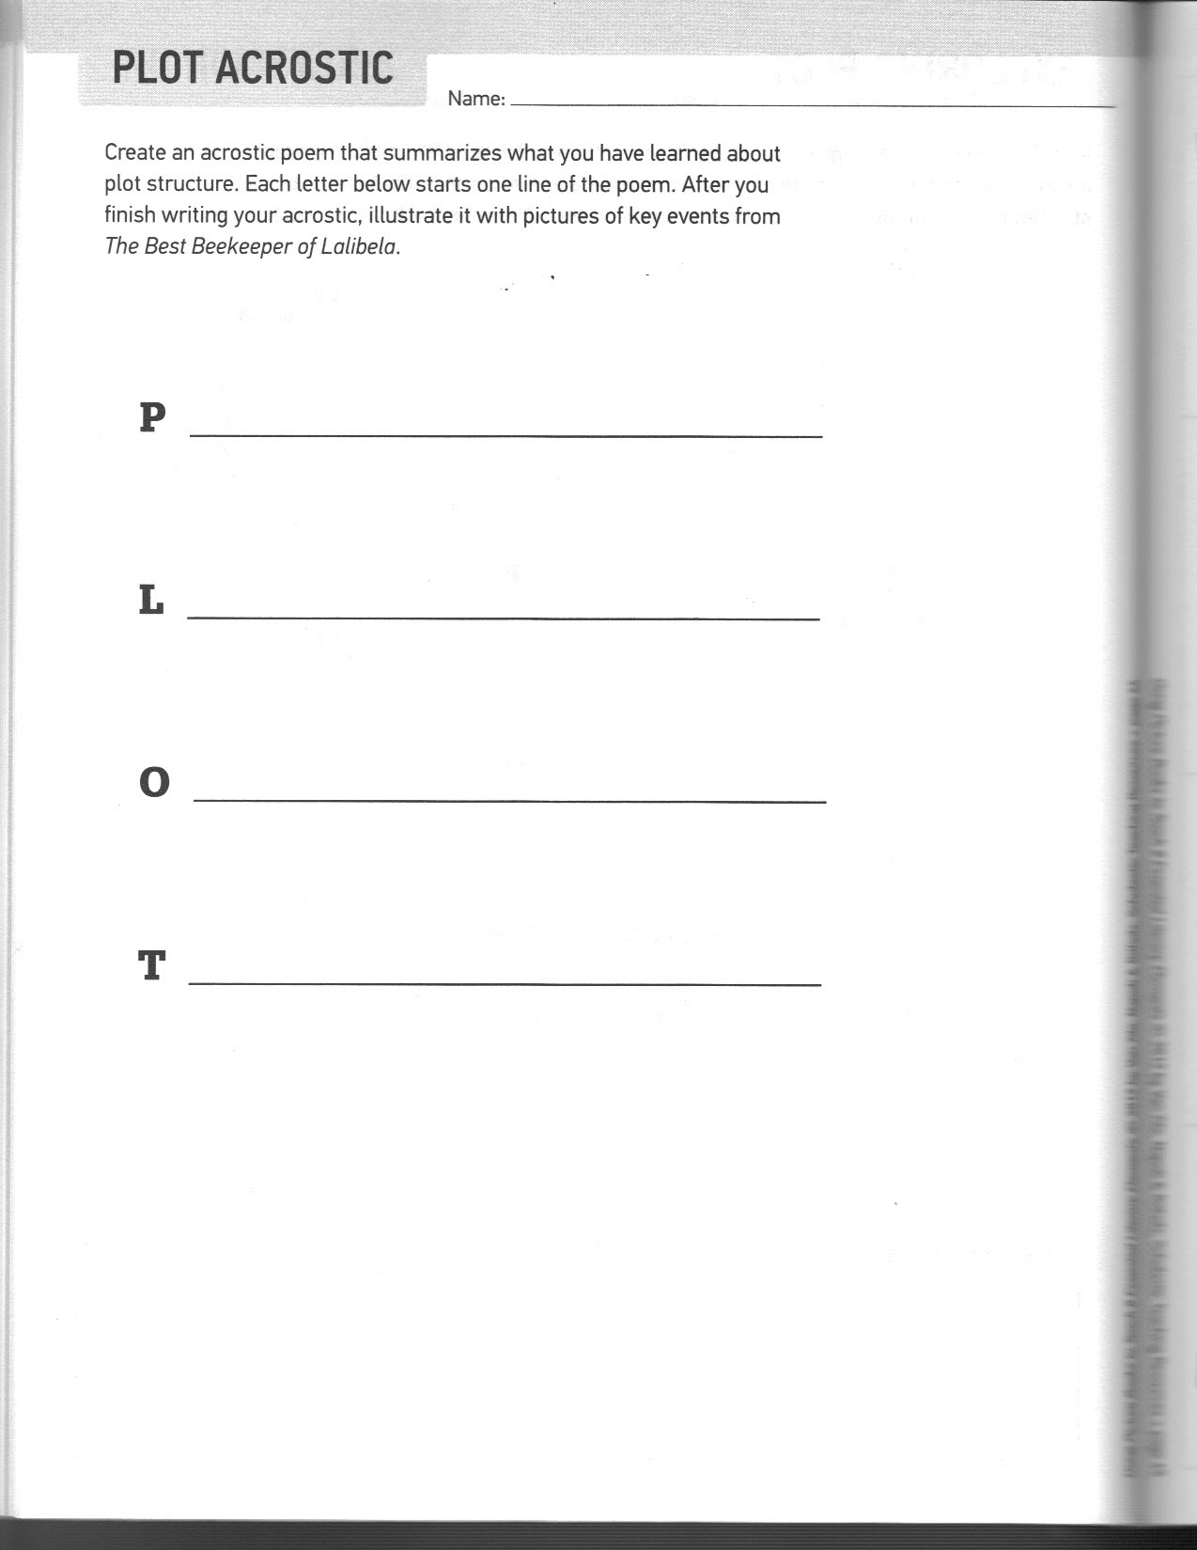
Day Two: Plot Analysis

- Concept Learned – The children will analyze the author’s techniques for developing a story including setting, character traits, main events, and problem and solution.
- Lesson Objectives
Students will identify the problem and solution to the problem in the story. (Knowledge)
Students will describe how a story’s plot unfolds. (Knowledge)
Students will analyze the techniques authors use to describe characters to better understand the text. (Analysis & Comprehension)
Students will identify the main and minor events of the plot and explain how each event builds on to the next. (Knowledge & Comprehension)
Students will summarize the text using important ideas and details. (Synthesis)

- Procedures
Engagement – (5 min) Read The Best Beekeeper of Lalibela- A Tale From Africa to the whole class after showing them on the Promethean board where Lalibela is located and letting them listen to the brief introduction by the author. http://www.cristinakessler.com/Books_8.htm
Exploration – (15 min) As the students listen to the story, have them listen for the problem in the story and how the main character overcomes the obstacles she faces with certain character traits to develop the story. Also, have them list the obstacles in their reading notebook as they are listening.
Explanation – (20 min) After reading the story, distribute the Exploring Plot reproducible. Have the students fill out the graphic organizer identifying the components of the story.
Possible responses include:
Goal: To produce the best honey in Lalibela
Problem: Almaz does not know how to be a beekeeper.
Events That Hinder: The men in the village say beekeeping is men’s work. Almaz cannot climb the trees to reach the hive. Ants turn Almaz’s hive into a mound of mud.
Events That Help: The priest declares that Almaz can be a beekeeper. Almaz discovers a way to make honey. Almaz sees her brother pulling a tomato paste can filled with water.
Resolution: Almaz puts four table legs in tomato paste cans filled with water. The ants drown, the bees thrive, and Almaz makes the best honey in Lalibela.
What Almaz Learns: She learns that it takes great effort to accomplish a goal and that to find solutions to problems you need to look around and observe your surroundings.
Extension- (5 min) For homework, have students make a graphic organizer for Number the Stars (Lowry, 1989) showing the elements of plot for the story. (Number the Stars is a book that all sixth graders read during our interdisciplinary unit on World War II; therefore everyone would be familiar with this story.)
Evaluation –– (5 min) Have the students fill out an exit slip as they leave class. Ask students to write on their exit slip an example of something they have read recently (newspaper article, independent reading book, social studies or science article etc.) that contained a problem and resolution.
- Materials
The Best Beekeeper of Lalibela- A Tale From Africa (Kessler, 2006)
Student reading notebooks
Exploring Plot handout (Van Zile, 2012)
Promethean board
Paper/Pencils
- I Can Statements
I can identify the problem and resolution in a story.
I can find the main and minor events in a story.
I can make a graphic organizer showing the elements of plot for a story.

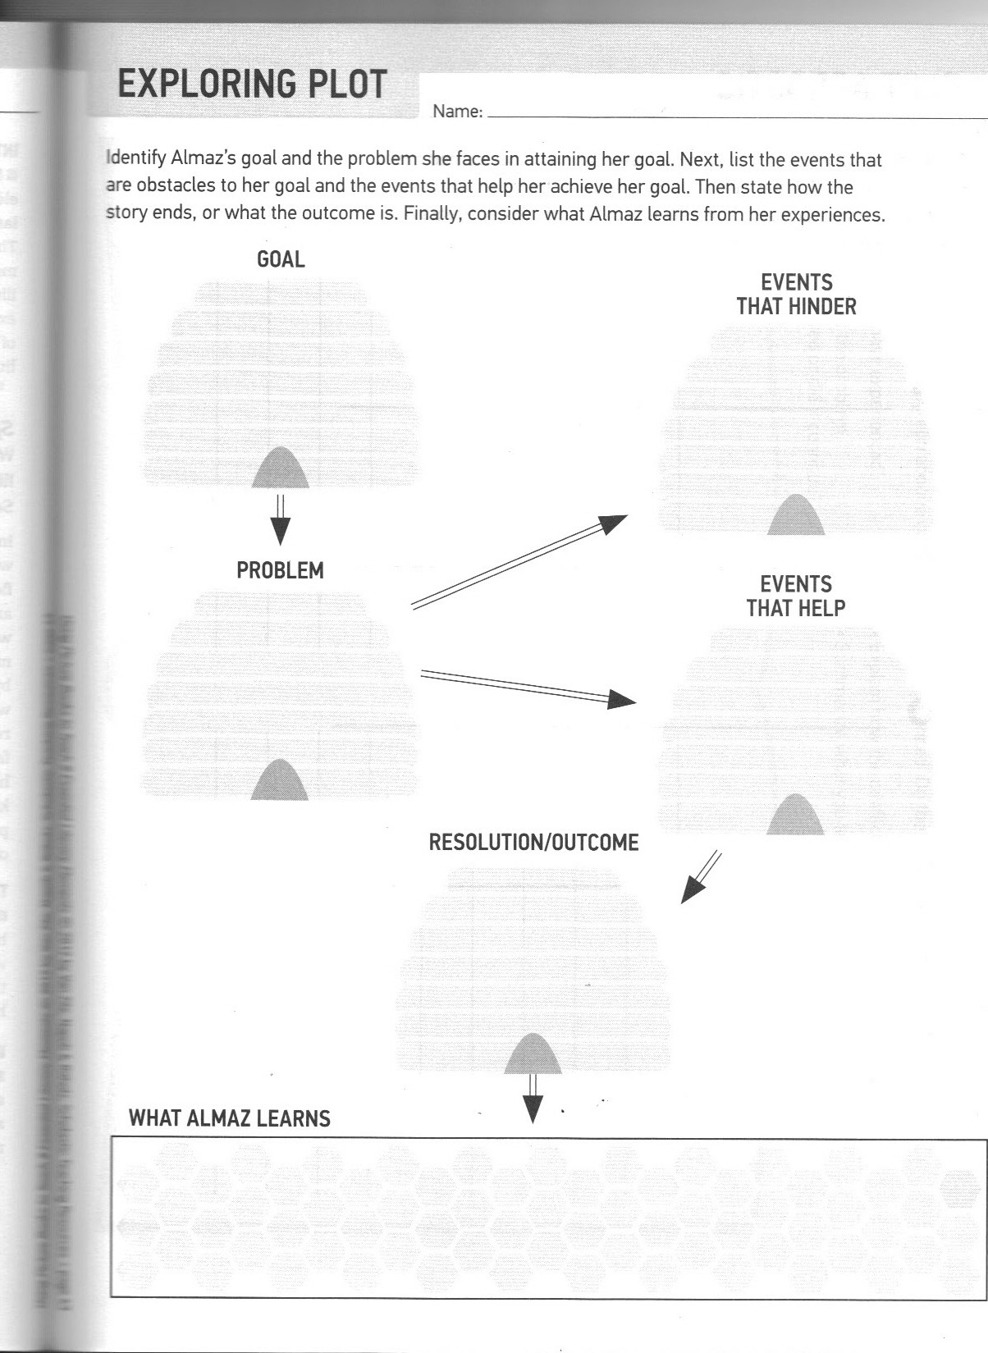
Day Three: Rising & Falling Action
- Concept Learned – Students will learn about rising/falling action and climax.
- Lesson Objectives
Students will identify the main and minor events of the plot and explain how each event builds on to the next. (Knowledge & Comprehension)

Students will diagram the rising action, climax and falling action of a story on a graphic organizer. (Analysis)

- Procedures
Engagement – (15 min) Give the students legos and ask them to build a pyramid type structure. Discuss how the base of the structure is important because it supports all the other pieces and how the structure rises to a peak. Compare this with the rising/falling action in a story and the climax. Explain that the climax is the turning point, the peak, or the big wow event of the story.
Exploration & Explanation – (25 min) Put the students in small groups and ask them to pick a fairy tale that each member of the group is familiar with. Decide the main events of the fairy tale chosen including what events would be the rising action, the climax, and the falling action. Give each group sentence strips and have them write the events of the story on the strips. Finally have each group tape their sentence strips on the board in the shape of a pyramid as they share the events of their story with the class.
Extension – (5 min) For homework, give each student a copy of Danger Canyon. They need to read the story and then draw a diagram that includes the rising action, climax, falling action and resolution in the story.
Evaluation – (5 min) Before switching classes, have students give a thumbs up, thumbs middle, or thumbs down to show how comfortable they were with the material in today’s lesson and with the homework. Answer any questions that remain before students are dismissed.

- Materials
Legos
Sentence strips
Tape
Danger Canyon story (Sorenson, 1995)
Paper/pencil

- I Can Statements
I can diagram the rising action, falling action and climax of a story.

from Danger Canyon
By Margo Sorenson
Calvin stopped chewing. “What was that?” he asked, his mouth full. “That noise. Did you just open a bag or something?”
Rob set his soda down. He looked puzzled. “No, why?” he asked.
“ It sounded like a bag of chips opening or something,” Calvin said. “You sure?” he asked again. His heart began to pump.
“I don’t even have any chips,” Rob said slowly.
“Then what made that crackling sound?” Calvin whispered. Did he dare look over the side of the boulder?
Crackle! There it was again. Something was down there…
Calvin’s heart raced. What was down there? He looked at Rob. Rob’s face was white. His eyes were wide with fright. What should they do?
Calvin lay down on his stomach. He inched his way across the boulder. He tried to keep his belt buckle from scraping on the granite. He held his breath. He was almost to the edge. He waited and listened. Nothing. All he heard were the pines.
Calvin took a deep breath. All right, he told himself. This is it. He eased his head slowly over the edge of the huge boulder.
Suddenly, a streak of yellow flashed below. It raced back into the forest.
“Holy cow!” Calvin yelled. He sat up. “It was a mountain lion! I saw it!”
Rob scrambled over. He looked in the direction Calvin was looking.
“Are you sure?” Rob asked. “I don’t see anything.” He peered into the forest.
Calvin strained his eyes. It was hard to tell what was a shadow of a tree and what might be something else. “I know it!” he cried. “It was yellow! And could it move! It was fast!”
Rob looked doubtful. “Are you sure it wasn’t a big chipmunk?” he asked. “A squirrel? A deer? Or maybe someone’s dog? Mountain lions don’t like to get close to people, do they?”
“I swear it looked like one,” Calvin said. But then he stopped. He hadn’t actually gotten a good look at it. All he had seen was a yellow flash. “Maybe you’re right,” Calvin admitted. “I am kind of jumpy today.”

Day 4, 5, & 6: Apply What You’ve Learned About Plot
- Concept Learned – In the final two days of this unit, the students will be taking what they have learned about the elements of plot and applying it by creating their own story.
- Objectives
Students will use situations focusing on the problems of preadolescents and adolescents to develop new perspectives in their own lives. (Application)

Students will choose a resolution to a problem in the text and justify why it would be the best solution. (Evaluation)

- Procedures
Engagement – (10 min.-day 4) Discuss the problems that guided the story in the last several books the class has read. For example, in Number the Stars Annemarie has to be brave and perform courageous acts in order to save her Jewish friend Ellen. Let students share other problems we have read about. Introduce to the students that they will be choosing a problem experienced by a typical sixth grader today for this next assignment. (Ex. bullying, peer pressure, relationship conflicts, smoking, grades)
Exploration – (15 min.-day 4) Divide the class into groups of four and explain that each group will be developing a story that they will share with the class in whatever way they choose. They might write their story as a picture book, make a power point, create a poster, record an audio book, or make a movie trailer. Have each group begin brainstorming about a problem they would like to base the plot of their story on.
Explanation – (25 min.-day 4) After the groups have determined the problem that they want to base their story on, they will go to the ReadWriteThink website http://www.readwritethink.org/files/resources/interactives/storymap/ which allows them to outline the plot of the story. (ReadWriteThink, 2012) Each member will fill out one section of the story map and print their ideas. (Sections include setting map, character map, conflict map and resolution map) The group will then come back together to discuss the ideas and to figure how they want to design their project.
Extension – (50 min.-day 5) Each group will create a story that represents the life of a typical sixth grader and design it in a way that they can present to the class. The presentation will need to include each of the elements in plot. (Ex. As the group is sharing their story, it needs to include main characters, setting, rising/falling action etc.)
Evaluation – (Day 6 & 7?) Each group will present their story to the class, and this project will be used to evaluate the students’ understanding of the elements of plot. A post assessment will also be given to determine how well each student learned the concepts taught.
- Materials
Computers
Paper/pencil
Poster board
Colored pencils, markers, crayons
- I Can Statements
I can write a story about a problem that relates to my life using the elements of plot.

Name_______________________________
Date________________________________

Post Assessment for Plot

Write the definition for each element of plot.
- setting-

- main characters-

- rising action-

- falling action-

- climax-

- problem-

- resolution-

See Pre assessment for answers.
References
Kessler, C. (2006). The best beekeeper of Lalibela-a tale from Africa. New York, NY: Holiday House.
Kessler, C. (2010). The best beekeeper of lalibela. Retrieved from http://www.cristinakessler.com/Books_8.htm
Lowry, L. (1989). Number the stars. New York, NY: Bantam Doubleday Dell Books.
Ohio Department of Education. (n.d.). Plot connections. Retrieved from http://dnet01.ode.state.oh.us/IMS.ItemDetails/LessonDetail.aspx?id=0907f84c80531094

ReadWriteThink. (2012). Student interactive story map. Retrieved from http://www.readwritethink.org/files/resources/interactives/storymap/
Sorenson, M. (1995). Danger canyon. Logan, IA: Perfection Learning Corporation.
Van Zile, S., Napoli, M., & Ritholz, E. (2012). Using picture books to teach 8 essential literary elements. New York, NY: Scholastic Inc.

