Tigris and Euphrates (Mesopotamia) River Civilization

Sarah Taylor, Nicole Mell, and Lisa Dunham
Grade: 6
Strand: History
Topic: Early Civilizations -The eight features of civilizations include cities, well-organized central governments, complex religions, job specialization, social classes, arts and architecture, public works and writing. Early peoples developed unique civilizations. Several civilizations established empires with legacies influencing later peoples.
Content Statement: (#2) Early civilizations (India, Egypt, China and Mesopotamia) with unique governments, economic systems, social structures, religions, technologies and agricultural practices and products flourished as a result of favorable geographic characteristics. The cultural practices and products of these early civilizations can be used to help understand the Eastern Hemisphere today.
Additional Related Geography Content for Grade 6:
Strand: Geography
Topic: Places and Regions- A place is a location having distinctive characteristics, which give it meaning and character and distinguish it from other locations. A region is an area with one or more common characteristics, which give it a measure of homogeneity and make it different from surrounding areas. Regions and places are human constructs.
Content Statement: (#5) Regions can be determined, classified and compared using various criteria (e.g., landform, climate, population, cultural, economic).
Strand: Geography
Topic: Human Systems
Human systems represent the settlement and structures created by people on Earth’s surface. The growth, distribution and movements of people are driving forces behind human and physical events. Geographers study patterns in cultures and the changes that result from human processes, migrations and the diffusion of new cultural traits.
Content Statement(s):
(#6) Variations among physical environments within the Eastern Hemisphere influence human activities. Human activities also alter the physical environment.
(#7) Political, environmental, social and economic factors cause people, products and ideas to move from place to place in the Eastern Hemisphere in the past and today.
Tigris and Euphrates (Mesopotamia) River Civilization Introduction/Description:
Mesopotamia is a term from Greek historians meaning “the land between the rivers.” Mesopotamia, the land between the Tigris and Euphrates Rivers, was settled between 6000 and 4000 B.C. by early farming communities. The silt deposited from the nearby rivers made Mesopotamia a true Fertile Crescent. Grains like barley became an important staple in Mesopotamian culture, used for food and used for trading and economic purposes. Religion was also an important part of Mesopotamian culture. Hundreds of gods and goddesses were worshipped, each one representing an important part of the world, including Anu, father of the gods. Ziggurats and other temples were built to house important prayer and government documents and to provide a place to worship the gods. Mesopotamia is also credited with numerous technology developments. The Sumerians created the earliest form of writing and provided a method for record-keeping in Mesopotamia. One of the most famous pieces of literature from Mesopotamia is the Epic of Gilgamesh, a work originally recited aloud but recorded when writing was developed. Mesopotamia is credited with inventing the seeder plow, wheel, irrigation and sanitation techniques, the concept of zero, glass, the Pythagorean Theorem (though they did not call it that), and architectural concepts like the arch, column, and dome. Mesopotamia was a place of rich culture and invention (The Oriental Institute, 2012).
Please reference the artifacts below to continue building your understanding of the Mesopotamian civilization. Beside each artifact, a geography theme or topic from the history content statement has been provided in parentheses to show how each artifact could be used to teach a specific theme or topic.
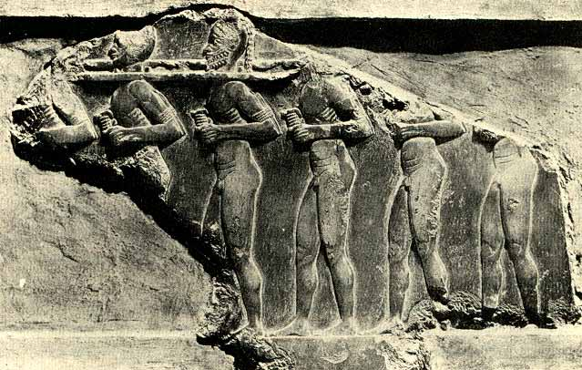
Artifact: Shackles (Social Structure)
In Mesopotamia, slavery was an acceptable practice. In the Mesopotamian social structure, slaves were at the bottom of the hierarchy. Slaves worked for the upper classes, the king, the priests, and the wealthy. They did not receive wages nor did they have any rights. However, they were offered a small shelter to live in while working. In contrast, the normal people of Mesopotamia had their own rights, and they had jobs where they got paid. The shackles symbolize the acceptance of slavery in Mesopotamia. In the classroom, students could analyze the social ladder of the people in ancient Mesopotamia. Students could split into groups and perform skits that show the differences between the three main social groups. After all the skits are performed, the teacher can lead a class discussion that highlights the main differences between the different social groups. Students could also hold a debate about whether slavery was appropriate or inappropriate to have in ancient Mesopotamia. Finally, students could compare the social structure in Mesopotamia to other early river civilizations.

Artifact: Fish (Economic System and/or Human/Environment Interaction)

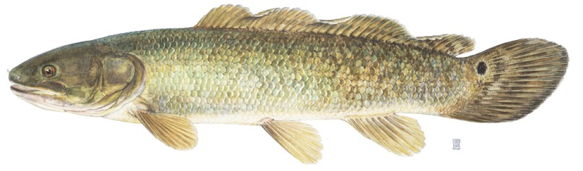
Fish were plentiful in the Tigris and Euphrates rivers and in the man-made canals of Mesopotamia. Fish and other aquatic animals were the main source of meat available in ancient Mesopotamia. Fish was used for both food and fertilizer for crops. Because the food supply in Mesopotamia was quite rich, this early civilization thrived. Ancient Mesopotamians often traded fish for other goods and services in their primitive bartering economic system. In the classroom, students could engage in an experiential activity to learn more about Mesopotamia’s early economic system. Students could be provided with a certain good or service, such as milk from a cow, a certain amount of fish or barley, or the ability to weave baskets or make bread. Students would be given a list of items that they need and they would have to barter with other students to obtain the materials needed. Students would have to agree to provide a service or trade some goods to other students in order to get what they want. After the activity is completed, students could discuss the positive and negative aspects of this economic system. They could describe the challenges they encountered and brainstorm other ways to obtain the items that they needed in this type of economic system.
Artifact: Vegetables (Economic System, Human/Environment Interaction, and/or
Agricultural Product)

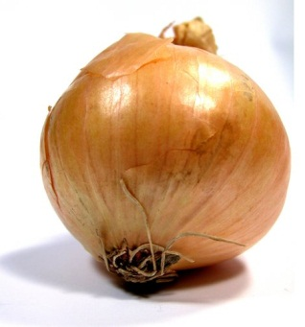

In order to care for crops and herds of animals, people needed to live in one place. By
5800 BC, people were living in the southern plains of the Tigris and Euphrates rivers. The land in this area was very fertile, but there was not enough rainfall to grow crops. The people of early Mesopotamia developed successful irrigation systems. Ditches laced the fields near the rivers, making a maze of artificial waterways that allowed the growth of crops, including cucumbers, onions, apples, dates, and spices. In addition, the economy of ancient Mesopotamia was based around a trade and bartering system. Once irrigation systems allowed crops to be grown quickly, the people of Mesopotamia could use these products to trade within their own civilization and with other civilizations in need of vegetables and other foods. In the classroom, students could grow some vegetables that were commonplace in ancient Mesopotamia. Students could discuss the possible challenges faced in an agriculture-based economy where there was unpredictable weather, such as frequent floods or lack of rainfall. Students could be presented with a scenario that involves the destruction of crops and they would have to create a backup plan that would prevent the starvation of ancient Mesopotamians.
Artifact: Seeder plow (Agricultural Practice)

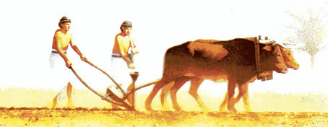
The seeder plow was invented by the Mesopotamians and is considered a major technological achievement. This invention allowed people to seed and plow their fields at the same time. Seed was dropped down the middle funnel into the furrow that the plow created. The ancient Mesopotamians believed the god Enlil created the seeder plow and that the image of the plow could be seen in the stars. In the classroom, students can create their own models of the seeder plow and analyze how it contributed to better agricultural practices in Mesopotamia. If an actual example of a seeder plow can be found, students can try to use it and discuss the advantages and disadvantages of the technology.
Artifact: Map (Favorable Geographic Characteristics, Location, and/or Movement)

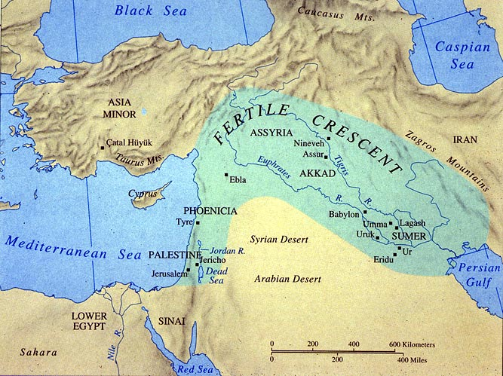
Ancient Mesopotamia is located inside the geographic region referred to as “The Fertile Crescent.” Ancient Mesopotamia was located in a part of “The Fertile Crescent” in what is now southern Iraq. The word Mesopotamia actually means “the land between the rivers.” The two rivers are the Tigris and Euphrates Rivers. Early settlers wandered into this area and found that the natural vegetation and wildlife kept the people well fed. The rivers provided drinking water. These early people settled in and began to farm the land. In the classroom, students could compare the climate and geography of ancient Mesopotamia with that of their own community or with other early river civilizations. Students could identify the positive and negative aspects of the geography of Mesopotamia. Students could write about how the location and place of early Mesopotamia allowed this civilization to thrive.
Artifact: Wheel (Technology)

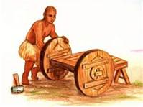

The wheel was believed to have been created by the Sumerians around 3500 B.C.E. In its earliest stages, the wheel was simply utilized as a roller that was placed underneath heavy objects to more easily move them and then evolved into wheels and axles. This invention revolutionized the ancient people’s way of life as they were able to travel much easier and began to create chariots. Students could understand the impact of inventions on a culture through brainstorming a problem they have in their own lives and attempting to create an invention for a solution to their problem. Students could work through all the necessary scientific steps by first identifying a problem, brainstorming solutions, and then the creation process of their invention. Another option could be for students to create a list either individually, in pairs, or in small groups of different items they are familiar with that utilize the wheel. Students could then create a master list and complete a journal entry reflecting on how our world would be different without this invention and why it is still very important today.
Artifact: Cuneiform on a clay tablet with stylus (Technology)

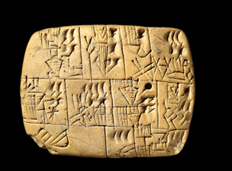
The people of ancient Mesopotamia are also recognized for developing the earliest form of writing. Writing was done on clay tablets using a stylus made from materials such as wood or reeds that grew by the rivers. Pictograms were initially used and as the needs for writing changed, the script began to change to cuneiform, a text composed of wedge-shaped symbols. With their written language, the Sumerians were able to keep very detailed, accurate records. Cuneiform also allowed for the people of Mesopotamia to begin creating literary texts such as the Epic of Gilgamesh. Students could become familiar with the ancient text through being provided a copy of the cuneiform alphabet and having students create their own written messages, records, or texts. To truly give students an authentic experience, students could be provided clay materials and a “stylus” that they would use to transcribe their cuneiform. Each student could write a short message to another student using the cuneiform script and then have their classmate read their text. If utilized in the math classroom, students could attempt simple math computations using cuneiform and the Babylonian base 60 number system. An extension of this activity could also include having students create their own written language and scripting a message that their friend must then transcribe.
Artifact: Irrigation system (Human/Environment Interaction)

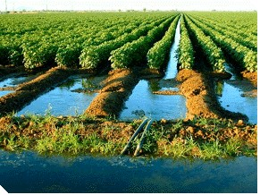
Due to the low rainfall and spring flooding of the Tigris and Euphrates Rivers, farmers had difficulty growing crops. To remedy this, an irrigation system was created using canals to carry water from the river to their fields and dams to help hold back floodwaters. Reservoirs were also utilized during times of drought to get water to crops through the ditches in the fields. This irrigation system was important to ancient Mesopotamia because it allowed for permanent settlements in this area. In order for students to understand the human/environment interaction taking place because of this irrigation system, students can identify why it was important for the civilization to adapt to their environment and the positive and negative effects of the irrigation system. Students can also compare the Mesopotamian irrigation system with irrigation systems we have today and the positive and negative consequences associated with our modern irrigation systems.
Artifact: Barley (Economic System and/or Agricultural Product)

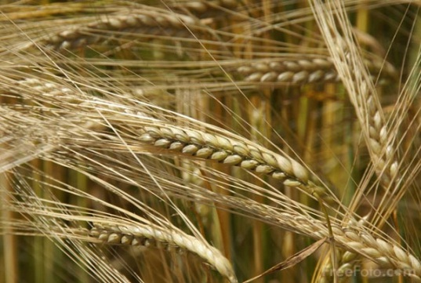
Barley was not only a major crop produced in Mesopotamia but was also an early form of currency. Along with wheat, barley was considered a staple food in the early civilization and was also used to make beer. In regards to currency, ancient Mesopotamians had a standardized system based on weights rather than money. The smallest unit of weight was one grain of barley, which they referred to as a barleycorn. Silver eventually replaced barley as a form of currency but the crop still remained very important to the Mesopotamians. An activity pertaining to this artifact could involve students creating their own items to sell related to Mesopotamia, such as clay pottery, crops, etc. and then have students barter and sell items using the ancient Mesopotamian form of currency. This would allow for students to not only familiarize themselves with products created and produced in ancient Mesopotamia but would also give students an idea of how different the Mesopotamian form of currency is from our own. Students could then write a simulated journal entry as a citizen of ancient Mesopotamia detailing one account of how they used barley in their everyday life.
Artifact: Hammurabi’s Code (Government)

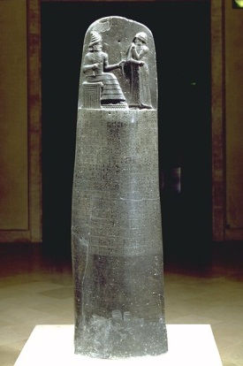
Hammurabi’s Code is the first known set of written laws, created by King Hammurabi who ruled from 1792-1750 B.C.E. The rules were discovered on a stone stela that stands almost 7 ½ feet high and contains about 282 written laws. The laws are centered around the “eye for an eye” theme and applied to and protected all citizens, including women and slaves. An illustration is engraved in the stone above the laws depicting Hammurabi receiving the rod and ring from the Sun God, reinforcing the idea that laws came from the Mesopotamian gods. An activity that could make these laws relevant to students could involve having students first brainstorm a list of rules (about 10) that they would enforce if they were the King/Queen of a new civilization. Students could then write a brief rationale for their reasoning behind choosing their specified rules and why they think they are the most important. Students could then come together as a class and share their rules along with their rationales. An extension of this activity could involve giving students a list of some of Hammurabi’s laws. After students have had a chance to read some of the rules, the teacher could read to students several situations that arose during Hammurabi’s rule and have students hypothesize as to how they believe Hammurabi dealt with the situation. After students have had a chance to share their hypotheses, the teacher can then explain to students how King Hammurabi dealt with each specific situation.

Artifact: Ziggurat (Government and/or Religion)

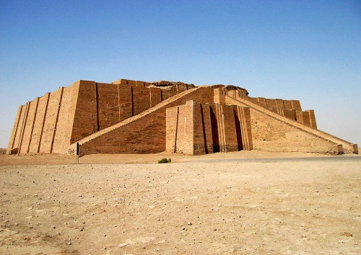

The ziggurat pictured is the ziggurat at Ur, one of the most famous ziggurats of Mesopotamia. By 2000 B.C., ziggurats were common structures in Mesopotamian cities. These structures were constructed from bricks, bitumen, and reeds and typically consisted of four to seven layers. The height of a ziggurat was important because it could protect the building from floods. Also, Mesopotamians believed that gods lived in the nearby mountains. By building the ziggurats to a tall height, the Mesopotamians believed they were making connections to the gods or perhaps building a “stairway to heaven.” One of the most famous ziggurats is at Ur, and like many other ziggurats, this structure was built on top of pre-existing temples that became too small or too old. Cuneiform tablets were used to record stories of people and kings and these were often stored in temples, like ziggurats, or in palaces. Temples were used for religious activities, such as worshiping or providing offering tables for the gods and goddesses said to live within the temples. Priests and priestesses often served individual gods and goddesses. Ziggurats were used as places for gods to live (especially the patron god of the city individual ziggurats were located in) rather than places for the average citizen to enter and worship. In ancient Mesopotamia, kings derived their power from the gods and thus laws were said to come from the gods. Students could be divided into groups, and each group could be given a different example of writing (translated into English) that might have been found within a temple, including prayers and laws. The class could then jigsaw and share their understanding of each piece of writing. The teacher could conduct a whole class discussion, and students could create a master list of common themes found in the writing. Students could connect each of these themes to other knowledge they have gained about Mesopotamia.
Artifact: Cylinder Seal and Clay (Technology)

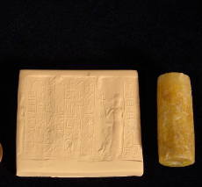
Though many cylinder seals have been found from ancient Mesopotamia, this particular one demonstrates inscription and a person holding a bird. As far back as 3500 B.C., the first writings of the Sumerians appeared. This group has been determined to have developed the earliest form of writing. Cuneiform provided a method for record-keeping and “copy books” were even created to teach future scribes. In addition to writing with a stylus on wet clay, the Sumerians also developed the use of the cylinder seal. The cylinder seal provided a way of printing multiple copies of the same writing or pictures. The writing and/or pictures were carved onto the cylinder seal, typically made of materials like quartz or greenstone. Some seals were used to mark a person’s property while others were used to record prayers. In the classroom, each student could create a cylinder seal by using fast-drying clay, rolling the clay into a cylindrical shape, and creating art engravings on the cylinder. Each student could create a personalized engraving that represents Mesopotamia or one of its artifacts in some way. Once the cylinders have dried, they could be shared among different groups, and students would roll the cylinders across wet clay to see the art that was engraved on the cylinder seals. Since students traded cylinders, they could discuss and write about the importance of each symbol or artifact engraved on the cylinders. The art created could also be displayed in the classroom.
Artifact: Silt (Favorable Geographic Characteristics and/or Place)

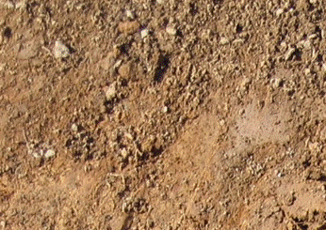
The land where Mesopotamia once was is today made up of extensive desert. However, when Mesopotamia was first settled, the land was very fertile because of the Tigris and Euphrates rivers and their tributaries. Each time the rivers flooded, silt was deposited, making the land very suitable for growing plants since there was sufficient rain as well in some areas (and later irrigation was also developed and used by the Mesopotamians). This land has become known as the Fertile Crescent. This rich land provided a way to grow more crops and raise more cattle, and population growth was encouraged because of the availability of food. The rich land is because of silt, which is created through the erosion of rock. In rivers, it is often created through rocks and water rushing against each other forcing rock particles to emerge, otherwise known as silt. Silt is very fertile growing ground because its make-up provides for air circulation and it holds water efficiently. For students to understand why this artifact was so important for the development of Mesopotamia, students could try growing plants in different kinds of soil, including silt, sand, and clay. Students could use this experiment to analyze first-hand the benefits of using silt and why it encouraged an entire civilization to emerge in Mesopotamia. This could also provide an opportunity for students to demonstrate the seeder plow models created in association with that artifact. Students could keep a log about each plant’s progress and explain why silt helped the Mesopotamian civilization grow.
Artifact: Goddess of Vegetation (Religion)

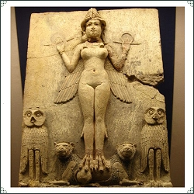
Mesopotamian people all worshipped the major gods, like Anu (father of the gods and god of the sky) and Utu (the sun god and lord of truth and justice). Hundreds of gods were worshipped overall though, and each city and each person had a patron god or goddess. When an individual person worshipped a personal god, this god was seen as someone who would interact with the other gods or goddesses on the worshipper’s behalf. Many Mesopotamian artifacts are focused on gods and goddesses, showing the importance of religion in ancient Mesopotamia. Carved human figures from stone were often created, carved in constant prayer, and placed in temples so that even if one was working at home or in the fields, his or her figure could still be in prayer. One particular cylinder seal, the one represented by this artifact, the goddess of vegetation, shows the sun god interacting with the goddess of vegetation. This seal shows the importance of the sun in helping crops grow and thus sustain life for people in Mesopotamia. The goddess of vegetation holds a flowering branch and is decorated with grain growing on her robe. Each student could choose a god or goddess worshipped in Mesopotamia and find out what made that chosen god or goddess important. The teacher could provide information about the goddess of vegetation as an example. Students will create an artifact to represent their chosen god or goddess along with a museum card explaining what they have learned. Students will tour these museum displays in the classroom to learn more about religion in Mesopotamia.
Artifact: Cattle (Region)

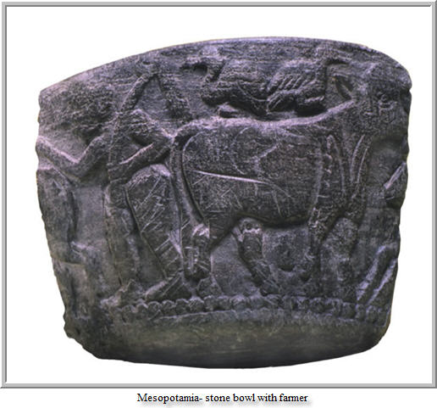
Artwork of cows and other cattle depict the importance of cattle in Mesopotamia. The Tigris and Euphrates Rivers formed a plain between them, the Mesopotamian delta.This area contained swamps, marshes, lakes, foothills, and steppe lands. The rich soil in this region, as well as the use of irrigation and some rainfall, provided the availability of plants for people and cattle to eat. Cattle, including cows, sheep, pigs, and goats, were an essential part of Mesopotamian economy. These animals provided such goods as meat, dairy products, leather, wool, hair, and sometimes a means of sacrifice. Mesopotamians were known for their metalwork, woolen textiles, and pottery. As in the artwork mentioned previously, pottery often depicted daily life, like taking care of cattle, and woolen textiles were made possible from wool and hair taken from cattle. Wool was also traded to other people in exchange for goods not easily obtained in Mesopotamia, like copper, tin, and timber. To understand cattle and their importance to this region, students in the classroom could be divided into different civilizations, each specializing in certain goods. For students representing the Mesopotamian civilization, they would need to trade wool and other items to obtain the goods their civilization needs. Trades could also be made within civilization to show how each animal or item was used within the civilization for survival and growth. Students could use a record-keeping system similar to those used by the Mesopotamians to keep track of trades (making a connection to cuneiform and tablets made from clay). Afterwards, students could meet within their groups and discuss trading and why it would have been important for this civilization.
Resources:
Ancient Mesopotamia for Kids. (2012). Retrieved from
http://mesopotamia.mrdonn.org/index.html.
Farndon, J. & Steele, P. (2007). DK Eyewitness books: Mesopotamia. New York, NY: DK
Publishing.
Nardo, D. (2001). Empires of Mesopotamia. San Diego: Lucent Books.
National Geographic. (2012). Silt. Education beta. Retrieved from
http://education.nationalgeographic.com/education/encyclopedia/silt/?ar_a=1&ar_r=3
Nemet-Nejat, K. R. (1998). Daily life in ancient Mesopotamia. Westport, CT: Greenwood Press.
The British Museum. (2012). Ziggurats. Ancient civilizations: Mesopotamia. Retrieved from
http://www.mesopotamia.co.uk/staff/resources/background/bg22/home.html
The Oriental Institute. (2012.) Life in Mesopotamia. Retrieved from
http://mesopotamia.lib.uchicago.edu/mesopotamialife/index.php.
The River Valley Civilization Guide. (2010). Tigris-Euphrates Civilization. Retrieved from
http://www.rivervalleycivilizations.com/tigris-euphrates.php

