Indus Valley River Civilization Artifact Box
By Catherine Bowman and Erica Jacobs
Grade Level: 6
Strand: History
Topic: Early Civilization- The eight features of civilizations include cities, well-organized governments, complex religions, job specialization, social classes, arts and architecture, public works and writing. Early peoples developed unique civilizations. Several civilizations established empires with legacies influencing later peoples.
Content Statement (2): Early civilizations (India, Egypt, China, Mesopotamia) with unique governments, economic systems, social structures, religions, technologies and agricultural practices and products flourished as a result of favorable geographic characteristics. The cultural practices and products of these early civilizations can be used to help understand the Eastern Hemisphere today.

Background:
The Indus Valley Civilization dates back to between 4,500 and 5,000 years ago. From about 2,600 B.C.E to 1,700 B.C.E, many settlements were built on the banks of the Indus River and its surrounding areas. These settlements are estimated to have covered almost 1.25 million kilometers of the region. Today, that region would include part of Afghanistan, Pakistan and northwestern India. The first cities discovered by archaeologists are known as Harappa and Mohenjo-daro. These cities were once the great urban centers for the Indus Valley Civilization. Many of the Indus cities were well organized with planned streets and drainage systems. The homes were built from brick and stone and included wells and water storage systems that were the most sophisticated in the ancient world.
The Indus people domesticated animals and harvested crops, such as sesame, cotton, peas, barley, and wheat. Also, city workers crafted pots, beads, jewelry, and cotton cloth. An extensive part of the Indus Valley culture was trading these crops and goods. Farmers and workers brought their food or materials to the city and took away finished goods to other cities, such as Mesopotamia. On these trading journeys, traders traveled by wooden carts pulled by bullocks and flat-bottom boats on the river. Instead of using money to trade, they weighed and exchanged goods on balance scales using stone cubes, as weights. The weights were made from cubes of flinty rock called grey chert. Additionally, traders used seals as labels to show who owned a good, such as a sack of grain.
A writing system developed by the people of the Indus Valley is said to have been used for several hundred years. However, specialists have not been able to decipher the script. To learn more about the daily lives of this ancient civilization, archaeologists turned to studying the structures that remain and the artifacts uncovered. Since there is no evidence such as tomb paintings or written records to decipher, using what has been uncovered is the only way to learn about this civilization and the way they lived.
Listed below you will find artifacts that represent the Indus Valley River Civilization.

Artifact: Indus Valley Map
Location: The Indus River Valley Civilization is along the southwestern part of the Indus River and stretches across present day India, Pakistan, Bangladesh, Napal, Sri Lanka, and Bhutan. The Indus River Valley’s borders consisted of the Himalaya Mountains and the Arabian Sea. The largest city was Mohenjo-daro, in present day Pakistan, and Harappa. There were also other settlements stretched all along the river.
Teaching Idea: Using a map, students will be able to determine which present-day countries inhabit the same area where the Indus Valley civilization was located. Additionally, students will be able to research the differences between present-day Pakistan and the Indus Valley Civilization.

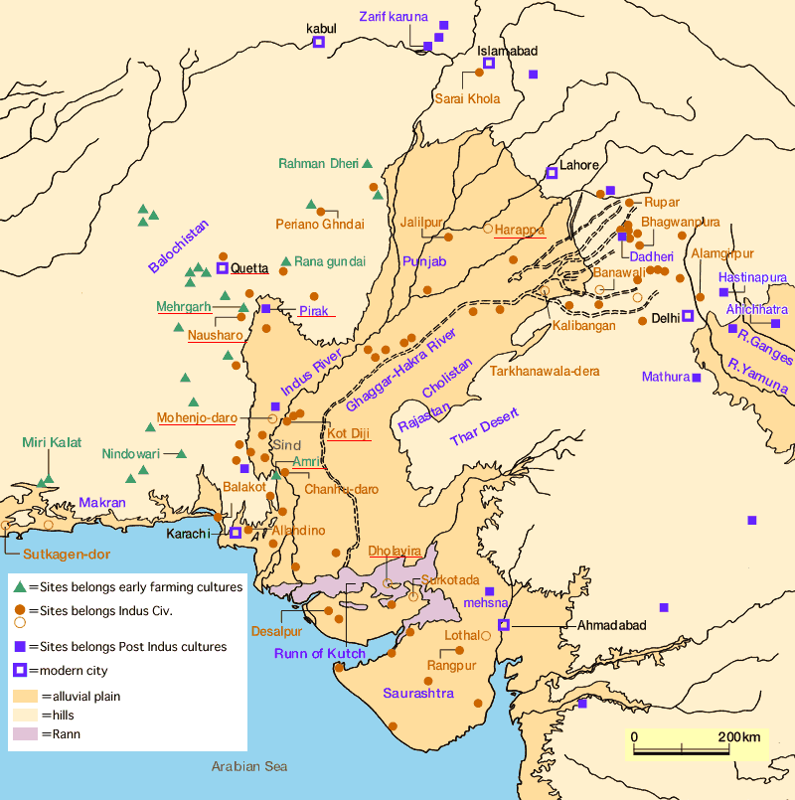

Artifact: The Citadel in Mohenjo-daro
Religion/Government: In the center of Mohenjo-daro there was a Citadel, which served as a palace and a temple. The Citadel stood at least forty feet high and contained a huge water supply, known as the Great Bath. This bath was often used for priests and rulers to bathe in for religious ceremonies. In addition, there is speculation that the Citadel was used as defense and perhaps where the priests and rulers lived. It is also suggested that because there were many large buildings built on the Citadel mound, important administrative activities may have been held there along with public gatherings.
Teaching Idea: A fun activity for students will be to design their interpretation of the Mohenjo-daro Citadel. After researching the Citadel, they will learn it had tall walls for defense, contained the Great Bath, and had a possible granary. Just like the artifact I designed, they will design their own.

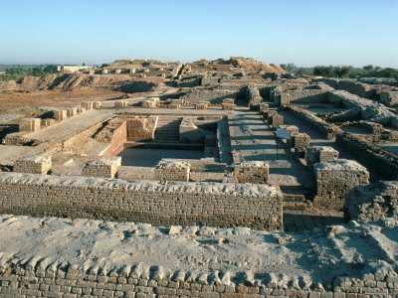

Artifact: Seals
Economic System/Movement/Cultural Contributions: Over many years a few thousand seals have been discovered in Indus Valley cities, showing hundreds of pictographs. This is too few in number for the language to have been ideographic (only symbols and no sound) and too many for the language to have been phonetic (connection between symbols and sounds). Most seals are small, square or oblong, and made from steatite or faience, which is usually baked hard. Each seal has a picture and writing on it, carved with a copper tool. Often times, a seal would be used as a tag, which could then be tied to a pot or basket. Indus Valley traders probably used seals like labels, to show who owned a sack of grain or that the correct city tax had been paid. There is also some notion that seals could have been used to represent family names.
Teaching Idea: A great lesson that will incorporate seals is a trading activity. Each student will be assigned to a different crop, livestock, jewelry, tool, or any product traded between the Indus civilians and Mesopotamians. Before the students trade, they must create their own seal that will let other traders know who owned the product.

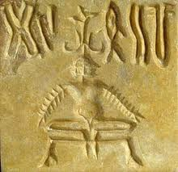

Artifact: Indus Valley Priest-King
Government/Religion: In 1927, a small stone statue was found at Mohenjo-daro. This statue shows the head of a man with a beard, headband, and robe with a three-leaf pattern on it. Since this discovery, people have called it the Priest-King. While the Indus Valley River Civilization has no exact answers of people in power, there are traces that the country was run by Priest-Kings, who kept order within the country. They have come to this conclusion because archeologists have found similarities between Mesopotamia’s Priest-Kings and the Indus region.
Teaching Idea: In order for students to learn about the supposed Indus Valley Priest-King, we will discuss why archeologists believe this statue represents the Priest-King. Also, the students will collaborate in small groups about other possible reasons people believe this statue depicts the Indus Valley Priest-King.

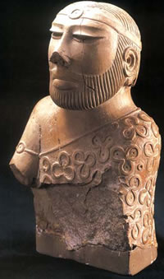

Place/Region: The Indus Valley cities were built on a grid system about 4,500 years ago. Before the first brick was laid there was a lot of planning and drawings created. The cities had straight roads, which made a grid pattern and divided the city into blocks. The main streets were almost ten meters wide, so two bullock carts could pass by each other. Also, drains were laid along the streets and wells were dug for water. In particular, Mohenjo-daro was divided into two parts by the Citadel, which was on the upper level and included the Great Bath.
Teaching Idea: When discussing the Indus Valley grid system, the students will work in groups to brainstorm possible reasons why the Indus Valley civilians created the cities in this method.

Artifact: Perfect Grid Pattern Cities/Streets

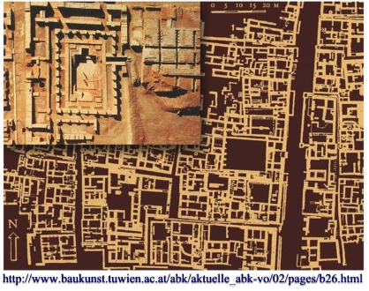

Artifact: Dancing Girl Of Mohenjo-daro

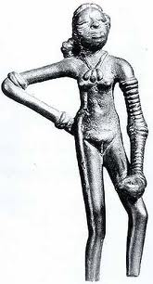
Art: While many female figurines of all shapes and sizes have been found, this bronze statuette called Dancing Girl of Mohenjo-daro is considered the most popular piece of Indus Valley art. It was uncovered in 1926 and is estimated to be about 4500 years old. The statue is 10.8 centimeters tall and shows a woman with braided hair wearing bangles and a necklace. This piece of art changed the way people looked at Indian art from ancient times. It speaks volumes of the outstanding craftsmanship and of the caster’s skills.
Teaching Idea: Each student could create their own piece of art after researching what has been recovered from the Indus Valley Civilization. The students could then become archeologists and explain what it may have represented.

Human-Environment Interactions/Technology: It is believed that entire neighborhoods were planned out well before they were built due to the advanced drainage systems that have been found. Drainage systems were found throughout the city of Mohenjo-daro that linked together. This allowed most houses to have bathing areas and toilets. The drainage system allowed for waste water to flow away from the homes, into street drains and out of the city. Clean water was accessed in homes through deep brick wells, usually inside the houses. The wells were built to collect clean water. The wells were sophisticated as they were build with wedge shaped bricks that locked together to form a strong cylindrical shape which stopped the wells from caving in and kept water pure.
Teaching Idea: The class could create their own rain water barrels to simulate the reservoirs the Indus Valley Civilization used and complete some research on how and why they are used today. (To make one, reference http://ag.udel.edu/extension/horticulture/pdf/Appoq%20RainBarrel%20Brochure.pdf .)
A speaker from the local water and sewer department could come to the class and speak with the students about the process used today and they could compare the processes.
Artifact: Large reservoirs and sophisticated drain systems

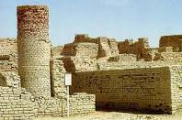

Artifact: Flat-bottomed boat
Movement/Economic System: Harappa and Mohenjo-daro became the largest cities of important trading posts and manufacturing centers in the Indus Valley. Flat-bottomed boats may have been used to transport goods thousands of miles to trade goods such as copper and bronze. No boats have been discovered but clay models and seals with flat-bottom boats have. Tar to waterproof boats have been found with impressions of boat planks which strengthen the notion that boats were used for trade. Indus Valley-style artifacts have been found in Mesopotamia, Iraq, Bahrain and Oman. The Indus Valley may have also traded with Central Asia as popular images from that area have been found in Harappa.
Teaching Idea: Students could create present day seals that represent how good are transported today.

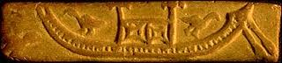
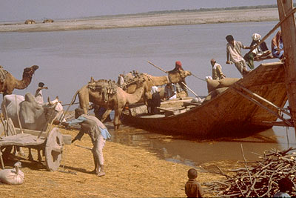

Artifact: Grains and Seeds
Agricultural Practice and Production: Researchers have found that the people in the Indus cities ate a wide variety of foods from fish, fruits, meats, and vegetables. This is known because of the artifacts they have found such as animal bones and carbonized grains and seeds. Grains that have been accidentally burned do not rot and can survive for thousands of years. Many common grain seeds were found in the Indus cities. These include common grains such as wheat, barley, and millet. Other seeds found were lentils, chickpeas, mustard, and sesame seeds. Archeologists discovered that Indus Valley farmers cultivated their fields twice a year to allow for food all year round.
Teaching Idea: Students can research the crops grown in the Indus Valley Civilization and in their area and compare the crops and climates.

Region/Human-Environment Interactions: In the Indus Valley Civilization, houses were built on artificial mounds or platforms. This was found in the largest city of Mohenjo-daro and also in Dholavira. Because the civilization was situated near the Indus River, flooding became an issue for living. Although the river allowed for travel and trade and kept crops watered, it’s flooding destroyed many other things in its path. This civilization began to build their homes either atop other already built building or they created artificial mounds to build on.
Teaching Idea: Students can research present-day locations that struggle with flooding or even hurricanes. Similar to the Indus Valley civilians, present day humans have tried to prevent damage through various methods. Students can research different ways that present day people avoid flood damage. This will allow students to compare how and why the Indus Valley people built their houses on artificial mounds and platforms.
Artifact: Platform Homes

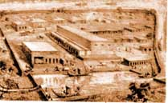

Resources:
Aronovsky, I., & Gopinath, S. (2005). The Indus Valley: Excavating the Past. Chicago, IL: Heinemann Library.

Citadel. The British Museum. Retrieved July 12, 2012, from http://www.ancientindia.co.uk/indus/explore/cit_b1.html

Dancing Girl Of Mohenjodaro, Indus Valley Civilization. flickr. Retrieved July 9, 2012, from http://www.flickr.com/photos/mukulb/5212019674/

Greenwood, C. Economics of the Indus Valley Civilization. California State University Chico. Retrieved July 8, 2012, from http://www.csuchico.edu/~cheinz/syllabi/asst001/fall97/2chd.htm

(2012). Indus Valley. BBC News. Retrieved July 8, 2012, from http://www.bbc.co.uk/schools/primaryhistory/indus_valley/land_of_the_indus/

Indus Valley Civilization. (2011, November 1). In Columbia Electronic Encyclopedia online. Retrieved from http://encore.cuyahoga.lib.oh.us:50080/ebsco-web/ehost/detail?sid=af948337-f168-4ec8-b80e-6a1f4b6da14c%40sessionmgr15&vid=2&hid=17&bdata=JnNpdGU9ZWhvc3QtbGl2ZQ%3d%3d#db=f5h&AN=39013217&anchor=AN0039013217-3

Indus Valley. The British Museum. Retrieved July 9, 2012, from http://www.ancientindia.co.uk/indus/home_set.html

(2011 September, 12). Indus River Valley Civilization. The River Valley Civilization Guide. Retrieved July 7, 2012, from http://www.rivervalleycivilizations.com/indus.php

Indus Valley Civilization. The Gill Farm. Retrieved July 9, 2012, from http://www.thegillfarm.com/indus-valley.html

(2008 September). Indus Valley Civilization. DilipKumar.in. Retrieved on July 8, 2012, from http://dilipkumar.in/india/indus.php

Lal, V. (1998 January, 17). Indus Valley Civilization. Manas. Retrieved July 9, 2012, from http://www.sscnet.ucla.edu/southasia/History/Ancient/Indus2.html

