Lauren Elliott
Authentic Assessments
Social Studies
6th Grade
Content Strand: Geography
Includes: Web quest implementation for background knowledge and additional practice
Content Standards: 3. Globes and other geographic tools can be used to gather, process and report
information about people, places and environments. Cartographers decide which information to include
and how it is displayed.

4. Latitude and longitude can be used to identify absolute location.

For building background knowledge and providing additional practice for using latitude, longitude, and map features this
Web quest would be useful for student use for review. http://www.zunal.com/webquest.php?w=139519
The advantage of this web quest is that is has built in videos for student to access to clear up
any misconceptions they may have about latitude and longitude and map features. It also provides
three tasks that students can complete to practice their skills.
Name ___________________________Rotation ____________________________________
Creating Own Country Project
Geographic Theme: Location

For this group activity, you are going to create your own country. After studying many countries around the world, it is now your turn to develop the perfect country. Use the map below to indicate the absolute and relative location of the country you are creating. Remember, you can make your country exist in any type of environment that you wish, but the environment and natural resources that you choose will affect the rest of your country project. For instance, if you have your country existing in the North Pole, you will have to keep that in mind when designing their clothing, foods, and shelters later on. If your country exists on an island, thousands of miles away from any other civilization, then trade and travel might be very difficult.

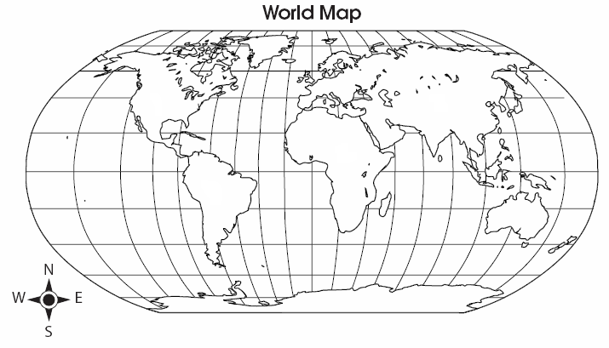
1. On the map above, mark where your country is located.

2. Absolute location of the capital city: ________ latitude ________ longitude

3. Relative location describes where a country is located in relation to other political or physical features. For example, the United States is on the continent of North America. It is south of Canada, north of Mexico, west of the Atlantic Ocean, and east of the Pacific Ocean. Describe your country’s relative location:

Create a detailed map for the country you are creating. This map should include political and physical features.
Be sure to include a key, with lakes, mountains, rivers, cities, deserts, any other important landmarks.
Include a compass rose and a title for your map.
Once you have drawn and labeled your map, you should add color.
The information on this map must match the information on the front of this page.

Making A Map : Create Your Own Country Map

Teacher Name: Mrs. Elliott
Student Name: ________________________________________

CATEGORY | 4 | 3 | 2 | 1
Title | Title tells the purpose/content of the map, is clearly distinguishable as the title (e.g. larger letters, underlined, etc), and is printed at the top of the map. | Title tells the purpose/content of the map and is printed at the top of the map. | Title tells the purpose/content of the map, but is not located at the top of the map. | Purpose/content of the map is not clear from the title.
Map Legend/Key | Legend is easy-to-find and contains a complete set of symbols, including a compass rose. | Legend contains a complete set of symbols, including a compass rose. | Legend contains an almost complete set of symbols, including a compass rose. | Legend is absent or lacks several symbols.
Labels & Features - Neatness | 90-100% of the labels/features can be read easily. | 89-80% of the labels/features can be read easily. | 79-70% of the labels/features can be read easily. | Less than 70% of the labels/features can be read easily.
Scale | All features on map are drawn to scale and the scale used is clearly indicated on the map. | Most features on map are drawn to scale and the scale used is clearly indicated on the map. | Many features of the map are NOT drawn to scale even though a scale is clearly indicated on the map. | Many features of the map are NOT drawn to scale AND/OR there is no scale marker on the map.
Knowledge Gained | On the map the student can accurately label all features. | On the map the student can accurately label most features. | On the map the student can accurately label some features. | On the map the student can accurately label few features.

Authentic Assessments
Social Studies
6th Grade
Content Strand: Government
10. Governments can be categorized as monarchies, theocracies, dictatorships or democracies, but
categories may overlap and labels may not accurately represent how governments function. The extent
of citizens’ liberties and responsibilities varies according to limits on governmental authority.
Includes: video to present background knowledge for students. It also gives a way for students to remember
The different forms of government by providing a rap for student engagement.

Forms of Governments
Build Background knowledge for students use the following video: Students will watch this video as an overview of the different forms of government. This will give exposure to students as well as see how information can be presented in a fun and creative way. The students in the example made a rap to help remember and distinguish between the different forms of government. This will assist students by giving them background knowledge on the different forms of government and allow them to be able to focus in-depth research on one of the four we will be covering in sixth grade social studies including monarchies, theocracies, dictatorships or democracies.
http://www.youtube.com/watch?v=KrZczH2504k

The teacher will also use these power points to be able to assist students in understanding the different forms of government. Based on this background knowledge they will pick one form of government to discover more in depth.
http://government.mrdonn.org/powerpoints/types.html

1. Choose one of the four major governments (monarchies, theocracies, dictatorships, or democracies)
2. Use the provided outline to research the government you have chosen.
3. When the outline is complete, create a brochure to explain the government you have chosen.
4. Your brochure document must include the following:
- All of the information from the outline
- At least 2 images related to the government
- A consistent and readable font throughout the document

- Document sources used

Forms of Governments

Directions: Use the outline below to collect information for your brochure document. You must complete your outline before you can begin creating your brochure document.

Government: ______________________________________

- Definition
- Example

II. Locations
  - Where

  - When

III. Responsibility
- Leaders

- Citizens

- Power

IV. Critique
- Pros

- Cons

Making A Brochure: Government Brochure

Teacher Name: Mrs. Elliott
Student Name: ________________________________________

CATEGORY | 4 | 3 | 2 | 1
Content - Accuracy | All facts in the brochure are accurate. | 99-90% of the facts in the brochure are accurate. | 89-80% of the facts in the brochure are accurate. | Fewer than 80% of the facts in the brochure are accurate.
Knowledge Gained | All students in the group can accurately answer all questions related to facts in the brochure and to technical processes used to create the brochure. | All students in the group can accurately answer most questions related to facts in the brochure and to technical processes used to create the brochure. | Most students in the group can accurately answer most questions related to facts in the brochure and to technical processes used to create the brochure. | Several students in the group appear to have little knowledge about the facts or technical processes used in the brochure.
Attractiveness & Organization | The brochure has exceptionally attractive formatting and well-organized information. | The brochure has attractive formatting and well-organized information. | The brochure has well-organized information. | The brochure\'s formatting and organization of material are confusing to the reader.
Writing - Mechanics | Capitalization and punctuation are correct throughout the brochure. | Capitalization and punctuation are correct throughout the brochure after feedback from an adult. | There are 1-2 capitalization and/or punctuation errors in the brochure even after feedback from an adult. | There are several capitalization or punctuation errors in the brochure even after feedback from an adult.
Sources | Careful and accurate records are kept to document the source of 95-100% of the facts and graphics in the brochure. | Careful and accurate records are kept to document the source of 94-85% of the facts and graphics in the brochure. | Careful and accurate records are kept to document the source of 84-75% of the facts and graphics in the brochure. | Sources are not documented accurately or are not kept on many facts and graphics.
Graphics/Pictures | Graphics go well with the text and there is a good mix of text and graphics. | Graphics go well with the text, but there are so many that they distract from the text. | Graphics go well with the text, but there are too few and the brochure seems \"text-heavy\". | Graphics do not go with the accompanying text or appear to be randomly chosen.

