**Longitude and Latitude Activity**

**Lesson Engagement and Background knowledge**

**Geography: Location**

**Day 1**

**Steps:**

1. Draw or create a chart with all the desks in your classroom.
2. Assign each row a letter and each column a number.
3. Assign each student a card with a letter and a number.
4. Have the students find their seats using the chart on the board and their notecard.
5. This can be used to create a seating chart and practice Latitude and Longitude.

Example:

|  |  |  |  |  |
| --- | --- | --- | --- | --- |
| **A** |  |  |  |  |
| **B** |  |  |  |  |
| **C** |  |  |  |  |
| **D** |  |  |  |  |
|  | **1** | **2** | **3** | **4** |

|  |
| --- |
| **D-4** |

Use the same card for each period and wrote the students’ names on the back.

**Ancient Egypt Civilization**

**Day 1**

**Geography: Location**

**Latitude and Longitude: Location on a Map**

Directions: Practice locating points on a map by using the longitude and latitude of each city listed below. Plot each city by placing a dot and writing the name of the city in the correct place on your map.

|  |  |  |
| --- | --- | --- |
| **City** | **Latitude** | **Longitude** |
| 1. **Greenwich, England** | **53° N** | **0°** |
| 1. **Moscow, Russia** | **56° N** | **18° E** |
| 1. **New York, New York** | **41° N** | **74° W** |
| 1. **Sydney, Australia** | **34° S** | **151° E** |
| 1. **Beijing, China** | **40° N** | **116° E** |
| 1. **Buenos Aires, Argentina** | **35° S** | **58° W** |
| 1. **Capetown, South Africa** | **12° S** | **25° E** |
| 1. **Cairo, Egypt** | **30° N** | **31° E** |
| 1. **Edmonton, Canada** | **53° N** | **114° W** |
| **10. Calcutta, India** | **22° N** | **38° E** |

Use the attached map.

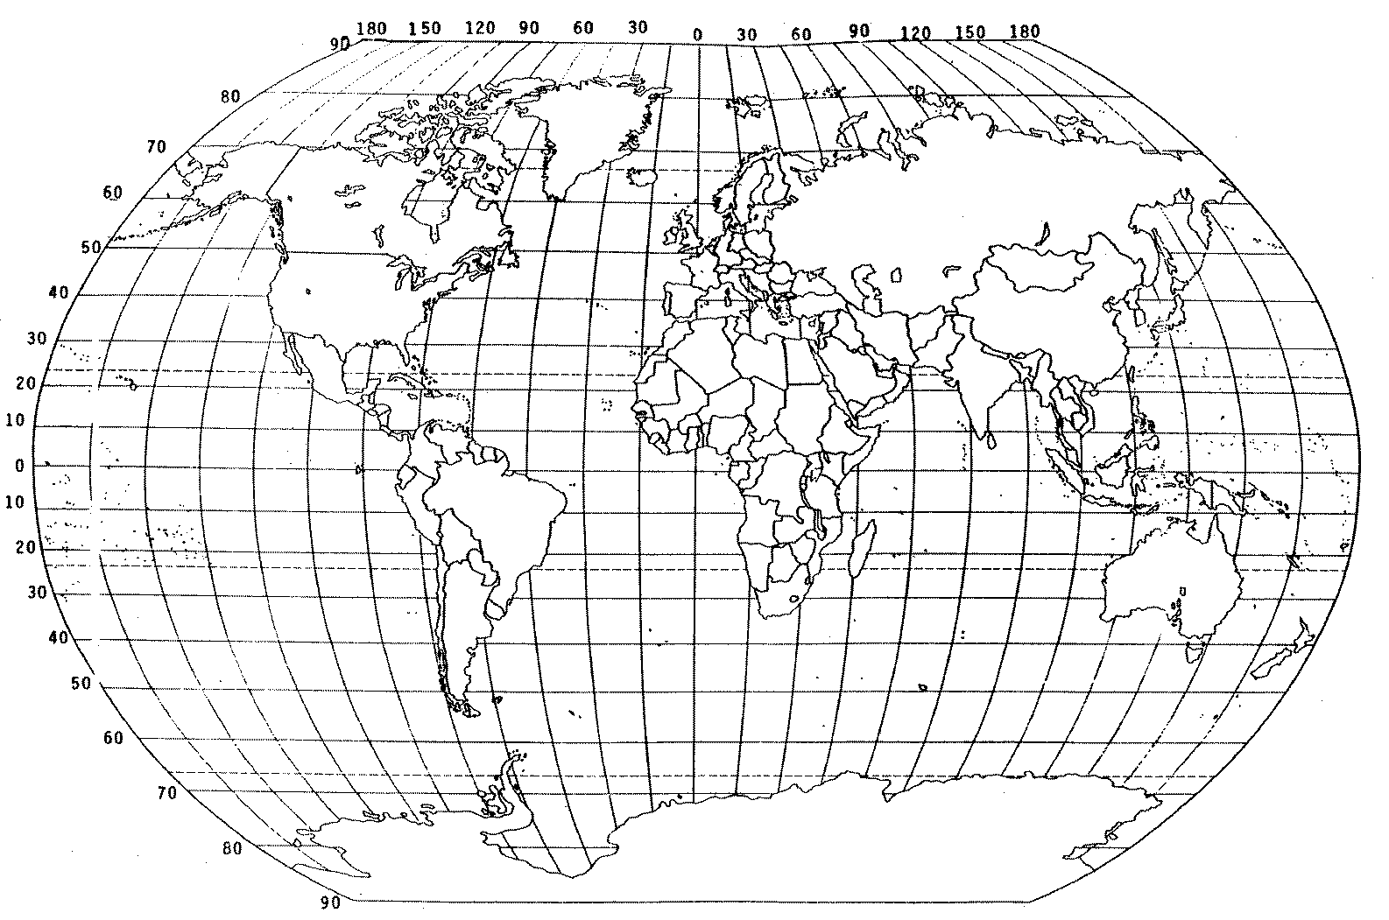

GEO 2 Formative Assessment

Name __________________________ Rotation ____________________

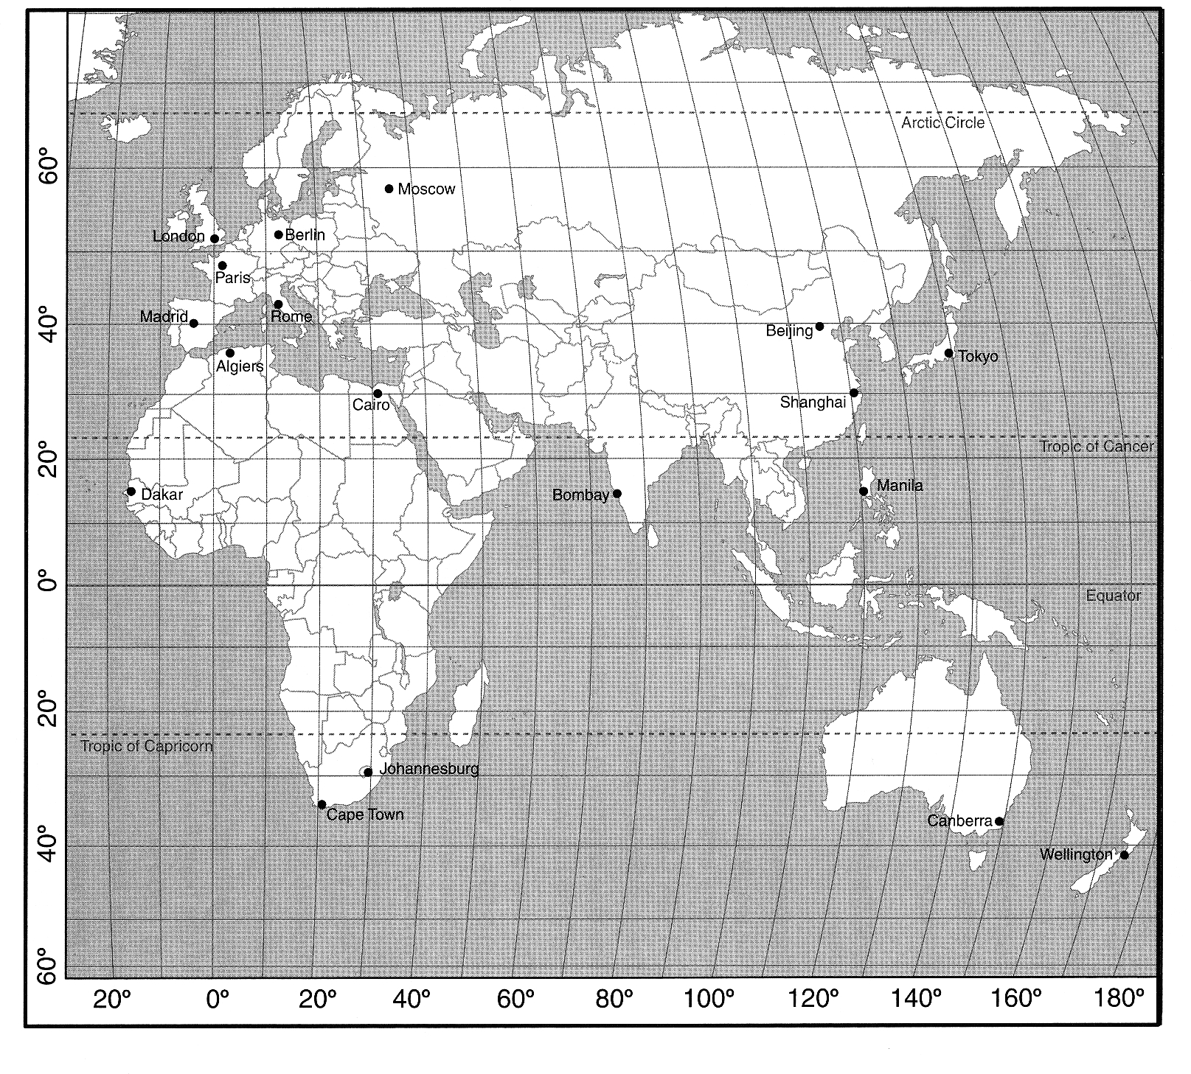

MCj02390150000[1]

***Use the map above to answer questions #1 & 2.***

What are the latitude and longitude coordinates of Cairo, Egypt?

_________ _________

What city is located at 15° N and 74° E?

­­­­­­­­_______________________________________

Day 2:

Geography: Place

Land Features Graphic Organizer

|  |  |  |
| --- | --- | --- |
| Land Features  What distinguishes this place from another? | Picture  *Draw a picture representation* | Explanation  *Why do you think these features are important?* |
|  |  |  |
|  |  |  |
|  |  |  |
|  |  |  |
|  |  |  |
|  |  |  |
|  |  |  |

Day 3:

Geography: Human Environment

Graphic Organizer

Directions: Upon completing the 360 degree tour and watching the videos identity at least three main features that have developed from Ancient Egypt based upon human interaction. Explain why these three features are important and critical to the development of Ancient Egypt Civilization. Think of what Ancient Egyptians were able to create and develop that has altered their civilization and way of life.

|  |  |
| --- | --- |
| Human Environment Interaction | Why this is important to Ancient Egypt Civilization? |
|  |  |
|  |  |
|  |  |
|  |  |

Day 4

Geography: Movement

Directions: Reflect on the following question and answer in complete sentences.

***How did The Nile River serve as an important resource to the Egyptians? Describe how the Nile River was used to support the unification of two kingdoms. Why do you think the two kingdoms became united?***

***Day 5***

***Geography: Region***

Directions: Reflect on the following question and answer in complete sentences.

***How was the Ancient Egypt Civilization region divided? What resources were help to the development of Ancient Egypt Civilization? What resources were difficult to the development of Ancient Egypt Civilization? Explain the pros and cons two at least two examples of how the region affected the development of Ancient Egypt Civilization.***