Artifact Box Handout

Name: Lauren Elliott

Ancient Egypt Nile River Civilization
Grade Level: 6th

Theme: Regions and People of the Eastern Hemisphere

Strand: History

Topic: Early Civilization

Link: http://youtu.be/oGq3S5zA5ps
Content Statement: Early civilization (India, Egypt, China and Mesopotamia) with unique governments, economic systems, social structures, religions, technologies, and agricultural practices and products flourished as a result of geographic characteristics. The cultural practices and products of these early civilizations can be used to help understand the Eastern Hemisphere today.

Summary: Egyptian civilization flourished for over 3,000 years due to its ability to unit into one kingdom under one leader and had a powerful resource to flourish its lands. The Nile River is the longest river stretching over 4,100 miles and helped the Egyptian civilization with agriculture, transportation, and trade. The Egyptian civilization is located in Egypt in Africa and the Nile River their main source of development runs from the central part of Africa to the Mediterranean Sea. The Egyptians are known for a great deal of influences including The Nile River, Menes King Hat, pyramids, mummification, Hieroglyphics, papyrus, and calendar.

Artifacts in Box
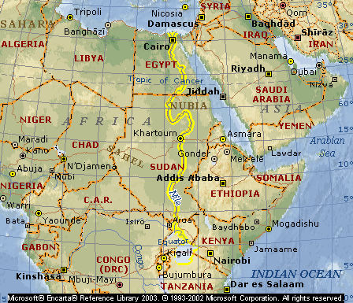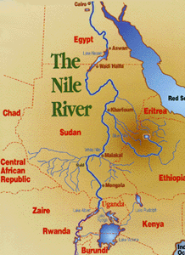

Nile River

The Nile River is the longest river in the world and it is over 4, 100 miles long. The Nile River is in Africa and extends from Egypt and extends into Burundi, Tanzania, Uganda, and Ethiopia. Every year in July the Nile River floods from the rain and snow melting in the mountains which produces rich soil. In October the flooding would leave behind a fertilized mud. This led to the peasants would prepare the soil for farming. This created a cycle that would cause flood, plant harvest and repeat every year. The Nile River has demonstrated as a resource of food through agriculture including wheat and bailey, water, fish, and wildlife. It was worshiped by the Egyptians and it called the “Gift of the Nile.” The Egyptians only occupied the lower portion of the Nile River. It was located the last 750 miles that flows north to the Mediterranean Sea. The River promoted trade and transportation between the North and South portions of the Nile River. The two were difficult to connect due to granite cliffs, boulders, and rapids.

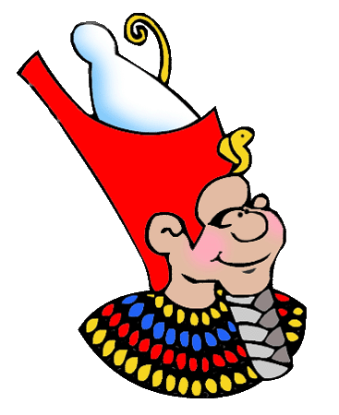

Menes King’s Hat

Egyptian farming villages were separated to the Upper Egypt and the Lower Egypt regions in 3200 B.C. and were ruled by two separate kings. The king of Lower Egypt wore a red crown and the king of the Upper Egypt wore a white crown shaped like a bowling pin. In 3100 B.C. the Upper Egypt king Menes joined both parts of Egypt together. He combined the two images of the kings’ crowns to create one unique collaboration and representation of the two parts of Egypt. Menes established the capital Memphis which was where the Upper and Lower Egypt met and created the first Egyptian dynasty. Since then there has been a total of 31 Egyptian dynasties over the past 2,600 years. The story of Menes was told years later and his story was passed from generation to generation but he was considered a hero to the Egyptians.

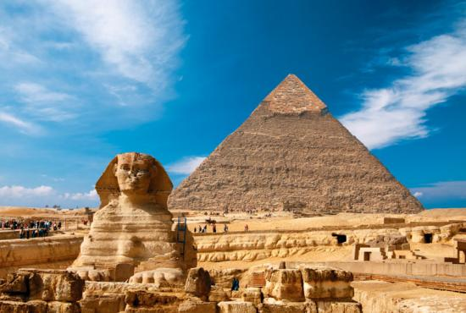

Pyramid
The Pyramids are an iconic symbol that represents Egyptians culture in a variety of ways. The Pyramids are build to honor the dead and believe that the king rules even after death. By their Egyptians beliefs since the pyramid is their forever resting place their kings’ tombs are elaborate than their palaces.
The pyramids were built before the invention of the wheel and took a great deal of planning, man power, engineering and geometry to build a pyramid. The pyramids included areas like kings’ chamber, air shaft, grand gallery, queen’s chamber, and an escape passage. The Great Pyramid of Giza is the largest pyramid because it weights at least 2 ½ tons in each block of stone and combines to up to 2 million blocks which is up to 481 feet high and covers 13 acres and was created in 2556 B.C. The pyramids are made out of limestone and granite stone. Also the pyramid triangular shape is also symbolic to the class system of four distinct areas designed by Egyptians. One it places the kings, queen and royal family on top at the peas. Second was the upper class which included wealthy land owners, government officials, priests, and army commanders underneath the first class. Third was the middle class who contained the merchants and artisans. Lastly at the bottom and the most included was the lower class which included peasant farmers, unskilled laborers, and slaves. People could move up the class system by marriage or getting a successful job. Being able to read and write opened up jobs in the army, royal treasury, priesthood, and the kings court. Women also had the same rights as men in the Egyptian class system in which she could own land, propose marriage, or divorce.

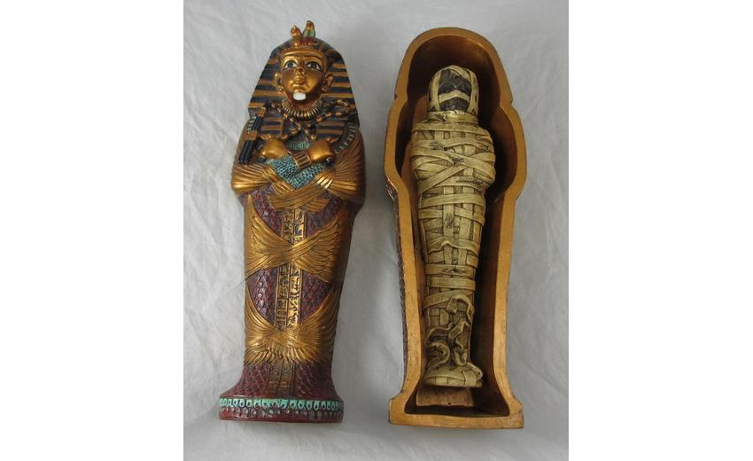

Tomb with Mummification

The Egyptians believed in the afterlife and life continued after death. The Egyptians worshiped over 2,000 gods and goddesses. The most important gods were Ra the sun god and Horus the god of light. The most important goddess was Iris who was the ideal mother and wife. Egyptians believed they were judged at death by the god of death Osiris. By weighing the people’s heart and if the heart was as light as a feather he would decide if grant that person eternal life in the Other World. People planned for their death and arranged for burial to be mummified in a tomb or pyramid. The Egyptians mummified the dead by embalming and drying the corpse to prevent the body from decaying. The tomb would be filled with clothes, food, cosmetics, jewelry, and hymns to be used in their afterlife.

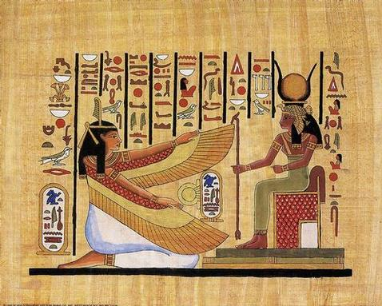

Hieroglyphics
Hieroglyphics was one of the earliest forms of writing for Egypt where Egyptians would use picture drawings to represent information. The word hieroglyphics comes from the Greek word meaning “sacred carving”. These images would represent an idea and then evolved to sounds like an alphabet. Hieroglyphics were first written on clay or stone. It was a way to communicate and leave messages through pictures and symbols.

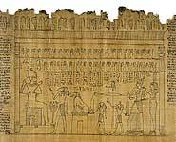
Papyrus

In the Egyptian civilization evolved its hieroglyphics to be able to incorporate these images on a portable structure called papyrus. Papyruses are tall stacks that were slit into narrow strips and dampened and pressed together. This process allowed the strips to glue together when it dried. This created a paper like sheet to be able to communicate using hieroglyphics.

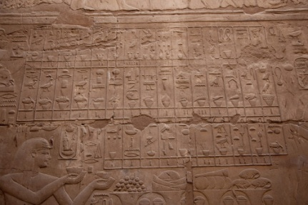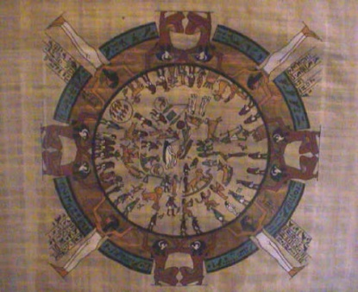

Calendar

The Egyptian Civilization also created a calendar. They did this to be able to predict when the floods were occurring each year. They discovered that the bright star Sirius would appear before the floods. The Egyptians created a calendar that was 360 days, 12 months, and 30 days in each month. They added 5 days for holidays and feasting to create a total of 365 days. The Egyptian calendar is only six hours shorter than a solar year.

Resources for Nile River Egypt Civilization

“Nile River Valley Civilization.” The River Valley Civilization Guide. Web. 8 July 2013. Retrieved from http://www.rivervalleycivilizations.com/nile.php

“Pyramids on the Nile.” Early River Valley Civilizations, 3500 B.C.-450 B.C. Web. 8 July 2013. Retrieved from http://www.ltisdschools.org/cms/lib/TX21000349/Centricity/Domain/287/Chapter2.pdf

“Life Along the Nile.” Ancient Civilizations. Web. 8 July 2013. Retrieved from http://www.ushistory.org/civ/3a.asp

