Artifact Box Alicia Birkmire

Indus River Valley Civilization

Ohio Academic Content Statement

Grand Level Band: 6-8
Grade Level: 6
Benchmark: History >> Early Civilizations
Content Statement: 2. Early civilizations (India, Egypt, China and Mesopotamia) with unique governments, economic systems, social structures, religions, technologies and agricultural practices and products flourished as a result of favorable geographic characteristics. The cultural practices and products of these early civilizations can be used to help understand the Eastern Hemisphere today.

Grade Level Band: 6-8
Grade Level: 6
Benchmark: Geography >> Spatial Thinking and Skills
Content Statement: 4. Latitude and Longitude can be used to identify absolute location.

Grade Level Band: 6-8
Grade Level: 6
Benchmark: Geography >> Places and Regions
Content Statement: 5. Regions can be determined, classified and compared using various criteria (e.g., landform, climate, population, cultural, or economic).

Grade Level Band: 6-8
Grade Level: 6
Benchmark: Geography >> Human Systems
Content Statement: 6. Variations among physical environments within the Eastern Hemisphere influence human activities. Human activities also alter the physical environment.
Content Statement: 7. Political, environmental, social and economic factors cause people, products and ideas to move from place to place in the Eastern Hemisphere in the past and today.

Common Core State Standards

Grade Level Band: 6-8
Grade Level: 6
Benchmark: Reading for Informational Text >> Integration of Knowledge and Ideas
Content Statement: 6.7. Integrate information presented in different media or formats (e.g., visually, quantitatively) as well as in words to develop a coherent understanding of a topic or issue.

Grade Level Band: 6-8
Grade Level: 6
Benchmark: ELA- Literacy in History and Social Studies >> Integration of Knowledge and Ideas
Content Statement: 6-8.7. Integrate visual information (e.g., in charts, graphs, photographs, videos, or maps) with other information in print and digital texts.

Introduction

From approximately 3000 to 1500 B.C.E. the complex, urban civilization existed along the Indus River, while dominated by large cities such as Harappa and Mohenjo-daro. Because Harappa was one of the largest cities dominating the civilization, the Indus River Civilization is mainly known as the Harappan Civilization. Stretching across present day India, Pakistan, Bangladesh, Nepal, Sri Lanka, and Bhutan, the civilization used to be surrounded by mountains and the Arabian Sea, keeping it was attack and disease from other civilizations. The civilization was big on irrigation systems, which allowed for them to grow wheat, barley, rye, peas, cotton and rice, to feed themselves. Sadly, the Indus Valley civilization ceased. There are many theories as to why the civilization ended; including one theory that earthquakes and frequent floods caused the end for the Indus people, whereas another theory included the idea that the Indus River changed its course, forcing the people to leave their civilization.

Artifacts

The following five artifacts not only describe the Indus River Valley Civilization, but also fall into the five main themes of geography. Keep in mind that the standards chosen on the first page of the handout, help describe how students could meet the standards through the research of the five main themes of geography, in connection to the Indus River Valley civilization research.
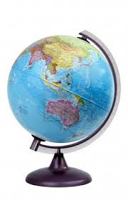
- Globe: (paper globe to represent a larger globe)

The paper globe is obviously not anywhere near as accurate as a larger globe, but it represents that on a larger globe, you can use the latitude and longitude coordinate of 24.3121° N, 67.7637°E to find where the Indus River is located. Using this skill allows for practice of the geography theme “location”, more focused on the absolute location. The Indus River was not the only location for the civilization. The civilization stretched across present day India, Pakistan, Bangladesh, Nepal, Sri Lanka, and Bhutan, leaving parts of its civilization further away from the river than others. Looking at some globes that show physical features, you would be able to see some relative locations of the Indus Valley civilization in regards to being surrounded by the Himalaya mountains, the Arabian Sea, Indian Sea, and Thar Desert. Knowing the Indus River Valley Civilization location in the nominal, absolute, relative, and cognitive sense, allow us to understand that the civilization took much care of themselves in regards to food and shelter. Eventually they learned to trade with other civilizations, but the location of their own civilization caused them to be separated from others, keeping attacks and disease to a bare minimum.
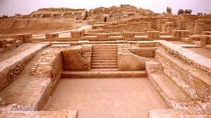
2) Clay Housing (clay brick to represent their structures)

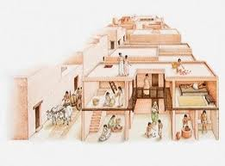
Moving on to the second theme of geography, “place”, the Indus River Valley civilization is well know for its urbanized developments, including its structures and buildings. The clay brick serves as a symbolic artifact of the amazing housing developments the Indus Valley civilization built. Although this civilization did not leave behind large monuments, tombs, pyramids, etc., they did leave behind some fantastically thought out housing architecture. The Indus Valley housing structures were well planned and built with baked bricks all of congruent size. This provides theory that the people created mold structures to assist in forming the dirt/clay into bricks. What’s left of the streets shows that the people created their roads with right angles to one another, including an elaborate system of covered drains. The remains show a definite division in styles and localities as houses were tagged for the upper and lower levels of society, for example, the upper class houses were well thought out two-story houses with a flat rooftop for extra room. Other than houses, there were some public buildings, including the most famous building being the Great Bath at Mohenjodaro, where the upper class people would come bath and relax in the sun and water.
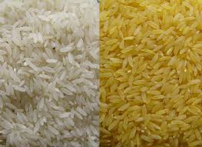
3) Agriculture/Food (rice represents one of their crops)

When we look at the next theme of geography, “relationship between places”, we can look at the human-environment interaction. In this case, the Indus Valley civilization both adapted to the environment, as well as modified the environment. For example, instead of living in teepees or log cabins, the people adapted their lifestyle and type of housing by living in clay-brick housing. They adapted to being on their own because the landforms and barriers surrounding their community hindered their communication and interaction with other civilizations. When we look at how the Indus Valley people modified the land, we can look at their types of crops and the way they planted their crops to be successful. The Indus Valley civilization shows remains of highly used irrigation systems that carried water from the river, to the fields and crops. This helped the population of people feed themselves. They grew wheat, barley, rye, peas, cotton, and rice, in addition to their animals being a source of food. Because of seasonal flooding, the people built their homes and planted their crops on platforms and elevated ground. The nearby river provided fertile land for growing crops, but theories provide explanation that the river eventually changed its course, causing the downfall of the civilization because the irrigation systems became useless, ground became dry and unfertile, and the crops stopped growing.

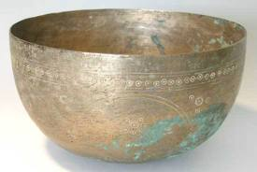
4) Trade (pitcher representing bronze as one metal they traded)

The fourth theme of geography is “movement”, which brings up the next topic of the Indus Valley Civilization. Although landforms and barriers kept them to themselves, eventually the civilization ventured past mountains, down stream, etc., to trade with other civilizations every so often. The Indus Valley civilization traded amongst themselves, and eventually with Mesopotamia. Trade led to the movement of goods, language, cultural beliefs, etc., until the Indus Valley civilization was soon spreading and influencing other cultures. Trade was a big factor in the urbanization of the Indus Valley as they soon traded for metals and started created tools and objects from bronze, and sometimes copper and iron.
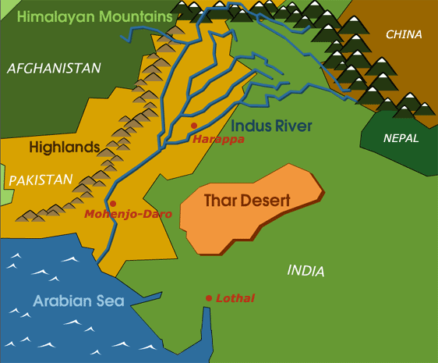
5) River Map (map shows the regions/areas affected by river)

The last theme of geography is “region”, which describes a group of places with similar characteristics. Characteristics can involve human properties, physical properties, or both. In this case, the Indus Valley Region involves the region of both human characteristics and physical characteristics. The Indus Valley civilization remains show that all of the people in the civilization spoke/wrote in the same language. The confusing part? None of the other civilizations have any remains of speaking/writing in the same language. With the physical barriers dividing the civilizations, the Indus Valley civilization created their own language and to this day, researches are still trying to decipher it. When we look at the physical characteristics in relation to regions, river maps assist us in proving that the Indus Valley River was the main river that traveled and broke into smaller rivers that affected other civilizations and parts of the Indus Valley civilization. The many rivers show that the civilizations in the area all can be grouped as “river civilizations” as their irrigation systems, agricultural lifestyle, source of water/transportation, etc., were all influenced and affected by the many rivers in the area.

Conclusion

Sadly, the Indus Valley civilization came to an end, and why, historians don’t know. The many theories of their decline include the following: change in the climate, increase in population, decline in agriculture, frequent floods ruining the crops, and possible invasion of the Aryan people due to the trade, causing imports of other cultures, slowly altering their own. With showing five different resources that connect to location, place, relationship between places, movement, and region, the artifacts help viewers/listeners learn about the geography influence and main components of the Indus River Valley civilization. By learning about connections with other civilizations/surrounding areas, symbolic tools and materials, exact location, agricultural components, and movement about the Indus Valley civilization, it helps us understand the relationships and influence the civilization had on civilizations to follow. The artifacts lend a hand in experiencing the civilization and making connections with tools in our lives today that relate to the tools back then.

Sources

Early River Valley Civilizations. (n.d.). Retrieved from http://old.clevelandstatecc.edu/courses/ngreenwood/history 1110/online_presentations/first_river_valley_civilizations.htm

Indus River Valley Civilization. (2007, September 12). Retrieved from http://www.rivervalleycivilizations.com/indus.php

Geography of Ancient India: The Indus River Valley. (n.d.). Retrieved from
http://project-history.blogspot.com/2006/11/geography-of-ancient-india-indus-river.html

Sinha, A. (n.d.). Teacher's guide: The ancient indus valley civilization. Retrieved from http://www.wgte.org/wgte/indusriver/TeacherGuide.pdf

uhistory.org. (2013). 8a. early civilization in the indus valley. Retrieved from http://www.ushistory.org/civ/8a.asp

