Huang-Ho River Civilization (Ancient China) Unit Outline
By: Amber Glick and Lisa Miller

Day 1:
Geography Themes: Introduction to the 5 themes of Geography.

Objectives:
- Students will be able to identify the 5 themes of geography.
- Students will be able to analyze what they already know about the Huang Ho River Civilization.

Lesson Overview/Assessments:
This first day of the unit we will be introducing the Huang-Ho River Civilization and discuss the end of unit project. This lesson will begin by having students in small groups, 4-5 students and each with a different color marker. Around the room, there will be five posters that are blank except for the title. The titles on each of the posters will be one of the five themes of Geography. Each group will start at a poster and write down what they know about that theme and how it relates to the Huang-Ho. If they aren’t sure about a certain fact, they put a question mark after it. After a couple minutes, the groups all switch to the next poster and do the same thing: write a concept or fact that they know or think they know. They should also read the information posted by the group before them. If they aren’t positive of a fact they posted, they should put a question mark next to their information. This activity allows students to first tell what they know about the various Geography themes and it also gives the students the opportunity to tell what they already know about the Huang-Ho. After each group visited every poster, we will go back to our seats and discuss. The benefit of having students use different colors is that we can determine what students used what facts. This will take about 20-25 minutes. Throughout the unit we will try to either confirm or reject the facts listed on the different posters. This activity will allow the teacher to assess student understanding and what misconceptions students may hold before even getting in to the lesson.

Next, we will briefly discuss and introduce what the themes of geography are and what they mean. Each lesson will address a theme more in depth. Describe that the “location” includes the absolute and relative locations. The teacher will point out when referring to “place”, students are looking for certain characteristics of the area (i.e. whether it is hot, humid, touristy, etc.). When discussing “Human/Environment Interaction”, students will learn that humans make positive and negative effects on the environment. The teacher will discuss the idea of “movement” with the students which describes how and why people move from one place to another and finally the teacher will talk about the “region” which is the study of sections of the earth and the characteristics that make up that area.

After introducing the themes, the teacher will present an example of a scrapbook that represents the five themes of Geography and the Huang-Ho River/Ancient China. The scrapbook will be the end of the unit project and students should work on developing their scrapbooks in class and be thinking of ideas for it as we travel through the unit. We will discuss that the scrapbook includes a variety of facts that represent the Ancient Chinese Culture. There should be at least two facts on each page of the scrapbook, representing each theme in Geography. The scrapbook will give students something that they can view and help them further understand the ancient civilization.

Day 2:
Geography Theme: Location

Objectives:
- Using a map, students will be able to apply knowledge of latitude and longitude to find a location.
- Students will design a map connecting locations using only latitude and longitude degrees.
- Students will be able to identify relative directions and landforms.

Lesson Overview/Assessment:
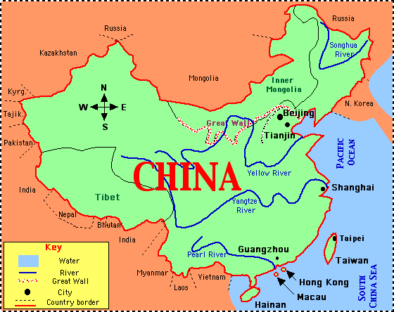
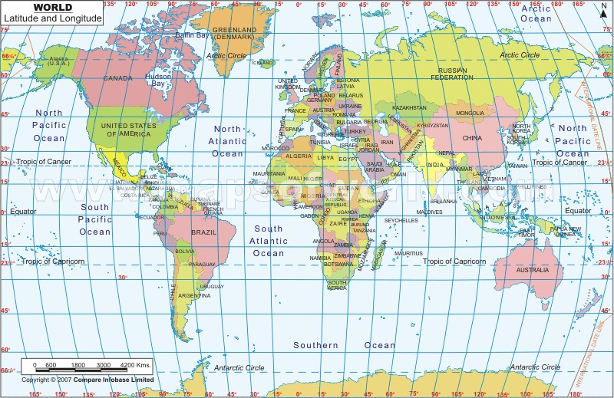
In this lesson, students will be interactive and be reinforcing their knowledge of latitude and longitude. In the fifth grade, students learn how to identify the latitude and longitude lines so this will be a refresher for some students. On the map provided, students will identify that latitude lines go from East to West and longitude lines from North to South. Given the map and information, students will find a couple locations using the latitude and longitude degrees given by the teacher. The lesson for today has students designing their own map. Given their own map, students find locations they want to connect and send their partner to find. The student will make two copies of the sheet. One that is blank except for the latitude and longitude degrees and the other will be an answer key. The student will be expected to find at least 5-7 locations, write them on the sheets and fill in the answer key. Students will be given 15 minutes to develop the map for their partner to complete. Their partner will be given 5 minutes to find the locations and fill in the sheet. They will give back the sheets to the student who designed it. They will grade it, staple it with their answer sheet and turn in.
Figure 1: Retrieved from http://ideagirlseverestormpredictionswarnings.files.wordpress.com/2012/12/latitude-and-longitude-map3-world.jpg

Next, we will focus our attention primarily on China, and find the latitude and longitude of the country. Students will be introduced to the concept of relative location. We will look at what surrounds China and what landmarks could be good identifiers. Students will be asked to “locate” China based on absolute location (latitude and longitude) and also by relative location (South of Mongolia).
Figure 2 [Web Map]. Retrieved from http://www.uni.edu/becker/Chinamap.GIF

Day 3:
Geography Theme: Human/Environment Interaction

Objectives:
- Students will be able to examine the reasons for the river being “yellow”.
- Students will be able to research and compose a solution to what dangers face the yellow river today.

Lesson Overview/Assessment:
In this lesson, we will be doing some cross-curricular learning with Science mixed with our social studies. The students will look in to what “loess sediment” is and how that could cause the river to turn a yellow color.

Students will use that knowledge and will do some research on the class set of iPads with given links. The students will be able to see some of the current issues that are occurring in the yellow river (i.e. pollution, flooding, rainfall amounts, and demand for water for agricultural purposes). The students will then look at the current issues with the river and see how they affect the people surrounding the river. Example: Pollution makes it unhealthy for people surrounding to use the water; Flooding: Damage to homes, people have to move frequently and take various precautions to guarantee their safety; Rainfall amounts: cause the river to either run low or run high. Running high results in flooding, running low makes the soil surrounding the river less fertile and doesn’t allow travel or export; demand for water: with a greater demand, it makes the river go down and makes it harder for transport. These are just a few examples; students should be able to develop a couple of their own.

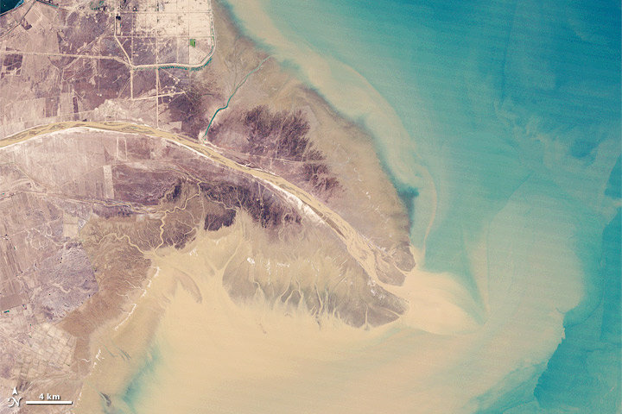
Students then will develop possible solutions to these problems. Remember, their solutions may pose other problems so make sure they are aware of that.
Figure 3: Yellow river delta [Web Photo]. Retrieved from http://earthobservatory.nasa.gov/Features/WorldOfChange/yellow_river.php

This lesson can be done in partners. With ten minutes left in class, students/partners can present their issue, how it affects humans/animals surrounding them, and a possible solution.

Resource: Przyborski, P. (n.d.). Yellow river delta. Retrieved from http://earthobservatory.nasa.gov/Features/WorldOfChange/yellow_river.php

This website will be a great resource for students. They are able to use other resources if they find them, but this would be a great starting point.
**Students should also be thinking about what item they can find for their artifact box!
Day 4:
Geography Theme: Movement

Objectives:
- Students will be able to investigate why people move from place to place
- Students will be able to justify why people live near a river.
- Students will be able to design a plan to get their secret of silk out.

Lesson Overview/Assessment:
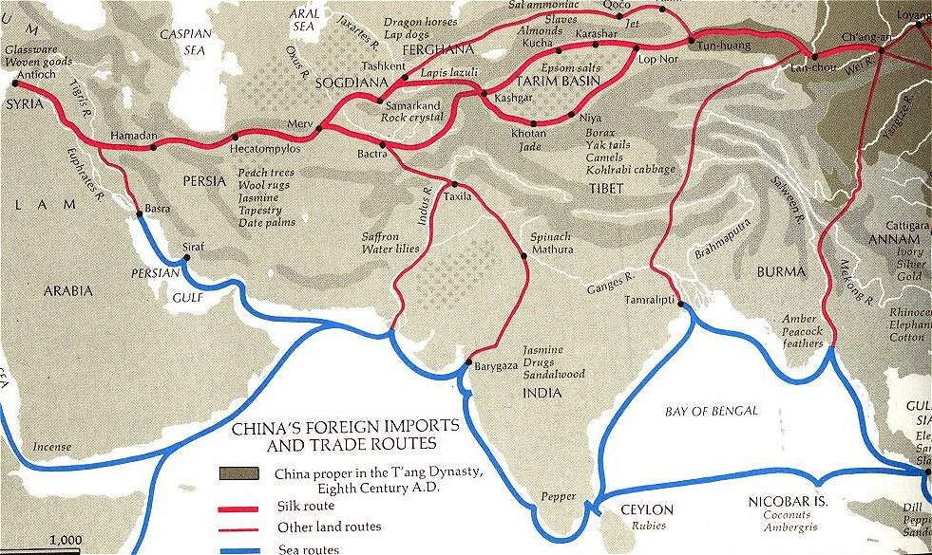
This lesson is very full with a lot of different objectives. The idea of movement in geography regards people moving from place to place but also the movement of ideas and products and goods. We will first investigate why people move from place to place. The students will use the promethean board to write down ideas of locally, why people move. Examples could be: Parents got a new job/lost a job, services relocation, support family, bigger/smaller house, etc. After locally, students can think about on a bigger scale and in the past. Examples: people used to move because they had no resources, the gold rush, war, famine, better opportunities. Students then should focus on specifically positives and negatives of living near a river. Some positives could be: fertile land for planting, fishing for food and hunting other animals that need water, transportation. Some negatives could be: flooding, animals always around because of water, etc. Students should work with a partner and debate. One side should focus on positives of living on a river; the other should focus on negatives. Then there will be a class discussion about what the partnerships determined.

Next, since we live in Ohio, students will talk about what they are more knowledgeable about: river transportation vs. road transportation. With this discussion, we will talk about the Silk Road and the great resource that became of silk. We will talk about the history of silk and how it was developed. Students will hear some of the myths.
Figure 4: China's foreign imports and trade routes. [Web Photo]. Retrieved from http://www2.kenyon.edu/Depts/Religion/Fac/Adler/Asia201/Maps/China-trade1.jpg

Students will have some time to develop a story and to design a plan of how they would get the secret of silk out. Students should be reminded that there were very strict restrictions on the roads and it wasn’t like today where they could send mail or get on the internet. At the end of class, the students will share their stories!

Resources:
History of Silk.Silkroad Foundation. Retrieved from www.silk-road.com/art1/silkhistory.shtml 10 July 2013
This resource would be extremely helpful because it not only discusses the history of silk, it also discusses how important the secret was and how was traded and used today. Students could use this to help develop their own smuggling idea.
Day 5 & 6:
Geography Theme: Place and Region

Objectives:
- Students will be able to identify the characteristics of the region of the world that China is located in.
- Students will be able to identify the climate, culture, and activity that occur in China.
- Students will be able to identify the similarities and differences between the region of the world China is located in and the region we live in.

Lesson Overview/Assessment:
The two Geography themes Region and Place are very relatable to one another. This lesson will last for two days, and the students will first explore the region of the world that China is located in, along with major characteristics of that region. They will also identify the climate, culture, and activity in China.

The lesson will begin with China written on one side of the board and Midwest United States written on the other. The students will brainstorm with others near them and we will write words that represent each region and its climate, culture, and activity underneath each place. After the students have written every word they can think of, we will discuss the words that are on the board and how they relate to each place.

The students will then be partnered up in order to complete an activity for the remainder of the lesson. The students will be provided with a computer per group. They will be conducting research on the region, climate, culture, and activity in both China and Midwest United States. As they work they will compile a list of items that represent each of the four things they will be researching for both places. The students will be expected to explain each thing they write down when they present the information to the class. After the students have listed everything down that they have researched, they will create a poster that will compare the similarities and differences between China and where we live. Poster board and markers will be provided. They will take all of the information they have researched and apply it to their poster. They can either list all of the facts or draw pictures.

After everyone is finished with their posters, they will present them to the class. As the students present, we will create a new list on the board all of the similarities and differences between China and the region we live in.

In concluding the lesson, the students will write a one page paper on the similarities and differences between China and Midwest United States. In their paper they will explain how the different regions, climates, cultures, and activities affect the people that live in both places in different ways. This allows students to see why the lives of humans are different in different areas of the world.

Day 7 & 8:
Geography Themes: Applying all 5 themes of Geography

Objectives:
- Students will be able to apply everything they have learned about the Huang-Ho River and Ancient China and the five themes of Geography.
- Students will be able to create a scrapbook using everything they have learned.

Lesson Overview/Assessment:
This lesson provides hands on learning for the students and an opportunity to creatively show what they have learned about the Huang-Ho River and Ancient China. They will be working with a partner or in small groups to complete this project. If students work with partners rather than small groups, more work days may need to be provided. The teacher will supply colored paper, ribbon, markers, crayons, colored pencils, stickers, the computer to print pictures, and other general classroom supplies. However, if the students would like to bring in any other materials they should consult with the teacher to see if what they will be bringing is acceptable, and they may do so if they receive approval.

For two days, the students will work on completing their scrapbooks by following the rubric provided. The cover of their scrapbook should represent Ancient China and the Huang-Ho River. In addition to the cover, they should create at least one page for each theme of Geography, and there should be at least two facts and one picture representing each theme. The final page of the scrapbook should include all sources that the students used for their project. The students should be working on the scrapbook and nothing else the entire class period for both days (three if necessary), and they should only be working with their partner or group members. The scrapbooks should be creative and put together neatly.

The scrapbook should be a representation of everything the students have learned throughout the entire unit, and should be something they can reference to recall information about Ancient China and the Huang-Ho River.

Day 9:
Geography Theme: Assessment over all 5 themes of Geography

Objectives:
- Students will be able to apply everything they have learned about the Huang-Ho River and Ancient China and the five themes of Geography and present them in the form of a scrapbook.

Lesson Overview/Assessment:
This lesson provides a final assessment over the students’ knowledge of the Huang-Ho River and Ancient China. The students have spent the previous two days working with a partner or in small groups to create a scrapbook similar to the one that was presented to them at the beginning of the unit.

The students will now have five minutes to present their scrapbook to the class. They should explain each page in detail, including the facts and pictures they chose to represent each theme. By having everyone present their projects, the students can see how everyone interpreted each theme of Geography and may even learn something new that they hadn’t considered.

Before leaving class the students will fill out an exit slip stating one thing they learned from the other groups and one thing they would have changed from the unit.

