Huang Ho (China) River Civilization Artifact Box
Video Link: http://youtu.be/oNnTCJmnB40
Introduction:
Chinese legend says that around 2000 B.C.E. Yu the Great drove out dragons and serpents along the Hunag Ho River. They said he then lifted the water from the river so it was no longer flooded so people could live along it. Though there is no fact to the stories, the Huang Ho River valley was known for having rich soil and the river banks would flood every year. The cities in the Huang Ho Civilization had a palace and a temple in the center, other important buildings surrounding, and then out further were the workshops, burial grounds, and where the lower class citizens lived. The people worshiped many different spirits from the mountains, rivers, seas, etc. The people believed that if the spirits were mad, the members of society were punished with bad harvests or lose battles. Other important innovations that came from Early China were the way they farmed with terrace farming and some of the tools and weaponry had become more advanced.

OACS Standard(s):
Strand: History
Topic: Early Civilizations
Content Statement: 2. Early civilizations (India, Egypt, China, and Mesopotamia) with unique governments, economic systems, social structures, religions, technologies and agricultural practices and products flourished as a result of favorable geographic characteristics. The cultural practices and products of these early civilizations can be used to help understand the Eastern Hemisphere today.

Connection to Common Core:
Grade Level Band: 6-8
Grade Level: 6
Benchmark: ELA-Literacy.Reading Informational Text.
Content Statement: 6.3 Analyze in detail how a key individual, event, or idea is introduced, illustrated, and elaborated in a text (e.g., through examples or anecdotes)

Grade Level Band: 6-8
Grade Level: 6
Benchmark: ELA- Literacy in History and Social Studies. Integration of Knowledge and Ideas
Content Statement: 6-8.7. Integrate visual information (e.g., in charts, graphs, photographs, videos, or maps) with other information in print and digital texts.

Overview:
My artifact box includes objects that help represent the different aspects of Ancient China and the Huang Ho River Civilization. My five artifacts, the yin-yang symbol, the seismograph, silk, the Chinese waterwheel, and the compass each tell about the history of china. Also, on the outside of the box I have included a picture of the yellow river and a map that shows its actual length.
Artifact 1: Yin-Yang Symbol

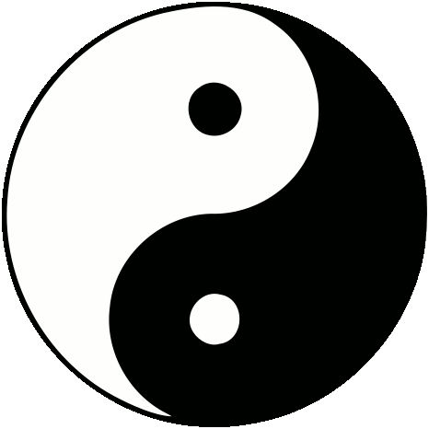
This is also known as the Taiji symbol. The circle represents Tao, the undifferentiated unity out of which all of existence arises. The movement in the symbol represents the ways in which Yin and Yang are mutually-arising and interdependent. One could not exist without the other.
Some examples include:
- Night and Day- Night becomes Day, Day becomes Night
- Friends and Enemies
- Birth and Death

The large circle is divided into two halves, one black and one white in a tear-drop shape. Within each half is a small circle of the opposite color. The smaller circle within the large circle is a reminder that the black and white are opposites and that even though they are exact opposites, they are dependent on one another. In Taoism, the appearance of things is considered the Yin part of the symbol. The opposite, the Yang is the absence of anything.

Artifact 2: Ancient Chinese Seismograph

Currently, a restored model of the ancient Chinese seismograph is being held at the Exhibition Hall of the Museum of Chinese History in Beijing. It was called the Houfeng Didong Yi, created by Zhang Heng, and its main job was to test wind and earth movements.

It was invented to determine the direction of an earthquake. Contrary to popular belief, Heng did not believe that earthquakes were signs of Heavens anger.

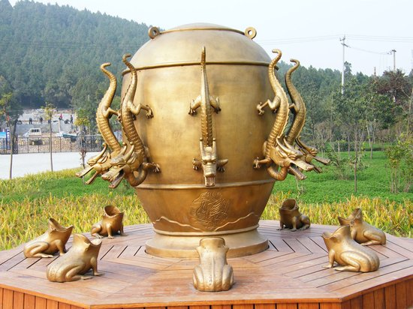
The original seismograph was made of fine copper. It was cast with eight dragons on the outside with their heads pointed in the eight directions, North, North-East, East, South-East, South, South-West, West, and North-West. Each dragon had a copper ball in its mouth. Below the dragons were eight toads raising their heads with their mouths open.

When an earthquake occurred, an earth tremor caused a pendulum on the inside to lose balance and activate a set of levers. One of the eight dragons would release the bronze ball and it would fall into the mouth of one toad and let out a sound which would alert and signify where and which direction the movement came from.
Artifact 3: Silk [tie]

For more than two-thousand years the Chinese kept the secret of silk to themselves.

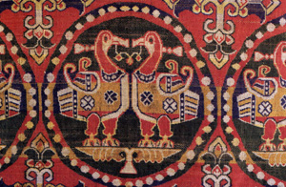
There are many varieties of wild silk moths in a number of different countries. China’s secret moth was with the blind, flightless moth, Bombyx morl. It lays 500 or more eggs in 4-6 days and dies soon after. The worms from the eggs of the moth would eat a ton of mulberry leaves and produce about 12 pounds of raw silk. There is a very specific and lengthy process that the Chinese kept a secret for many, many years. At first the silk was only allowed for the emperor and his close relations, gradually, everyone began to wear it.

The Chinese people started to use silk as a form of payment, and eventually as a form of trade which is why the silkroad became a huge way to trade resources.

The secret of silk making reached Korea in 200 BC and India in AD 300. In AD 440, the prince of Khotan courted and won a Chinese princess who smuggled some moth eggs out in her hair and in AD 550, the most common story of how the secret got out was that two monks who were passing through hid some eggs in their hollowed out bamboo staves.

Artifact 4: Chinese Waterwheel

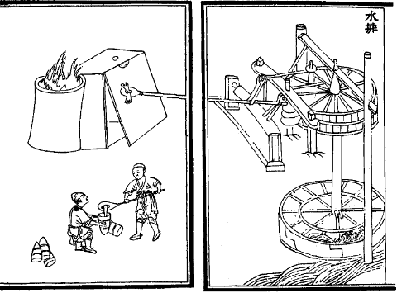
The Chinese Waterwheel became a huge resource. Waterpower was a big source of energy for the ancient Chinese civilization.

The engineer Tu Shih “invented a water-powered reciprocator for the casting of iron agricultural implements.” The smelters and casters were told to use the rushing water to operate their “billows” and they created the water wheel. Waterpower was very important in many different processes for the ancient Chinese especially in grinding grain. Unlike the common wheel that we are used to seeing, the Chinese waterwheel was typically horizontal.

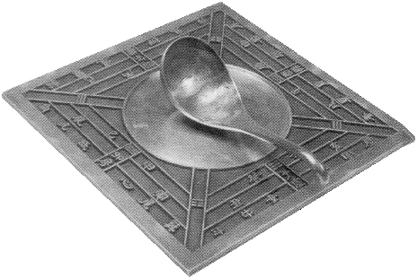
Artifact 5: Chinese Compass

Unlike the compasses we see today, the first compass was not designed for navigation. It showed people the way more figuratively than actually literally. It helped them order and harmonize their life similar to an aspect of feng shei.

The Chinese compass was built using a lodestone which is a form of the mineral magnetite that aligns itself with the Earth’s magnetic field. The lodestone sat on a flat, square-shaped plate made of bronze. The plate served as “Earth.” In the center of the plate was a large circle which represented “the heavens.” The lodestone, which is the piece that looks like a spoon, symbolized “the Great Bear” also known as Ursa Major. Because of the properties of the lodestone, the handle of the spoon always pointed South.

Sources:
Early Chinese Compass. Retrieved from <www.magnet.fsu.edu/education/tutorials/museum/chinesecompass.html> 10 July 2013
This resource can be used in teaching because it is a great website referring to the early Chinese compass and how it was developed. It also tells some of the basics of how a compass works today. I really liked this website because it was interactive and explained to students that this compass wasn’t used in the same way.

Hansen, R.D. Waterwheels. Waterhistory.org.retrieved from <www.waterhistory.org/histories/waterwheels/
I really liked this resource and found it very useful because it didn’t just refer to the Chinese waterwheel. It also discussed other waterwheels and how they were different. This could be used in the classroom because it gives students perspective that though the Chinese created their own waterwheel, they weren’t alone. Other people were doing similar things.

History of Silk.Silkroad Foundation. Retrieved from www.silk-road.com/art1/silkhistory.shtml 10 July 2013
I loved this website because it was very informative and very interactive. It had a lot of information on the history of silk and even described some of the myths that surround the history. It helps students understand how rare silk was at that time.

Revisiting the Ancient Chinese Seismograph. Retrieved from <kaleidoscope.culture-china.com/en/137kaleidoscope6712.htm> 10 July 2013
This resource would be great for the classroom because it showed students how different a seismograph was in the past. It also goes a little bit in to how the idea might be a myth because they can’t find any evidence of one in the past. It describes how the ancient seismograph was used and how it benefited the members of society.

Taoism. The Yin Yang Symbol. Retrieved from <Taoism.about.com/od/visualsymbols/p/yinyang.htm> 10 July 2013
This website was very interesting because it described aspects of a religion and of how people think. The idea of the Yin Yang has been around for so long and students are used to seeing the symbol but this resource reinforces the fact that there is a lot of deeper meaning surrounding the everyday image that they see.

Images:
Ancient Chinese Technology-compass. Retrieved from <http://library.thinkquest.org/23062/compass2.gif>

Metallurgical bellows, powered by a horizontal waterwheel, from the Chinese work of 1313Ad. Retrieved from <www.waterhistory.org/histories/waterwheels/waterwheelill3.png>

Seismograph.nd. [Seismograph invented by Chinese ancient Zhang Heng from Eastern Han Dynasty] retrieved from <www.china.org.cn/china/2010-12/03/content_21472907.htm>

Sogdian Silk. 8th century. Retrieved from <www.silk-road.com/art1/silkhistory.shtml>

The Yin-Yang Sylmbol: Dance of Opposites. [image] retrieved from <Taoism.about.com./od/visualsymbols/ig/Taoist-symbols/yin-yang-symbol.—jj.htm>

