Sydney Bland
Artifact Box
Nile River Civilization
Grade Level Band: Grades 6-8
Grade Level: Grade 6
Benchmark: History
Content Statement: History Strand: Early Civilization: 2- Early civilizations (India, Egypt, China and Mesopotamia) with unique governments, economic systems, social structures, religions, technologies and agricultural practices and products flourished as a result of favorable geographic characteristics. The cultural practices and products of these early civilizations can be used to help understand the Eastern Hemisphere today.

Grade Level Band: 6-8
Grade Level: 6
Benchmark: Geography : Spatial Thinking and Skills
Content Statement: 4. Latitude and Longitude can be used to identify absolute location.

Grade Level Band: 6-8
Grade Level: 6
Benchmark: Geography: Human Systems
Content Statement: 6. Variations among physical environments within the Eastern Hemisphere influence human activities. Human activities also alter the physical environment.
Content Statement: 7. Political, environmental, social and economic factors cause people, products and ideas to move from place to place in the Eastern Hemisphere in the past and today.

Common Core

Grade Level Band: 6-8
Grade Level: 6
Benchmark: Reading for Informational Text >> Integration of Knowledge and Ideas
Content Statement: 6.7. Integrate information presented in different media or formats (e.g., visually, quantitatively) as well as in words to develop a coherent understanding of a topic or issue.

Introduction:

The Nile River Civilization thrived along the Nile River in Egypt. The life of these early inhabitants revolved around the Nile River and the yearly floods. The people of the Nile were able to grow crops in the otherwise dry and barren land of Egypt. Without this fertile soil that appeared once a year, this early civilization would not have existed. This civilization was not only known for the fertile soil but also for their enormous structures, the pyramids. These were elaborate tombs for their pharaohs and were constructed over many years. Many of these elaborate structures are still standing today. The Nile River Civilization was a very strong civilization that seemed to think beyond their time. The early settlers came up with ways to collect taxes by developing a system of written numbers for counting, adding, and subtracting. The Egyptians also created a calendar to help keep track of the time between the flooding of the river and the planting of their crops. This early civilization developed and created many sophisticated things during the 3,000 years that it thrived.
In this artifact box, you will find various things that represent the Nile River Valley Civilization. The five artifacts correlate with the five themes of geography: location, place, relationship between places, movement, and region. The five items you will find in this box are a map of the civilization, information about the pyramids built during the time period, an explanation of the “Gift of the Nile,” a picture of the Rosetta Stone, and finally information about the natural borders that surrounded the Nile River Civilization. Each of these five artifacts was important to the Nile River Civilization and played a part in the thriving of the civilization.

- Location: Map and geography of the Nile River
The Nile River Valley Civilization was located along the Nile River. The Nile is 4,135 miles long, making it the world’s longest river. The two sources of the river are Lake Victoria and Lake Tana. It is estimated that the Nile drains an area of 1,293,000 square miles. The Nile would flood yearly, creating very fertile land for the people who lived along the river. They used to river for agriculture and transportation. The people of the Nile River Civilization would not have been able to survive without the river. There are many ways that this can be used to class. Student can use the map to locate different locations and monuments that were built by the early Nile Civilization using latitude and longitude lines. With a map you can also talk about the land surrounding the river and why was it important to have the yearly flooding; students could think about what would have happened to the civilization if the river did not flood.
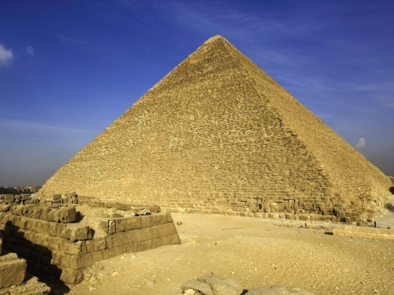
- Place: Pyramids
In the times of the Nile River Civilization, the Egyptians believed their king ruled even after he had died. Since they believed he reigned forever, their built enormous tombs for them called pyramids. There have been over 100 pyramids discovered in the deserts of Egypt. One of the largest pyramids is the Great Pyramid of Giza, which is 482 feet tall. This pyramid is one of the Seven Wonders of the World. Historians are not sure how the workers built them, but they do have theories; the workers may have dragged, lifted or rolled the stones for the Great Pyramid. More than 2 million granite/limestone blocks make up the pyramid and it is believe that it took 20 years and roughly 20,000 men to build this massive structure. There are many ways that this artifact can be used in class. Students can work on finding the area or surface area of the structure or they can build models of them, making them exact replicas to a smaller scale.
- Relationship between places: “The Gift of the Nile”
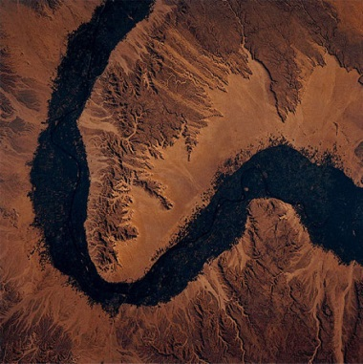
Each year the Nile River would flood, leaving behind fertile land for farmers to plant their crops. Each year in July rains and melting snow caused the river to rise and overflow over its banks. The river would be flooded until October and when it finally receded, it would leave behind black mud which was extremely fertile. For this reasons, farmers did not need any type of fertilizer for their crops. Before the mud would dry, the farmers would plant their fields. This cycle would repeat itself each year, which is why it became known as “The Gift of the Nile.” The early civilizations would not have thrived if it was not for this “gift.” This artifact could be used to discuss the different agriculture of the early civilization and discuss the different crops the farmers planted in the fertile land.

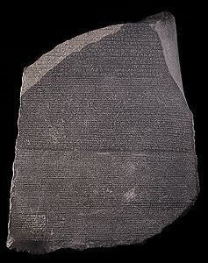
- Movement: Rosetta Stone
The Rosetta Stone was found in 1799 by a group of French soldiers. On the stone, there was a message written in three different languages; one was written in hieroglyphics that was used for important or religious documents, one script was written in demotic which was the common script in Egypt, and a third in Greek because this was the language of the Egyptian rulers of the time. The stone was written in a three languages so priests, government officials, and Egyptian rulers could read what it said. When the stone was found, no one was able to read it. Since Greek was well known, it gave clues to the different meanings of the hieroglyphics. It took years to decipher what the stone said but finally in 1822, Jean Francois Champollion, broken the code of the hieroglyphics. This artifact can be used in many different ways in class. Since this is a primary resource and the different symbols are now known, students can look at the symbols and figure out different Egyptian texts or even work on writing English words using hieroglyphics.
- Region: Natural barriers
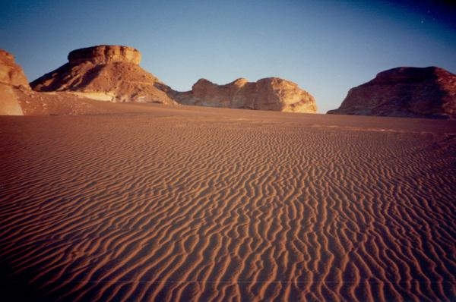
The Nile River Civilization was surrounded by many natural barriers that protected the people from invaders. The Red Sea is the border to the East while the desert is a border to the west. The area was also protected by the Mediterranean Sea to the North and mountains are the border to the South. These borders made a great place to form a civilization and offered natural protection from surrounding civilizations. The Nile River also had rapids that prevented people from travelling up the river and attacking the people of the Nile River Civilization. These natural borders also allowed this civilization to prosper and grow. This artifact can be used for studying different natural landforms and how they can offer protection to civilizations.

Sources:
- Early River Valley Civilizations. Retrieved from http://www.ltisdschools.org/cms/lib/TX21000349/Centricity/Domain/287/Chapter2.pdf
- Rosetta Stone. Retrieved from http://www.ancientegypt.co.uk/writing/rosetta.html
- The Importance of the Annual Nile Flooding for the Nile River Civilization. Retrieved from http://marktanner.com/niletrip/importance-of-nile-river-floods.html
- Dealing with the Deluge (1996, March 26). Retrieved from http://www.pbs.org/wgbh/nova/earth/dealing-deluge.html
- Ancient Egyptian Construction (2012, June 7). Retrieved from http://blueprintmasonry.com/ancient-egyptian-construction/
- The Nile River. Retrieved from http://www.socialstudiesforkids.com/articles/geography/nileriver.htm
- Ancient Egypt. Retrieved from www.awhistory.com/egypt/
- Nile River Valley Civilization. Retrieved from http://civilization.yolasite.com/nile.php

