Sydney Bland and Alicia Birkmire
Historiography: What really caused World War I?
Description
For this activity, students will be researching World War I and trying to figure out the cause or causes of the war. Many historians still debate over the causes of the war. Many of them believe it was the assassination of Archduke Franz Ferdinand started the war while others believe the causes were militarism, alliances, imperialism, and nationalism. Students will be looking at various resources to figure out the causes of the war. They will be working in partners do research then coming to a conclusion about their ideas. Once they figure out the causes, they will write a short paper then present their ideas to the class.
Standard:
Civil Participation and Skills: Statement 9-Different perspectives on a topic can be obtained from a variety of historic and contemporary sources. Sources can be examined for accuracy.
Question:
What caused World War I to begin? Many historians debate over the cause(s) of the war. It is up to you and your partners to figure out what actually caused World War I.
Resources
- http://www.kidskonnect.com/subjectindex/16-educational/history/287-world-war-i.html
- http://www.slideshare.net/maggiesalgado/causes-of-world-war-i-11337746
- http://www.bbc.co.uk/learningzone/clips/four-main-causes-of-the-first-world-war/5646.html
- http://www.firstworldwar.com/source/harrachmemoir.htm
- http://www.angelfire.com/mi3/ww1/causes.html
- http://www.painesville-township.k12.oh.us/userfiles/1139/Classes/6285/major%20causes%20of%20wwi.pdf
- http://www.history.com/this-day-in-history/archduke-franz-ferdinand-assassinated
- Additional resources can be approved by the teacher for student use.
In class activity
- At the beginning of class, students will share all their thoughts and ideas about World War I. Students will share their ideas then go and write them up on the board. They can share anything they know about the war (causes, how long it lasted, etc.). Explain to students that we will mostly be looking at the causes of the war.
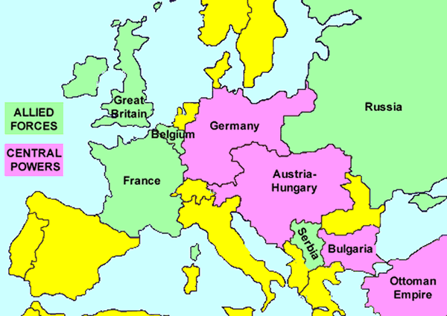
- After students have shared their ideas, the class will look at a map of the different countries involved in the war to make themselves familiar with the areas we will be talking about during this activity.
- After looking at the map, describe to students what a historiography is. Students will watch a short video that helps explain the assignment.
  - http://www.youtube.com/watch?v=pB3xb1_gp4Y
- Once students have seen the video, explain to them once more what the assignment is to clear up any confusion.
- Students will then be presented with the question: What caused World War I to begin? Many historians debate over the cause(s) of the war. It is up to you and your partner to figure out what actually caused World War I. Did the assassination of Archduke Franz Ferdinand cause the war or were there many different things lead to the war?
- After students have been presented with the question, their assignment is to research the causes, choose what they think caused the war, write a short paper (about 2 pages), then present their findings to the class.
- Allow students time in class to begin research with laptop, books, etc. Students will work until the end of the class period. Not all students will be finished, carry activity over to next day or two if needed.
- Once all groups are finished with their research, they will begin to write their paper on the topic. They will work together when writing their paper to turn in.
- All groups will present their findings to the class on their scheduled day.
Assessment
- Student will be graded on their work in class, the paper they write, and their presentation to the class.
- This assignment is worth 50 points.
  - 10 points for in class work based on teacher observation and partner feedback
  - 20 points for written paper
  - 10 points for works cited page
  - 10 points for in class presentation

