Ohio Academic Content Statement
GRADE 6
History Strand: Early Civilizations: Content Statement: 2. Early civilizations (India, Egypt, China and Mesopotamia) with unique governments, economic systems, social structures, religions, technologies and agricultural practices and products flourished as a result of favorable geographic characteristics. The cultural practices and products of these early civilizations can be used to help understand the Eastern Hemisphere today.
Common Core Connections
GRADE 6
Reading Standards for Informational Text: Integration of Knowledge and Ideas: 7. Integrate information presented in different media or formats (e.g., visually, quantitatively) as well as in words to develop a coherent understanding of a topic or issue.
Reading Standards for Literacy in History and Social Studies: Integration of Knowledge and Ideas: 7. Integrate visual information (e.g., in charts, graphs, photographs, videos, or maps) with other information in print and digital texts.
Introduction and Description of Civilization
Mesopotamia is a Greek word that means “land between two rivers.” The two rivers being referred to are the Euphrates and Tigris Rivers. These rivers made it easy for the people to fish, travel, and trade. The land and civilization that developed between these two rivers is thought to be the earliest civilization and one of the most influential civilizations in history. These people are credited with several inventions and thought processes. It was the first civilization to utilize irrigation systems for farming. Using the two nearby rivers, the Mesopotamians created canals and ditches to aid in watering their crops. They are also credited with developing a base six number system, a calendar system, cuneiform writing, and inventing the wheel. The achievements of the Mesopotamian people spread throughout the world.
Politics ruled in Mesopotamia. The land was divided into city-states, more due to geographical reasons than any other. There were three classes of people: the Upper Class (kings, priests, government people), the Middle Class (artisans, merchants, farmers, fishermen), and Lower Class (enslaved people). Kings ruled the land and were known for making laws that carried harsh punishments. There were several wars fought over time for rule of Mesopotamia. These wars resulted in several power changes, however they were all male rulers and they would sometimes stay in power long enough for sons of the king to take control once the elder died, keeping the rule in families for generations.
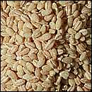
Artifacts
Agriculture
Artifact: Barley
The land in Mesopotamia was very fertile and good for growing crops, however lack of rain on one end of the spectrum and flooding on the other end, made farming difficult. In fact, the Mesopotamian people came up with a way to irrigate their crops using canals and ditches during the dry times. Even with these extremes, the Mesopotamians were able to grow some crops, especially grains. Barley and flax were the two most popular choices and were used for many things. Flax was used for cloth, oil, food, and put in medicines. Barley was a main food source and put into bread, soups, and used to make beverages. Other agricultural items that were harvested were: dates, olives, and grapes.
Hammurabi’s Code
Artifact: Cuneiform Clay Tablet
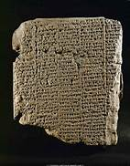
Hammurabi was the ruler of Babylon from 1792-1750 BC. He took over rule after his father and grew Babylon from a small city-state to a large state. He was the first to unify all of the city-states in Mesopotamia. During his reign, he took the best laws from all the areas and created on set of laws for everyone to follow. There were 282 laws that covered everything from crimes to farming and business to marriage and family. Historians are still split whether these laws are fair or cruel. The ones who say they are fair say so because they referred to all aspects of society and addressed all people. The ones who say they are cruel is because most punishments were violent or resulted in death and some laws had different punishments depending on class.
Map
Artifact: Map of Mesopotamia
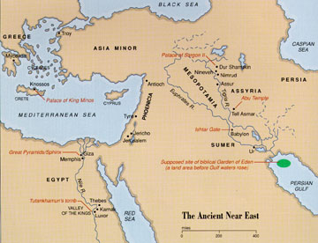
The land of Mesopotamia was quite fertile due to the ever changing path of the Tigris and Euphrates Rivers. The Euphrates River is on the West and the Tigris River is on the right. They also have the Zagros Mountains in the east. The Northern part of Mesopotamia had hills and plains which made it a good place to farm. Southern Mesopotamia was somewhat marshy and flat. The present-day land of Mesopotamia is located in parts of Iraq, Syria, Turkey, and Iran.
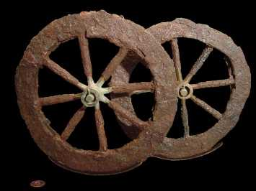
The Mesopotamian Wheel
Artifact: Clay Wheel
Archeologists believe that the first wheel was invented around 8000 BC. However, the oldest wheel ever found was in Mesopotamia and was probably made around 3500 BC. The first wheel made may have been used as a potter’s wheel. Once the idea was there, the Mesopotamians put it in to use to make life easier for transporting goods and travel. There are sculptures and artwork depicting Ancient Mesopotamians in chariots, so they must have put a lot of thought into evolving wheels to that point.
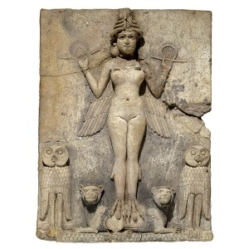
Mesopotamian Religion
Artifact: Picture of a sculpture of a god
The people of Mesopotamia believed that battles between the different gods is what created the world and its people. There were gods to represent every aspect of their lives: from gods of agriculture, water, and health, to gods of bricks and everything in between. They would pray to these gods for things of major importance, like health, down to the everyday items and actions of life. Every city had a temple to the patron god. This was located right in the center of the city and was the largest of all temples. At least once a year, the statue of the god was removed from the temple and paraded around the city as a way of honoring him or her.
Conclusion – How Artifacts Can Be Used in Teaching
These artifacts could be used to teach this content statement in many ways. Two examples are:
- It could be used as an introduction activity to get students excited about the content they are about to learn. If a teacher had an artifact box for all the different ancient river civilizations, it would be neat to have a group of students inspect each box individually and try to make conclusions about the civilizations based just on the artifacts in the box. They could then learn about the different ancient river civilizations and see if their predictions/assumptions were correct.
- It could be used as an example. After learning about the different ancient river civilizations, students could use the teacher created box as an example of what they would need to create for an artifact box of their own. It is always good to model learning so that students have a better understanding of what is being asked of them and where the final result should be.

Sources
Chapter 1: The first civilizations. In (2008). World History Journey Across Time The Early Ages (Teacher Wraparound Edition) United States of America: The McGraw-Hill Companies, Inc.
Early river valley civilizations. (n.d.). Retrieved from http://old.clevelandstatecc.edu/courses/ngreenwood/history 1110/online_presentations/first_river_valley_civilizations.htm
Edzard, D. O. (n.d.). History of mesopotamia. In Encyclopedia Britanica. Encyclopedia Britanica, Inc. Retrieved from http://www.britannica.com/EBchecked/topic/376828/history-of-Mesopotamia
Geography. (n.d.). Retrieved from http://www.mesopotamia.co.uk/geography/home_set.html
Invention of the wheel. (n.d.). Retrieved from http://library.thinkquest.org/C004203/science/science02.htm
Major crops produced in ancient mesopotamia. (n.d.). Retrieved from http://www.ancientmesopotamians.com/ancient-mesopotamian-crops.html
Mark, J. J. (2011). Mesopotamian religion. In Ancient History Encyclopedia. Ancient History Encyclopedia. Retrieved from http://www.ancient.eu.com/Mesopotamian_Religion/
The mesopotamian wheel. (n.d.) Retrieved from http://www.ancientmesopotamians.com/the-mesopotamian-wheel.html

