Euphrates River Civilizations:
Mesopotamia
Grade Level: 6
Strands and Content Standards:
History:
6.1 Early civilizations (India, Egypt, China, and Mesopotamia) with unique governments, economic systems, social structures, religions, technologies and agricultural practices and products flourished as a result of favorable geographic characteristics. The cultural practices and products of these early civilizations can be used to help understand the Eastern Hemisphere today.
Geography:
6.3 Globes and other geographic tools can be used to gather, process and report information about people, places, and environments.
6.4 Latitude and longitude can be used to identify absolute location.
6.6 Variations among physical environments within the Eastern Hemisphere influence human activities. Human activities also alter their physical environment.
Government:
6.10 Governments can be categorized as monarchies, theocracies, dictatorships, or democracies, but categories may overlap and labels may not accurately represent the government’s function. The extent of citizens’ liberties and responsibilities varies according to limits on governmental authority.
Economics:
6.15 The interaction of supply and demand, influenced by competition, helps to determine price in a market. This interaction also determines the quantities of outputs produced and the quantities of inputs used.
6.16 When selecting items to buy, individuals can compare the price and quality of available goods and services.
• The content will be focused on:
- Geographic Location
- Government
- Religion
- Economic Systems
- Agriculture
- Social Structures

The Euphrates River was the Western border of the ancient civilization of Mesopotamia.
Mesopotamia means the land between two rivers as it sets between the Euphrates and Tigris Rivers. Mesopotamia included the Sumer, Akkadian, Babylonian, and Assyrian Civilizations. All of the Cultures share many similarities with one another including type of government, religion, economics, agriculture and social structures. They also shared the same advancements in science and technology including the wide spread use of large irrigation systems, and the writing style called cuneiform. The area is known as the Fertile Crescent because of it extremely fertile valley. The land is so fertile because of the two rivers and their many tributaries flow from the Southern part of Turkey to the Persian Gulf. This area is also referred to as the cradle of civilization since Mesopotamia’s origins go all the way back to the dawn of written history around 3100 BC.
In my artifact box you will find a variety of objects that show a representation of the location, government, religion, economic system, agriculture, and social structures of the Mesopotamian cultures. The objects you will find are: a map; cloth for a robe; a ziggurat; a money pouch; a farmer and a cow; and a clay tablet. You will also find student activities that could be done with each section.

- Geographic Location -
Artifact: Map that labels the Euphrates River, Euphrates River Valley, and historic sites.

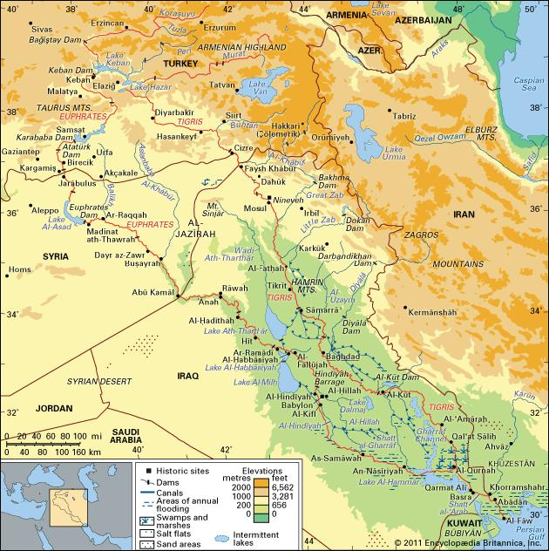
The Euphrates River is, and Mesopotamia was, located in modern day Iraq, Kuwait, Iran, Syria, and Turkey. The Euphrates and Tigris Rivers empty out into the Persian Gulf. The area of land from the Mediterranean Sea to the Persian Gulf was called the Fertile Crescent because it had rich soil and abundant crops to sustain life in the early civilization, but today is dessert. Mesopotamia was also separated into Upper Mesopotamia and Lower Mesopotamia. Upper Mesopotamia was the area between the Euphrates and the Tigris Rivers from their sources down to modern day Baghdad. The Lower region was between Baghdad and the Persian Gulf. The students could also use this map to find the locations of historic places along the Euphrates River. The students could also draw the outline of Mesopotamia on this map along with the locations of Assyrians, Sumerians, and Babylonians. The students could also use the map to mark trade routes with other civilizations or show the expansion of the Mesopotamian Empire. Also during this lesson you use the map to teach the social concepts longitudes, latitudes, elevations, and how to use a map key. This map also lends itself to the utilization of some skills with finding the difference between elevations, using scale to find distances, and again the use of longitude and latitude.

- Government -
Artifact: Cloth for a robe
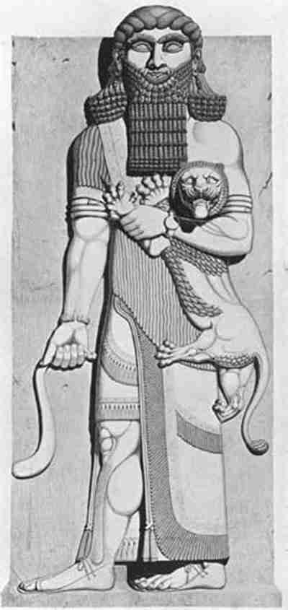
The Mesopotamian cultures that included the Assyrians, Akkadians, Sumerians, and the Babylonians were all monarchies like the modern day British Monarchy. However, the monarchs in Mesopotamian cultures were believed to be the decedents of the Gods. Also, the kings wore robes of a fine cloth instead of a crown. In Mesopotamia the monarchies grew from single rulers of a single city-state, to a single ruler over several city-states, and finally just a single ruler with power over the entire empire. The kings created laws through their decisions and by legal precedence, and these laws usually only pertained to a single city-state or providence. The most well known set of laws from Mesopotamia are the laws set fourth in the Code of Hammurabi. The Code of Hammurabi was written on giant stones, metals, and clay tablets. The code consisted of 282 laws. The laws covered everything from theft to murder, building mandates, divorces, and military service. The teacher will appoint a student king, and have them put on the “royal robe” (a bed sheet). The student king will then create their own set of rules for the class, and the punishments that go with them. The students would then transcribe them on a “tablet” to hang in the room. The class would follow these rules for a day or two, and then decide on a new ruler. The process would be repeated a few more times, and with another appointed succession. After all the rulers are overthrown, have the class discuss their experience and decide who was the best ruler.
- Religion -
Artifact: Ziggurat

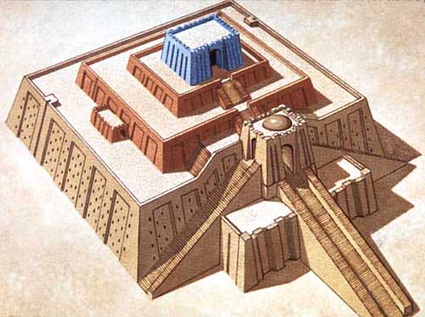
A ziggurat is a massive structure that is commonly rectangular in shape built mostly along the Euphrates River and in the valley between the Euphrates and Tigris Rivers. The ziggurat was built by all the Mesopotamian cultures to use in their local religions. Some of the better-known ziggurats include the Great Ziggurat of Ur in Iraq, the Ziggurat of Aqar Quf also in Iraq, and the Ziggurat Sialk in Iran. All of the religions were polytheistic, which means they worshipped many gods, and would be lead in their worship by priests. Not only would the people worship several gods, but they would also worship different gods depending on their location. The students could create their own ziggurats using model magic, or clay. They would also create, or choose, a god that would be worshiped at their ziggurat. The students could then write about their ziggurat describing its shape, size, color, and ornamentation. The students could then also describe their god, what they control, and how they are worshipped.

- Economic Systems -
Artifact: Money pouch with gold, silver, copper, and grain.

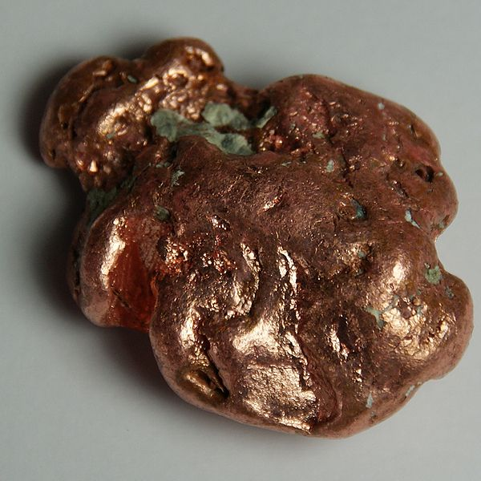
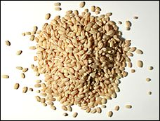
The Mesopotamians economic system relied on the barter system. Along the Euphrates River people would catch fish, farm and raise livestock not only to feed themselves, but to also barter for goods they needed. They would also use metals like gold, silver, and copper to trade with since these could be used to make jewelry, tools, or even weapons. However, the most commonly bartered items were grain and livestock. A person might trade a basket or barley or a cow to get something else they needed or wanted. The students could bring in items, or candy, and then barter with other students to try to get their “goods.” After the bartering has ended have the class create a “price list” starting with the most wanted items to the least wanted items. Then go through the list to see how many lesser items it took to purchase the better item. After the discussion have the students write about their experience and if they thought they received a fair trade for their “goods.” The bartering system and prices list would also be a great math tie in.

- Agriculture -
Artifact: Farmer and Cow

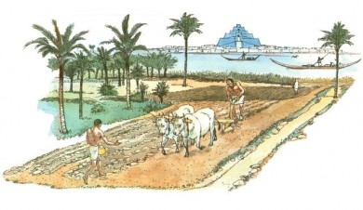
The Euphrates River was one of the two rivers that helped to create the Fertile Crescent. The Fertile Crescent extended from modern day Turkey through Iraq and Syria finally ending in Israel. Farming was a not only a job, but a way of life. Farmers grew the food, but also had the most sought after items for trading. The earliest crops were wheat, barley, various legumes, grapes, melons, dates, pistachios and almonds. Not all of the land was suitable for farming around the Euphrates River so the Mesopotamian cultures began to use irrigation techniques to make the land usable. For instance, the Sumerians built huge embankments along the Euphrates River, drained the marshes, and dug irrigation ditches and canals. This allowed more people to farm and for there to be larger harvests to feed the growing populations. To help with the farming, the Mesopotamians also created tools like the hoe or plow. Both tools would be used to create cuts in the ground in order to plant new seeds. However, the plow would require the farmer to have access to metal and own several heads of cattle in order to pull it. The students could create a diorama of an ancient farm featuring ancient techniques. They could then create a diorama of a modern farm using modern techniques, and use it to compare them to each other to see the differences and similarities.

- Social Structures -
Artifact: Clay tablet
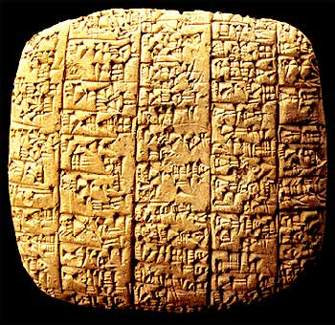
Clay tablets were the main way of recording important information in Mesopotamia. Scribes were in charge of keeping track of all the laws and transactions that occurred within a city-state. They would also keep record of the social statuses of families in their region on clay tablets. Even though scribes were the children of noble birth, being a scribe was considered to be very prestigious, they were not considered to be at the top of the social system in Mesopotamia. All of the Mesopotamian cultures based their society a social hierarchy. At the top were the priests because they were the ones that spoke on behalf of the gods. The King, or ruler over the city-state or region, usually either was on the same level as the priests because they were considered to be a descendent of one of their gods. Below the priests and kings were the noble free citizens. This level was comprised of government officials and people with great wealth. This level dressed in finer clothes and rarely did manual labor themselves. Below the nobles were the soldiers and scribes. On the next level down were the traders, craftsmen, merchants, farmers, and other free citizens. Finally, on the lowest level were the slaves that were comprised of people who were in debt, prisoners, and criminals. The students will create their own clay tablet to tell a story. The students will need to come up with their own symbols and meanings to write on their tablets. When the tablets are completed, the students will share their stories with the class.
Resources:
Ascalone, Enrico. Mesopotamia: Assyrians, Sumerians, and Babylonians. Berkley, CA:
University of California Press. 2007. Print.
Mehta-Jones, Shilpa. Life in Ancient Mesopotamia. New York, NY: Crabtree Publishing
Company. 2005. Print.
Mountjoy, Shane. The Tigris and Euphrates Rivers. Philadelphia, PA: Chelsea House Publishers.
2005. Print.

