Benefits Modelling / Benefits Mapping Briefing Sheet

What is a benefit?
A benefit is a “measurable improvement resulting from an outcome which is perceived as an advantage by a stakeholder. Benefits are anticipated when a change is conceived”.
Value Chain:
Project Output
Business Change
Outcomes
BENEFITS
Strategic Objective

Benefits Value Types:
Value Type |  | Definition | Example
 |  | Definition | Cashable | Non-Cashable
Tangible | Definite | Value may be predicated with certainty | Reduced costs | Fewer steps in a process
Tangible | Expected | Value may be predicated on the basis of historic trends | Increased rates | Quicker performance of tasks
Tangible | Anticipated | The benefit is anticipated but its value is not really predictable | Lower insurance premiums | Greater customer satisfaction
Intangible |  | May be anticipated but difficult to substantiate. Relies on proxy measurement and assumptions | Improved image (Proxy: improved results in customer satisfaction surveys)

Benefits Profile: Each benefit identified should have a benefits profile associated to it. A benefits profile could contain many of the factors listed below.

- Description of benefit or dis-benefit
- Programme/organisational objectives supported; KPIs
- Current baseline performance
- Improvement/deterioration anticipated
- Other benefits that this benefit contributes to
- Costs (not included in this project)
- Benefit Owner
- Features required for benefit tp be realised i.e. other projects
- Business changes required (process, culture, people, policy)
- Earlier benefits on which this depends
- Related issues and risks
- Dependencies on other programmes/projects

- Measurement (financial where possible)

Benefits Modelling Process:
Objective(s)
- Establish and document the relationship between different benefits
- Capture any additional benefits/dis-benefits emerging from the process
What is a benefits model?
The main objective of the model is to illustrate the benefits of a programme/project on a one page diagram. In essence it is a route map of how change and new capabilities delivered by a programme/project lead to benefits to the business. The inter-relationship and dependencies between project outputs and business benefits are represented using a cause and effect model.
Once all the main benefits have been identified and documented , it is important to clarify the relationship between the different levels of benefit. This structuring, or modelling, can be developed and presented using a graphical representation known as a benefit model.
Key components of a benefits model
The model is usually developed from left to right and has 3 main sections or channels:
Enablers – these can be defined as any new capabilities that are directly attributable to the investment in the project. Enablers are what the project is going to build, buy or deliver. If an enabler doesn’t come directly from what the project/programme delivers then it cannot be part of the project’s benefits.
Intermediate benefits – these benefits describe the actual operational improvement resulting from the project e.g. quicker access to information, improved financial management, faster turnaround times etc. These functional or operational benefits must be able to be measured, or a project cannot prove they are indeed benefits, or that any improvement is directly attributable to changes implemented by the project. If an intermediate benefit can’t be measured then it isn’t a useful benefit. An individual benefit profile is produced for each intermediate benefit. This is used to record the benefit, allocate responsibility for measuring it and to identify any activities required to manage benefit delivery. This will also include all dis-benefits.
End benefits – these are strategic/organisational level benefits or benefits linked to the wider NICS and are generally aligned with organisational strategy and corporate plans. End benefits usually describe what the organisation is seeking to achieve as a result of the business changes. Measurement of an end benefit is achieved through the measurement of its component intermediate benefits.
Who does Benefits Modelling?
The programme/project manager should organise and co-ordinate this stage of the process with the actual development work done by the project team, working / steering group and any additional stakeholders as required.
How?
The project team must decide how best to structure and model the benefits. Often benefit workshops are used as they provide a focused and effective means to consider the interrelationship between project benefits. This approach allows for open discussion between the project team and affected parts of the business, and should ensure a comprehensive and fully agreed set of structured benefits are produced. The use of an experienced facilitator who isn’t a major stakeholder can be useful to encourage productive discussion and to assist the development of the benefit model.
Guidelines for developing a benefits model
- Enablers must be new tangible capabilities directly attributable to the investment in the project/programme
- An intermediate or end benefit will always have one or more predecessors and must be traced back to an enabler
- An intermediate benefit can have another intermediate benefit as its predecessor
- All intermediate benefits should have a unique identifier e.g. A, B, C
- All intermediate benefits must have a category i.e. COST, TIME, SATISFACTION
- An end benefit can have another end benefit as its predecessor
It is essential that all benefits identified can be measured, whether quantitatively or qualitatively. If this cannot be done, then the benefit should not be claimed.
Benefits modelling is an iterative process and may require several workshops to agree a final version. The model should remain flexible and open to new and emerging benefits and dis-benefits. Additionally, during the benefits modelling process it is very likely that the original list of benefits identified in the benefits statement will alter significantly. Some new benefits (and dis-benefits) will emerge and some existing benefits will cease to be relevant or meaningful. At this developmental stage, benefits should be re-visited, critically evaluated and, where necessary, amended on a regular basis.
Advantages of Benefits Modelling
- Relatively quick model turn-around
  - Short run time but requires subject matter expert input per iteration
- Enables consideration of both technical and non-technical factors e.g. training and logistics in an integrated framework
- Enables consideration of dissimilar solutions
- Traceability of causal-chains allow better support to decision-making than provision of ‘just a number’
Disadvantages
- Method is not suitable for ‘initial elicitation of problems for which stakeholders have little clear understanding’ [Mathieson, 2002]
- As the method is based on subjectivity, there is generally a preference to not use the method in isolation but in addition to ‘hard’ system performance models
Example of a benefits map:
- Problem: Understanding the benefits of enhancements to the capability of an intelligence analysis organisation (Alecia Lewis, 2009, Dstl)
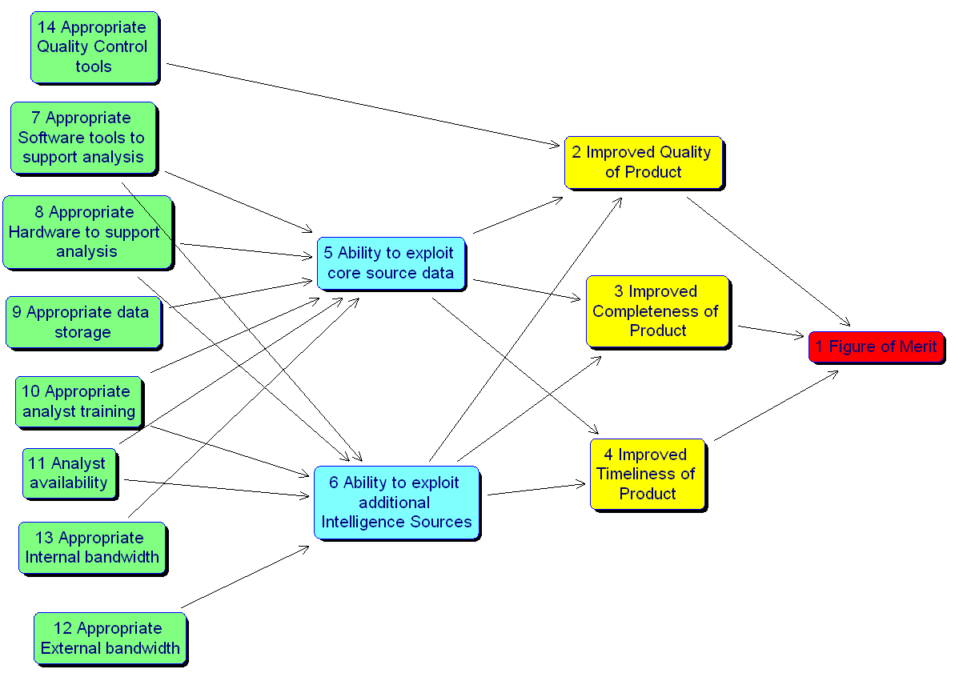
Further reading:
- Benefits Analysis- A Robust Assessment Approach, Mathieson G, JORS, 2004.

