Early Civilizations: Egypt

Grade Level Band: 6-8
Grade Level: 6
Theme: Regions and People of the Eastern Hemisphere
Strand: History
Topic: Historical Thinking and Skills
Content Strand 1: Events can be arranged in order of occurrence using the conventions of B.C. and A.D. or B.C.E. and C.E.
________________________________________________________________________

Grade Level Band: 6-8
Grade Level: 6
Theme: Regions and People of the Eastern Hemisphere
Strand: History
Topic: Early Civilizations
Content Strand 2: Early civilizations (India, Egypt, China and Mesopotamia) with unique government, economic systems, social structures, religions, technologies and agricultural practice and products flourished as a result of favorable geographic characteristics. The cultural practices and products of these early civilizations can be used to help understand the Eastern Hemisphere today.
________________________________________________________________________

Grade Level Band: 6-8
Grade Level: 6
Theme: Regions and People of the Eastern Hemisphere
Strand: Geography
Topic: Places and Regions
Content Strand 5: Regions can be determined, classified and compared using various criteria (e.g., landform, climate, population, cultural, or economic).
________________________________________________________________________

Grade Level Band: 6-8
Grade Level: 6
Theme: Regions and People of the Eastern Hemisphere
Strand: Geography
Topic: Human Systems
Content Strand 6: Variations among physical environments within the Eastern Hemisphere influence human activities. Human activities also alter the physical environment.
________________________________________________________________________

Grade Level Band: 6-8
Grade Level: 6
Theme: Regions and People of the Eastern Hemisphere
Strand: Geography
Topic: Human Systems
Content Strand 7: Political, environmental, social and economic factors cause people, products and ideas to move from place to place in the Eastern Hemisphere in the past and today.
________________________________________________________________________

Grade Level Band: 6-8
Grade Level: 6
Theme: Regions and People of the Eastern Hemisphere
Strand: Government
Topic: Roles and Systems of Government
Content Strand 10: Governments can be categorized as monarchies, theocracies, dictatorships or democracies, but categories may overlap and labels may not accurately represent how governments function. The extent of citizens’ liberties and responsibilities varies according to limits on governmental authority.
________________________________________________________________________

Grade Level Band: 6-8
Grade Level: 6
Theme: Regions and People of the Eastern Hemisphere
Strand: Economics
Topic: Scarcity
Content Strand 13: The fundamental questions of economics include what to produce, how to produce and for whom to produce.

The Ancient Egyptian civilization was a part of the Nile River Valley. The Egyptians used resources available to them because of the river near their civilization. As far back as 10,000 B.C. to 525 B.C., people thrived. This time can be divided into six different kingdoms of time.
Many aspects of their lives grew because of the close location to the Nile River. Egyptian government was a monarchy lead by a Pharaoh. The society was based on a hierarchy of people in the area. The farming of grain, flax, cattle, and many others forms around the Nile River solely affected the economy. People worshiped many Gods like Ra, Isis, Horus, Osiris, and many more. They believed that the gods controlled all things in their lives. The Egyptians were also innovative by creating calendars, using hieroglyphics, medicine, and shipbuilding.
In this artifact box, you will find objects that are symbolic of the Egyptian government, economics system, social structures, religion practices, and technology. Some of the artifacts in the lesson and others are simply representations of the Egyptian civilization. You will find a pyramid, calendar, miniature bow and arrow, pictures of the various gods, hieroglyphics, and a cow figurine.

Pyramid
Artifact: Lego Pyramid

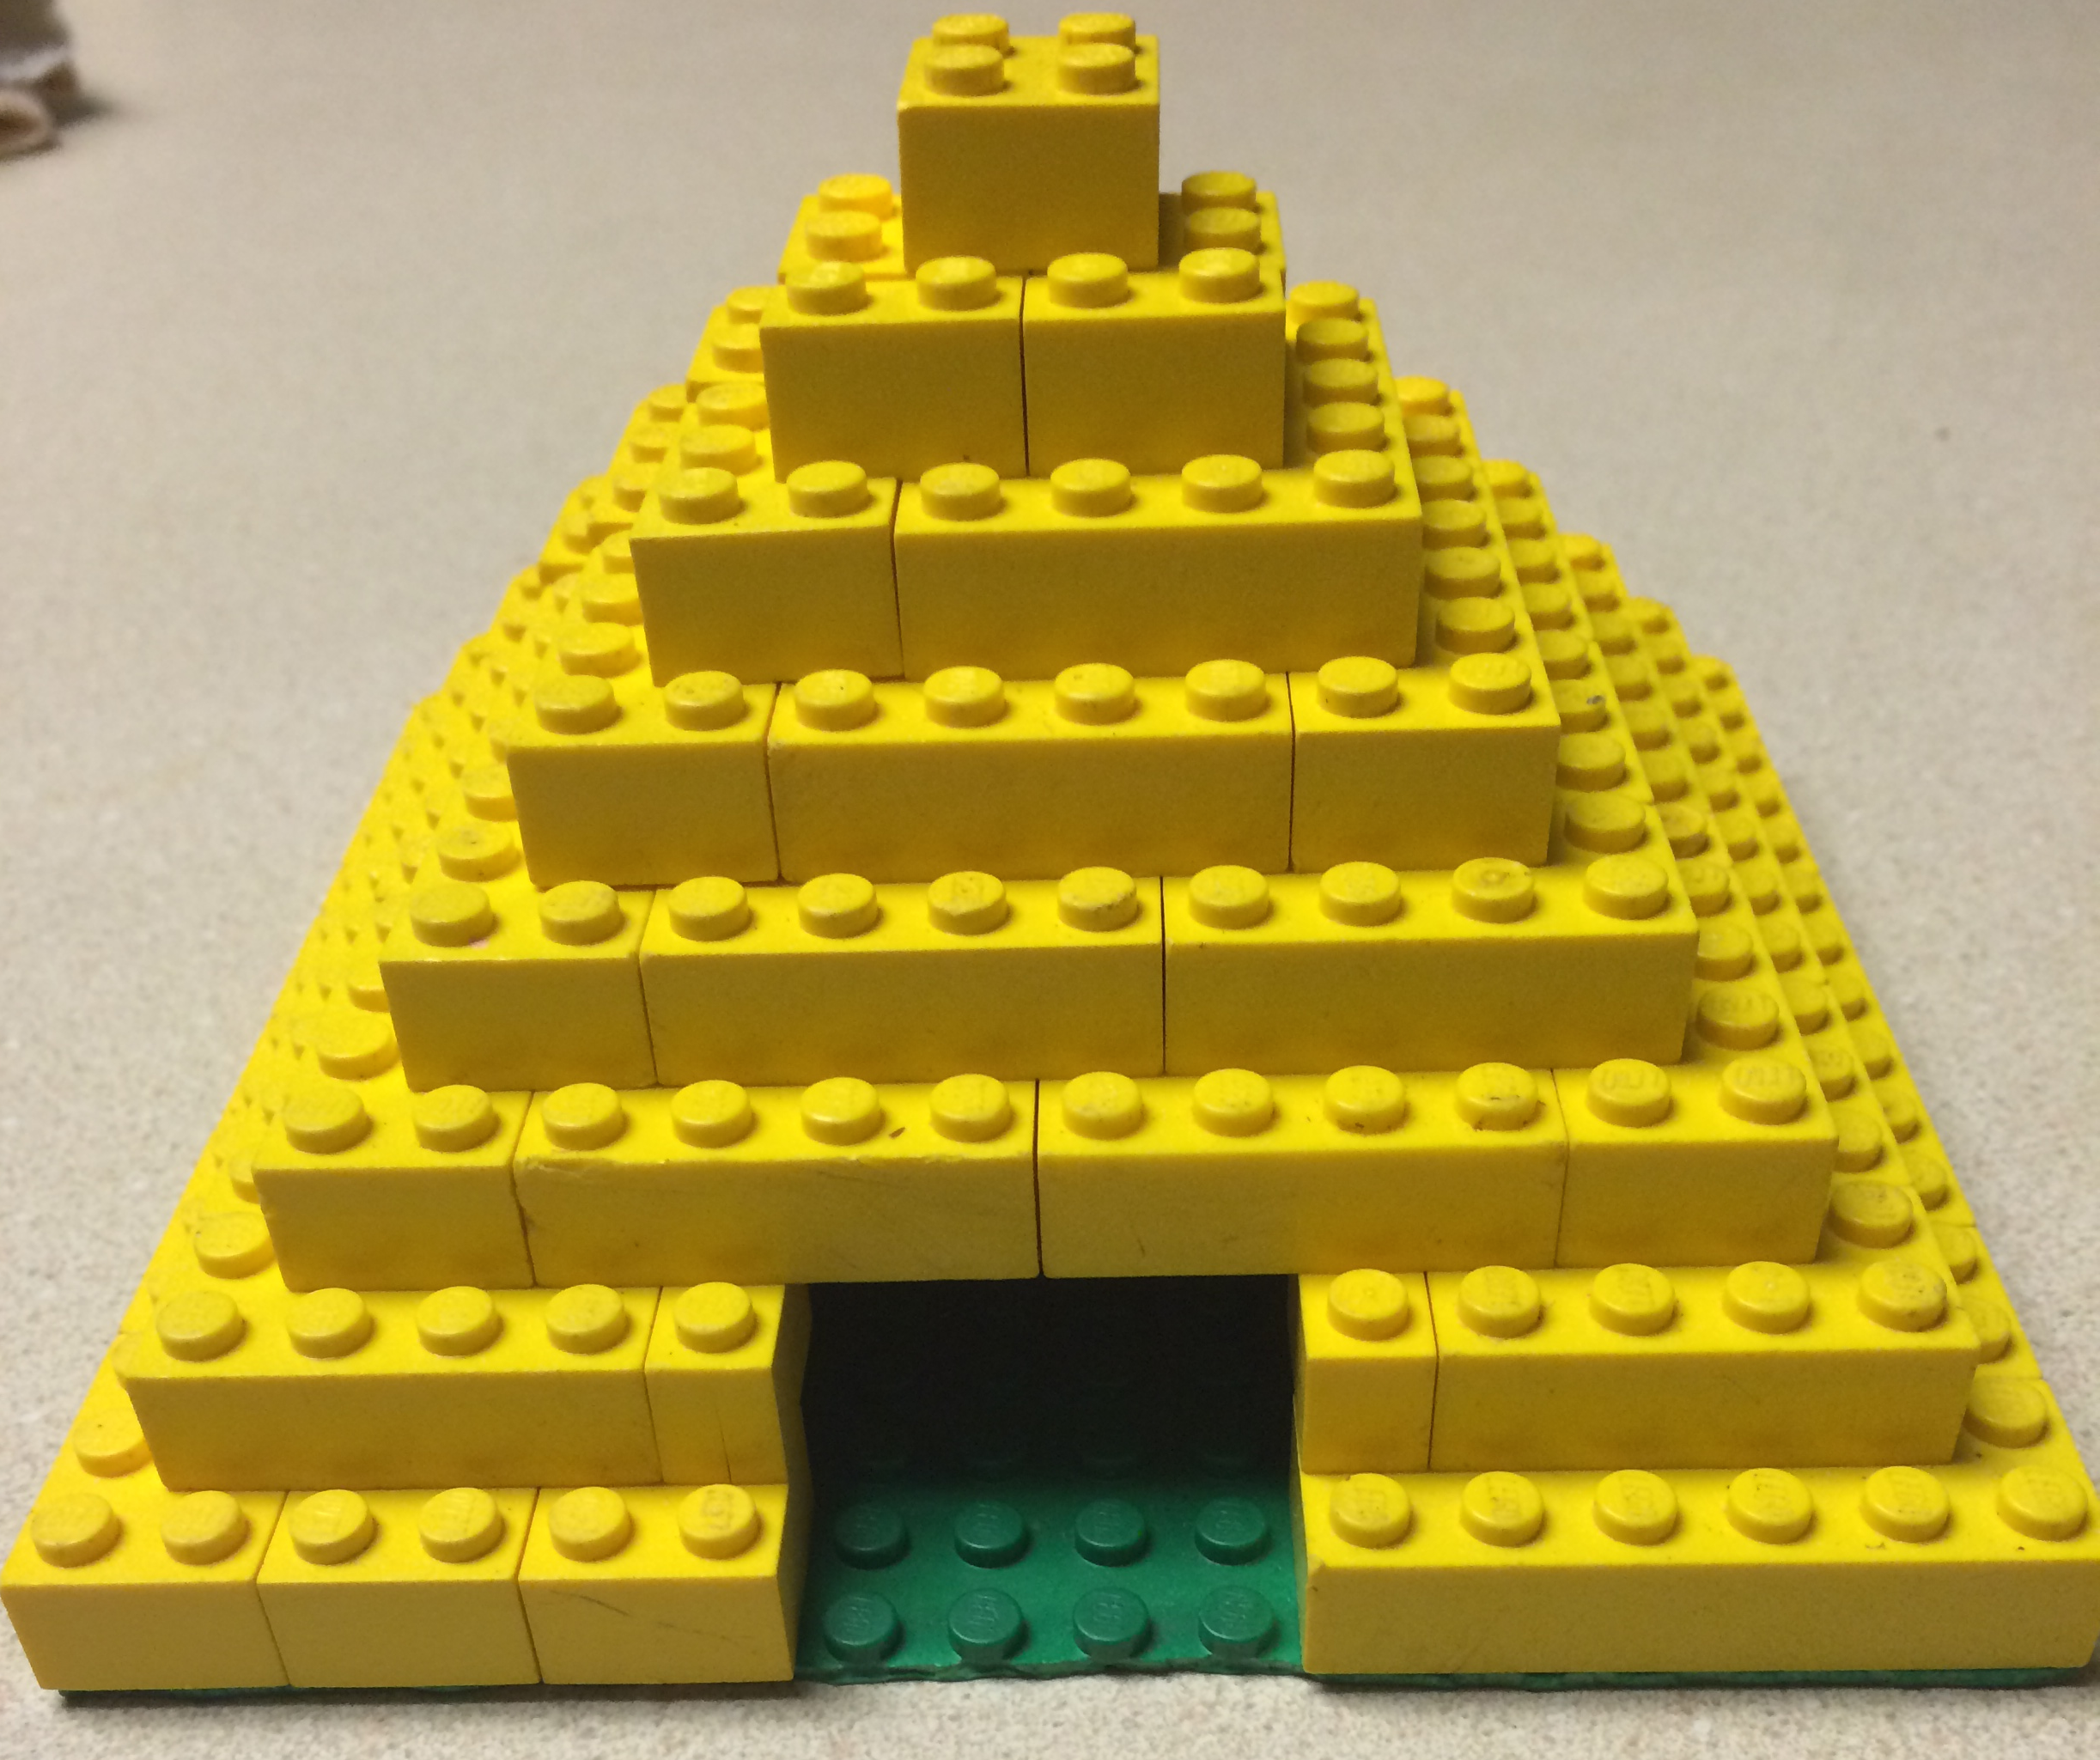
The Ancient Egyptians used the pyramids to honor their Pharaohs. The pyramid represents the social structure of the Ancient Egyptian civilization. They had a monarchy where the Pharaohs were the kings of the land and considered the most important people. Pyramids were built as monuments or tombs for themselves. They owned everything in the land.
Society was based on a hierarchical system. Underneath the Pharaohs was the Vizier who was the Pharaoh’s advisor. Next came the Nobles and Priests, followed by the Scribes and Soldiers. Then the craftsmen were next, whom were followed by the farmers and slaves at the bottom of the chain.

Teaching Activity:
I would allow students to pick a pyramid and ask them to simply do some research the background of that pyramid. Students would need to be able to describe the pyramid, determine why it was built, and what significance the pyramid brings today. Then students would be asked to create their own pyramid and produce a short commercial trying to persuade viewers that it is important that their new pyramid be build and why it is.

Calendar
Artifact: Miniature Present-day Calendar
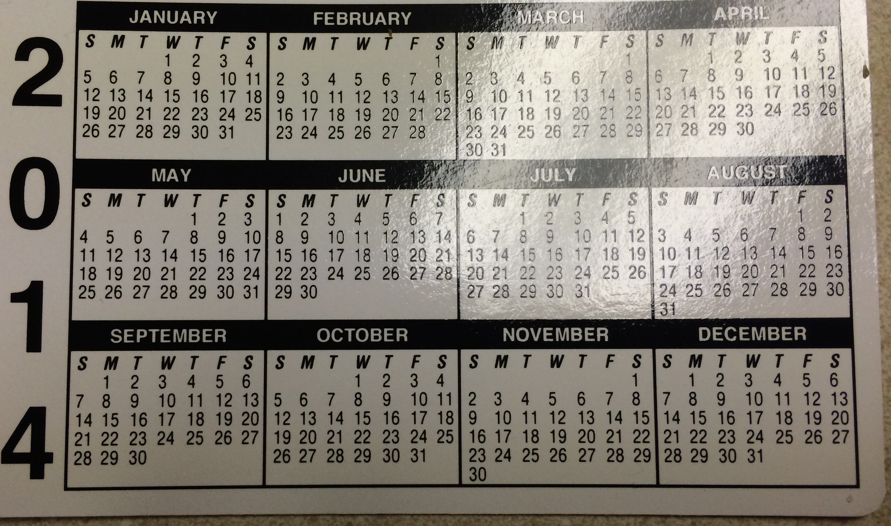
The Egyptians were able to establish a calendar year. At first, they based it off of lunar cycles, which consisted of twelve months. Each month had either 28 or 29 days. A new moon meant the beginning of a new month. They soon realized that the lunar calendar was a bit shorter than the solar calendar so they added a thirteenth month.
Later on, the civil (solar) calendar was produced. It had 365 days and twelve months. Each month consisted of 30 days each with five extra days at the end of the year. This calendar led to the form of the current Western calendar.

Teaching Activity:
Students can create their own calendar like the Egyptians. They could observe the moon cycles similar to how it was done and document the time (day) and moon phase. A shorter activity might include students taking the idea that there are 365 days in a year and allow them create their own calendars. They must provide reasoning behind their thoughts for month lengths, names, etc.

Egyptian Warfare
Artifact: Miniature Bow and Arrow

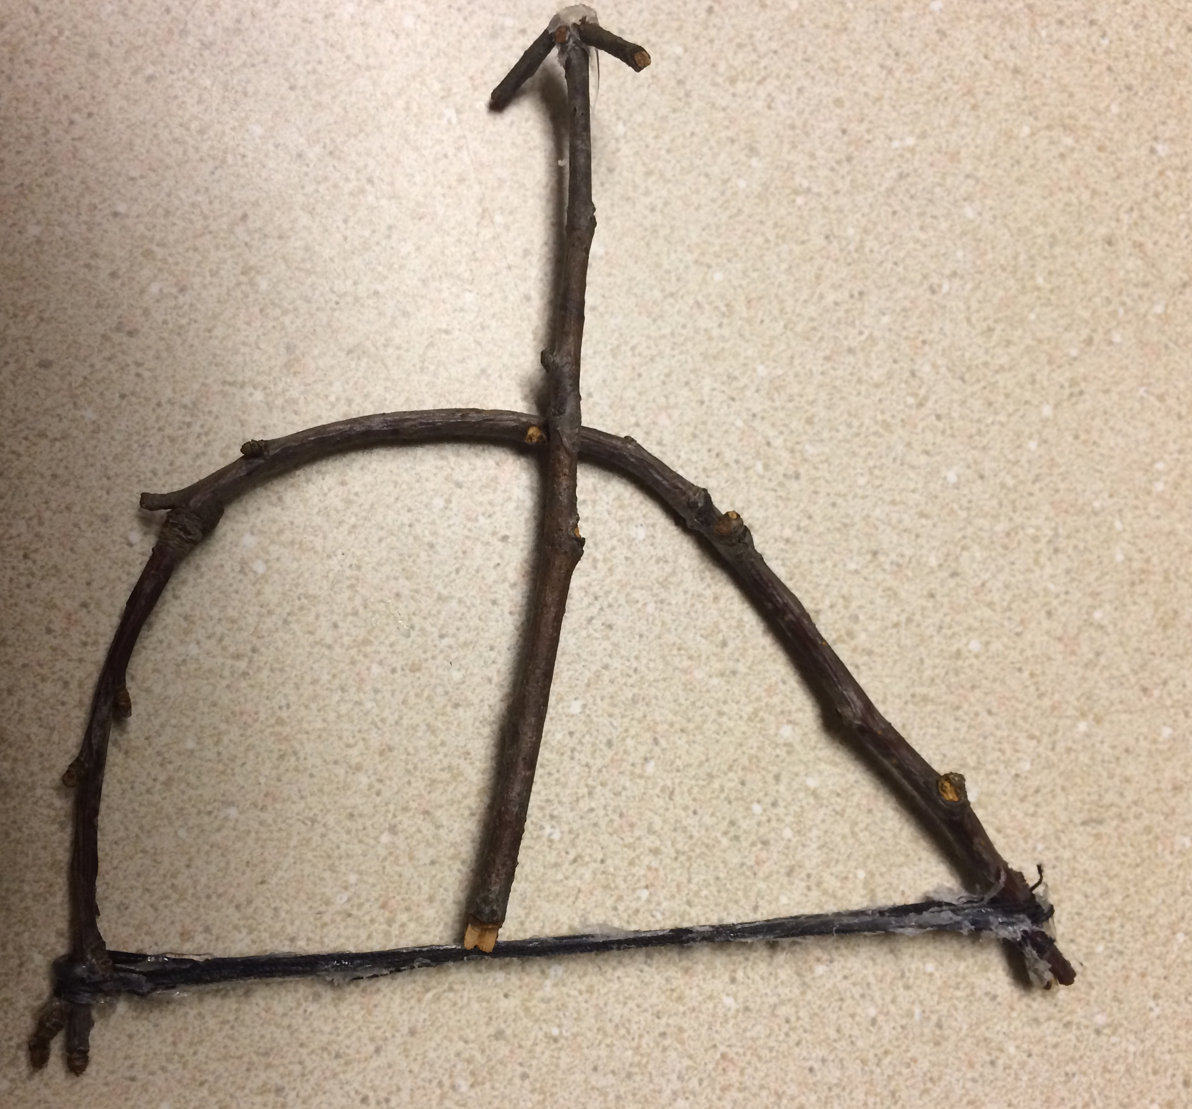
Typically, the Egyptians were at peace because they were surrounded by desert land. At times, the Egyptians did fight between each other about who should be in charge. On a few accounts, they also had to ward off other armies that were trying to invade. Egyptians also attempted to invade other lands to gain property and power.
In the army, soldiers used bows and arrows as weapons. They used a composite bow. Egyptians learned how to make the bows from the Hyksos. Many soldiers could shoot the arrows over 600 feet, which allowed for the enemy to be injured or killed from a far distance.

Teaching Activity:
Students can create a map of Egypt and discover the times where the army needed to defend or invade. These instances can be illustrated on a map. Students would be able to better understand why the army was necessary and to observe their movement.

Egyptian Gods
Artifact: Pictures of Various gods (Ra, Isis, Horus, Osiris)

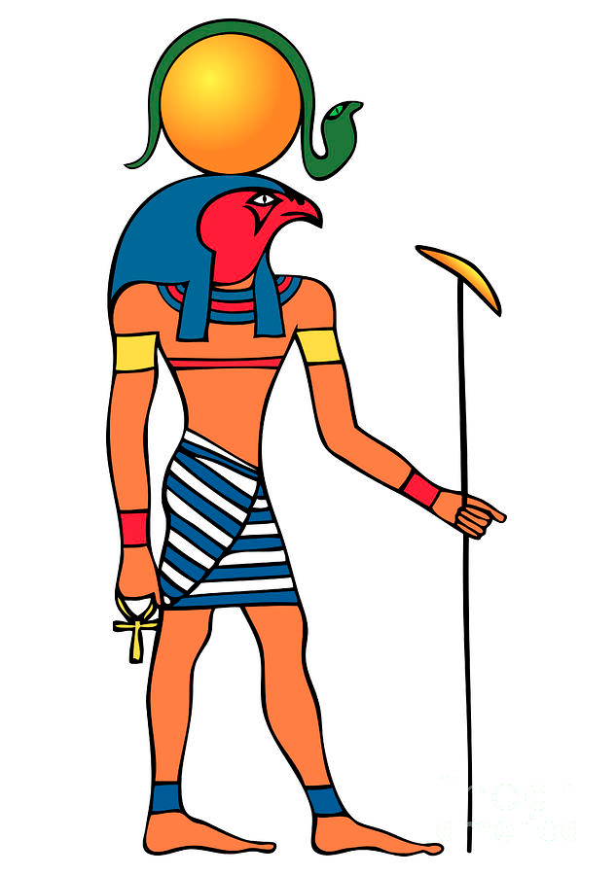
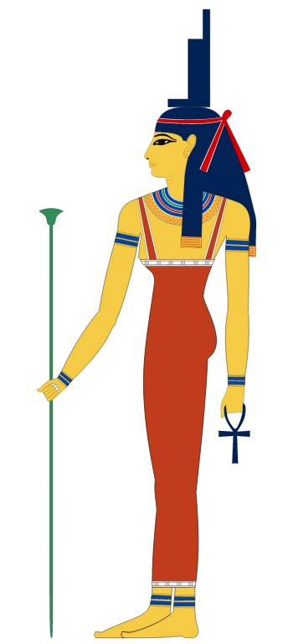
Egyptian religion was polytheistic, consisting of many gods that the people worshipped. People would sacrifice animals and hole processions. They believed that the gods controlled all things and Egypt belonged to them. People also thought that the Pharaoh was the gods’ representative on Earth.
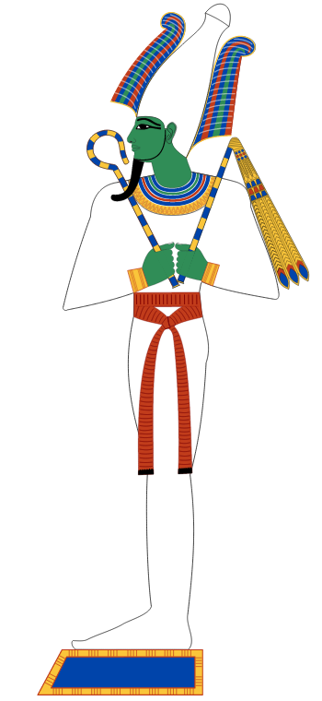
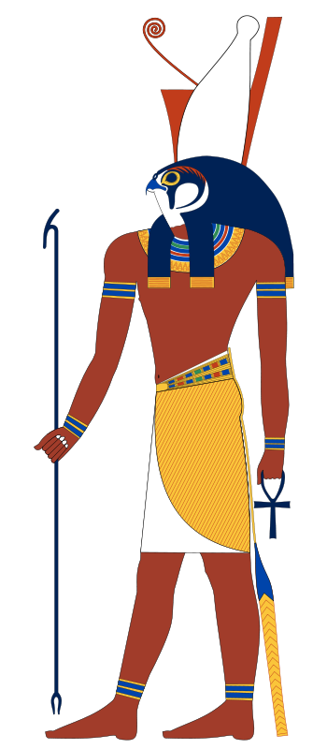
Four of the most prominent gods were Ra, Isis, Horus, and Osiris. Ra is the god of the sun. In writings, Ra travels from the east to the west in the sky. He is considered the supreme ruler of the gods. Isis is the goddess of nature and magic. She is considered a mother who would protect those in need. Horus was the god of the sky and the son of Isis and Osiris. It was thought the Pharaoh was the human version of Horus. Osiris was the god of the dead and ruler of the underworld. He was married to Isis.

Teaching Activity:
I would have students work in groups to compare and contrast the gods of Egypt to the gods of another civilization like the Greek gods. Students would gain a deeper understanding of how a polytheistic society works together. Another option for students would be to create masks that represent a specific god. The students could use the artifacts to do so.

Hieroglyphics
Artifact: Hieroglyphics Alphabet
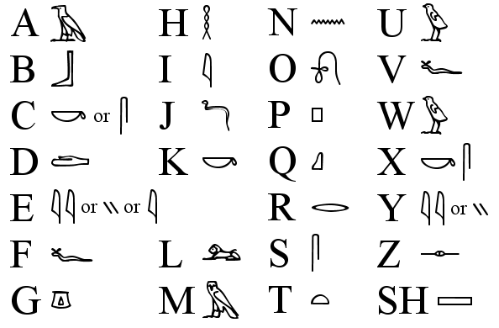
The Egyptians used pictures in their writing instead of letters. Many of the hieroglyphics represented letters, sounds, or whole words. The writing could be written in any direction unlike the English left to right. There was also no punctuation. The goal of using hieroglyphics was to make it look like art.

Teaching Activity:
Students could use the alphabet guide to create their own messages for a partner and that partner must determine what the message says. Also, I would have students create a poster using hieroglyphics. They would need to make it look like it belonged in Ancient Egypt.

Farming
Artifact: Cow Figurine

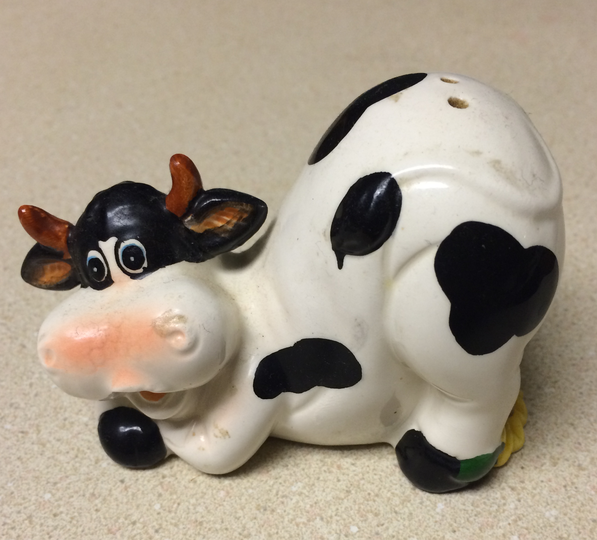
The Egyptians farmed everything that they needed to live. They used an irrigation system to help water easily meet crops and help them to grow. Most of the farming was done near the Nile River banks because of the fertile soil. Egyptians grew barley, grain, wheat, and flax. These resources went to make many other objects in every day life. Egyptians would also grow basic vegetables. Sheep, goats, cattle, pigs, and cows were the most commonly farmed animals in Egypt. They would use the animals for meat and for other products. Farming made up a large portion of the Egyptian economy. People were able to buy or trade for food and goods.

Teaching Activity:
I would have students participate in a hands-on activity in which they would become farmers and good traders. They would need to know how much product they need or want to be able to successful live in society. I would also have the students journal about the experience to help them reflect about any difficulties they may have had or any successful they have had.

References

Britton, P. (n.d.). TimeMaps. Atlas of World History. Retrieved July 14, 2014, from http://www.timemaps.com/civilization/Ancient-Egypt

Carr, K. (2012, January 1). Ancient Egypt. - Middle School History for Kids. Retrieved July 14, 2014, from http://www.historyforkids.org/learn/egypt/

Dollinger, A. (2000, January 1). An introduction to the history and culture of Pharaonic Egypt. Ancient Egypt: an introduction to its history and culture. Retrieved July 14, 2014, from http://www.reshafim.org.il/ad/egypt/index.html

Editors of Encyclopædia Britannica. (n.d.). Egyptian calendar (chronology). Encyclopedia Britannica Online. Retrieved July 14, 2014, from http://www.britannica.com/EBchecked/topic/180708/Egyptian-calendar

Nile river valley civilization. (2011, September 12). Retrieved from http://www.rivervalleycivilizations.com/nile.php

Technological Solutions, Inc. (2014, July). Kids history: Ancient egypt. Retrieved from http://www.ducksters.com/history/ancient_egypt.php

