Anna Foreman
EDTL 6430
Mesopotamia: Tigris and Euphrates
Introduction
Mesopotamia means land between the rivers. These river civilization lies between the Tigris and Euphrates Rivers in the ancient Mediterranean region. These areas are known today as Iraq, Iran, Syria and Turkey. The soil along the rivers was very rich which enabled farming during early civilization; this allowed the early people to sustain life. Industry was very important in the Mesopotamia river valley as well, the people were known for metal work, wool, textiles and pottery. The wheel was invented by the Mesopotamian people, which made trade much easier for them. The soil was very rich, 90 percent of the people who lived in the valley were farmers. The valley consisted of nobles, commoners and slaves. The nobles were the royal officers, the commoners worked as farmers and merchants and the slaves worked to build temples. A temple was built in the Sumerian City of the valley; it was dedicated to the gods and goddesses of the city. It was called a ziggurat and built on top of a massive tower. Most of the buildings in the river valley were built by sun dried bricks, only a few were made of stone or wood. At first the temple was used for religious events only, as time went on it became a place to learn as well. The people of the Mesopotamia river valley believed their city was protected by a god; there were many gods and goddesses they worshiped. The Sumerian people of the Mesopotamia River Valley are credited with one of the earliest known writing systems. They created documents by using triangular tipped stylus to make wedge shaped impressions in the clay.
Ohio’s New Learning Standards
Grade: 6
Theme: Regions and people of the Eastern Hemisphere
Strand: History
Topic: Early Civilizations
Content Statement: 2 early civilizations (India, Egypt, China and Mesopotamia) with unique governments, economic systems, social structures, religions, technologies and agricultural practices and products flourished as a result of favorable geographic characteristics. The cultural practices and products of these early civilizations can be used to help understand the Eastern Hemisphere today.
Grade: 6
Theme: Regions and People of the Eastern Hemisphere
Strand: History
Topic: Historical Thinking and Skills
Content Statement: 1. Events can be arranged in order of occurrence using the conventions of B.C. and A.D. or B.C.E. and C.E.
Grade: 6
Theme: Regions and People of the Eastern Hemisphere
Strand: Geography
Topic: Places and Regions
Content Statement: 5. Regions can be determined, classified and compared using various criteria (e.g., landform, climate, population, cultural, or economic).
Grade: 6
Theme: Regions and People of the Eastern Hemisphere
Strand: Geography
Topic: Human Systems
Content Statement: 6. Variations among physical environments within the Eastern Hemisphere influence human activities. Human activities also alter the physical environment.
Grade: 6
Theme: Order and Organization
Strand: Earth and Space Science
Topic: Rocks, Minerals, Soil
Content Statements:
- Soil is unconsolidated material that contains nutrient matter and weathered rock.
- Rocks, minerals and soils have common and practical uses.
Grade: 6
Theme: English language Arts
Strand: Reading Standards for History/Social Studies
Topic: Craft and Structure
Content Statement: 4. Determine the meaning of words and phrases as they are used in a text, including vocabulary specific to domains related to history/social studies.
Grade: 6
Theme: English Language Arts
Topic: Integration of Knowledge and Ideas
Content Statement: 7. Integrate visual information (e.g., in charts, graphs, photographs, videos, or maps) with other information in print and digital texts.
Artifacts
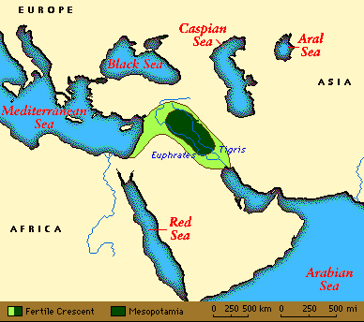
Mesopotamia River Valley Map
The Mesopotamia River Valley lies between two big Rivers, the Tigris and Euphrates. The ancient Mesopotamia is called the Cradle of Civilization because it is one of the first places where people gathered and created governments and cities. The map shows the Mesopotamia river valley in dark green and the light green shows the fertile land.
Students can use the map to find study where the Valley is in relevance to other places, today it mostly lays in Iraq. Students can also use the map to find the absolute location of the valley. Students can also use the map to identify the geographical features surrounding the area and identifying the neighboring continents and seas.
Wheel
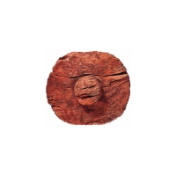
The ancient Mesopotamians invented the wheel around 3000 BC, this helped with their ability to trade. They were able to transport goods much quicker and easier.
Students can brainstorm things they use which use a wheel. Once they are done, they can choose one item and decide how they would use it if it didn’t have a wheel, and think of an alternative for it. They can build a model of their alternative method, make a chart showing the differences, explain using a poster, or any other teaching approved demonstration. This activity will show them how important the wheel invention was.
Temple
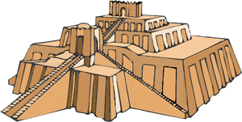
The most famous and important building in the Mesopotamia River Valley was the temple which was called a Ziggurat. This temple was originally used for worship but later became a learning center as well. It was built on a big tower and made from sun dried bricks.
Students can research the process of making sun dried bricks and create a poster, chart or other visual on the process. Students can also build a replica of the temple using materials of their choice (popsicle sticks, cardboard, wood, etc.)
Farmers
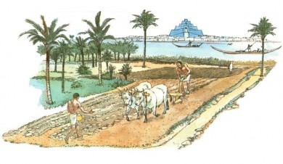
The soil along the Mesopotamia river valley was very rich. 90 percent of the people who lived in the valley were farmers. The areas which did not have rich soil were harder to farm because of lack of water. Farmers had to develop irrigation systems to water their crops.
Students can research the types of crops they grew and what equipment they used to plant and harvest their crops and then compare and contrast to modern day farming in our area. Students can write a paper to complete this, make a t chart showing the similarities and differences, use a venn diagram or create a visual showing pictures. Students can also create and label a map showing the areas of rich soil and the areas which relied on irrigation.
Clay
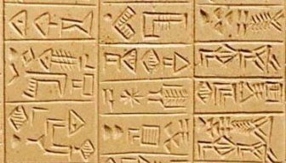
The Sumerian people of the Mesopotamian Valley were responsible for some of the first writings. They would use a triangular tipped stylus to make impressions in soft clay. Most of the first writings were pictures. Later on the writings were called phonograms which are closer to a modern day word. The Mesopotamians continued this way of writing until 100 BCE when the alphabet was introduced.
Students could use examples of the first writings and make their own writings in clay. They could research what the different symbols meant and write their name or a phrase in the clay.

Resources
Tigris/Euphrates River valley Civilization. (n.d.) The River Valley Civilization Guide. Retrieved from: http://www.rivervalleycivilizations.com/tigris-euphrates.php
Mesopotamia. (2009-2014). Ancient History Encyclopedia. Retrieved from: http://www.ancient.eu.com/Mesopotamia/
Ancient Mesopotamia. (2014). Ducksters. Retrieved from: http://www.ducksters.com/history/mesopotamia/ancient_mesopotamia.php
History of the Wheel. (2008-2014). Auto Evolution. Retrieved from: http://www.autoevolution.com/news/history-of-the-wheel-7334.html
Cuneiform.(2009-2014). Ancient History Encyclopedia. Retrieved from http://www.ancient.eu.com/cuneiform/

