Restraint of small ruminants:
Goats:
Goats should be trimmed while in a standing position. Goats should have their heads tied to a secure place, preferably on a wall or fence. This allows the person doing the trimming to stand to the outside of the goat and gently push the goat up against the fence or wall for extra control when needed.
Sheep:
- The most common method of restraining sheep is to place them on their rumps and hold them in the shearing position. This procedure can be accomplished by standing on the sheep’s left side, holding the jaw with the left hand and placing the right hand on the animal’s hip. Hold the jaw tightly and bend the sheep’s head sharply over its right shoulder. At the same time, press down on the animal’s right hip. When the sheep falls to the ground, raise the front feet and head so the sheep rests on its rump and leans off center of the tail bone and against the person doing the trimming. If a large number of sheep are to be processed, a bale of hay can serve as a rest during trimming.
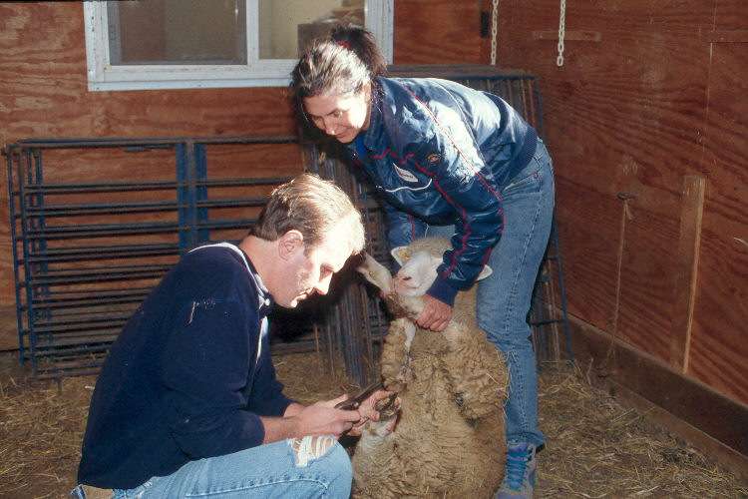

- A second method of restraint is to use a tilting squeeze table. The animal is rotated on its side while being restrained. This equipment requires added expense, but offers easy access to the animal’s feet. Care must be observed, however, to avoid being kicked. (Can be used for cattle, sheep and goats)
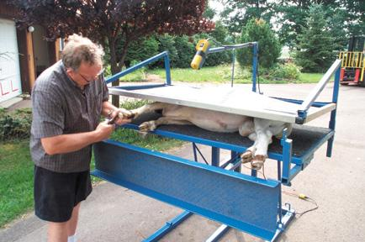

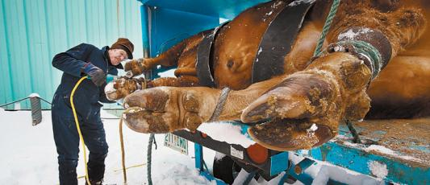

- A third method employs the use of a commercially-made sheep deck chair. This "beach" type chair is adjustable and holds the sheep on its dock comfortably and allows the operator the flexibility of having both hands free to concentrate on feet trimming rather than having to use one hand for restraining.
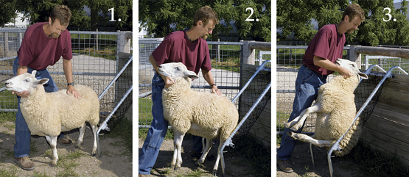

Sources:

https://www.infovets.com/healthysmrm/C322.htm

